USER MANUAL FOR PUSHKAR

WaterSoft

(For the Department of Panchayat Raj & Engineering Department, Rural Water Supply Sector, Govt. of AP)

National Informatics Centre
Department of Information Technology
Ministry of Communications and Information Technology
Government of India
WebSite : www.ap.nic.in

PREPARED BY :

PROJECT TEAM ,
NIC APSC,
HYDERABAD.

REVIEWED BY:

HEAD OF THE DEPARTMENT,
NIC APSC,
HYDERABAD.

APPROVED BY :

STATE INFORMATICS OFFICER
NIC APSC,
HYDERABAD.

Common Operations in the Software:

Click the button to close the Form.

 Click the button for online context help.

Home Click the button for Main Page.

Back Click the button for Previous page.

Print Click the button for Printable Version.

Excel Click the button for Excel Version.

Amount will be considered in Lakhs throughout the Software

1.PushkarGhat Entry Form:
Pushkar → PushkarGhat Entry 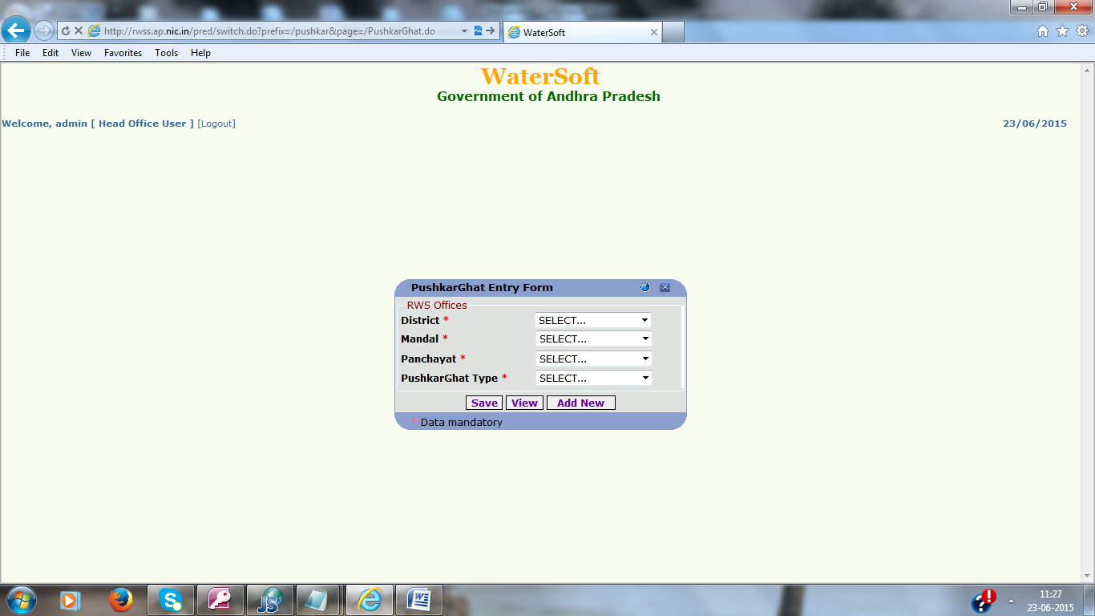
1. Select District,Mandal,Panchayat and PushkarGhat type.
2. Click “Add New” Button .
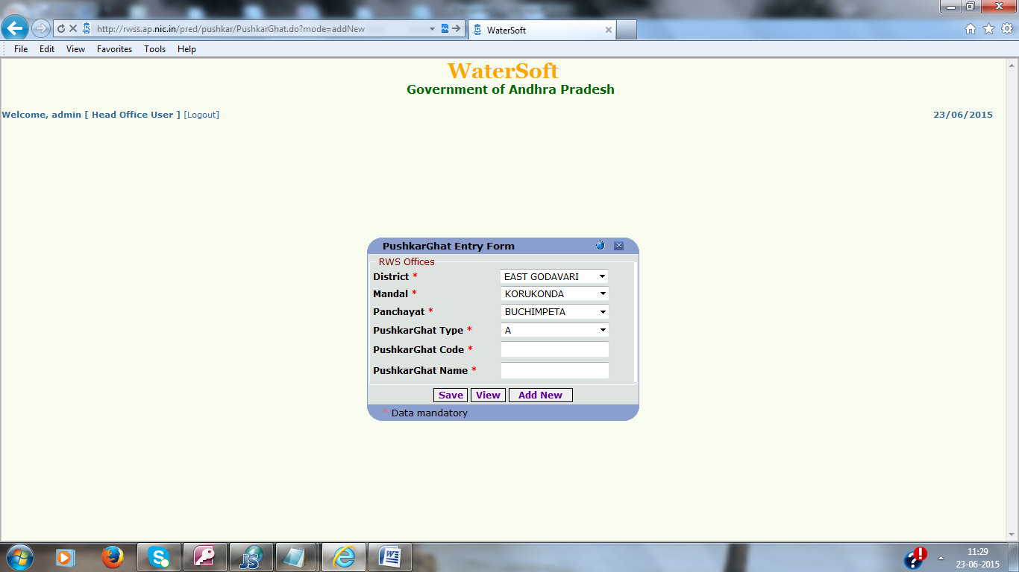
3. Enter PushkarGhat Code and PushkarGhat Name.
4. Click “Save”.
Note:
1. PushkarGhat Code is not auto-generated. It is user entered code and of 3 digits.
2. The combination of PushkarGhat Type and PushkarGhat Code should be unique.

PushkarGhat Entry Form:
Pushkar → PushkarGhat Entry
1. Select District,Mandal,Panchayat and PushkarGhat type.
2. Click “Add New” Button .
3. Enter PushkarGhat Code and PushkarGhat Name.
4. Click “Save”.
Note:
1. PushkarGhat Code is not auto-generated. It is user entered code and of 3 digits.
2. The combination of PushkarGhat Type and PushkarGhat Code should be unique.
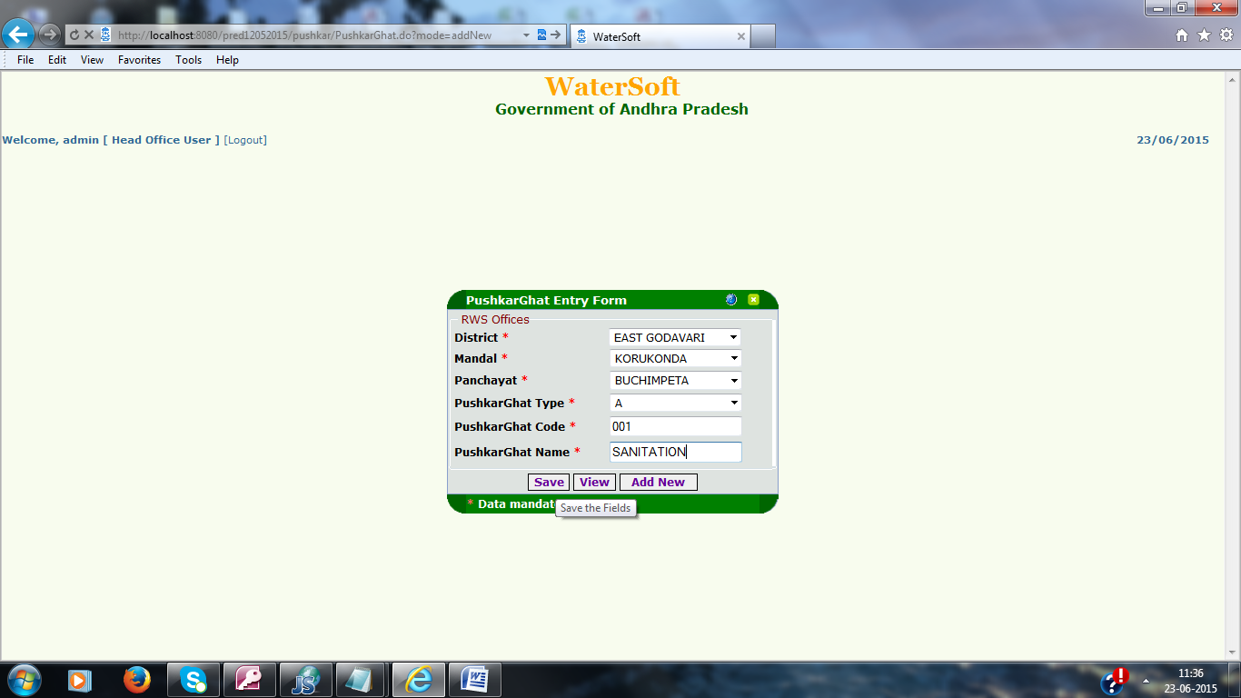
Confirm to “Save”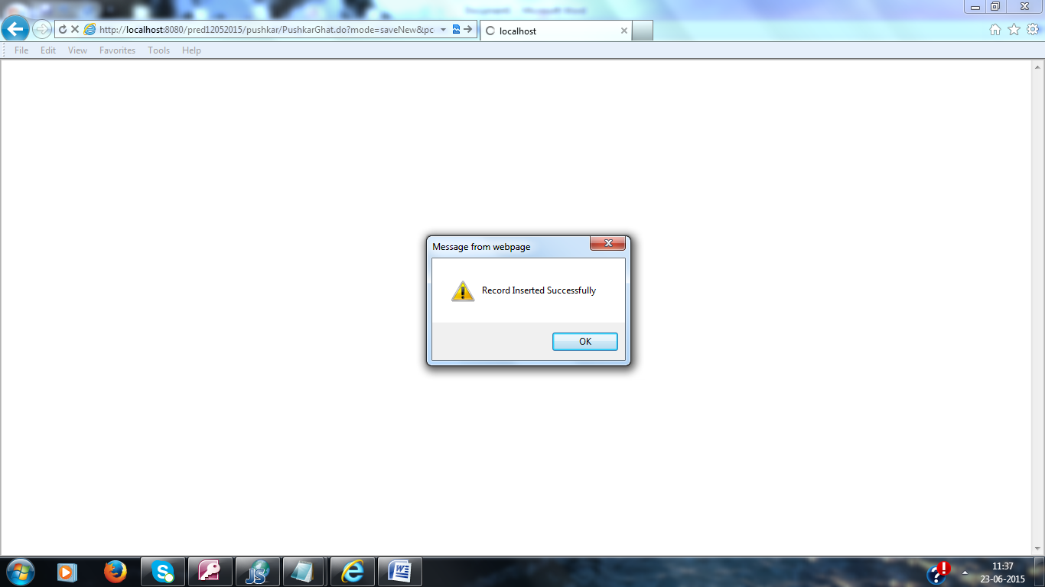
Click “ok”.

To View the Pushkar work Details:

- District, Mandal, Panchayat is Mandatory Fields.
- Click “View” button.

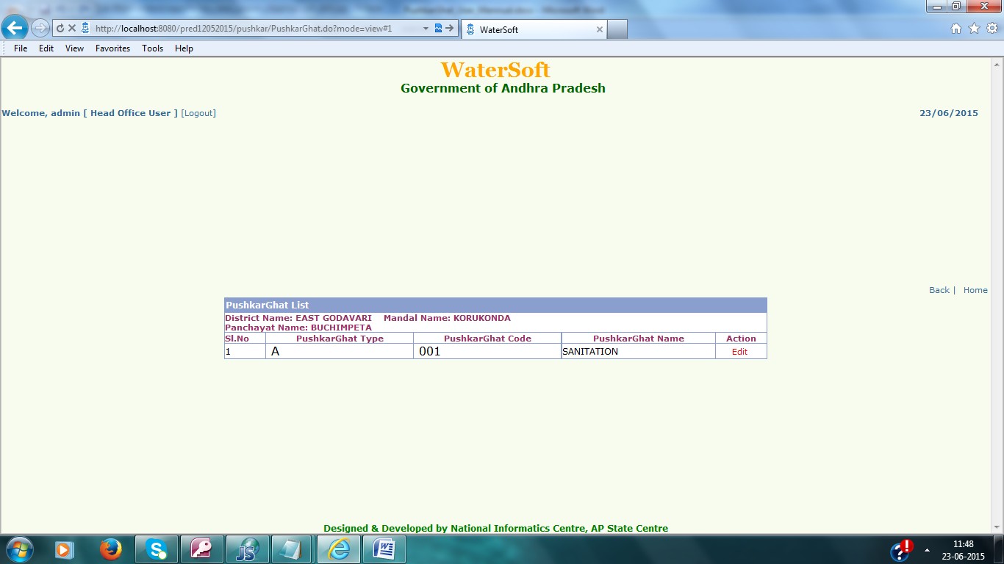

“Edit”
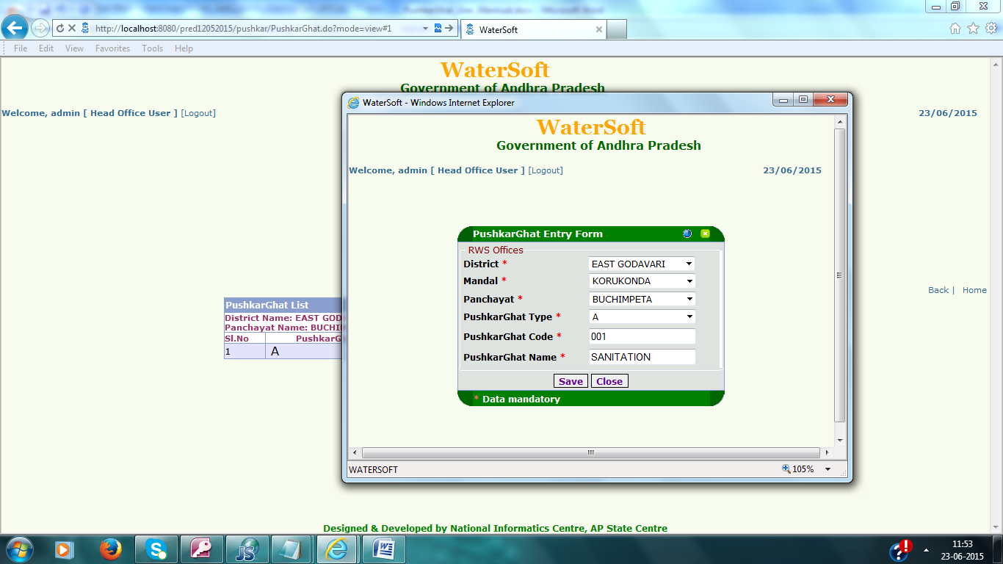

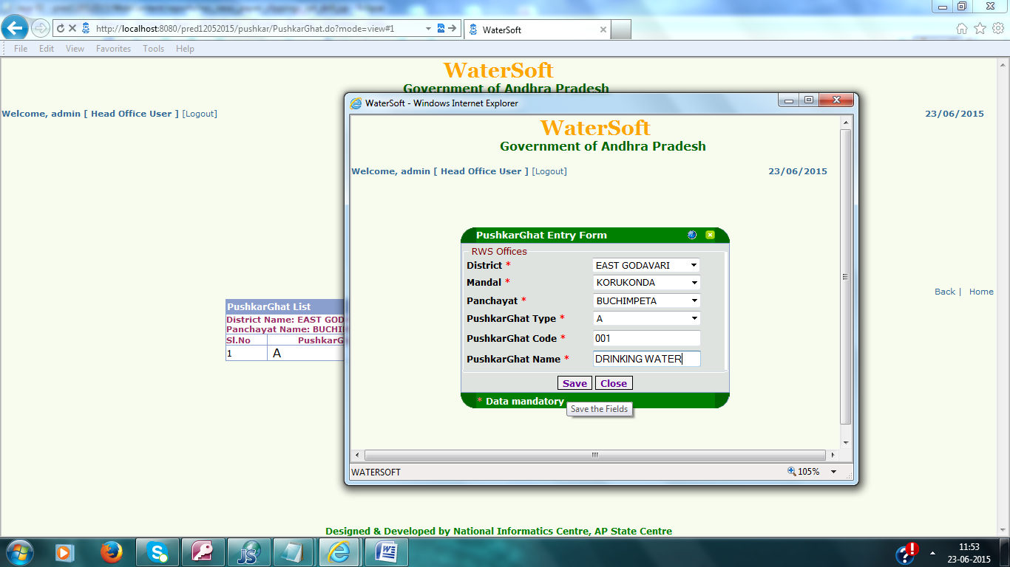

Click “Save”.
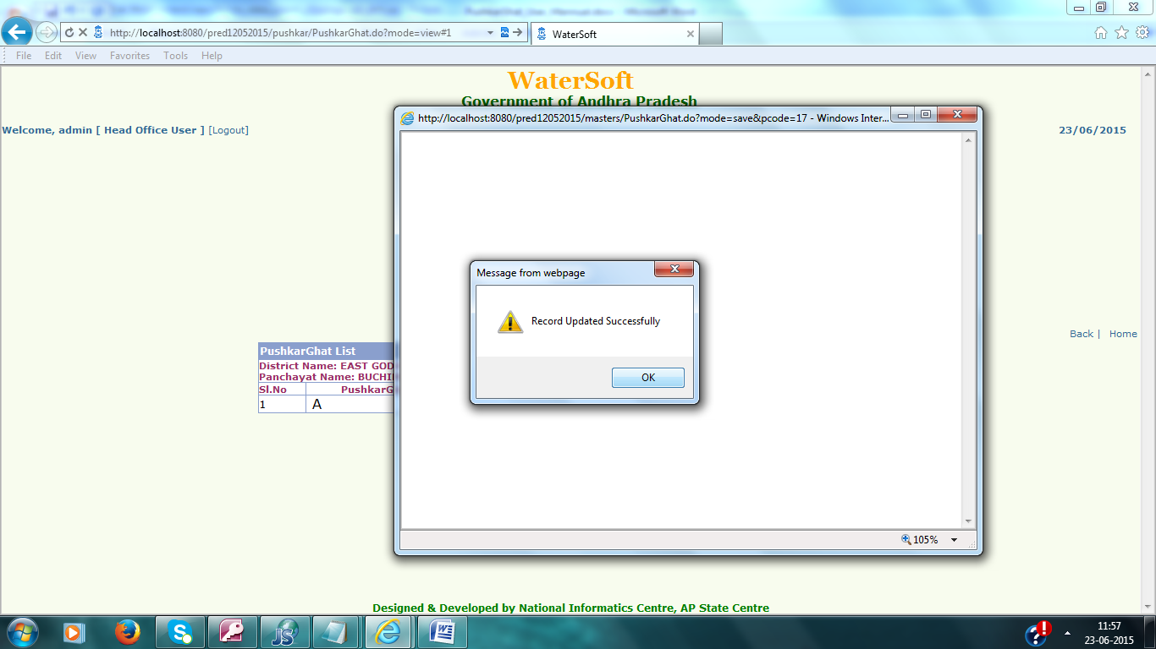
Click “Ok” button.

2.PushkarGhat Work Entry Form:
Pushkar→PushkarGhat Work Entry Form

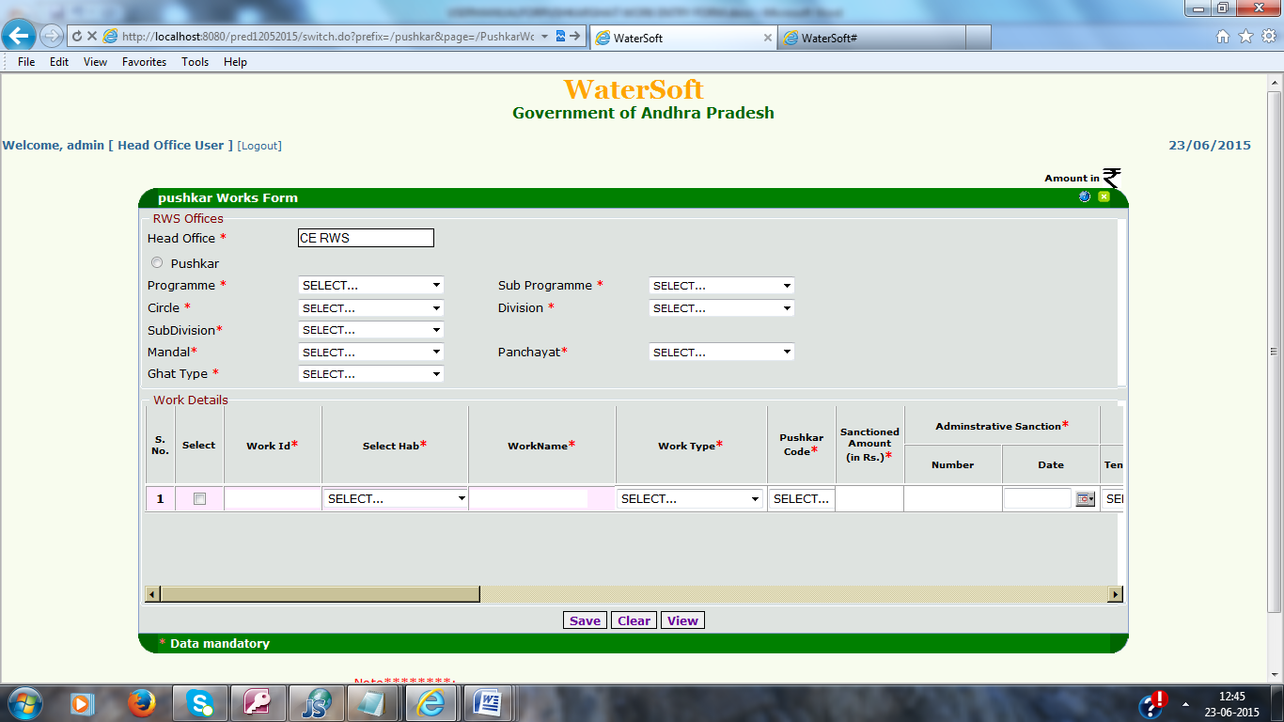

In PushkarGhat work Entry Form

- Select the Radio button ( pushkar), Programme,
Sub Programme,Circle,Division,SubDivision,Mandal,Panchayat and GhatType All are Mandatory Fields.
- Work Id (14 digits) will be Generated automatically based on programmeCode,SubProgramme Code ,Circle,Year.
- In work Id first 2 digits(1,2) is Programme Code .
3,4 is SubprogrammeCode
5,6 is circleCode
7,8 is 00
9,10 is year (15)
11 is P(pushkar)
12,13,14 are auto incrimented value
- Select habitation in SelectHab (Those are panchayat Related Habitations).
- Enter Work Name, Work Type.
- Select PushkarCode (the combo box shows Panchayat wise PushkarCodes Entered in PushkarGhat Entry Form).
- Enter Sanction Amount and Adminstrative Sanction(Amount should me in Rupees).
- Upload Work Image(Image Size should be 200kb).

Note: In PushkarGhat work Entry Form 1 to 8 points are Mandatory Fields

- Remaining Fields are Optional

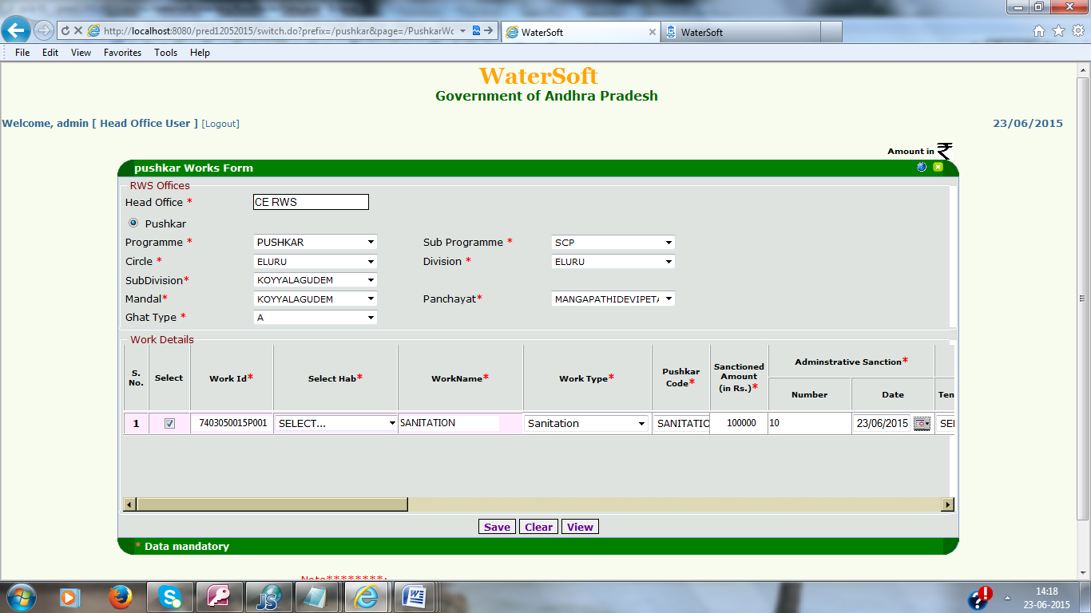

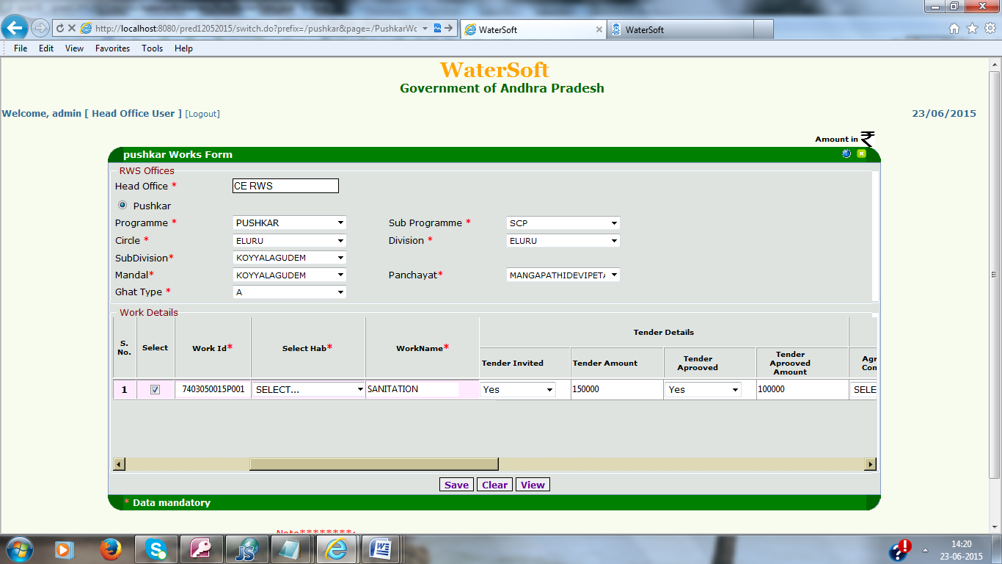

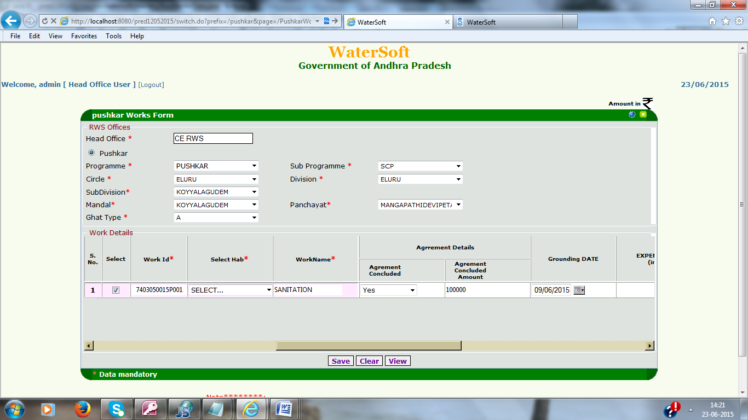

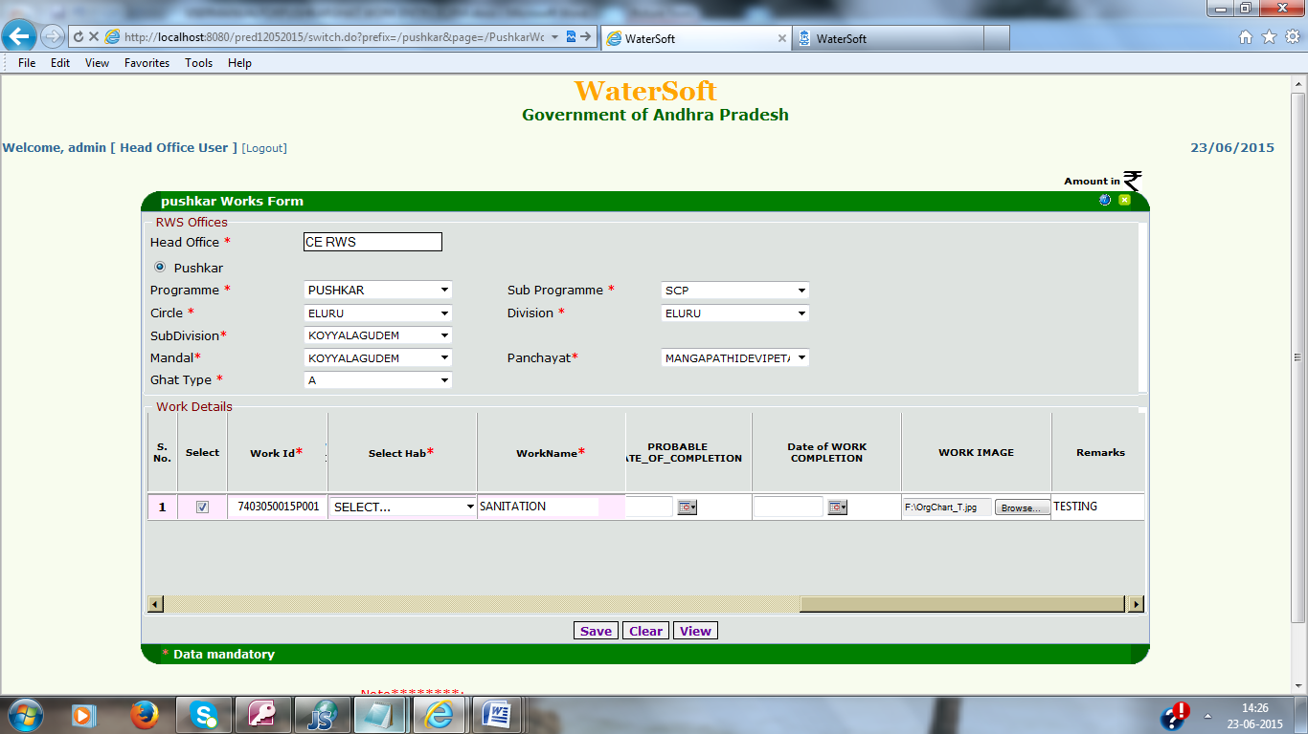

After Entering All Fields Click “Save” Button.

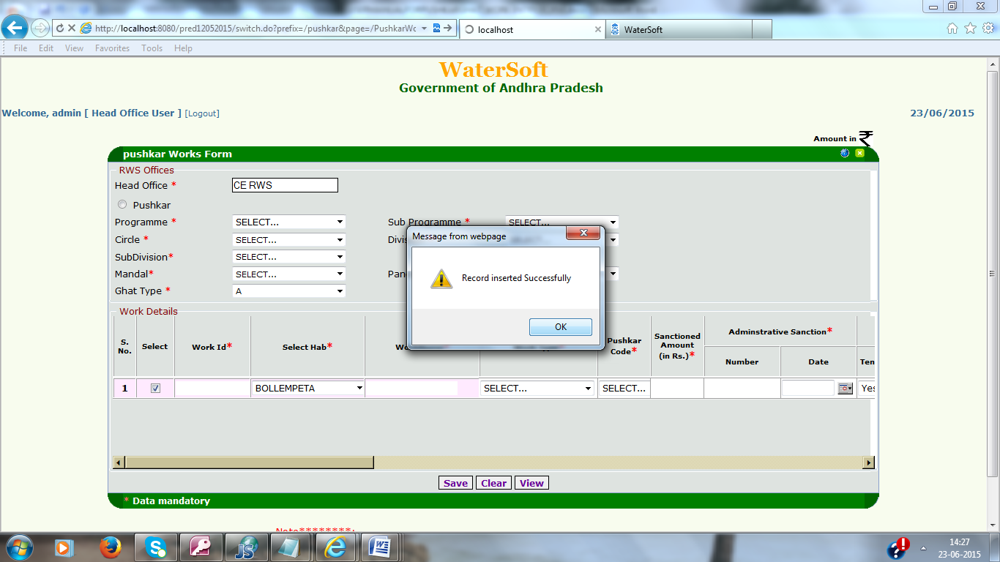

Click “ok” in popup.

To View the Pushkar work Details

1. Select Circle.
2. Click “View” button.

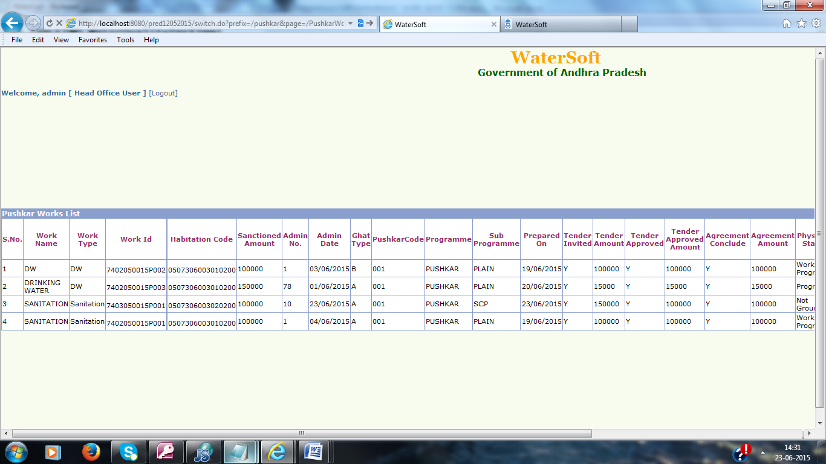

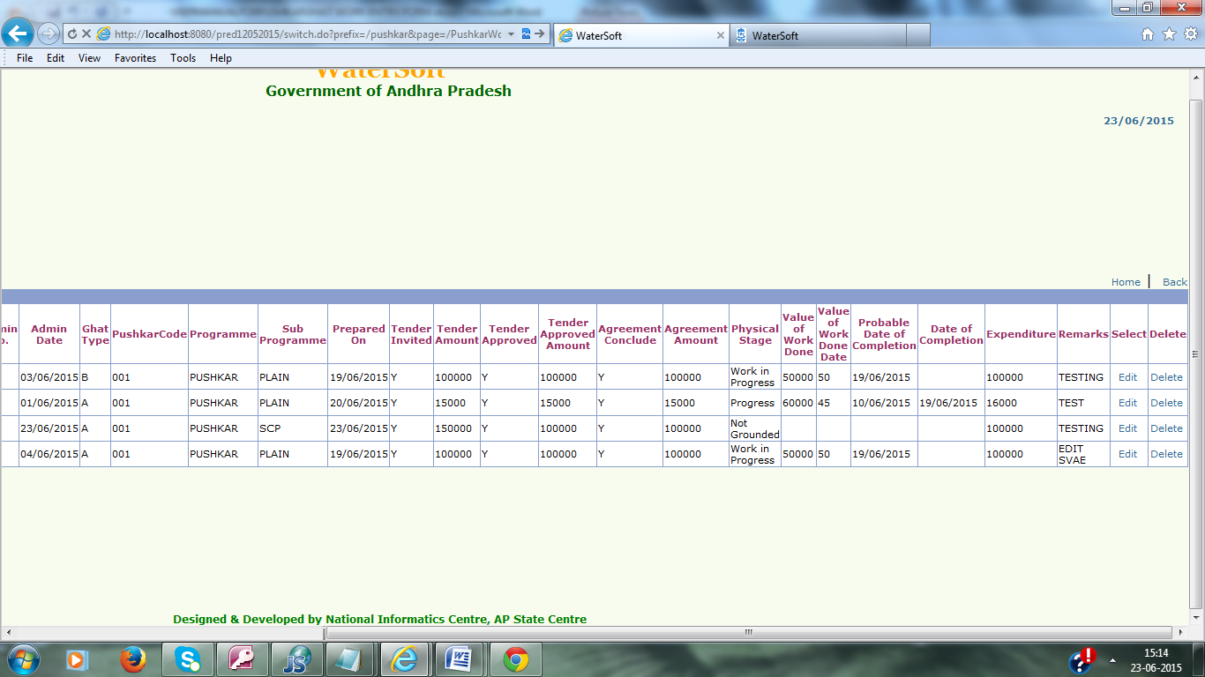

Note:- In Action Select “Edit” – To make Changes in Pushkar Works details – Pushkar Work Entry Form is displayed.

Note:-In Action Select “Delete”– To Delete Pushkar Work details.

