USER MANUAL FOR WORKS MONITORING

WaterSoft

(For the Department of Rural Water Supply Sector and Sanitation, Govt. of AP)

National Informatics Centre
Department of Information Technology
Ministry of Communications and Information Technology
Government of India
WebSite : www.ap.nic.in

PREPARED BY :

PROJECT TEAM ,
APDVIII, NIC APSC,
HYDERABAD.

REVIEWED BY:

HEAD OF THE DEPARTMENT,
APDVIII, NIC APSC,
HYDERABAD.

APPROVED BY :

STATE INFORMATICS OFFICER
NIC APSC,
HYDERABAD.

Amendment Log

Version Number | Date | Change Number | Brief Description | Sections Changed
1.0 | 1.1.2007 | - | First Release
1.1 | 20.3.2007 | - | Second  Release | ALL
1.2 | 28.3.2008 | - | Third Release | Administrative Sanction Form – Figure 2.  Revised Administrative Sanction – Figure 9.  Work Status Form – Figure 18.
1.3 | 5.2.2009 | - | Fourth Release | Due to changes made in the input design of Administrative Sanction Form – Figure 2.  Revised Administrative Sanction – Figure 7.  Work Status Form – Figure 18.
1.4 | 30.10.2009 | - | Fifth Release | Changes in Contractor Management  In Work Progress, column contractor/Firm Name combo box based on User Requirements.
1.5 | 20.11.2009 | - | Sixth Release | Change in Work Progress Remarks,Date Completed fields,  Change in Work Expenditure in Work Progress , value of work done but not paid field based on User Requirements.
1.6 | 20.02.2010 | - | Seventh Release | Augmentation to Mainscheme Linkage added based upon User Requirements.
1.7 | 26.02.2010 | - | Eighth  Release | Update Action Plan added based upon  User Requirements.
1.8 | 09.06.2010 | - | Ninth  Release | Changes in Work Expenditure,Work Completion based upon User Requirements.
1.9 | 18.06.2010 | - | Tenth  Release | Changes in Work Progress – Linking schools to works based on User Requirements.
2.0 | 13.09.2010 | - | Eleventh  Release | Changes in Work Progress – Contractor Management , Programme Management ( MileStones )

Sl No | CONTENTS | Page No
1 | Common Operations in the Software | 5
2 | Administrative Sanction | 6 – 15
3 | Augmentation Main Scheme Linkage | 16 – 20
4 | Revised Administrative Sanction | 21 – 29
5 | Work Progress | 30 – 63
6 | Update Action Plan | 64 - 69

Common Operations in the Software:

Click the button to close the Form.

 Click the button for online context help.

Home Click the button for Main Page.

Back Click the button for Previous page.

Print Click the button for Printable Version.

Excel Click the button for Excel Version.

Note : Amount is to be considered in Rs lakhs

Note I:- Depending on login Circle is Fixed . Fields marked with ‘ * ’ are Mandatory Fields.

WorkFlow - > Works Monitoring - > Administrative Sanction

Administrative Sanction

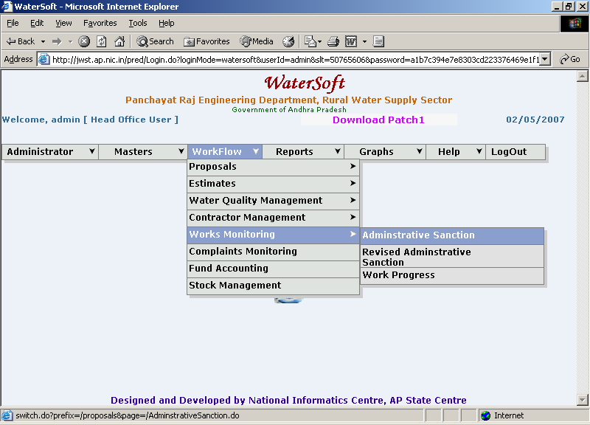
Figure. 1

Administrative Sanction

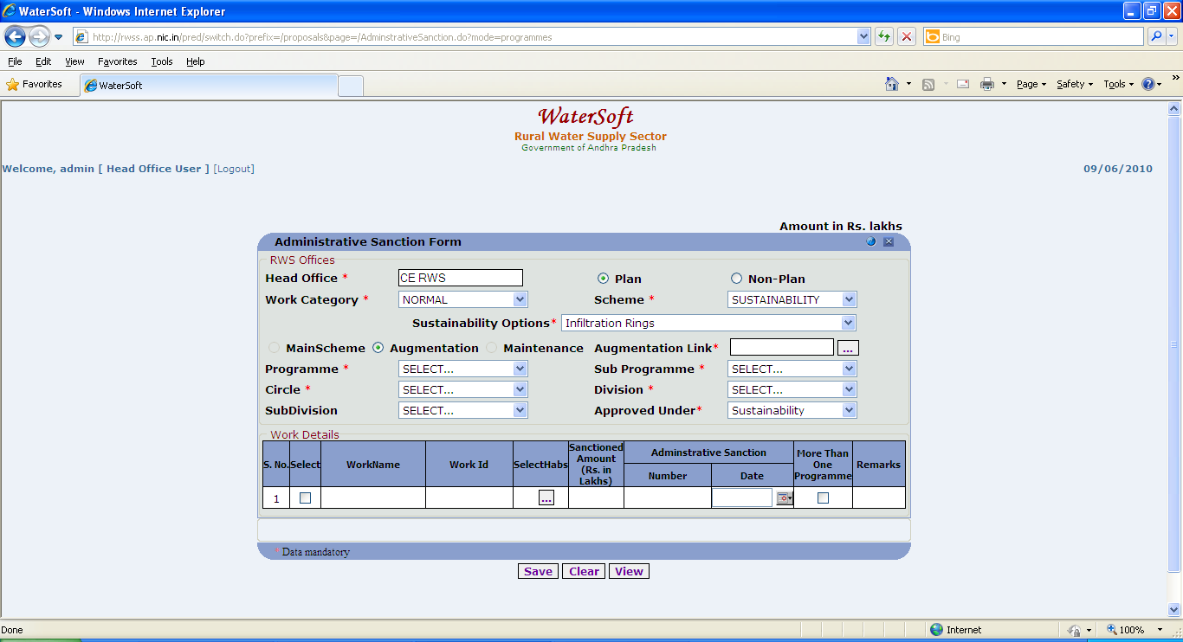
Figure. 2

Note :-If ‘ Sustainability ‘ is selected as scheme

->Select Sustainability Options

Sustainability Options are

- Infiltration Rings
- Recharge pits
- Check Dams
- Percolation Tanks
- Sub – Surfaces Dykes
- Injection wells
- Soak pit for Handpump
- Removal of Traditional water Harvesting structures
- Ponds/Tanks/ooranis
- Others

View /Save

- Head Office is fixed .
- Select Plan or Non – Plan ( default option is plan)
- Select Work Category ( For Eg. Normal ,District Level , Projects )
- Select Scheme . ( For Eg. Pws , Sustainability ).
- Select Main Stream , Augmentation( Default is Main Scheme).
- Select Maintenance ( For Non-Plan ).
- Select Programme.
- Select Sub Programme.
- Select Circle (fixed based on Login).
- Select Division.
- Select Sub Division (Optional)
- Select Approved Under (For Eg. Normal Coverage, Submission - Water Quality, Sustainability)

If Augmentation is selected series of steps follows… figures 3 & 4…. explain the process.

Click on ‘ Augmentation Link ‘ - > Works List Form is displayed .
Works List Form -> Select Circle -> Select Financial Year -> Select Scheme -> Works List details will be displayed -> Select Work.

The selected work will be automatically attached to augmentation link.

Works List

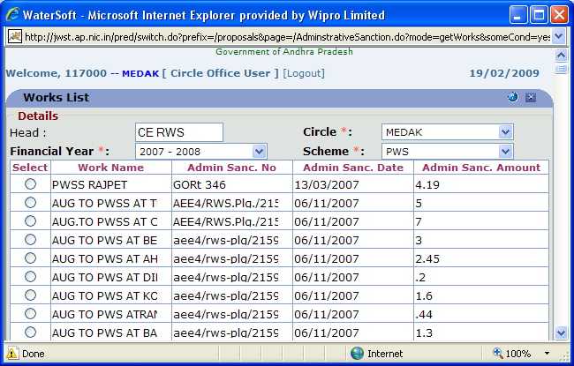
Figure 3.

Administrative Sanction Form

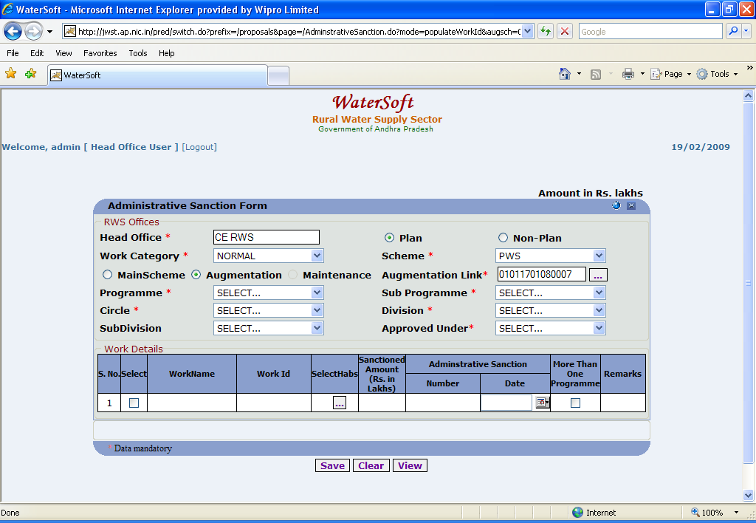
Figure 4.

Note II : This information is required either to Save a New Work or to View /Modify Existing Works.

Save

- Enter Work Name.
- Work Id is Auto Generated.
- Select Habs ( Habitations ).
- Enter Sanctioned Amount(Rs. Lakhs).
- Enter Administrative Sanction Number.
- Select Administrative Sanction Date.
- Select More Than One Programme ( in case if the work is sanctioned for more than one Programme).
- Enter Remarks.
- Click ‘Save’ to save the Work details.

Note III :-To Select ‘ Multiple Mandals ’ and Habitations Use CTRL Button.

Note IV:- To Select Habs – Select ‘ Mandals ’ → Click ‘ Get Habitations ’ button→ Habitations are displayed. Select ‘Habitations’ → Click ‘ Add Habitations ’
Press ‘OK’ wherever required.
(The screen shots are displayed figure 5 & 6 … explain the process

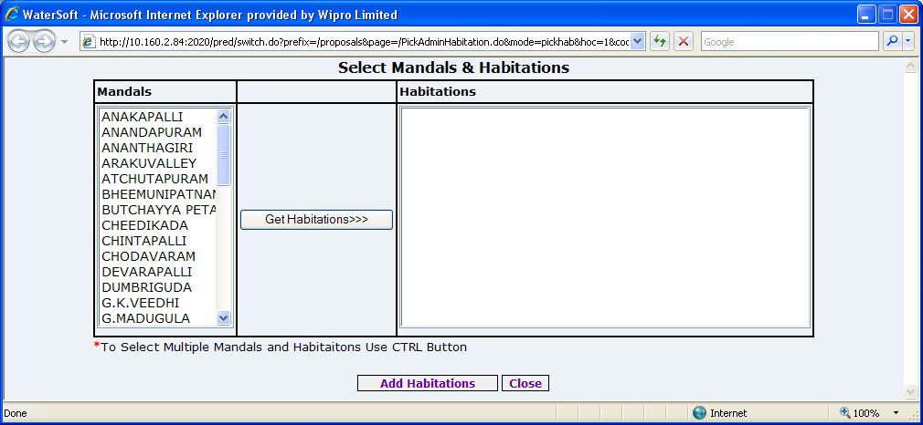

Figure. 5

Get Habitations

- Click ‘Get Habitations>>>’ buttons.

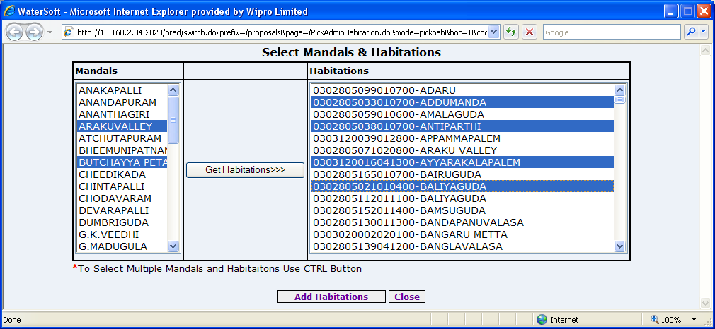

Figure. 6

Add Habitations

- Select Habitations.
- Click ‘Add Habitations’ button. ( To Select multiple Habitations Use CTRL Button )

View Data

- Click ‘View’ button.

The list of Administrative Sanctioned Works are Displayed as shown below .

Administrative Sanction List

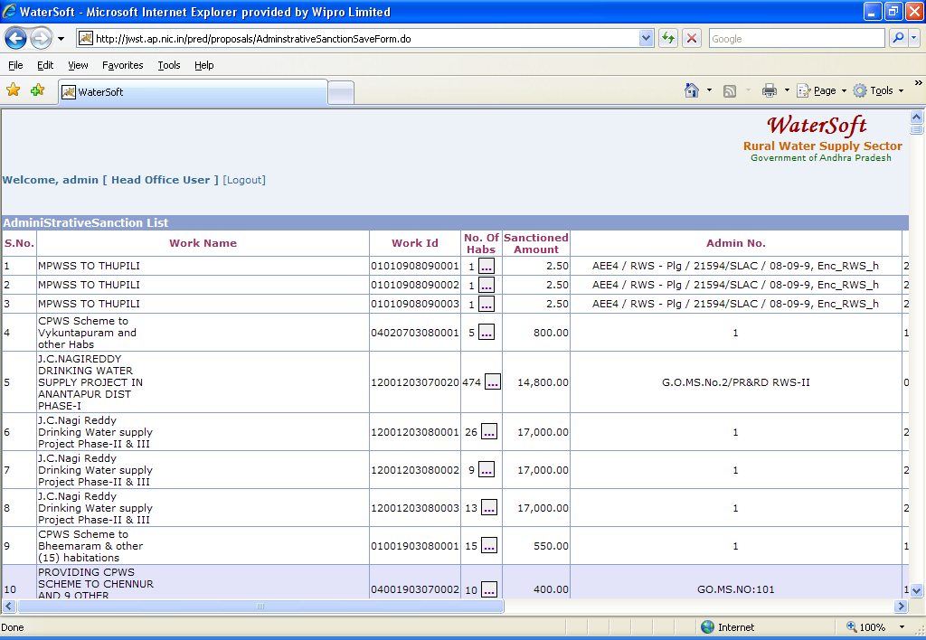
Figure. 7

Administrative Sanction List

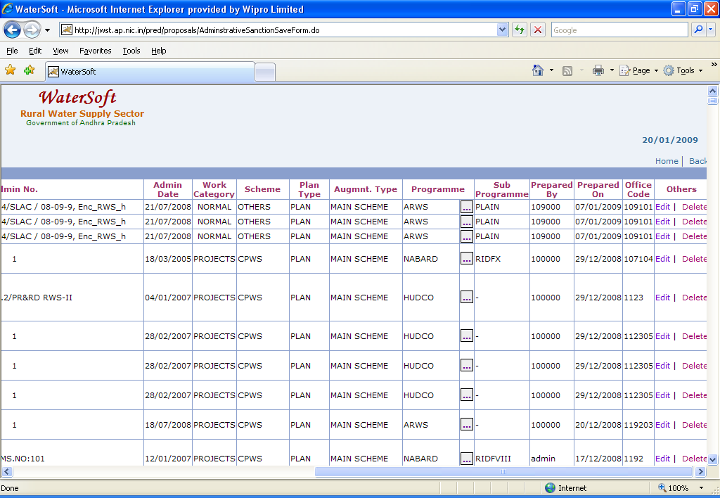
Figure 8.

Note V :- In Action – Select ‘Edit’ to make Modifications – Administrative Sanction Form is displayed.

In Action – Select ‘Delete ’ to Delete Works – This is a privileged option Enabled only for Selected User Logins.

For Entering the works which are Sanctioned under More than One Programme

Add Programs

- Select Programme.
- Select Sub programme.
- Enter Sanctioned Amount(Rs. In Lakhs)
- Enter Admn Sanc No.
- Select Admn Sanc Date
- Click ‘Add Programs’ to save

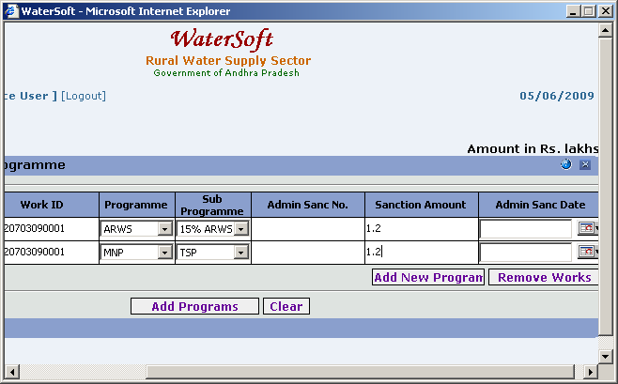
Figure. 9

Clear

- Click ‘Clear’ to clear the Form.

WorkFlow - > Works Monitoring - > Augmentation Main Scheme Linkage

Note VI:-Augmentation Main Scheme Linkage mainly helps in linking Augmentation works with MainSchemes ( Asset / Work ).

Augmentation Main scheme Linkage

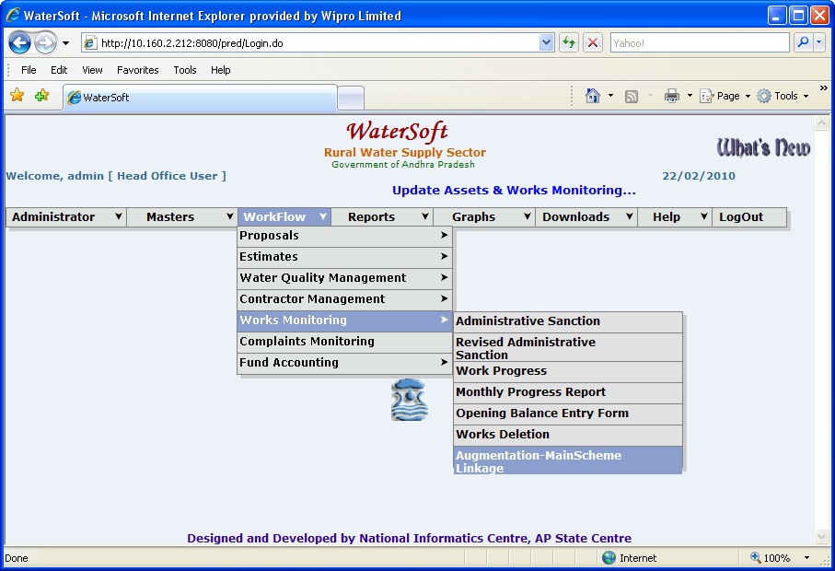
Figure. 10

Augmentation Main Scheme Linkage

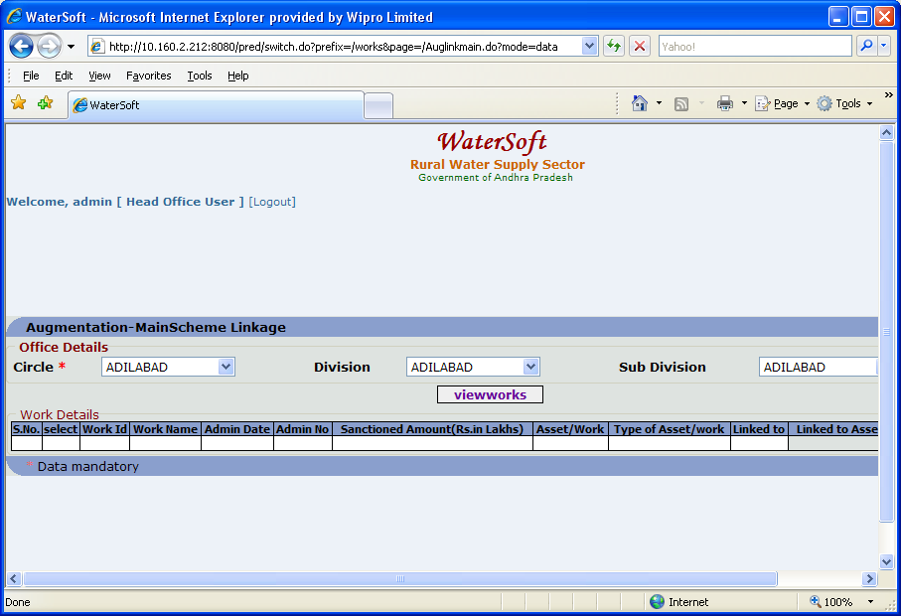
Figure. 11

View Works

- Select Circle ( For Eg. Adilabad )
- Select Division( For Eg. Adilabad ).
- Select Sub Division. ( For Eg. Adilabad ).
- Click ‘ View Works ‘ button.

Augmentation Work details are displayed as shown below:

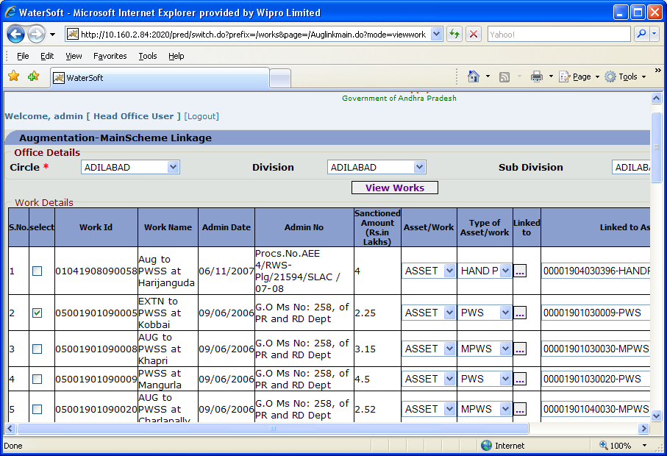
Figure. 12

Figure 13: (Contd. of Figure 12).
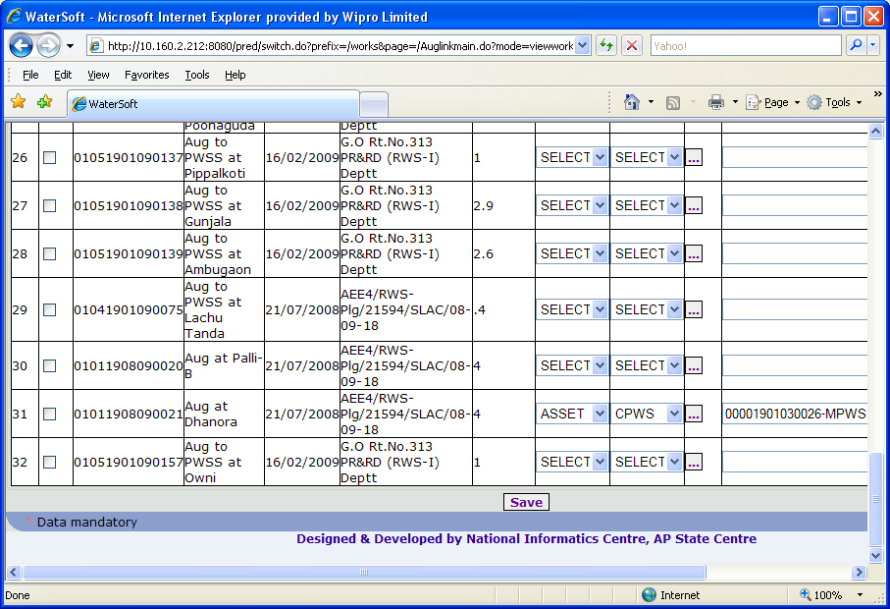
Figure 13.

Save
- Select Asset / Work. ( For Eg. Asset ).
- Select Type of Asset / Work. ( For Eg. PWS ).
- Select Aug. Works to link to Main Schemes. ( By selecting check box).
- Click ‘Linked to’ button. ( Figure 14. )

Main Schemes are displayed.
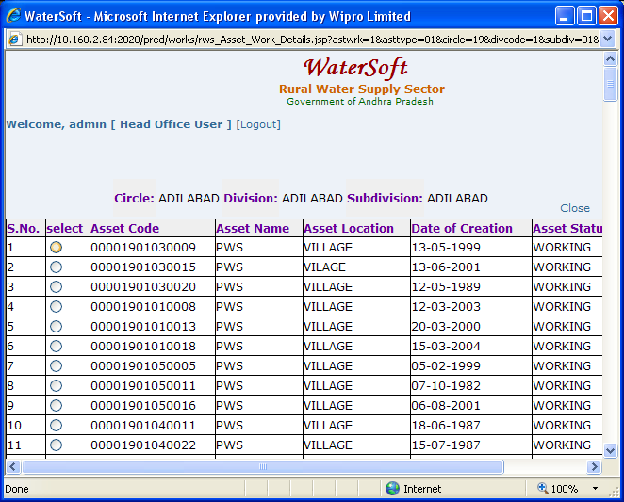
Figure 14.

Note VII:- Select any ‘ Main Scheme ‘ to link with selected Augmentation Work .

- Click ‘ Save ‘ button ( In Figure 13.)

WorkFlow - > Works Monitoring - > Revised Administrative Sanction

Revised Administrative Sanction

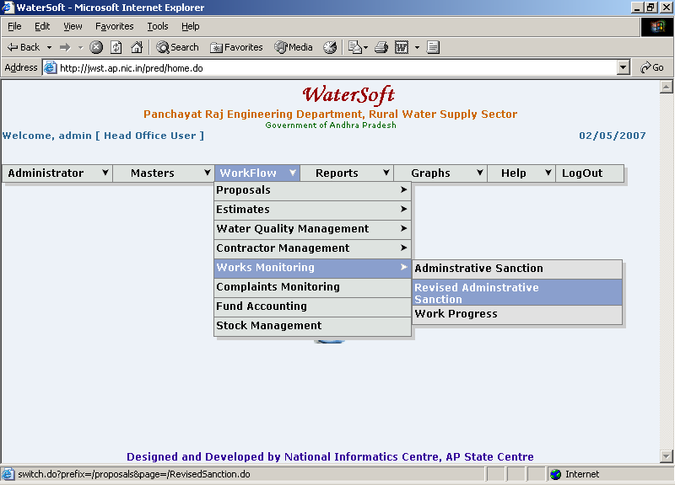
Figure. 15

Revised Sanction Form

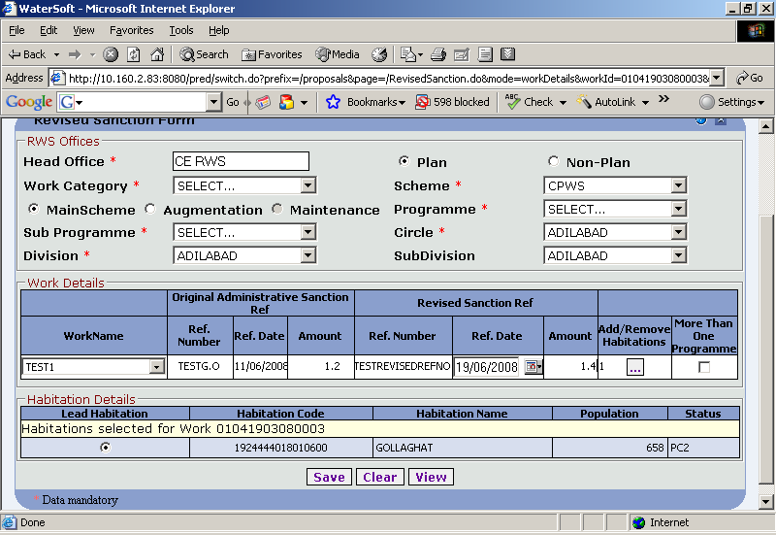
Figure 16.

View /Save

- Head Office is fixed .
- Select Plan or Non – Plan.
- Select Main Stream , Augmentation( For Plan).
- Select Maintenance ( For Non-Plan ).
- Select Programme.
- Select Sub Programme.
- Select Circle (fixed based on Login).
- Select Division.
- Select Sub Division (Optional)

Note VIII : This information is required either to Save a New Revised Administrative Sanctioned Work or to View /Modify Existing Revised Administrative Works.

Save

- Select Work Name.

For Original Administrative Sanction Ref

- Ref. Number is displayed automatically from Administrative Sanction
- Ref. Date is displayed automatically from Administrative Sanction
- Amount is displayed automatically from Administrative Sanction
- Enter Ref. Number for Revised Administrative Sanction(For Revised Sanction Ref)
- Select Ref.Date for Revised Administrative Sanction ( For Revised Sanction Ref ).
- Enter Amount for Revised Administrative Sanction(For Revised Sanction Ref)
- Select Add/Remove Habitations.
- Select More Than One Programme.
- Click ‘ Save’ button to save the Revised Sanction Works.

Note IX:- To Select Add/Remove Habitations – Select ‘Mandal’ → Click ‘Next’ button→ Habitations are displayed. Select ‘Habitations’ → Click ‘Add button’ .
Press ‘OK’ wherever required.
(The screen shots are displayed figure 17 & 18 … explain the process

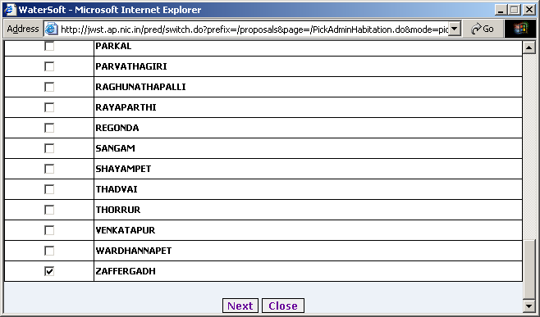
Figure. 17

Next
- Click ‘ Next’ button.

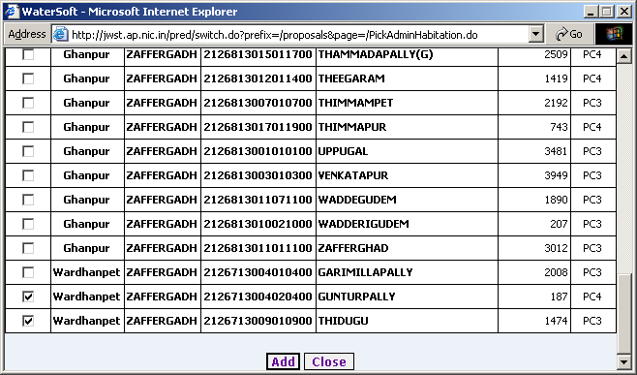
Figure 18.

Add

- Select Habitations.
- Click ‘Add’ button.

Clear button

- Click ‘Clear’ to clear Form

View
- Click ‘View’ to View Revised Administrative Sanctioned Works.

Revised Sanction List

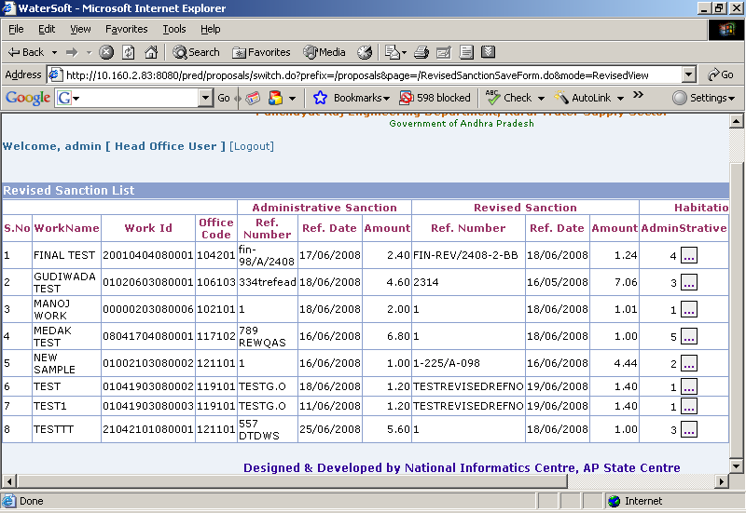
Figure. 19

Revised Sanction List

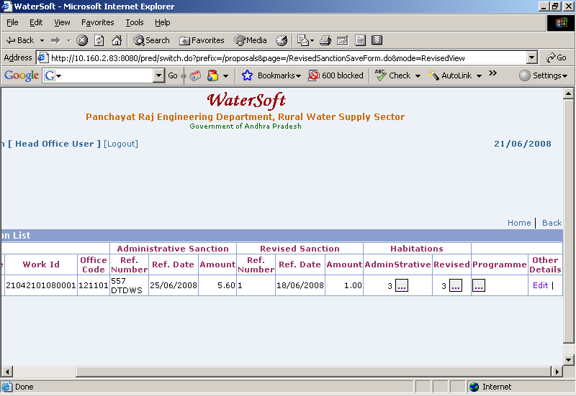
Figure 20.

Note X:-In Action – Select ‘ Edit ‘ to make Modifications - Revised Administrative Sanction Form is displayed.

In Action – Select ‘ Delete ’ to Delete Revised Administrative Sanctioned Works – This is a privileged option Enabled only for Selected User Logins.

For Entering the Revised Administrative Works which are Sanctioned under More than One Programme.

Update

- WorkName is Fixed
- WorkId is Fixed
- Select Programme
- Select Sub Programme
- Enter Sanctioned Amount
- Enter Admin Sanc No.
- Enter Admin Sanc Date
- Enter Revised Sanc No.
- Enter Revised Sanction Amount
- Enter Revised Sanction Date
- Click ‘Update’ to update Programmes

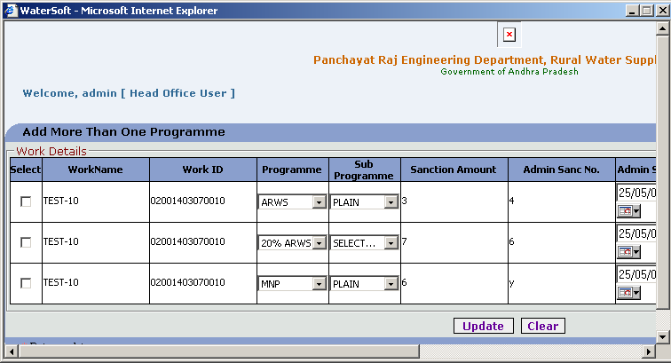
Figure. 21

Clear

- Click ‘Clear’ button

WorkFlow - > Works Monitoring - > Work Progress

Work Progress

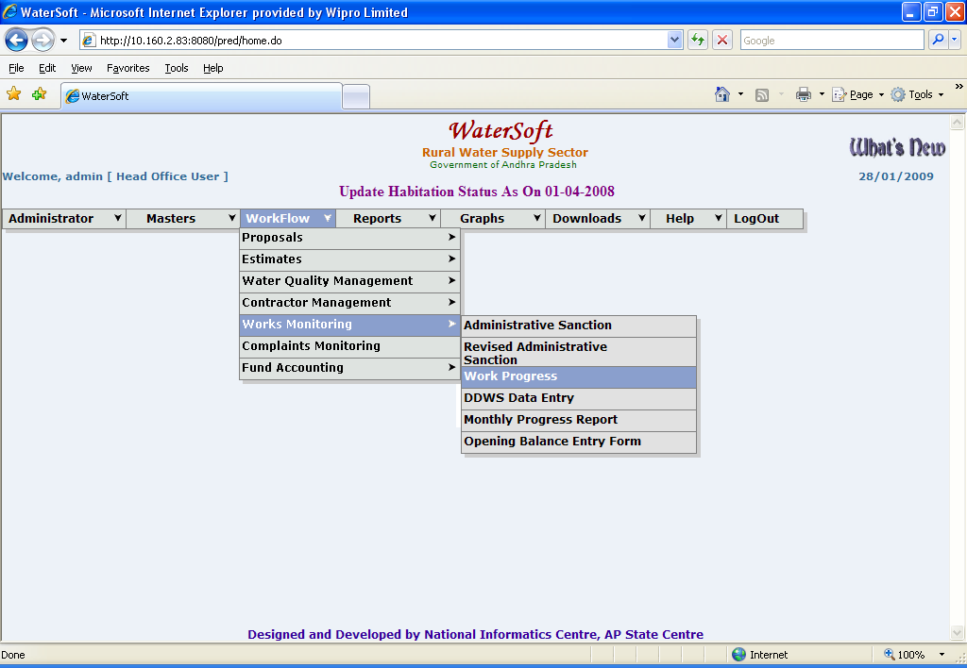
Figure. 22

Work Status Form

- Select Circle( Fixed ).
- Select Division.
- Select SubDivision.
- Select Plan /Non Plan
- Select MainScheme/Augmentation/Maintenance
- Select Work Category. ( Projects , Normal , District Level ).
- Select Programme.(Optional)
- Select SubProgramme. (Optional)
- Select Work.
- Scheme is displayed automatically.
- Select Work Stages

Work Stages

- Admin Sanction
- Technical Sanction
- Source Identification
- Contractor Management
- Program Schedule
- Work Expenditure
- Work Completion
- DDWS Data Entry

Work Status
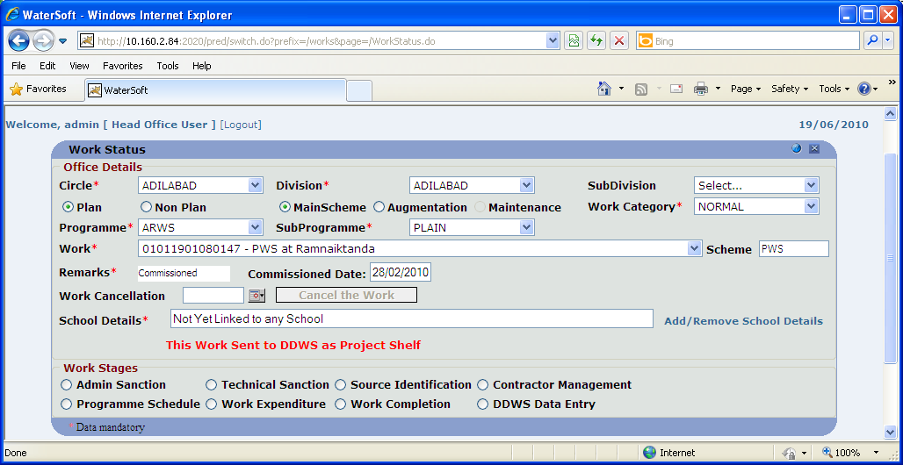
Figure. 23

Some important points for entering data for Work Progress

1.If work is sent to DDWS as ‘ Project Shelf ’ – the message is displayed as ‘ This Work Sent to DDWS as Project Shelf.

2. If work is not sent to DDWS as ‘ Project Shelf ’ – the message displayed as ‘ This Work Not Yet sent to DDWS as Project Shelf ’.

1.’ Technical Sanction Date ’ Should be greater than or equal to ‘ Administrative Sanction Date ‘.

2.If a work is not ‘ Technically Sanctioned ‘ there is no further navigation to ‘ Contractor Management ’.

3.’ Agreement Date ’ should be greater than or equal to ‘ Technical sanction Date ’.

4.’ Site Handing over Date ’ Should be greater or equal to ‘ Agreement Date ‘.
5.’ Stipulated Date of Completion ’ is automatically generated based on agreement date plus agreement duration in months.

6.’ Actual Date of Completion ‘ should be greater than or equal to ‘ start Date ‘.
7.’ Date of Commissioning’ should be greater than or equal to ‘ Actual date of Completion ‘.

8. ’ No Modifications ( Changes ) ‘ to any phase is allowed -- if the work is ‘ Financially Completed i.e., Financial Date of Completion is entered in work completion phase.

9. Cannot ‘ Edit ‘ Work Expenditure phase , Work Completion phase until the Work is Financially Completed.

10.Cannot Cancel the work if the work is already Completed(either Physically or Financially) or Commissioned and Work Cancellation done by Head Office only .

11.First enter for data for Technical Sanction ->Then enter data for Contractor Management phase
->Then Programme Schedule data can be entered->Later enter data for Expenditure & Work completion phases.

12.Source Identification is independent phase even the work is not Technically sanctioned then also enter the data for Source Identification.

13.Based on Work Start Date that is entered in Programme schedule, Financial Years are displayed in Work Expenditure phase ( For eg: work start date entered as 22/06/2006 then financial years starts from 2006-2007 – 2010-2011(current financial year) .

Series of steps ( 1…5) Explain the process of Linking Schools to Works .

Following Screen shots (Fig 24 – Fig 29. ) show how to link

Step 1

If the School is not linked with any work – message displayed as ‘ Not Yet Linked to any School ‘. ( Figure 24 ).

Step 2

Click on ‘ Add / Remove School Details ‘ . ( Figure 24 ).

Step 3

Select Mandals -> Click ‘ Get Habitations ’ button -> Habitations are displayed->’ Select all Habitations at a time ‘ -> Click ‘ Get Schools ‘ button. (Figure 25. & Figure 26.).

Step 4

Schools List for the Above Selected Habs are displayed ( Figure 27.) -> Select All the Schools at Once -> Click ‘ Add the Selected school this Work ‘ button. (Figure 27.)

Step 5

Now Work Already Linked to School(s)( Figure 28. ) – Click here to view School(s) (Figure 29.)

Add/Remove School Details

- Click ‘ Add/Remove School Details ‘ button

Figure 24.

Select Mandals -> Click ‘ Get Habitations ‘ button -> Habitations are displayed-> Select the Habitations -> Click ‘ Get Schools ‘ button

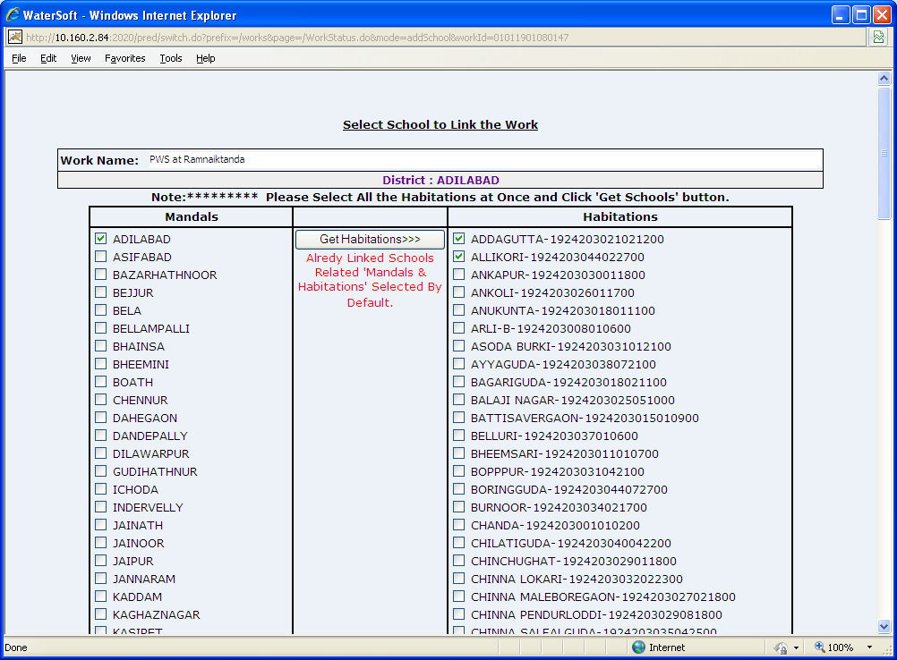
Figure 25.

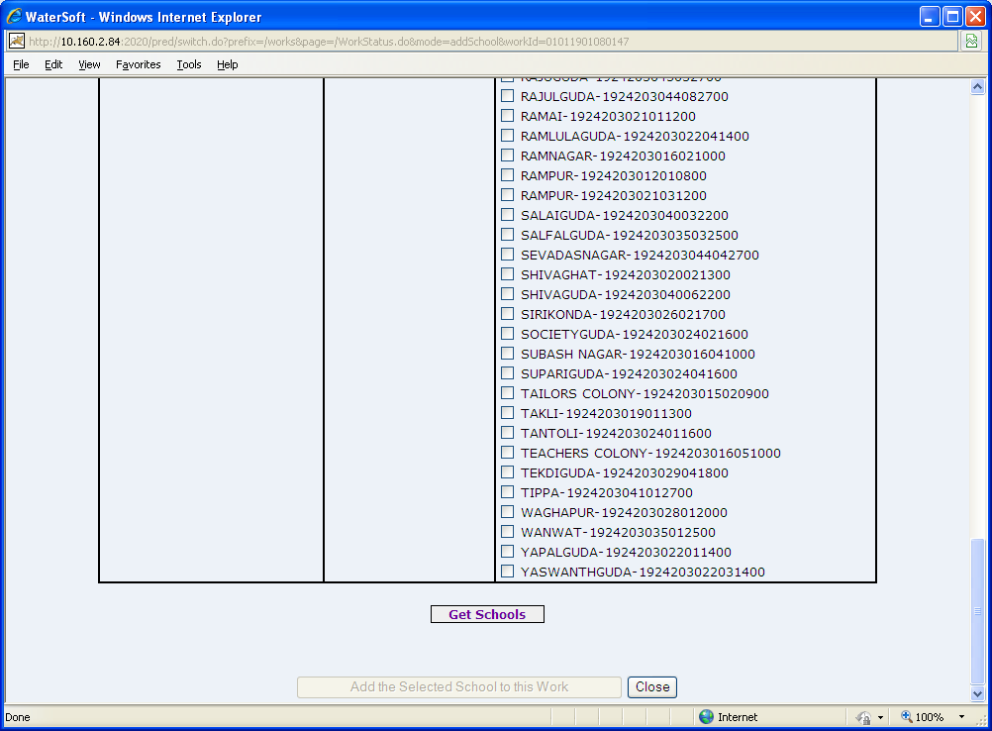
Figure 26.

List of Schools are displayed -> Select all the Schools -> Click ‘ Add the Selected School to this Work ‘ button.

Add the Selected School to this Work

- Click ‘ Add the Selected School to this Work ‘ button.

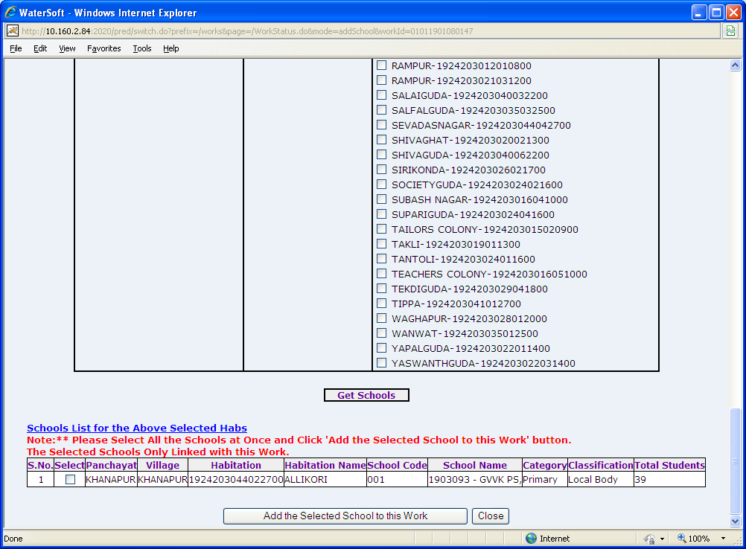
Figure 27.

Work Already Linked to School(s)-Click here to View School(s)

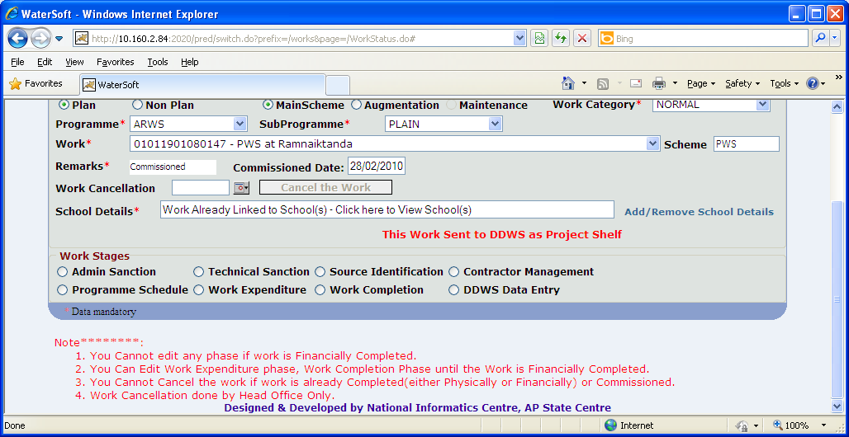
Figure 28.

The Linked Schools with this Work are displayed

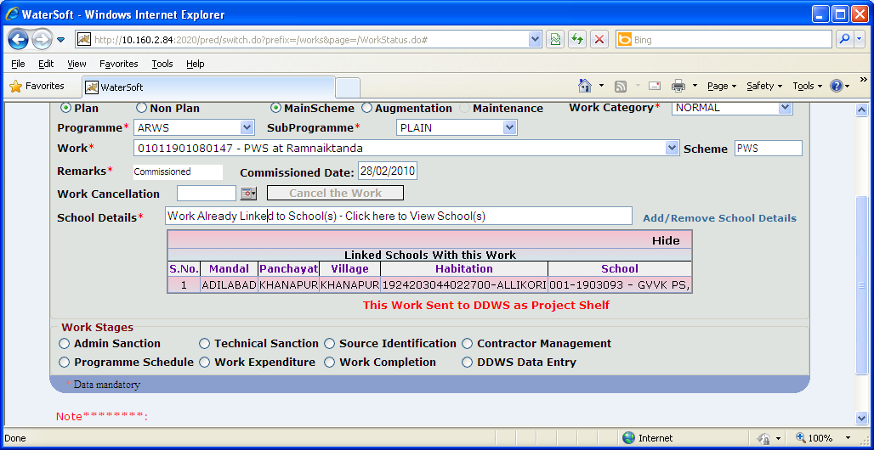
Figure 29.

Admin Sanction

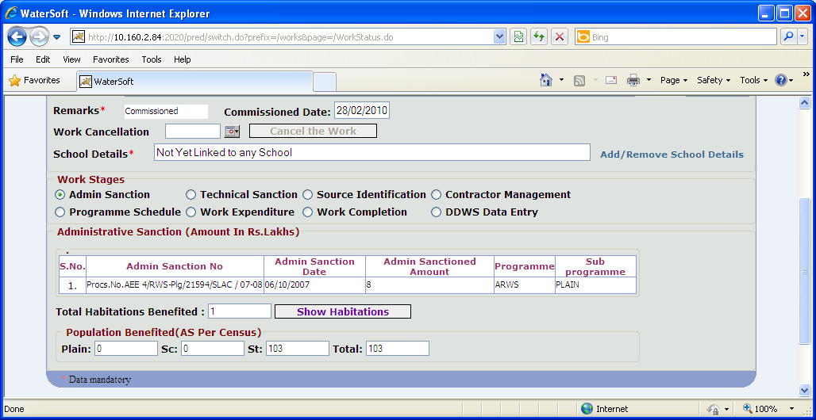
Figure. 30

For Administrative Sanction, if Revised Administrative Sanctions are present – details are displayed

Technical Sanction

Update

- Enter Technical Sanction Amount (Rs. In lakhs)
- Enter Technical Sanction Number
- Select Technical Sanction Date
- Select SSR Year. ( For Eg. 2008 – 2009 ).
- Total Habitations Benefited are displayed automatically
- Click ‘Update’ to save data.

Note XI:- Technical Sanction Date Should be greater than or equal to Administrative Sanction Date.

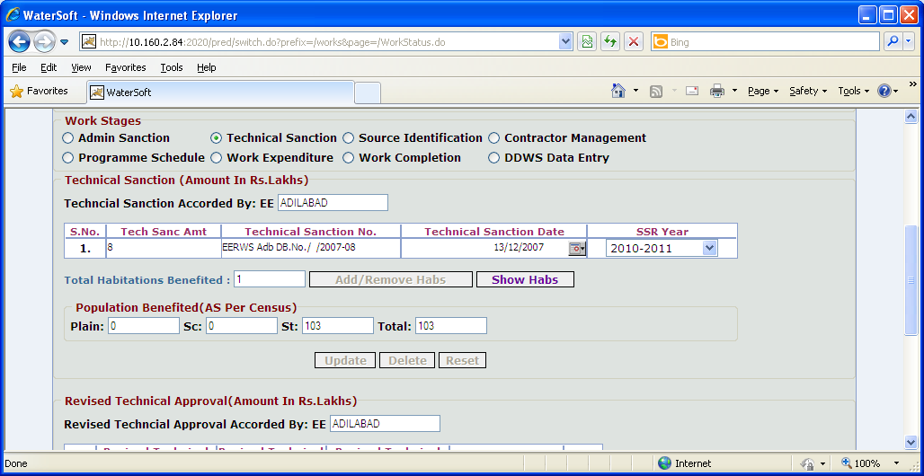
Figure. 31

Delete

- Click ‘ Delete ’ to delete technical sanction details.

Reset

- Click ‘Reset’ to reset data

Revised Technical Sanction
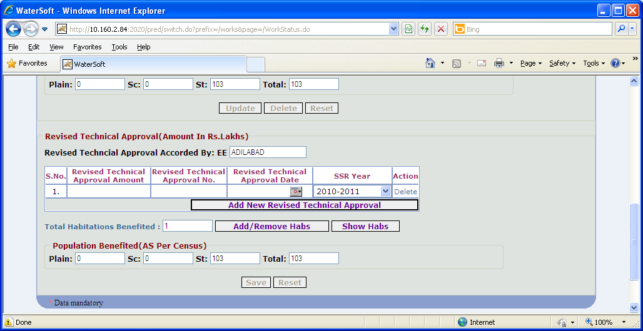
Figure 32

Save
- Enter Technical Approval Amount(Rs. In lakhs)
- Enter Revised Tech Sanction No.
- Select Revised Tech Sanction Date.
- Select SSR Year.
- Total Habitations Benefited are displayed automatically
- Click ‘Save’ button

Note XII:-In Action – Click ‘Delete’ button to delete Revised Technical Sanction Approval.

Reset
- Click ‘Reset’ button to Reset the data.

Source Identification

Save

- Select Mandal
- Select Source Habitation
- Select Source Type ( For Eg. SubSurface Source , Surface Source , Rain Water , Traditional , Others ).
- Select SubSource Type ( For Eg. Borewell , Rotary Borewell ).
- Select Existing Source or New Source.

Existing Source

- Select Source.( For Eg. 0302631003040100001HP003 – bordas house)
- Source Name is Fixed.

New Source

- Source is auto generated ( Depending on Selection ).
- Enter Source Name.

- Enter Site/Source Identified By. ( Enter Employee Code )
- Enter Source Site Handing Over Date.
- Enter Recommendations By Geologist.
- Click ‘Save’ to save data.

Note XIII:-In Source Identification Mandatory Fields/Columns:-

Source Name is compulsory column/Field after entering data then record will be saved in database.

In Source Identification Optional Fields/Columns:-

Site/Source Identified By , Source Site Handing Over Date , Recommendations By Geologist

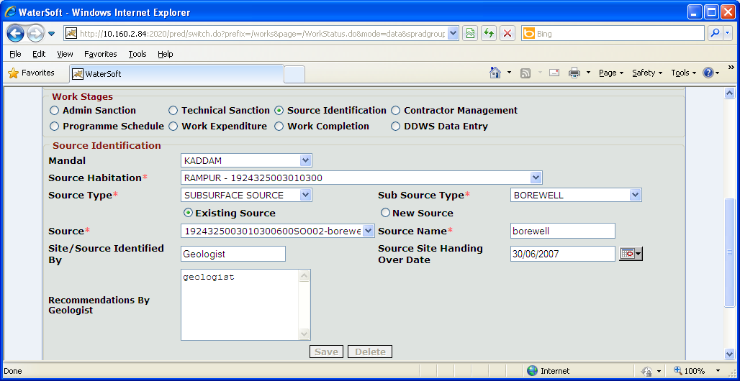
Figure. 33

Delete

- Click ‘Delete’ to delete data

Note XIV:-If a work is not technically sanctioned there is no further navigation to Contractor Management.

Contractor Management

Save

- Select Work Entrustment. (For Eg. Tender, Nomination).
- Enter Tender Notification Id (mandatory)
- Enter Tender Cost
- Enter Tender Percentage (For Less , Excess , Estimate Rates ).
- Enter Contractor/Firm Name
- Enter Tender Accepted Date
- Enter LOA Issued on Date
- Select Tender Committee or Competent Authority

Agreement Details

- Enter Agreement Reference No
- Enter Agreement Date
- Enter Agreement Duration in months
- Enter Agreement Value (Rs. In Lakhs)
- Enter Site Handing over Date
- Enter Stipulated Date of Completion

Note XV:- If Tender Percentage is selected as ’ Estimated Rates ‘ then Tender Percentage should not be entered.
Note XVI:- Agreement Date should be greater than or equal to Technical sanction Date.
Note XVII:- Site Handing over Date Should be greater or equal to Agreement Date
Note XVIII:- Stipulated Date of Completion should be greater than or equal to Site Handing over Date

Note XIX:- For Entering ‘Mile Stones’ Click ‘Add New Major MileStones’ button
Note XX:- For Removing Mile Stones Click ‘Remove Item for Existing MileStones ’ button

Contractor Management

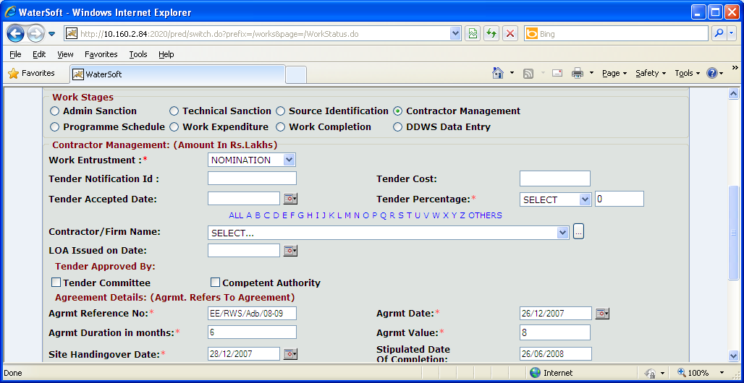
Figure. 34

Note XXI:-If Work Category selected as ‘Projects’ all the Contractors covered under ‘PROJECTS’ are listed in Contractor/Firm Name combo box.

Note XXII:- If Work Category selected as ‘Normal’ all the Contractors covered under ‘NORMAL’ for the selected DISTRICT are displayed in Contractor/Firm Name combo box.
Note XXIII:-If Work Category selected as ‘District Level’ – all the Contractors covered under ‘DISTRICT LEVEL’ for the selected DISTRICT are displayed in Contractor/Firm Name combo box.

Note XXIV:-Select option ‘ All’ – Contractors Names starting with A to Z are displayed in Contractor/Firm Name combo box.
Note XXV:-Select option Alphabets ‘ A – Z’ – Contractor Names starting with selected Alphabet are displayed in Contractor/Firm Name combo box.

Note XXVI:- To Enter ‘ Contractor Details ’ Click ‘ button ’ that is placed beside field Contractor/Firm Name combo box.

Mandatory Fields/Columns in Contractor Entry Form:-

First Name , Regn No

Pan No or Voter Id ( entry of any one column Pan No or Voter Id required)

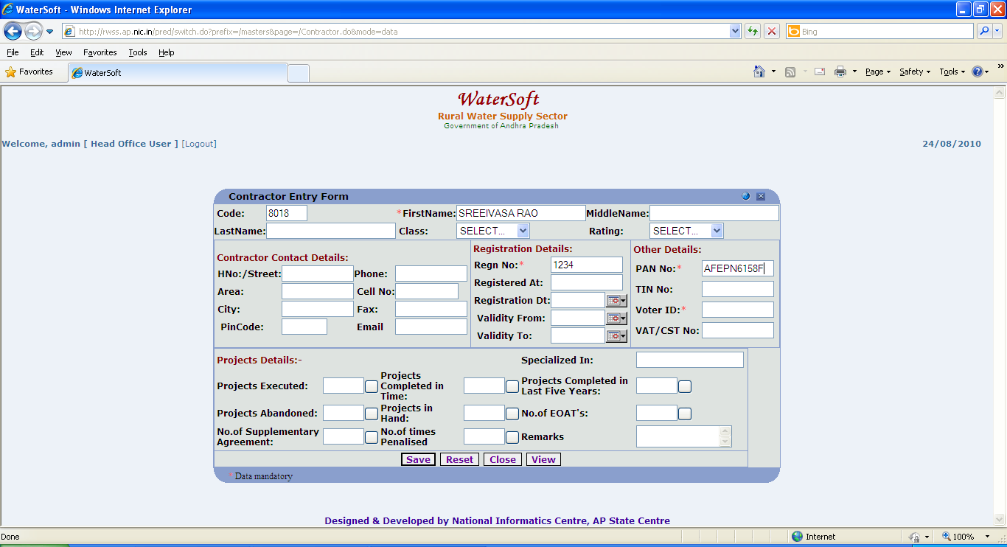
Figure. 35

Save

- Enter First Name ( Mandatory Field ).
- Enter Middle Name
- Enter Last Name.
- Select Class. ( For Eg Super Class , I , II )
- Select Rating ( For Eg. Active , BackListed ).
- Enter Contractor Contact details.( Hno/Street , Area , City , Pincode ).
- Enter Registration details. ( Regn No , Registered At , Registration Dt , Validity From , Validity To )
- Enter Regn No ( Mandatory Field )
- Enter Voter Id or Pan No ( Mandatory Field)
- Enter Other details. ( Pan No , Tin No , Vat/ Cst No. )
- Enter Remarks
- Click ‘Save’ button.

Reset

- Click ‘Reset’ button.

Note XXVII:-Enter any Alphabet (For Eg.. alphabet ‘A’ is entered ) in column First Name-> Click ‘ View ’ button->ContractorNames starting with alphabet ‘A’ are displayed.

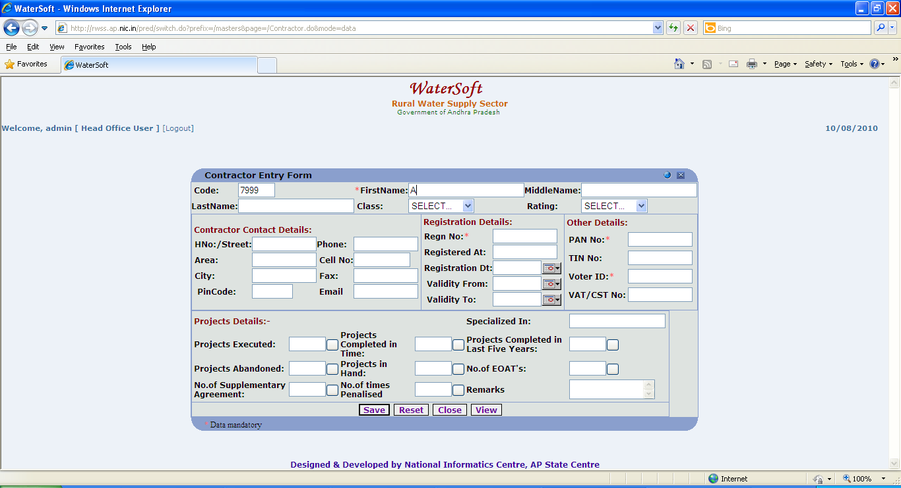
Figure. 36

Close

- Click ‘Close’ button.

View

- Click ‘View’ button.

Contractor Details are displayed with First Name starting with letter ‘ A ‘
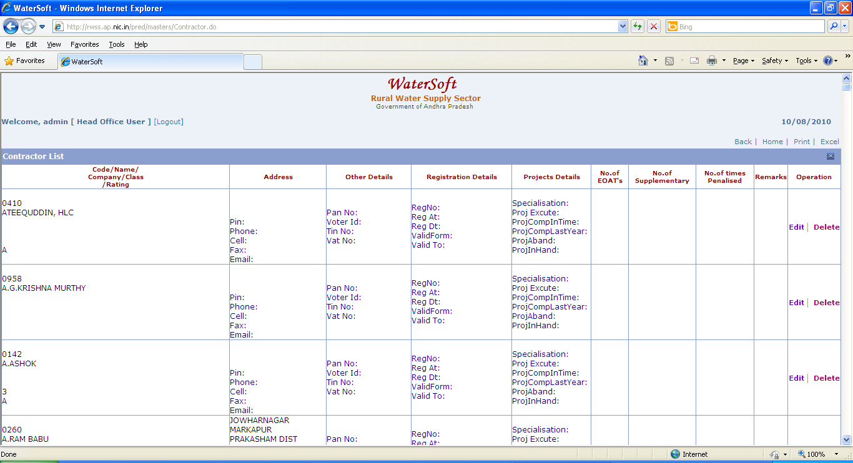
Figure. 37

Note XXVIII:-Milestones are compulsory for works which were sanctioned after ’ 1-4-2010 ‘ and ‘ Spillover works ‘ upto 31-03-2010.

Note XXIX:-Select Type of Contractor as ‘ Spill over ‘ ->if selected work is spill over work.

Note XXX:-If Type of Contractor is selected as ‘ Spill over ‘->Type of Item/Component is fixed as UPTO 31-03-2010

Note XXXI:- Entry of Spillover works and Spill over Item should be once for a work.

Note XXXII:-Milestones should be entered in Contractor management by selecting contractor who had started work . These milestones are bought from from contractor management to programme schedule where vouchers can be generated against each milestone.

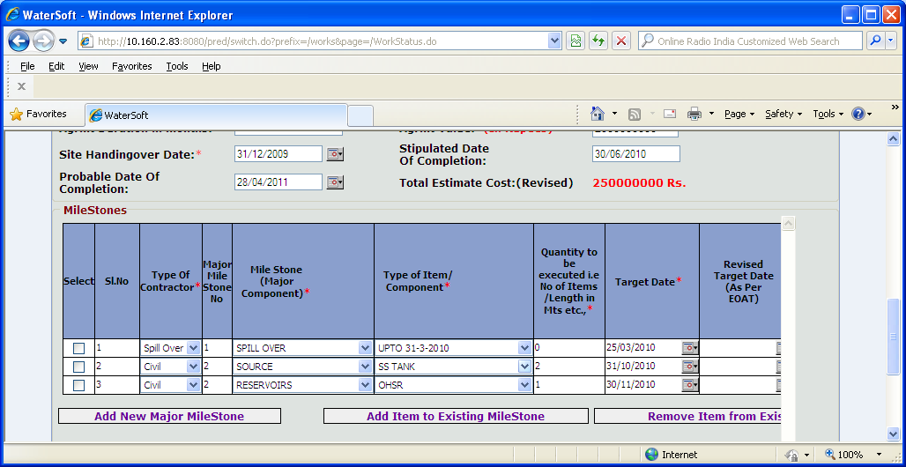
Figure 38.

Figure 39 contd.. of Figure 38

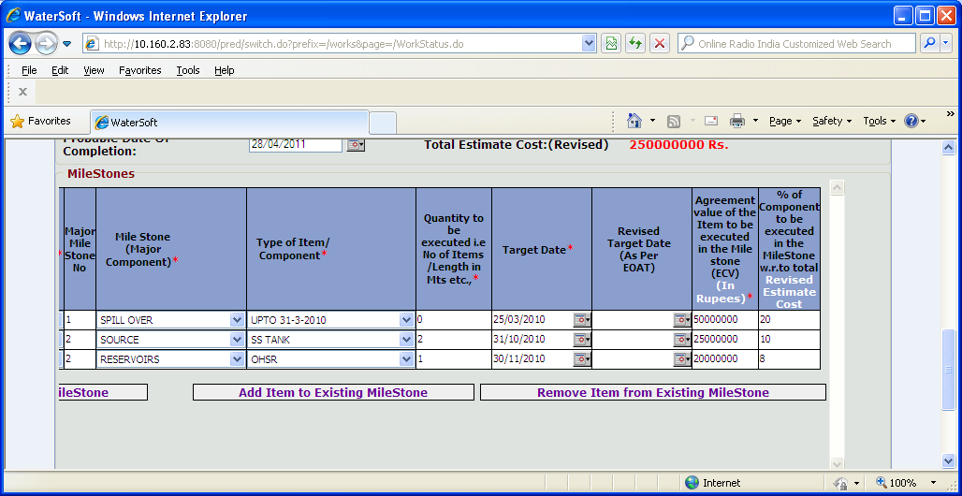
Figure 39.

Add New Major MileStone

- Click ‘ Add New Major MileStone ‘ button to add New milestone details.

Add Item to Existing MileStone

- Click ‘ Add Item to Existing MileStone ‘ button to enter milestone details.

Note XXXIII:- Click ‘ Add Item for Existing MileStone ‘ -> Select ‘ Major Code ‘ as shown in ( Figure 40 )

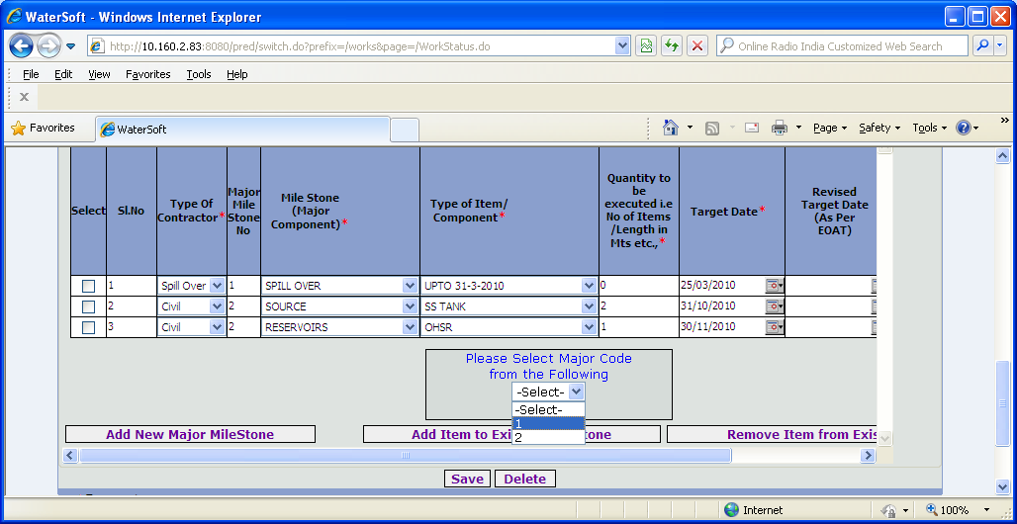
Figure. 40

Note XXXIV:-Select the checkbox by selecting it before clicking on ‘ Save ’ , ‘ Delete ‘ and ‘ Remove Item for Existing MileStone ‘ button

Save

- Select Type of Contractor ( For Eg Civil , Spillover , Electrical etc )
- Major Mile Stone No is fixed.
- Select MileStone ( Major Component )
- Enter Quantity be executed i.e No of Items/Length in Mts etc.,
- Select Target Date.
- Select Revised Target date ( As per EOAT )
- Enter Agreement Value of The Items to be executed in MileStone (ECV ) (In Rupees )
- Enter % of Component to be executed in the MileStone w.r.to total Revised Estimate Cost.
- Click ‘ Save ‘ button.

Remove Item from Existing MileStone

- Click ‘ Remove Item from Existing MileStone ‘ button.

Program Schedule

Save

- Select Sub Division Assigned to
- Select Engineers Assigned to
- Select Work Start Date
- Click ‘ Save ’ button.

Delete

- Click ‘ Delete ’ button

Note XXXV:-MileStones which were entered in contractor management for selected work are displayed in Programme schedule

Program Schedule

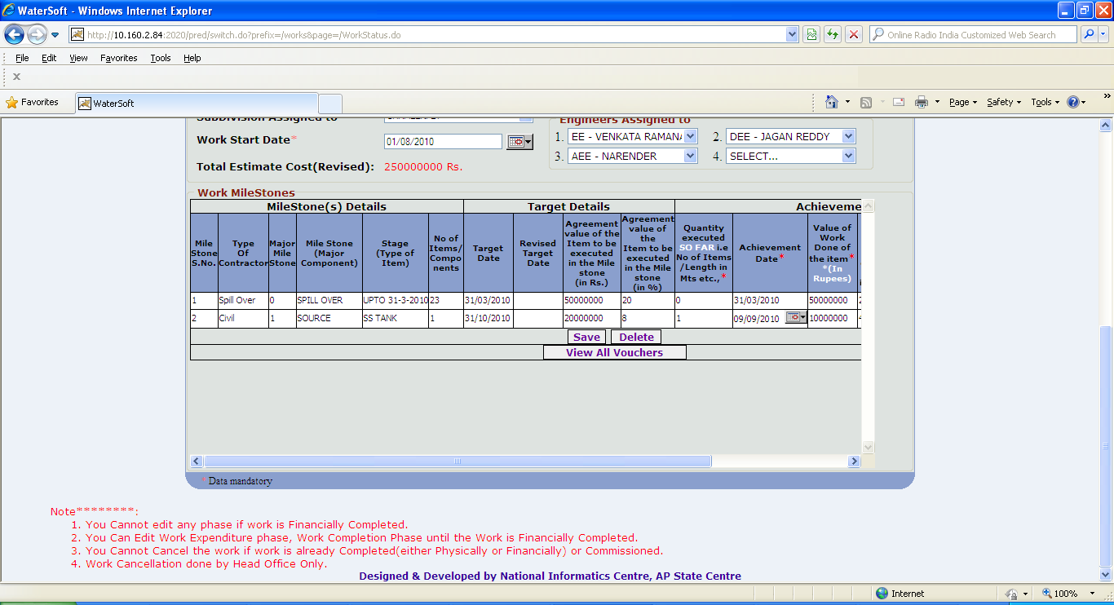
Figure 41

Programme Schedule

Note XXXVI:-Status is selected as ‘ Completed ‘ and the record is saved -> Modification to the item is not allowed.

Note XXXVII:-Status is selected as ‘ In Progress ‘-> Modifications are allowed.

Note XXXVIII:-Status is selected as ‘ Not Started ‘-> Modifications are allowed.

Note XXXIX:-Selection of ‘ Achievement Date ‘ is must for a work ( By Engineer )

Note XXXX:-Entry of Achievement Date By Engineer for selected work-> Then only DAO can prepare Bills and Vouchers

Save

- Type of Contractor ( is brought from contractor management ).
- Major MileStone ( is brought from contractor management ).
- MileStone Major Component ( is brought from contractor management ).
- Stage(Type of Item) ( is brought from contractor management )
- No of Items / components ( is brought from contractor management )
- Target Date ( is brought from contractor management )
- Revised Target Date ( is brought from contractor management )
- Agreement value of the Item to be execute in the MileStone ( in % ) ( is brought from contractor management )
- Enter Quantity executed SO FAR i.e No. of Items/Length in Mts etc.,
- Select Achievement Date
- Enter Value of work Done of the Item (in Rupees)
- Select Status ( For Eg. Completed , In Progress , Not Started )
- Enter Remarks
- Click ‘ Save ‘ button.

Figure 42 is contd.. Figure 41
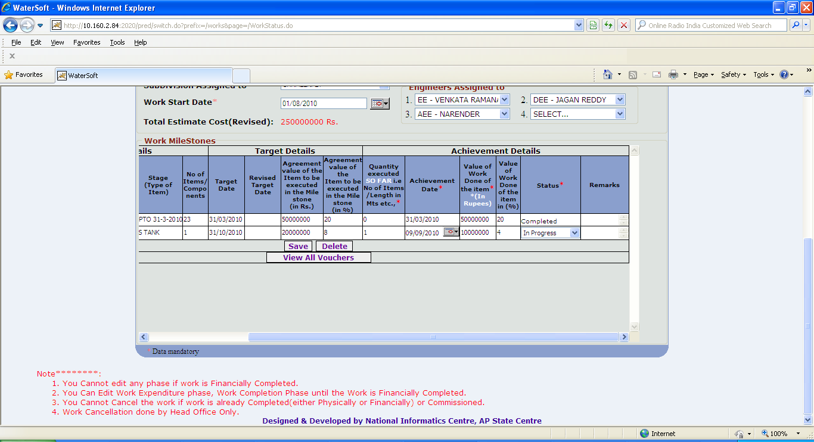
Figure 42

View All Vouchers

- Click ‘ View all Vouchers ‘ button.

Voucher details are displayed
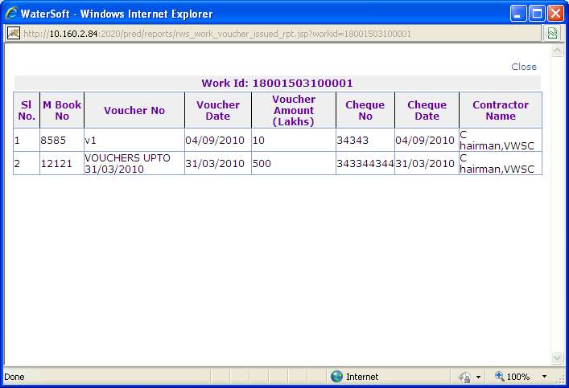
Figure 43

Work Expenditure

Note XXXXI:-Work Expenditure is carried from vouchers which were entered , The vouchers amount is cumulatively displayed monthwise.

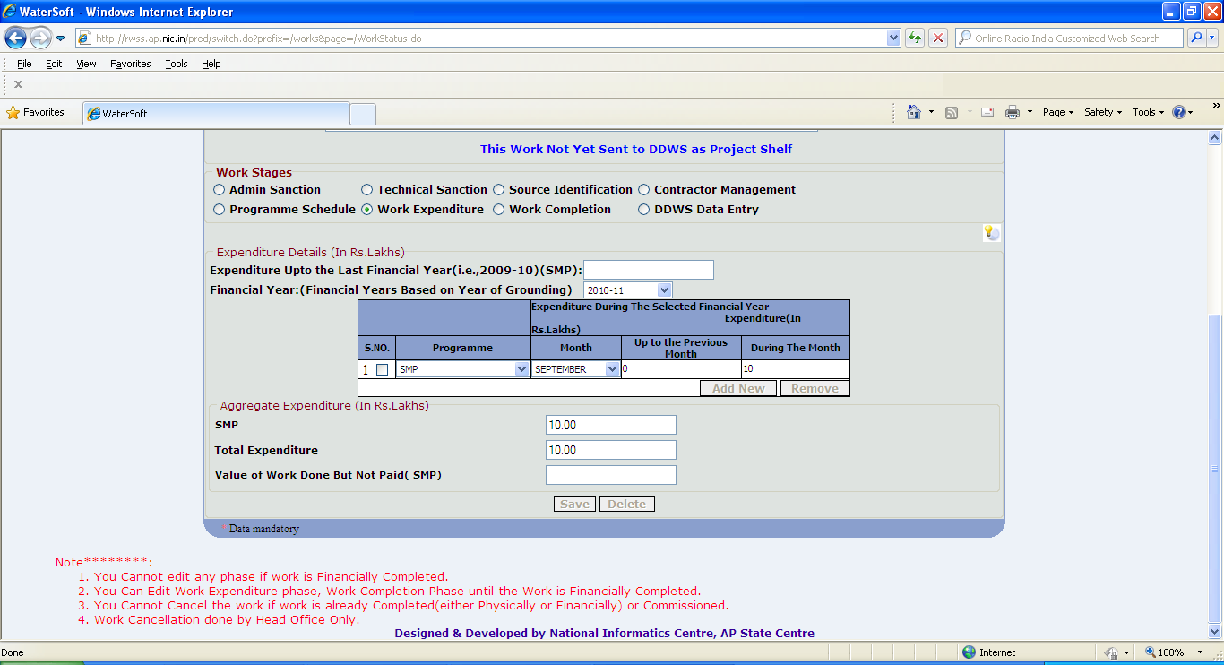
Figure 44

Work Completion

Save

- Start Date , Stipulated Date Of Completion are automatically displayed.
- Select Actual Date of Completion.
- Select Financial Date of Completion.
- Select Date of Commissioning.
- Habitations Benefited (No. ) is displayed automatically.
- Click ‘ Save ‘ button.

Note XXXXII :- Actual Date of Completion should be greater than or equal to start Date.
Note XXXXIII :- Date of Commissioning should be greater than or equal to Actual date of Completion.

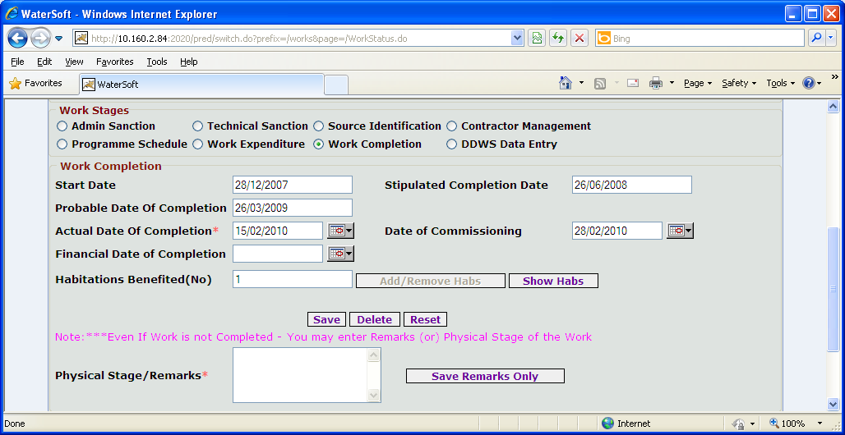
Figure. 45

Note XXXXIV:- Even If the work is not Completed enter Physical Stage/Remarks.

Save Remarks Only

- Click ‘ Save Remarks Only ’ button.

Reset

- Click ‘ Reset ’ button.

Delete
- Click ‘ Delete ’ button.

DDWS DATA ENTRY

Submit

- Select Approved Under ( Eg. Normal Coverage , Submission ( Water Quality ) , Sustainability ).

If Normal Coverage is Selected

- Estimate Capital Cost is auto generated.(Data carried from Administrative sanction)
- Enter GOI Share. ( In Rs. Lakhs )
- Enter State/Other Share ( In Rs. Lakhs )
- Enter Community Contribution Deposited ( Cash + Kind + Labour ).
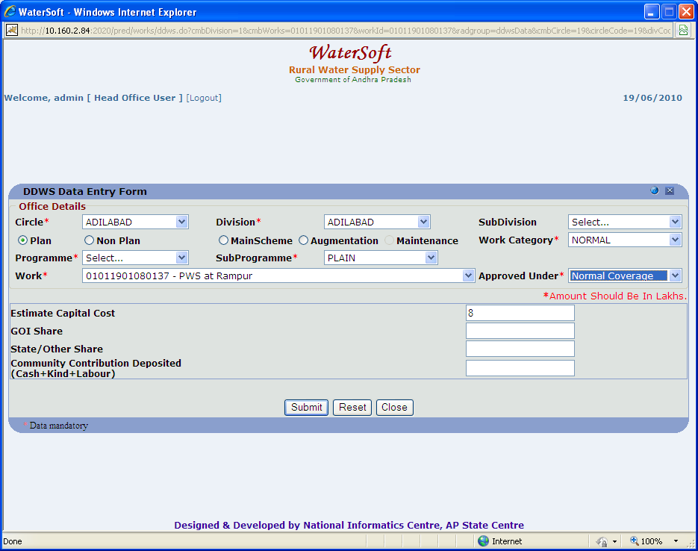

Figure . 46

If Submission (Water Quality) is selected

- Select Contamination Tackled ( Physical , Bacteriological , Chemical , Others )

Under Physical

- Select Turbidity

Under Chemical

- Select Arsenic or Iron or Nitrate or Calcium or Manganese or Salinity , Hardness or Alkalinity or Fluoride or Chloride or sulphates or Magnesium or Copper or TDS or Residual Chlorine

Under Bacteriological

- Select Faecal
- Select ColiForm

Under Others

- Select pH

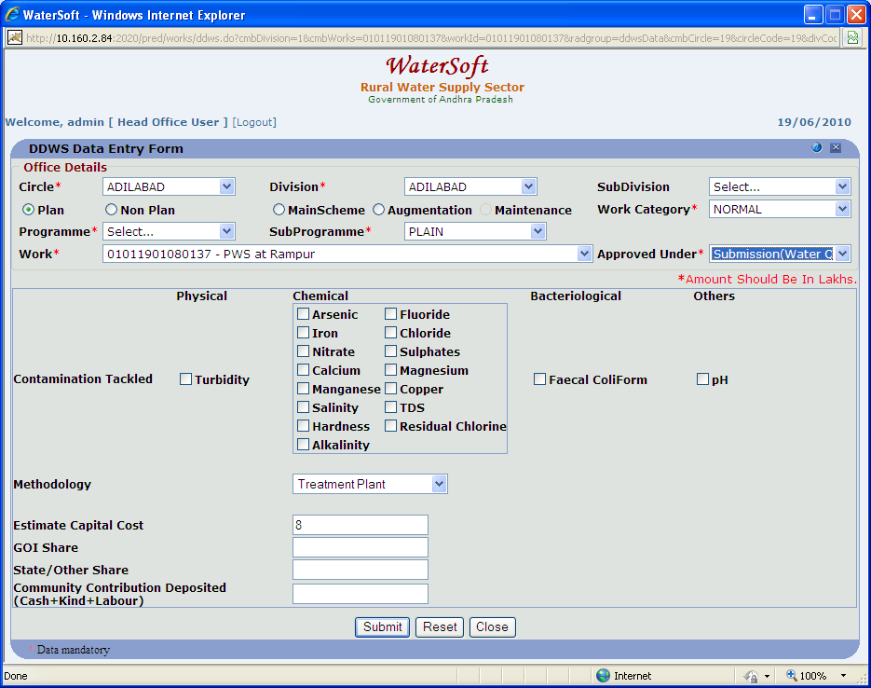
Figure 47

- Select Methodology ( For Eg. Treatment Plant , Alternative Safe Source ).
- Enter Estimate Capital Cost. ( In Rs. Lakhs )
- Enter GOI Share. ( In Rs. Lakhs )
- Enter State/Other Share ( In Rs. Lakhs )
- Enter Community Contribution Deposited ( Cash + Kind + Labour ).

If Sustainability is Selected

- Estimate Capital Cost is autogenerated.(Data carried from Administrative sanction or from Revised Administrative sanction)
- Enter GOI Share. ( In Rs. Lakhs )
- Enter State/Other Share ( In Rs. Lakhs )
- Enter Community Contribution Deposited ( Cash + Kind + Labour ).
- Click ‘ Submit ‘ button.

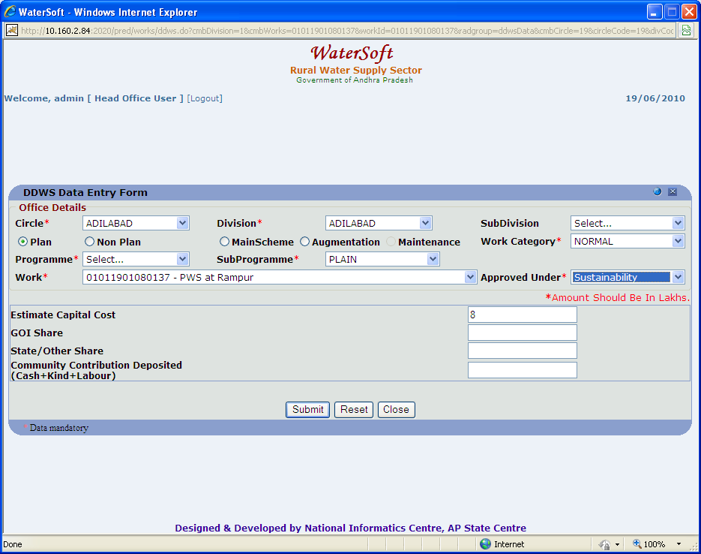
Figure 48

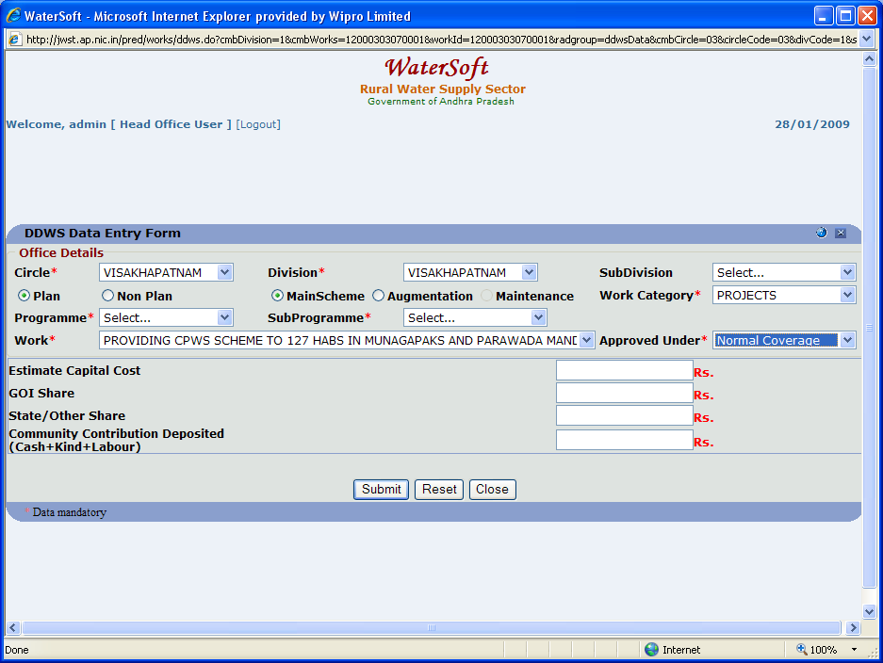
Figure 49

Reset

- Click ‘ Reset ‘ button.

Close

- Click ‘Close‘ button.

Work Flow->Works Monitoring->Update Action Plan

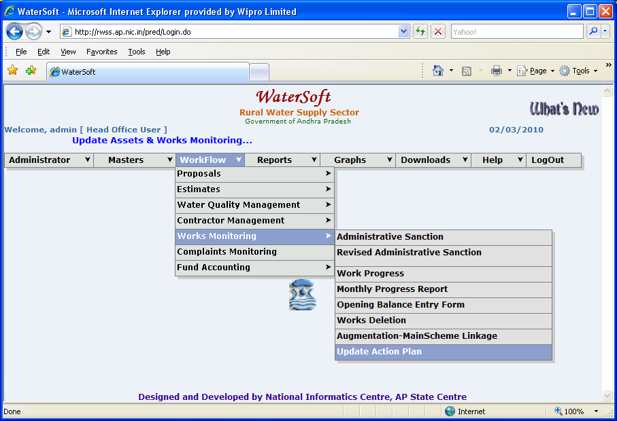
Figure 50

View Works

- Select Circle. ( For Eg. Adilabad).
- Select Division. ( For Eg. Adilabad).
- Select Work Category. ( For Eg. Normal ).
- Click ‘ View Works ’ button.

Works details are displayed as shown below.
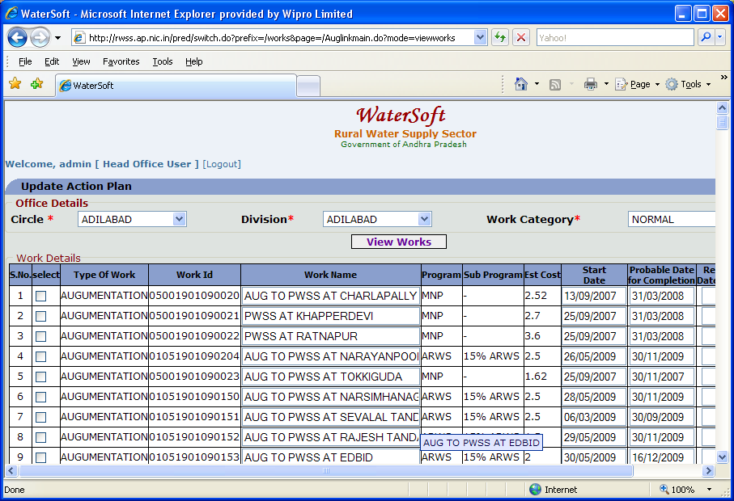
Figure 51

Figure 52: contd.. Figure 51
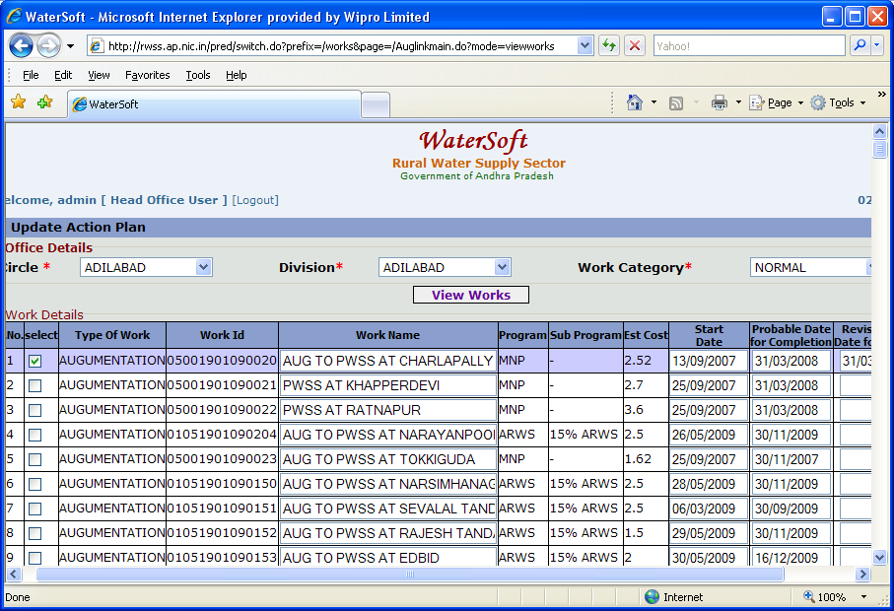
Figure 52

Figure 53: (Contd. of Figure 51).

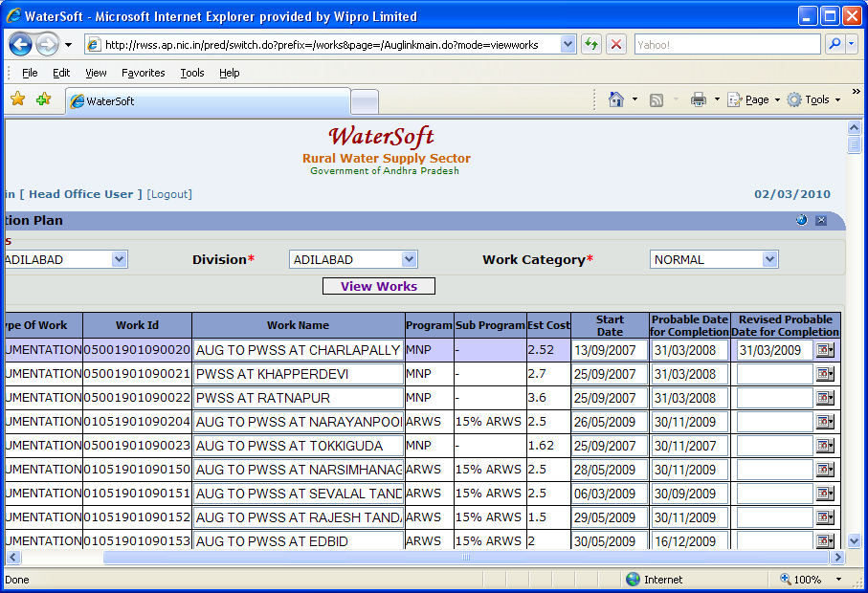
Figure 53

Update Works

- Select Work .( By selecting Check Box ).
- Select Revised Probable Date of Completion.
- Click ‘ Update Works ’ button.

Figure 53: (Contd. of Figure 51).
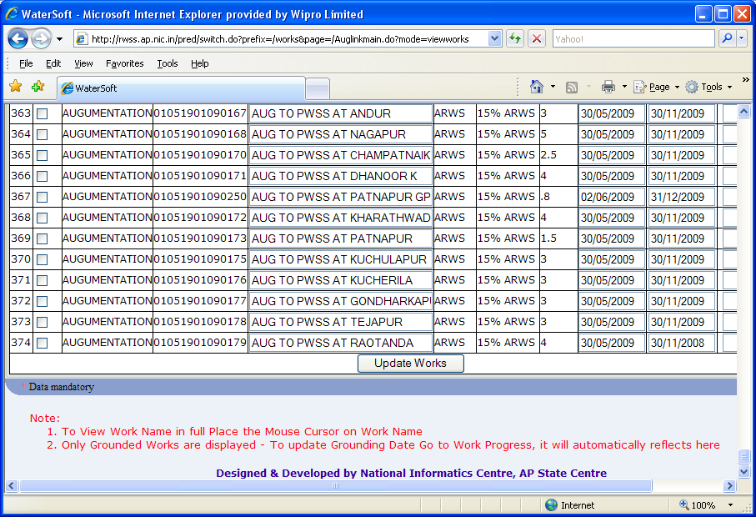
Figure 53

