Sl No | CONTENTS | Page No
1 | Common Operations in the Software | 2
2 | Quality Effected Habs Entry Form | 3 - 5

Common Operations in the Software:

Click the button to close the Form.

 Click the button for online context help.

Home Click the button for Main Page.

Back Click the button for Previous page.

Print Click the button for Printable Version.

Excel Click the button for Excel Version.

Amount will be considered in Lakhs throughout the Software

Quality Effected Habs Entry

Masters -> Quality Effected Habs Entry

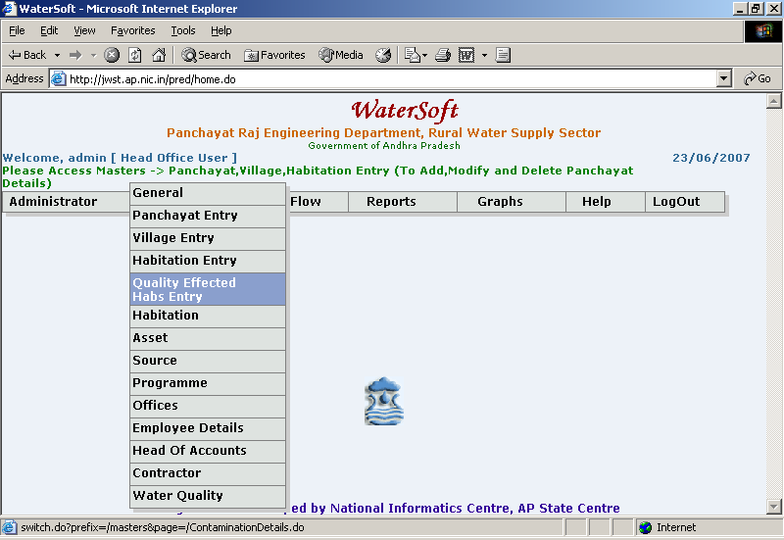

Quality Effected Habs Entry

Save

- Select District
- Select NSS Habs(All Habitations with Coverage Status ‘NSS’ only will be displayed in the List)
- Select Status Date
- Enter Flouride(PPM)
- Enter Brakish(PPM)
- Enter Iron(PPM)
- Click ‘Save’ button

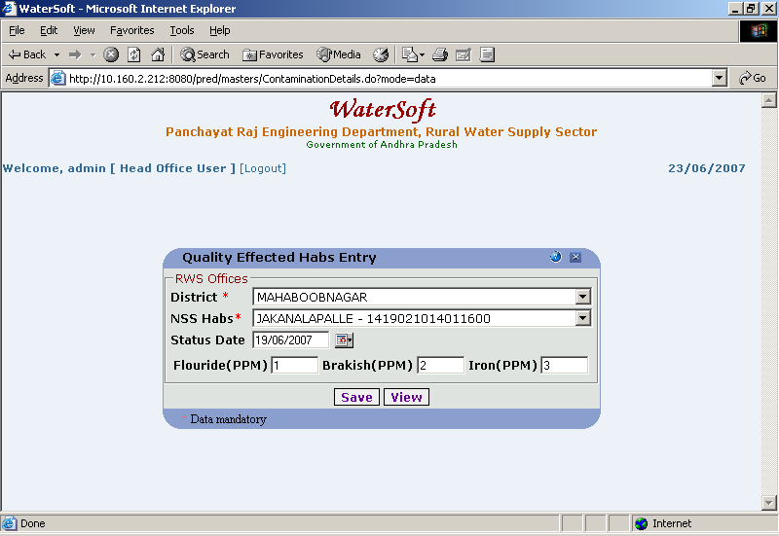

View

- Click ‘View’ button.

To View Contamination Details List

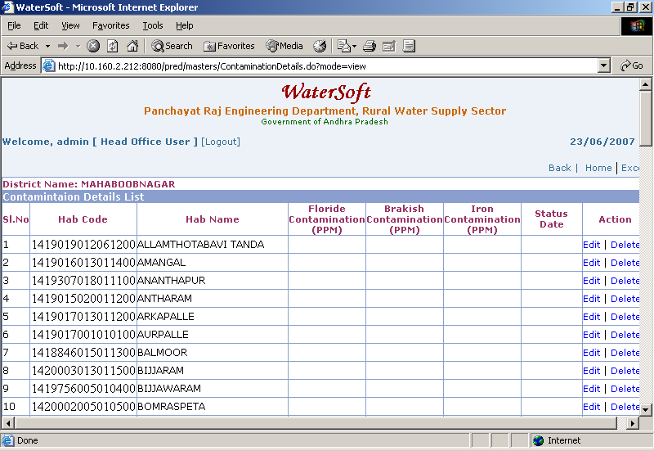

Note I:-In Action – Click ‘Edit’ – Quality Effected Habs Entry Form is displayed – To make Modifications

Note II:-In Action – Click ‘Delete’ to Delete Quality Effected Habs.

