USER MANUAL FOR SMS

WaterSoft

(For the Department of Panchayat Raj & Engineering Department, Rural Water Supply Sector, Govt. of AP)

National Informatics Centre
Department of Information Technology
Ministry of Communications and Information Technology
Government of India
WebSite : www.ap.nic.in

PREPARED BY :

PROJECT TEAM ,
NIC APSC,
HYDERABAD.

REVIEWED BY:

HEAD OF THE DEPARTMENT,
NIC APSC,
HYDERABAD.

APPROVED BY :

STATE INFORMATICS OFFICER
NIC APSC,
HYDERABAD.

Common Operations in the Software:

Click the button to close the Form.

 Click the button for online context help.

Home Click the button for Main Page.

Back Click the button for Previous page.

Print Click the button for Printable Version.

Excel Click the button for Excel Version.

Amount will be considered in Lakhs throughout the Software

- Registration Form:

Mobile → Registration Form:
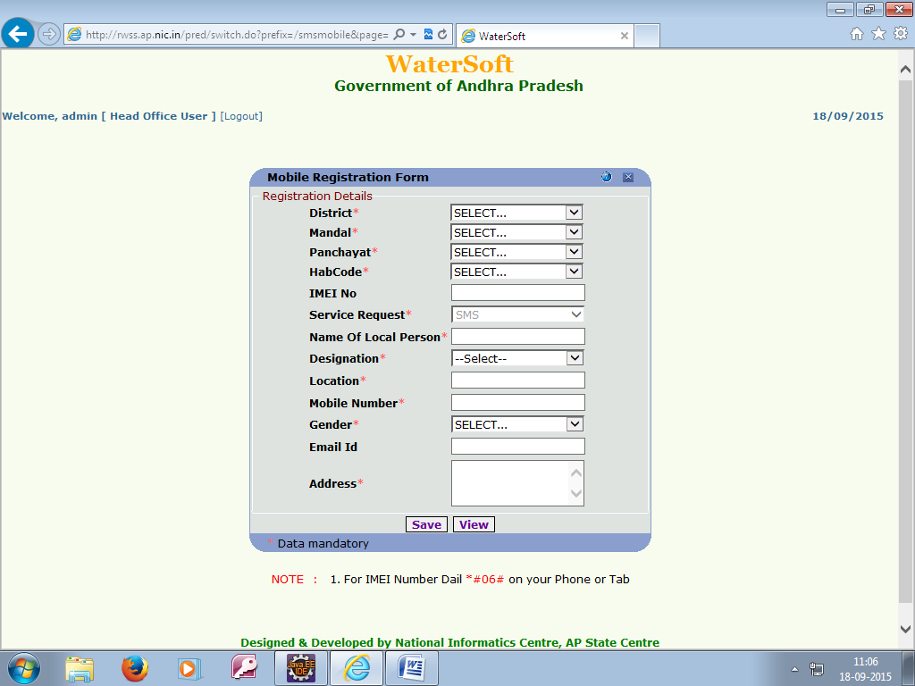

- Select District, Mandal, Panchayat and HabCode(all are mandatory)
- Enter IMEI no is optional for SMS and mandatory for MobileApplications
- Enter the name of Local person
- Select ‘Designation’
- Enter location (within the habitation)
- Enter 10 digit mobile no eg : 9899999999
- Select Gender
- Enter Email id
- Enter Address of the local person
- Click “Save” Button to save the data

Note:
1. * Indicates mandatory column
2. Only one mobile registeration is allowed for a habitation
3. For IMEI Number Dail *#06# on your Phone or Tab.

- Employee Mobile Entry Form:

Mobile → Employee Mobile Entry Form:
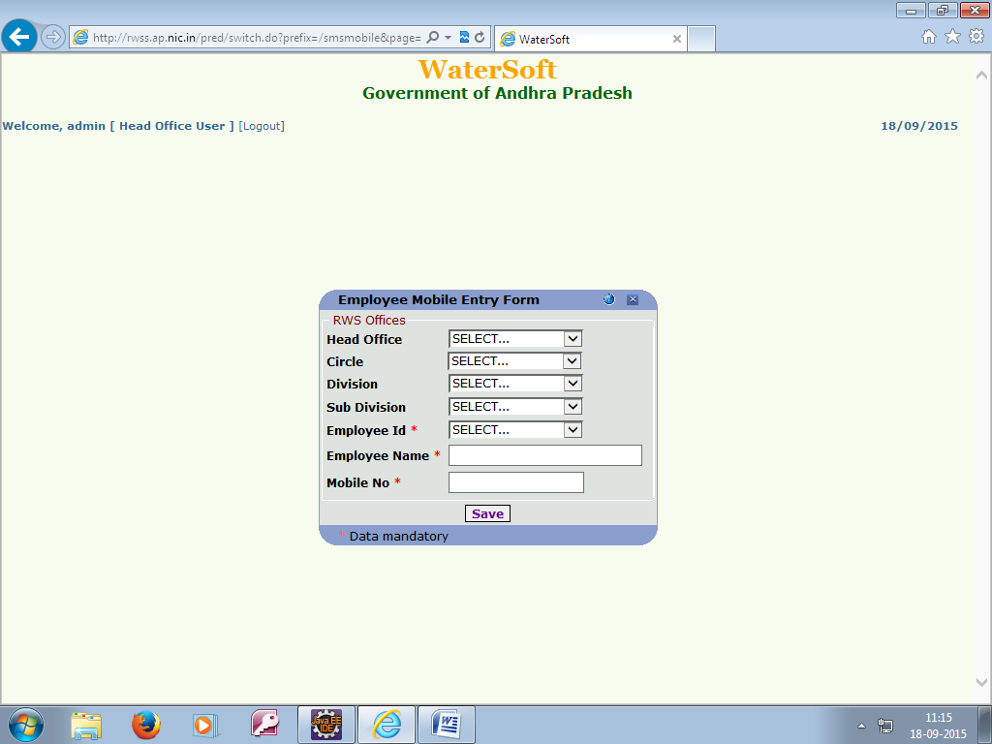

- Select Head Office, Circle, Division and Sub Division
- Select Employee Id, automatically Employee name will come.

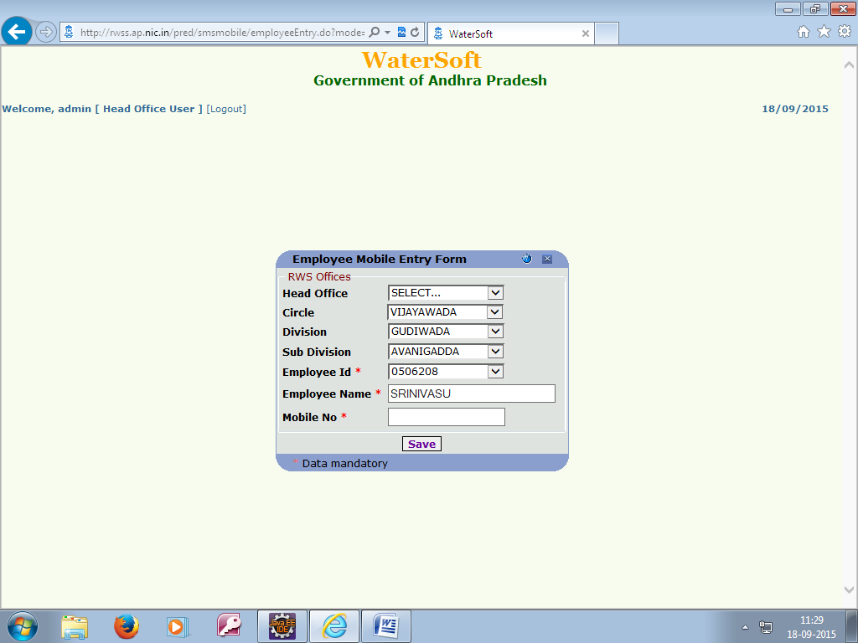

- Enter 10 digit mobile no eg : 9899999999
- Click “Save” Button to save the data

- MPDO/MRO ENTRY Form:

Mobile → MPDO/MRO Entry Form:
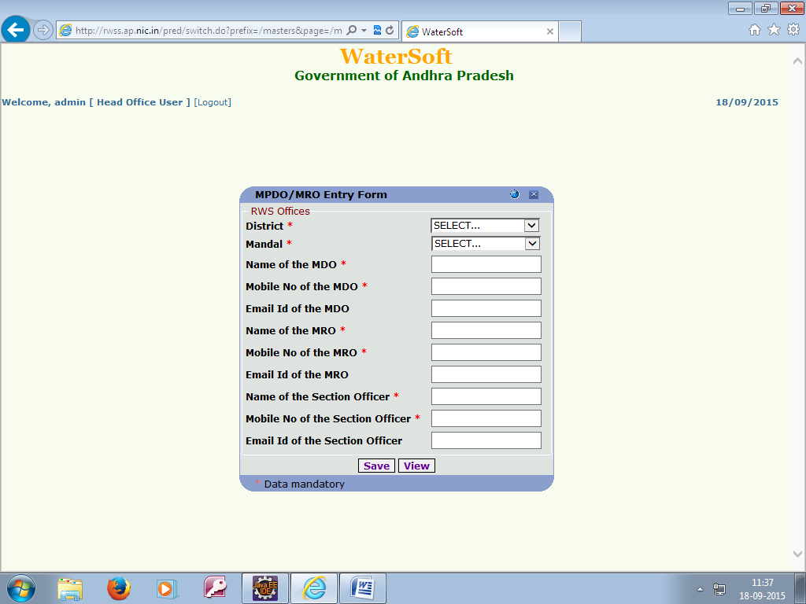

- Select District and Mandal.
- Enter Name of the MDO
- Enter 10 digit Mobile Number of the MDO eg : 9899999999
- Enter Email Id of the MDO
- Enter Name of the MRO
- Enter 10 digit Mobile Number of the MRO eg : 9899999999
- Enter Email Id of the MRO
- Enter Name of the Section Officer
- Enter 10 digit Mobile Number of the Section Officer eg : 9899999999
- Enter Email Id of the Section Officer
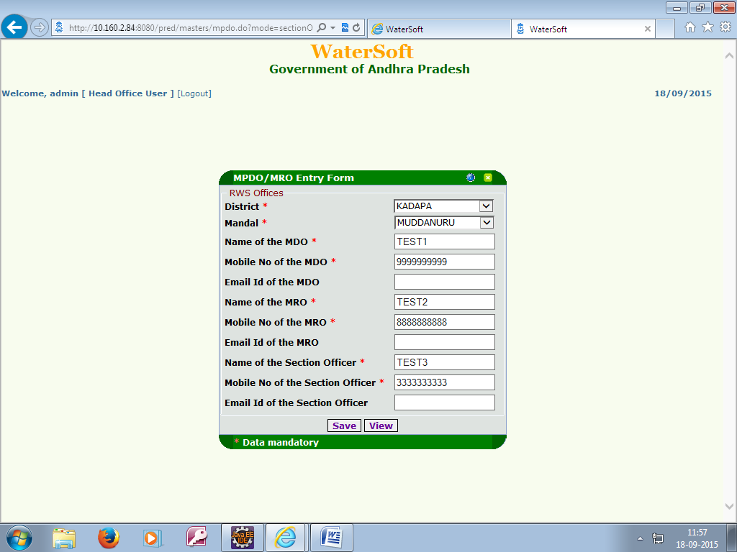

- Click “Save” Button to save the data

Note:
1. * Indicates mandatory column
2. Per MANDAL only one MDO, MRO and Section Officer is allowed.

- SARPANCH ENTRY Form:

Mobile → Sarpanch Entry Form:
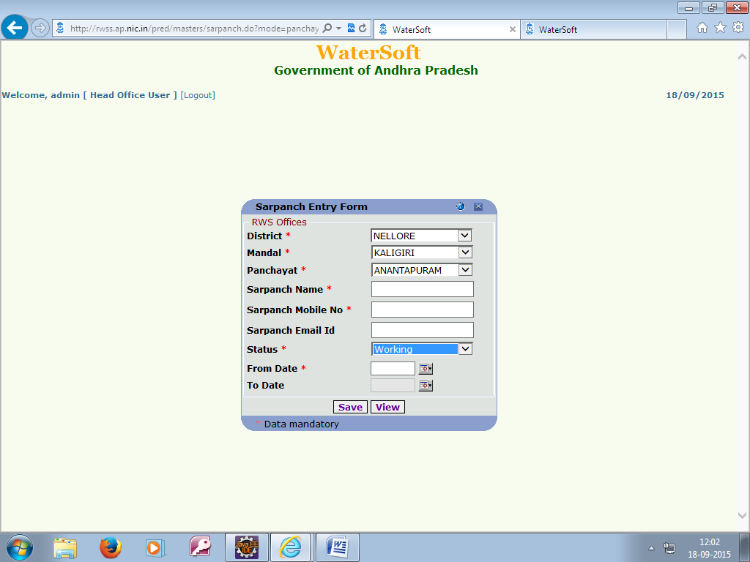

- Select District, Mandal and Panchayat.
- Enter Sarpanch Name
- Enter 10 digit Mobile Number eg : 9899999999
- Enter Sarpanch email Id
- Enter Status
- Select From Date.
- Click “Save” Button to save the data

Note:
1. * Indicates mandatory column
2. Per Panchayat only one Sarpanch will allow.

- VILLAGE SECRETARY ENTRY Form:

Mobile → Village Secretary Entry Form:
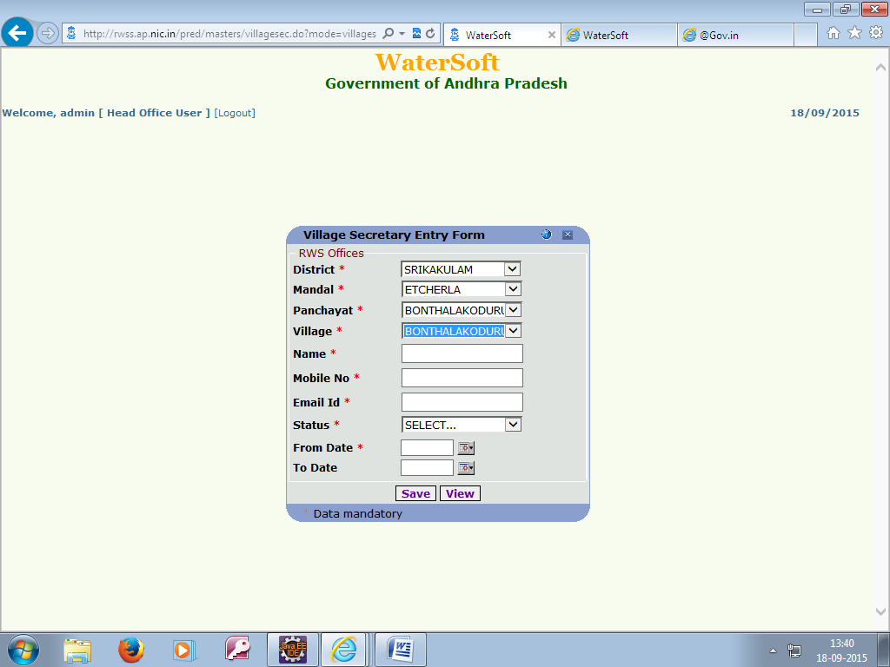

- Select District, Mandal, Panchayat and Village.
- Enter Name
- Enter 10 digit Mobile Number eg : 9899999999
- Enter email Id
- Enter Status
- Select From Date.
- Click “Save” Button to save the data

Note:
1. * Indicates mandatory column
2. Per Village only one Village Secretary will allow.

- RESIDUAL CHLORIDE-ACTION TAKEN ENTRY Form:

Mobile → Residual Chloride-Action Taken Entry Form:
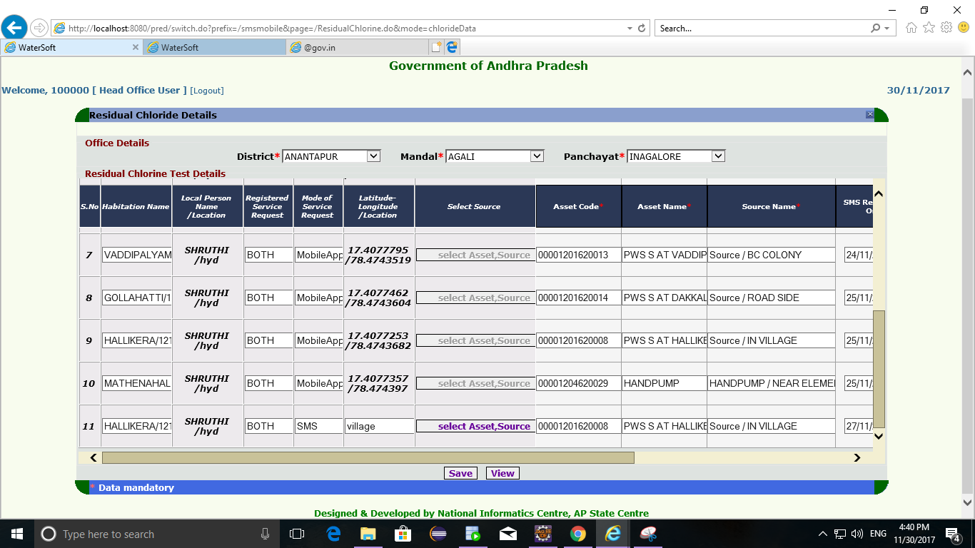
- Select District, Mandal, Panchayat
- Select Source if Mode Of Service Request is SMS based on location given through SMS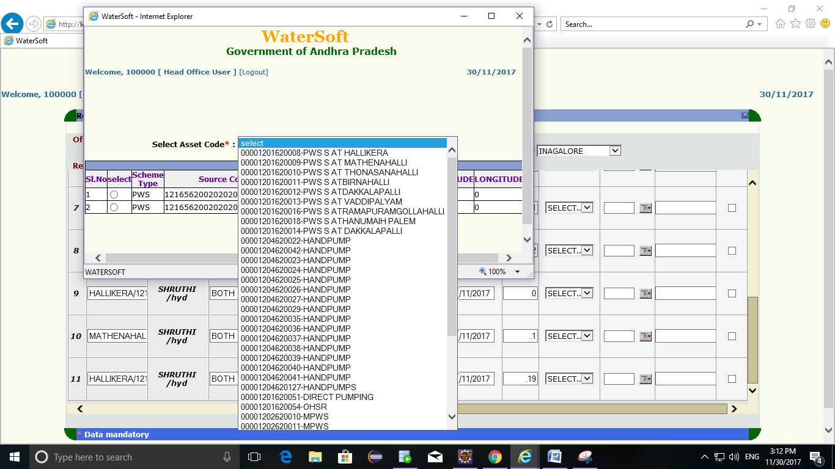

- Enter Action Taken
- Select Date of Action
- Enter Remarks
- Select check boxes
- Click “Save” Button to save the data

8.Click On ‘VIEW’ button to get the list of Action Taken Records.
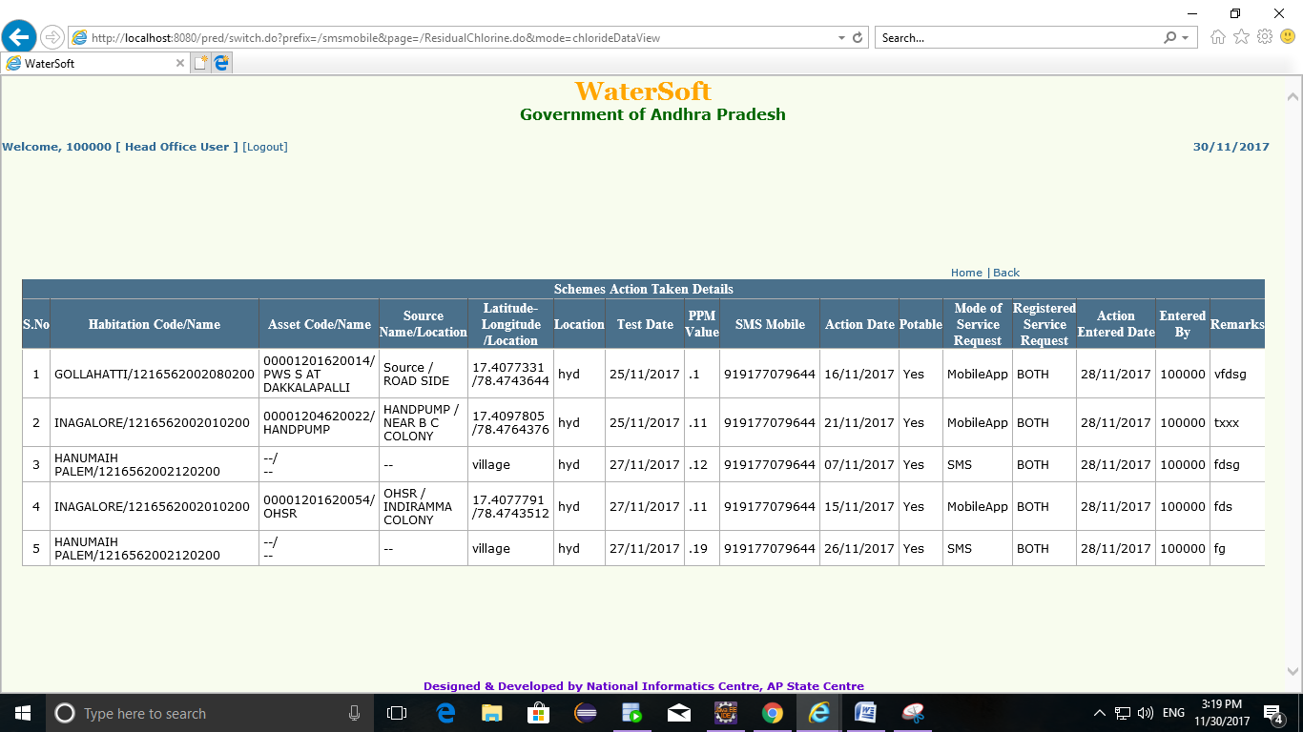

Note:
- * Indicates mandatory column

- SCHEMES-ACTION TAKEN ENTRY Form:

Mobile → Schemes-Action Taken Entry Form:
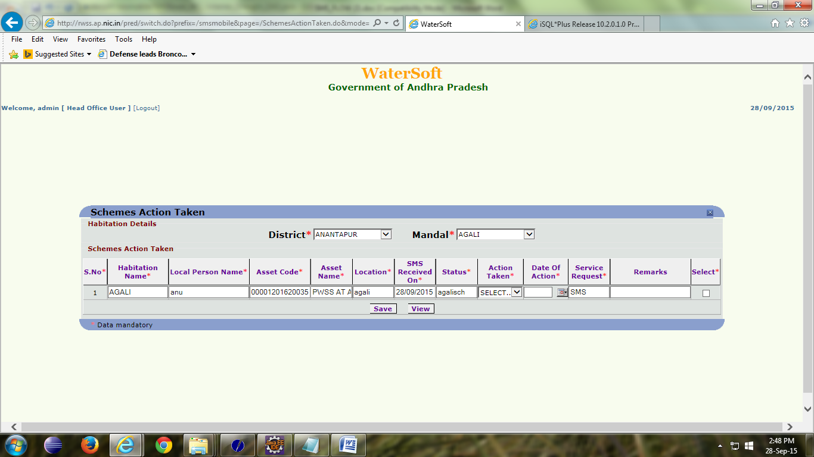

- Select District, Mandal
- Enter Action Taken
- Select Date of Action
- Enter Remarks
- Select check boxes
- Click “Save” Button to save the data

- WATER TANKER-ACTION TAKEN ENTRY Form:

Mobile → Water Tanker-Action Taken Entry Form:
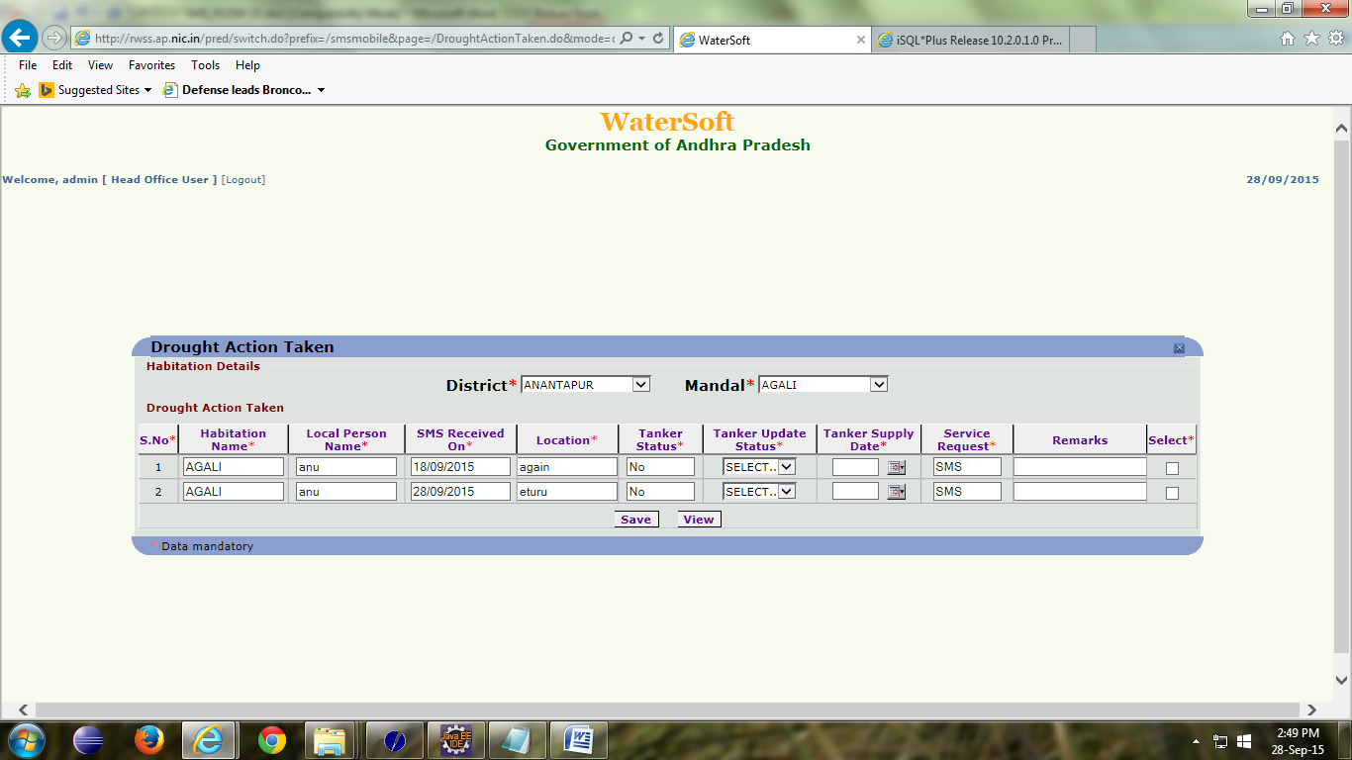

- Select District, Mandal
- Enter Tanker Upadte Status
- Select Tanker Supply Date
- Enter Remarks
- Select check boxes
- Click “Save” Button to save the data

Note:
1. * Indicates mandatory column

- OHSR & GLSR-ACTION TAKEN ENTRY Form:

Mobile → OHSR & GLSR-Action Taken Entry Form:
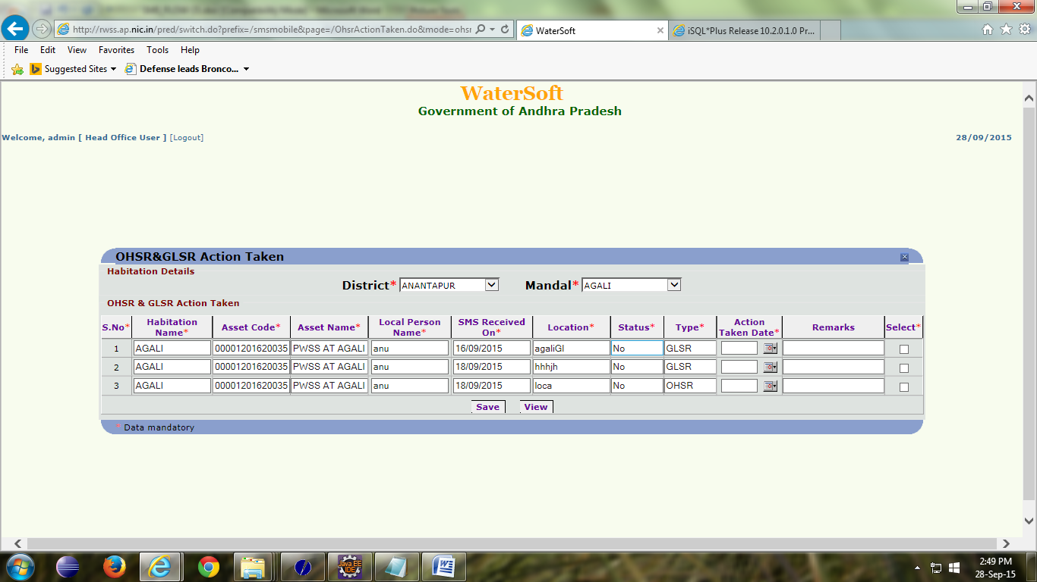

- Select District, Mandal
- Select Date of Action
- Enter Remarks
- Select check boxes
- Click “Save” Button to save the data

Note:
1. * Indicates mandatory column

