USER MANUAL FOR SCHOOL ENTRY FORM

WaterSoft

(For the Department of Panchayati Raj & Engineering Department, Rural Water Supply Sector, Govt. of AP)

National Informatics Centre
Department of Information Technology
Ministry of Communications and Information Technology
Government of India
WebSite : www.ap.nic.in

PREPARED BY :

PROJECT TEAM ,
NIC APSC,
HYDERABAD.

REVIEWED BY:

HEAD OF THE DEPARTMENT,
NIC APSC,
HYDERABAD.

APPROVED BY :

STATE INFORMATICS OFFICER
NIC APSC,
HYDERABAD.

Amendment Log

Version Number | Date | Change Number | Brief Description | Sections Changed
1.0 | 15.12.2008 | - | First Release
1.1 | 20.01.2010 | - | Second  Release | Addition of new features based upon User Requirements in school entry form.
1.2 | 21.01.2012 | - | Third Release | Addition of latitude,longitude,elevation,waypoint as per User requirements

Sl No | CONTENTS | Page No
1. | Common Operations in the Software | 5
2. | School Entry Form | 6 - 17

Common Operations in the Software:

Click the button to close the Form.

 Click the button for online context help.

Home Click the button for Main Page.

Back Click the button for Previous page.

Print Click the button for Printable Version.

Excel Click the button for Excel Version.

Amount will be considered in Lakhs throughout the Software

School Entry Form

Masters -> School -> School Form

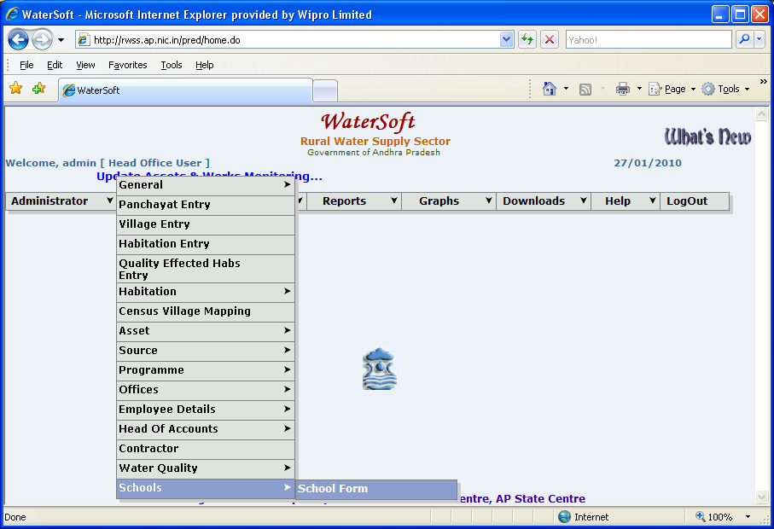
Figure 1.

Note :-For Existing schools follow series of steps.

Step 1:Select District->Select Mandal->Select Panchayat->Select Village

Step 2:Click->’ View ’ button->School details are displayed based on selection.

Step 3:Now Click->’ Edit ’ button

Step 4:
Enter data for latitude , longitude, elevation, waypoint -> Click ‘ Update ’ button along with school details.

New schools:

Note:-Enter all School details along with latitude,longitude,elevation,waypoint

School Entry Form
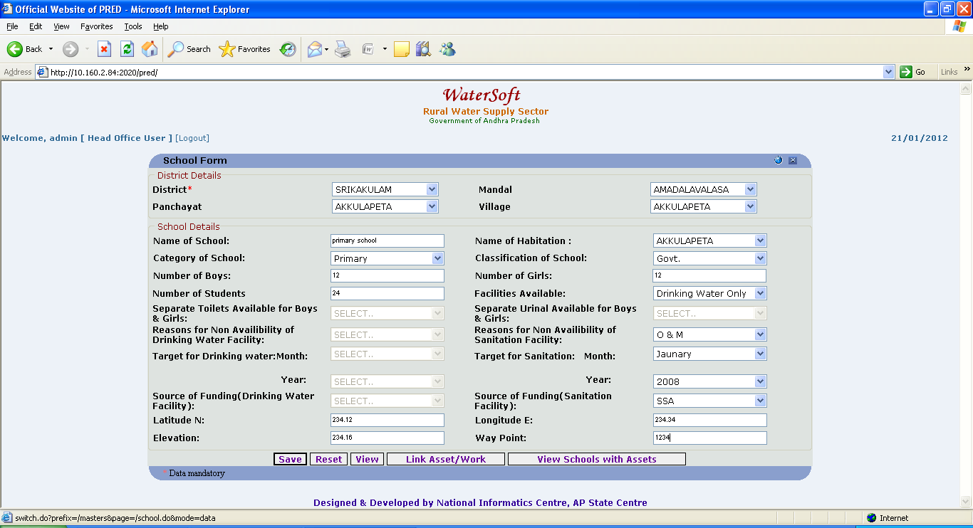
Figure 2.

To add New School

Save

- Select District( For Eg. Adilabad ).
- Select Mandal( For Eg. Adilabad ).
- Select Panchayat (For Eg. Ankoli ).
- Select Village ( For Eg. Ankoli ).
- Enter Name of School.
- Select Name of Habitation.
- Select Category of School. (For Eg. Balwadi/Aganwadi ) , Primary , Upper Primary , Sr. Secondary ).
- Select Classification of School.( For Eg. Govt. , Local Body , Govt. Aided , Private )
- Enter Number Of Boys.
- Enter Number Of Girls.

- Number Of Students ( is based on data entered for Number Of Boys + Number Of Girls ) -- Display Field
- Select Facilities Available. (For Eg. Drinking Water Only , Sanitation (Toilet Only ) , Sanitation ( Urinal Only ) , Sanitation ( Both ) , Both ( Drink & Sanitation ) , None ).

Note I:Further Navigation to the fields is based on the selection made :

If Drinking Water is Selected

- Select Reasons for Non Availability of Sanitation.
- Select Target for Sanitation Month.
- Select Target For Sanitation Year.
- Select Source of Funding ( Sanitation )

If Sanitation ( Toilet Only ) is Selected

- Select Separate Toilets Available for Boys and Girls.
- Select Reasons For Non Availability Drinking Water Facility.
- Select Target For Drinking Water (Month ) .
- Select Target For Drinking Water (Year ) .
- Select Source of Funding( Drinking Water Facility)
- Select Reasons For Non Availability Sanitation Facility
- Select Target For Sanitation Month
- Select Target For Sanitation Year
- Select Source of Funding( Sanitation)

If Sanitation ( Urinal Only ) is Selected

- Select Separate Urinal Available for Boys and Girls.
- Select Reasons For Non Availability Drinking Water Facility
- Select Target For Drinking Water (Month ) .
- Select Target For Drinking Water (Year ) .
- Select Source of Funding( Drinking Water Facility)
- Select Reasons For Non Availability Sanitation Facility
- Select Target For Sanitation Month
- Select Target For Sanitation Year
- Select Source of Funding( Sanitation)

If Sanitation( Both ) is Selected

- Select Separate Urinal Available for Boys and Girls.
- Select Separate Toilets Available for Boys and Girls.
- Select Reasons For Non Availability Drinking Water Facility
- Select Target For Drinking Water Month .
- Select Target For Drinking Water Year .
- Select Source of Funding( Drinking Water Facility)

If Both ( Drink and Sanitation ) is Selected

- Select Separate Urinal Available for Boys and Girls.
- Select Separate Toilets Available for Boys and Girls

If None is Selected

- Select Reasons For Non Availability Drinking Water Facility
- Select Target For Drinking Water ( Month ) .
- Select Target For Drinking Water ( Year ) .
- Select Source of Funding( Drinking Water Facility )
- Select Reasons For Non Availability Sanitation Facility
- Select Target For Sanitation Month
- Select Target For Sanitation Year
- Select Source of Funding( Sanitation)

- Select Separate Toilets Available For Boys & Girls. (For Eg. Yes (only For Girls , Yes (only For Boys ), Yes (for Both) , None )
- Select Separate Urinal Available For Boys & Girls. (For Eg. Yes (only For Girls , Yes (only For Boys ), Yes (for Both) , None )
- Select Reasons For Non Availability of Drinking Water Facility(For Eg. Drying of Sources , O & M , Multiple Reasons , Others , Quantity of Water, Quality of Water ).
- Select Reasons For Non Availability of Sanitation Facility. ( For Eg. Drying of Sources , O & M , Multiple Reasons , Others )
- Select Target of Drinking Water – Month ( For Eg. February )
- Select Target of Drinking Water – Year ( For Eg . 2008 )
- Select Target of Sanitation – Month ( For Eg. February )
- Select Target of Sanitation – Year ( For Eg . 2008 )
- Select Source of Funding Drinking Water Facility. ( For Eg. ARWSP , Swajaldhara , SSA , Financial Commission , State Scheme , Private )
- Select Source of Funding Sanitation Facility. (For Eg. SSA , Financial Commission , State Scheme , Private , TSC )
- Enter Latitude.
- Enter Longitude.
- Enter Elevation.
- Enter Waypoint.
- Click ‘ Save ’ button

Figure 3.

Note II :- Entries are considered Duplicate if within the same habitation
The following fields are repeated .

- School Name
- No of Boys
- No of Girls

Such entries are rejected.

To View the School Details

View

- Select District . ( For Eg . Adilabad ).
- Select Mandal. ( For Eg. Adilabad ).
- Select Panchayat. ( For Eg. Ankoli ).
- Select Village. ( For Eg. Ankoli ).
- Click ‘ View ‘ button.
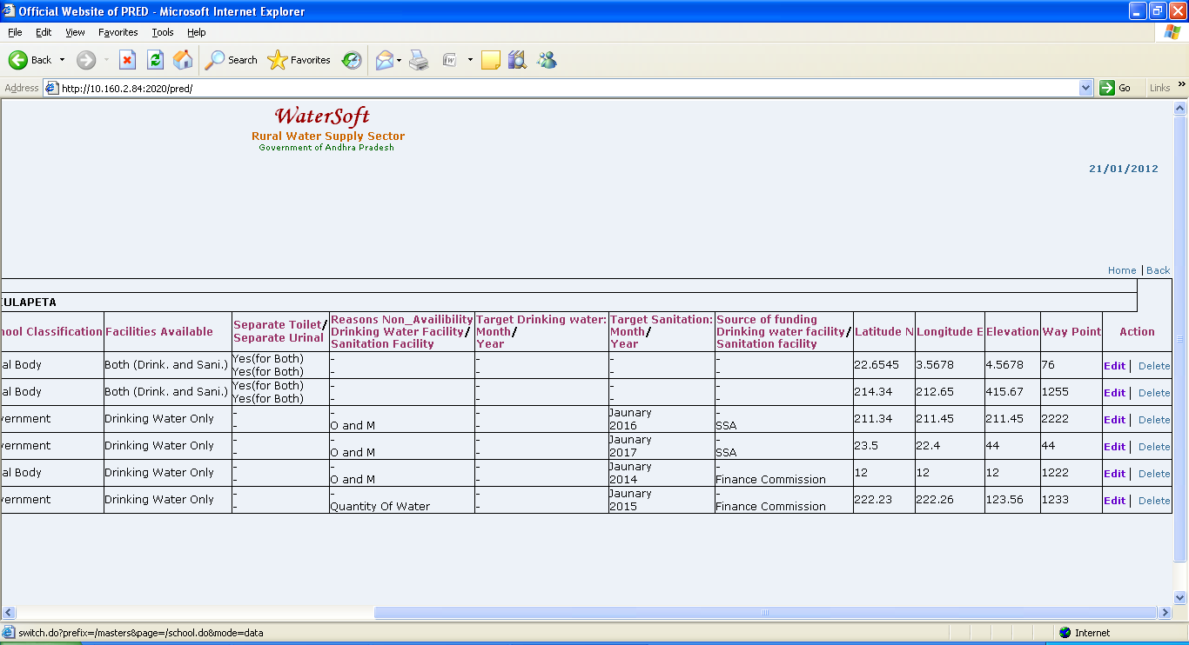

Figure 4.

Note III:- In Action Select ‘ Edit ’ – To make Changes in School details – School Entry Form is displayed.

Note IV:-In Action Select ‘ Delete ’ – To Delete School details.

Note V:-To link School to particular Asset / Work (Click on ‘ Link Asset/Work ‘ button.

Link Asset/Work

- Select District (For Eg. Adilabad ).
- Select Mandal (For Eg. Adilabad ).
- Select Panchayat ( For Eg. Ankoli ).
- Select Village ( For Eg. Ankoli ).
- Click ‘ Link Asset/Work ‘ button.
Figure 5.

Note VI:-The following screen shots(Figure 6 , 7 , 8 ) explain the process of linking School to particular Asset / Commissioned Work.

Click on ‘ Asset/Work ‘ button -> Select Asset Types -> Click on ‘Get Assets(or)Works’ button then Select required Assets/Works and Click on ‘Save Selected Assets (or)Works’ button to link School.

Select Asset/Work

- Click ‘ Select Asset/Work ’ button.

(Screen Shot Figure 6) 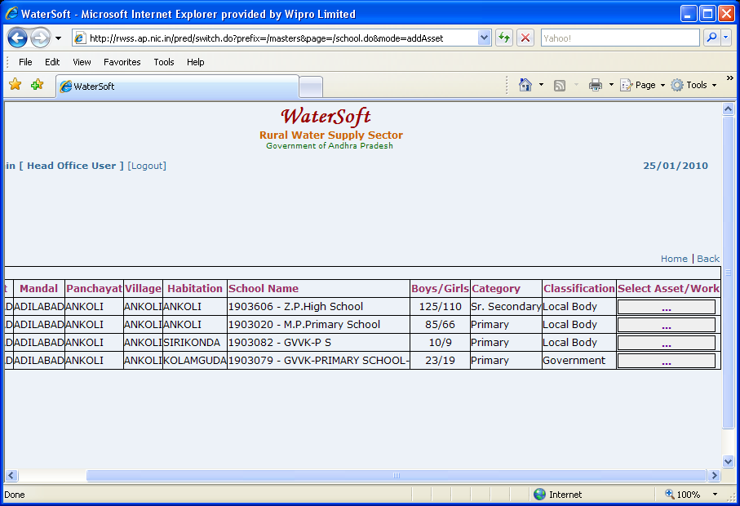
Figure 6.

Note VII:-Multiple Asset Types can be Selected for Eg. PWS , Handpumps or CPWS.

Get Assets (or) Works

- Select Asset Types ( For Eg. PWS , CPWS or Handpumps ).
- Click ‘Get Assets (or) Works’ button.

(Screen Shot Figure 7)

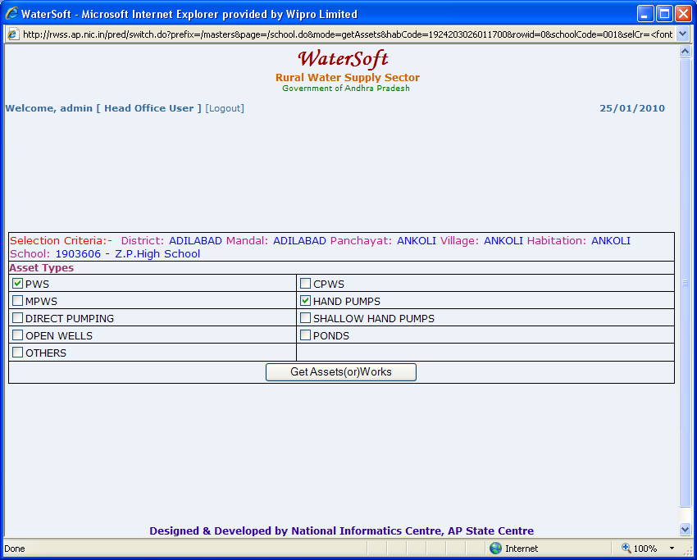
Figure 7.

Note VIII:-All the Assets that are related to selected AssetTypes are displayed .Then Select Assets or Works and Click on ‘Save Selected Assets(or)Works’
button to link School.

Save Selected Assets or Works

- Select Assets or Works (By checking them)
- Click ‘Save Selected Assets or Works’ button.

(Screen shot (Figure 8)
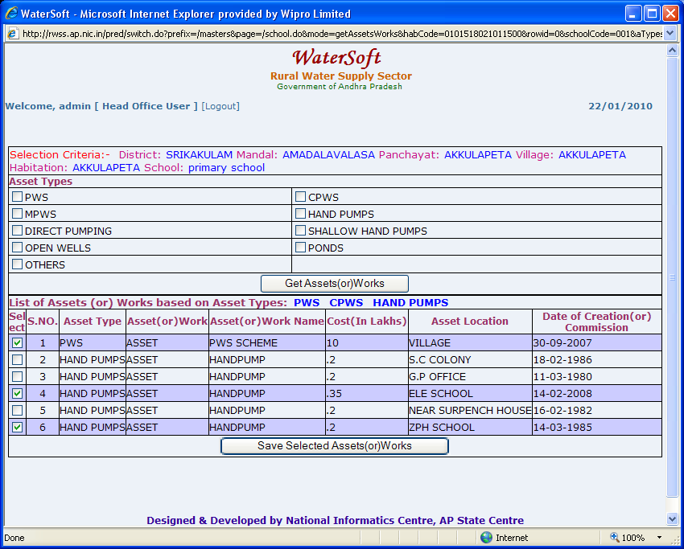
Figure 8.

View Schools with Assets

- Select District( For Eg. Adilabad ).
- Select Mandal ( For Eg. Adilabad )
- Select Panchayat ( For Eg. Ankoli )
- Select Village ( For Eg. Ankoli )
- Click ‘View Schools with Assets ‘ button.

Schools with Assets are displayed
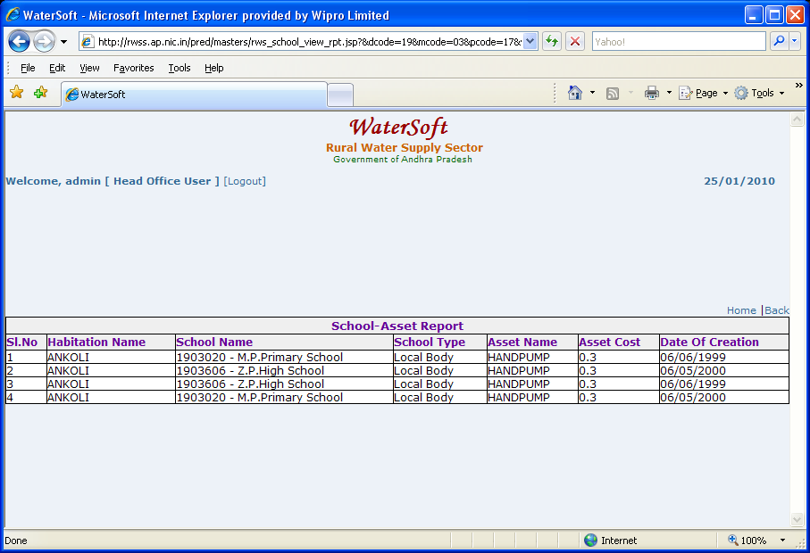
Figure 9.

