USER MANUAL FOR WORKS MONITORING

WaterSoft

(For the Department of Panchayati Raj & Engineering Department, Rural Water Supply Sector, Govt. of AP)

National Informatics Centre
Department of Information Technology
Ministry of Communications and Information Technology
Government of India
WebSite : www.ap.nic.in

PREPARED BY :

PROJECT TEAM ,
APDVIII, NIC APSC,
HYDERABAD.

REVIEWED BY:

HEAD OF THE DEPARTMENT,
APDVIII, NIC APSC,
HYDERABAD.

APPROVED BY :

STATE INFORMATICS OFFICER
NIC APSC,
HYDERABAD.

Amendment Log

Version Number | Date | Change Number | Brief Description | Sections Changed
1.0 | 1.1.2007 | - | First Release
1.1 | 20.3.2007 | - | Second  Release | ALL
1.2 | 28.3.2008 | - | Third Release | Administrative Sanction Form – Figure 2.  Revised Administrative Sanction – Figure 9.  Work Status Form – Figure 18.
1.3 | 5.2.2009 | - | Fourth Release | Due to changes made in the input design of Administrative Sanction Form – Figure 2.  Revised Administrative Sanction – Figure 7.  Work Status Form – Figure 18.
1.4 | 30.10.2009 | - | Fifth Release | Changes in Contractor Management  In Work Progress, column contractor/Firm Name combo box based on User Requirements.
1.5 | 20.11.2009 | - | Sixth Release | Change in Work Progress Remarks,Date Completed fields,  Change in Work Expenditure in Work Progress , value of work done but not paid field based on User Requirements.
1.6 | 20.02.2010 | - | Seventh Release | Augmentation to Mainscheme Linkage added based upon User Requirements.
1.7 | 26.02.2010 | - | Eighth  Release | Update Action Plan added based upon  User Requirements.
1.8 | 09.06.2010 | - | Ninth  Release | Changes in Work Expenditure,Work Completion based upon User Requirements.
1.9 | 18.06.2010 | - | Tenth  Release | Changes in Work Progress – Linking schools to works based on User Requirements.

Sl No | CONTENTS | Page No
1 | Common Operations in the Software | 5
2 | Administrative Sanction | 6 – 15
3 | Augmentation Main Scheme Linkage | 16 – 20
4 | Revised Administrative Sanction | 21 – 29
5 | Work Progress | 30 – 57
6 | Update Action Plan | 58 - 62

Common Operations in the Software:

Click the button to close the Form.

 Click the button for online context help.

Home Click the button for Main Page.

Back Click the button for Previous page.

Print Click the button for Printable Version.

Excel Click the button for Excel Version.

Note : Amount is to be considered in Rs lakhs

Note I:- Depending on login Circle is Fixed . Fields marked with ‘ * ’ are Mandatory Fields.

WorkFlow - > Works Monitoring - > Administrative Sanction

Administrative Sanction

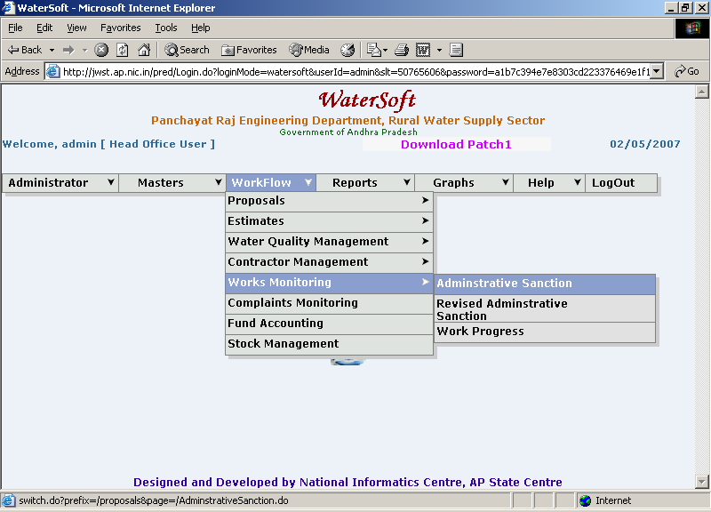
Figure. 1

Administrative Sanction

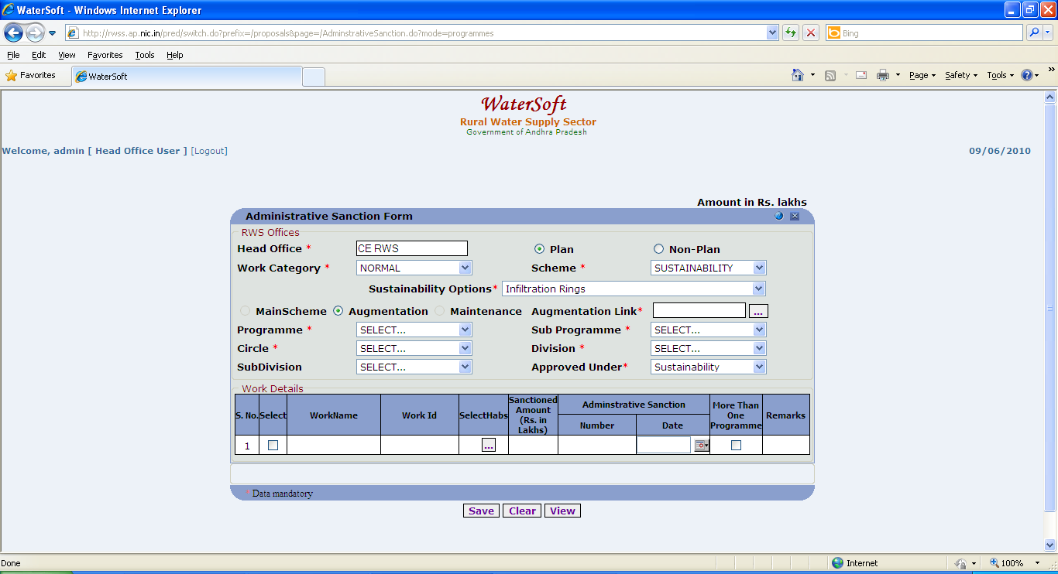
Figure. 2

Note :-If ‘ Sustainability ‘ is selected as scheme

->Select Sustainability Options

Sustainability Options are

- Infiltration Rings
- Recharge pits
- Check Dams
- Percolation Tanks
- Sub – Surfaces Dykes
- Injection wells
- Soak pit for Handpump
- Removal of Traditional water Harvesting structures
- Ponds/Tanks/ooranis
- Others

View /Save

- Head Office is fixed .
- Select Plan or Non – Plan ( default option is plan)
- Select Work Category ( For Eg. Normal ,District Level , Projects )
- Select Scheme . ( For Eg. Pws , Sustainability ).
- Select Main Stream , Augmentation( Default is Main Scheme).
- Select Maintenance ( For Non-Plan ).
- Select Programme.
- Select Sub Programme.
- Select Circle (fixed based on Login).
- Select Division.
- Select Sub Division (Optional)
- Select Approved Under (For Eg. Normal Coverage, Submission - Water Quality, Sustainability)

If Augmentation is selected series of steps follows… figures 3 & 4…. explain the process.

Click on ‘ Augmentation Link ‘ - > Works List Form is displayed .
Works List Form -> Select Circle -> Select Financial Year -> Select Scheme -> Works List details will be displayed -> Select Work.

The selected work will be automatically attached to augmentation link.

Works List

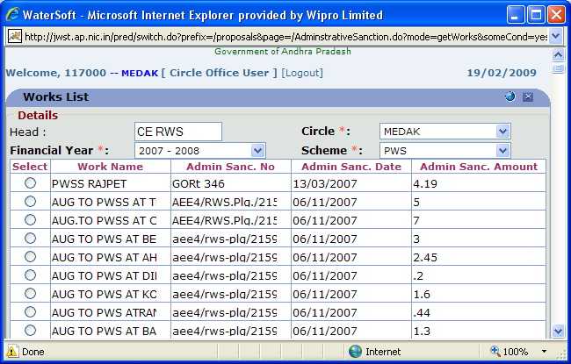
Figure 3.

Administrative Sanction Form

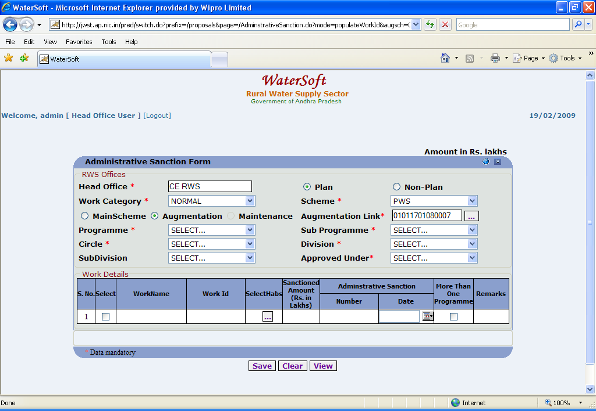
Figure 4.

Note II : This information is required either to Save a New Work or to View /Modify Existing Works.

Save

- Enter Work Name.
- Work Id is Auto Generated.
- Select Habs ( Habitations ).
- Enter Sanctioned Amount(Rs. Lakhs).
- Enter Administrative Sanction Number.
- Select Administrative Sanction Date.
- Select More Than One Programme ( in case if the work is sanctioned for more than one Programme).
- Enter Remarks.
- Click ‘Save’ to save the Work details.

Note III :-To Select ‘ Multiple Mandals ’ and Habitations Use CTRL Button.

Note IV:- To Select Habs – Select ‘ Mandals ’ → Click ‘ Get Habitations ’ button→ Habitations are displayed. Select ‘Habitations’ → Click ‘ Add Habitations ’
Press ‘OK’ wherever required.
(The screen shots are displayed figure 5 & 6 … explain the process

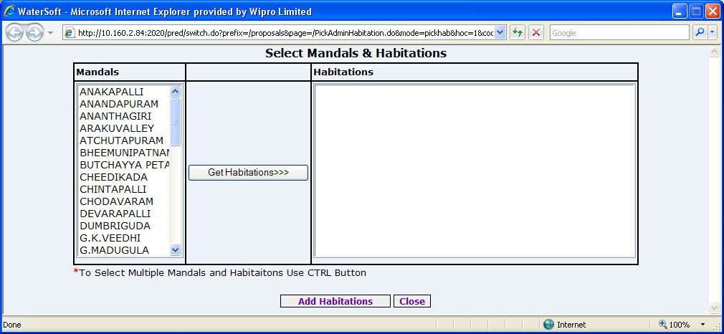

Figure. 5

Get Habitations

- Click ‘Get Habitations>>>’ buttons.

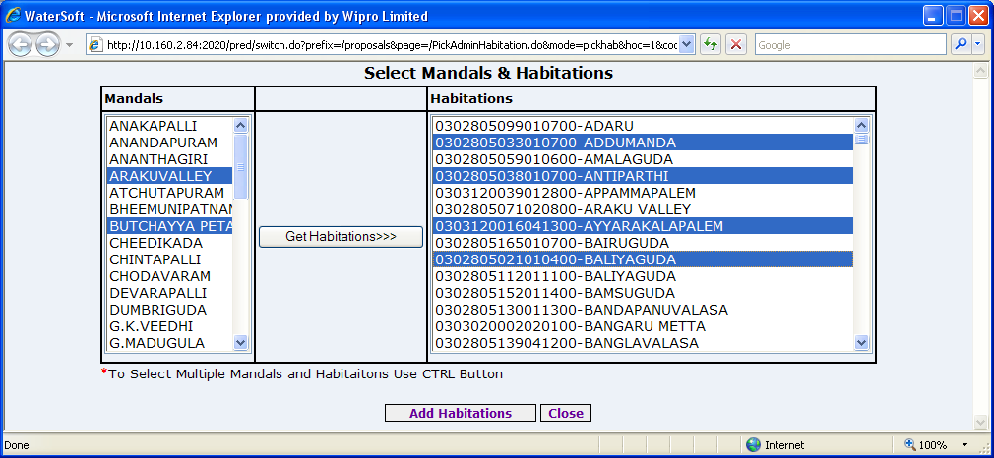

Figure. 6

Add Habitations

- Select Habitations.
- Click ‘Add Habitations’ button. ( To Select multiple Habitations Use CTRL Button )

View Data

- Click ‘View’ button.

The list of Administrative Sanctioned Works are Displayed as shown below .

Administrative Sanction List

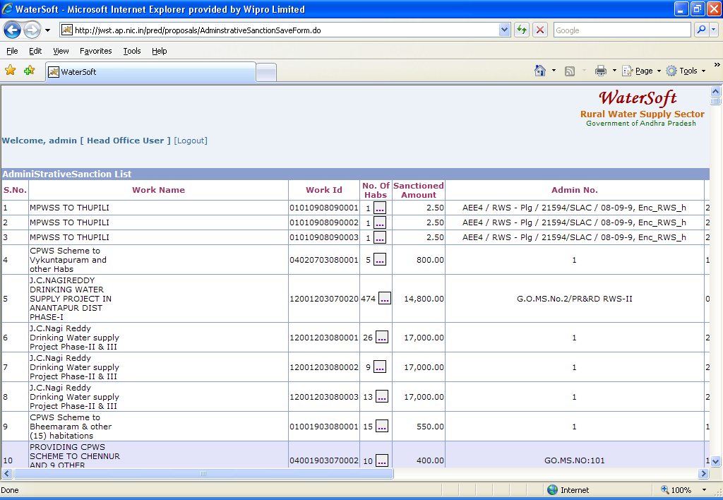
Figure. 7

Administrative Sanction List

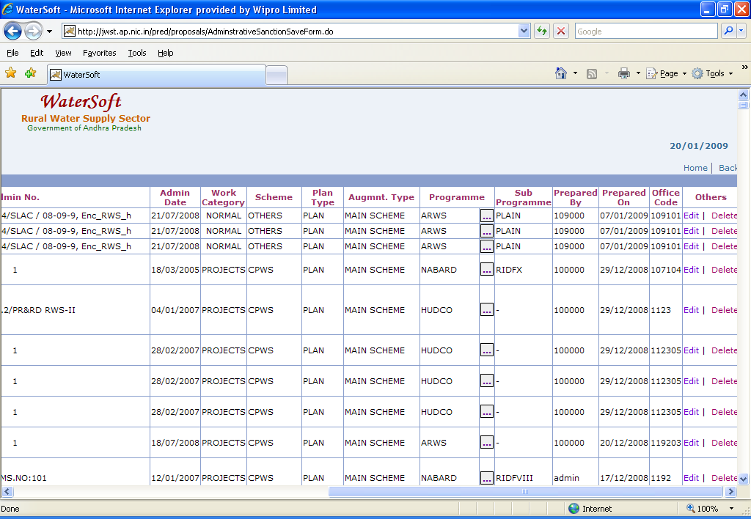
Figure 8.

Note V :- In Action – Select ‘Edit’ to make Modifications – Administrative Sanction Form is displayed.

In Action – Select ‘Delete ’ to Delete Works – This is a privileged option Enabled only for Selected User Logins.

For Entering the works which are Sanctioned under More than One Programme

Add Programs

- Select Programme.
- Select Sub programme.
- Enter Sanctioned Amount(Rs. In Lakhs)
- Enter Admn Sanc No.
- Select Admn Sanc Date
- Click ‘Add Programs’ to save

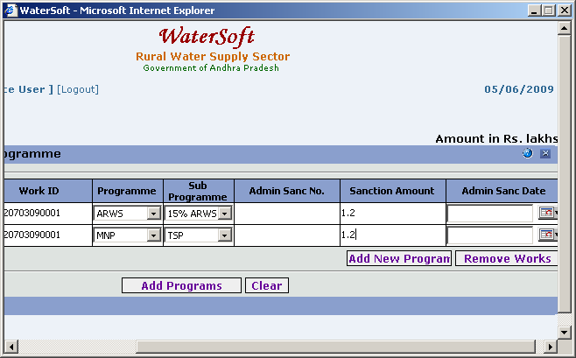
Figure. 9

Clear

- Click ‘Clear’ to clear the Form.

WorkFlow - > Works Monitoring - > Augmentation Main Scheme Linkage

Note VI:-Augmentation Main Scheme Linkage mainly helps in linking Augmentation works with MainSchemes ( Asset / Work ).

Augmentation Main scheme Linkage

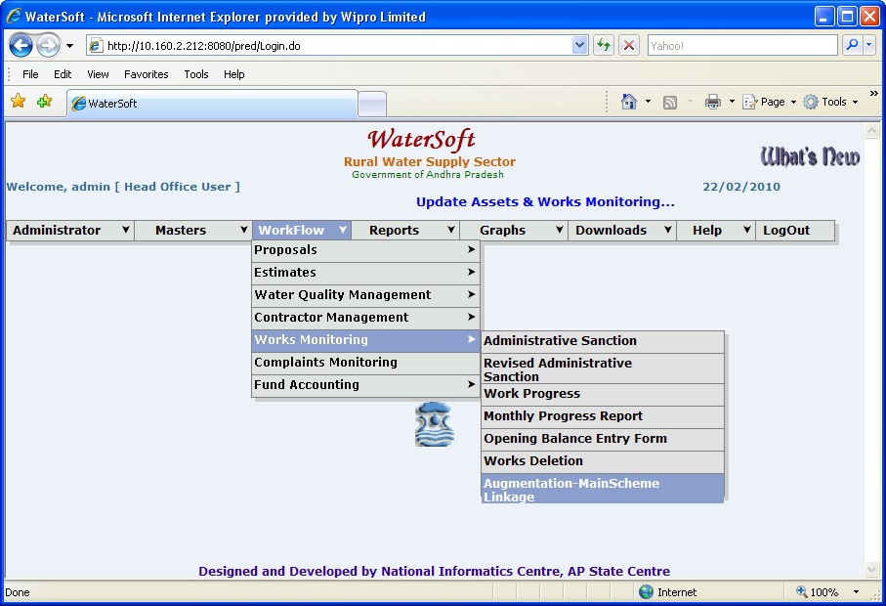
Figure. 10

Augmentation Main Scheme Linkage

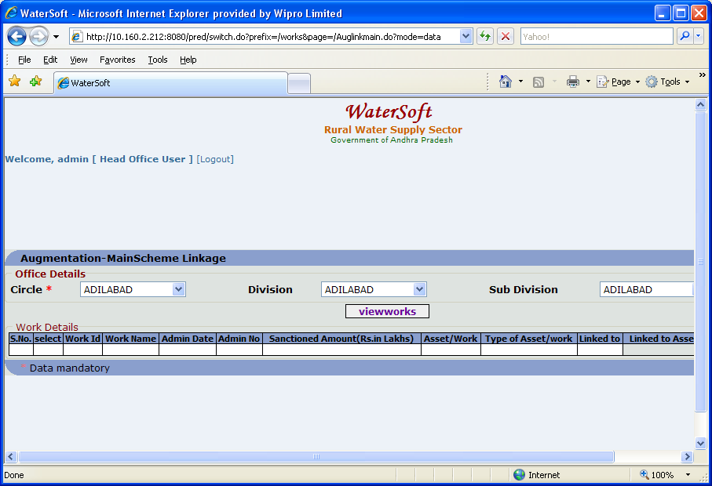
Figure. 11

View Works

- Select Circle ( For Eg. Adilabad )
- Select Division( For Eg. Adilabad ).
- Select Sub Division. ( For Eg. Adilabad ).
- Click ‘ View Works ‘ button.

Augmentation Work details are displayed as shown below:

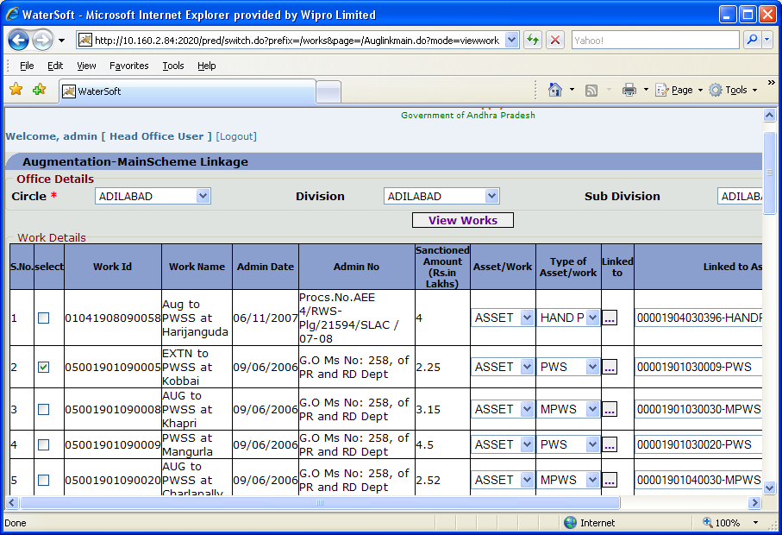
Figure. 12

Figure 13: (Contd. of Figure 12).
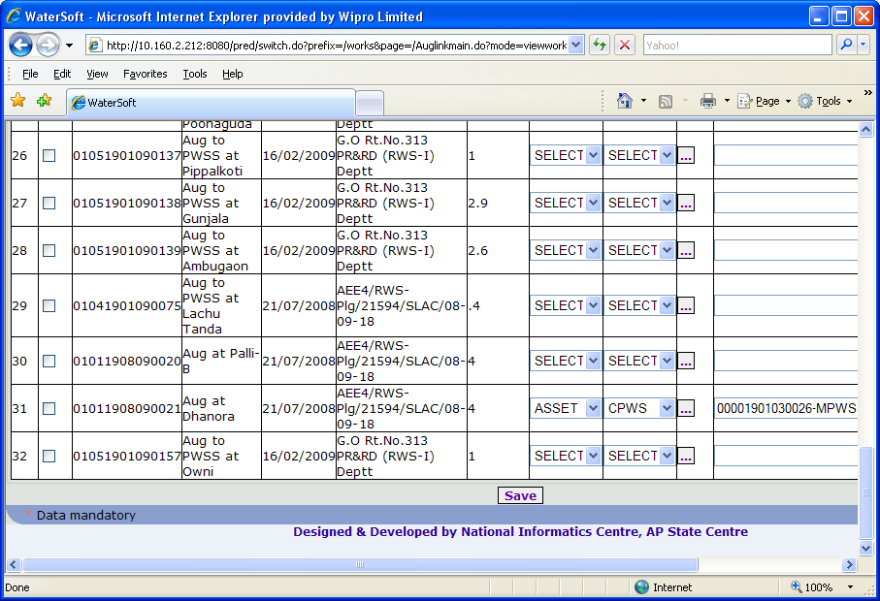
Figure 13.

Save
- Select Asset / Work. ( For Eg. Asset ).
- Select Type of Asset / Work. ( For Eg. PWS ).
- Select Aug. Works to link to Main Schemes. ( By selecting check box).
- Click ‘Linked to’ button. ( Figure 14. )

Main Schemes are displayed.
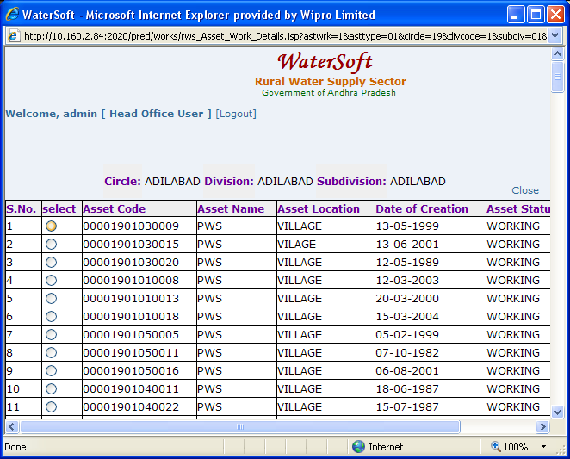
Figure 14.

Note VII:- Select any ‘ Main Scheme ‘ to link with selected Augmentation Work .

- Click ‘ Save ‘ button ( In Figure 13.)

WorkFlow - > Works Monitoring - > Revised Administrative Sanction

Revised Administrative Sanction

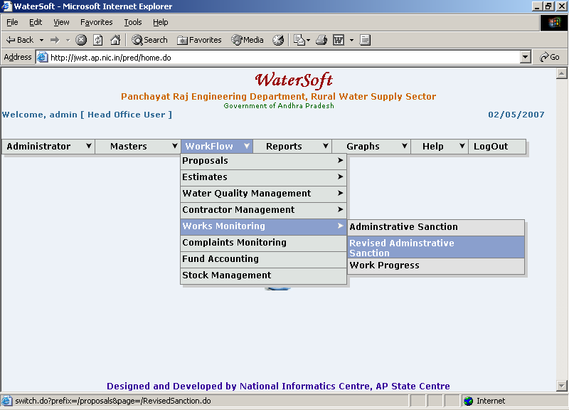
Figure. 15

Revised Sanction Form

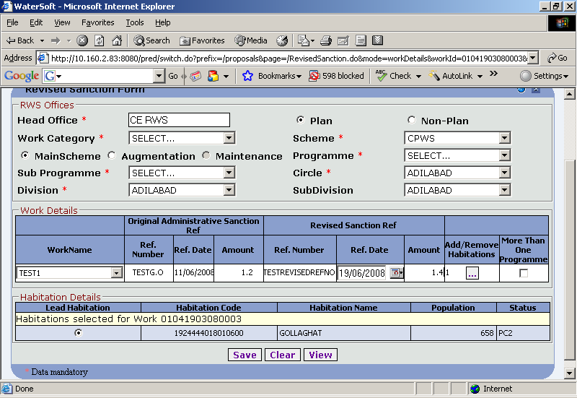
Figure 16.

View /Save

- Head Office is fixed .
- Select Plan or Non – Plan.
- Select Main Stream , Augmentation( For Plan).
- Select Maintenance ( For Non-Plan ).
- Select Programme.
- Select Sub Programme.
- Select Circle (fixed based on Login).
- Select Division.
- Select Sub Division (Optional)

Note VIII : This information is required either to Save a New Revised Administrative Sanctioned Work or to View /Modify Existing Revised Administrative Works.

Save

- Select Work Name.

For Original Administrative Sanction Ref

- Ref. Number is displayed automatically from Administrative Sanction
- Ref. Date is displayed automatically from Administrative Sanction
- Amount is displayed automatically from Administrative Sanction
- Enter Ref. Number for Revised Administrative Sanction(For Revised Sanction Ref)
- Select Ref.Date for Revised Administrative Sanction ( For Revised Sanction Ref ).
- Enter Amount for Revised Administrative Sanction(For Revised Sanction Ref)
- Select Add/Remove Habitations.
- Select More Than One Programme.
- Click ‘ Save’ button to save the Revised Sanction Works.

Note IX:- To Select Add/Remove Habitations – Select ‘Mandal’ → Click ‘Next’ button→ Habitations are displayed. Select ‘Habitations’ → Click ‘Add button’ .
Press ‘OK’ wherever required.
(The screen shots are displayed figure 17 & 18 … explain the process

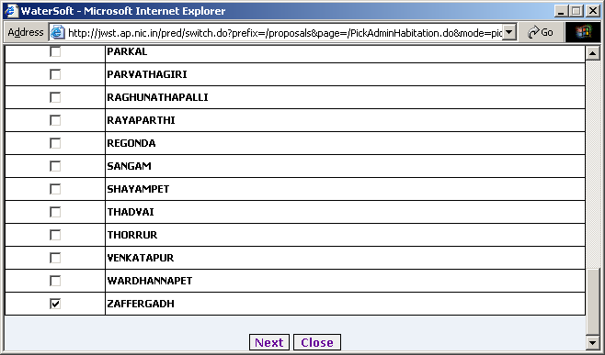
Figure. 17

Next
- Click ‘ Next’ button.

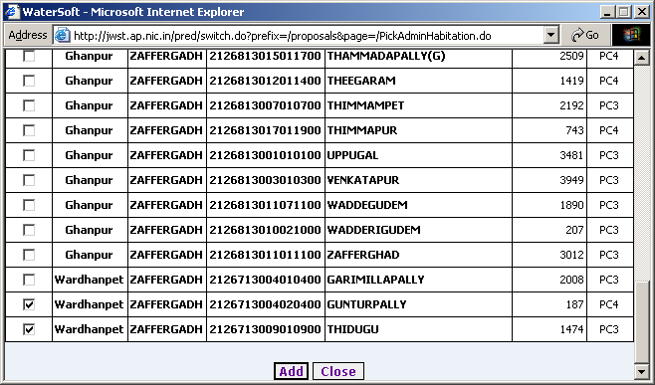
Figure 18.

Add

- Select Habitations.
- Click ‘Add’ button.

Clear button

- Click ‘Clear’ to clear Form

View
- Click ‘View’ to View Revised Administrative Sanctioned Works.

Revised Sanction List

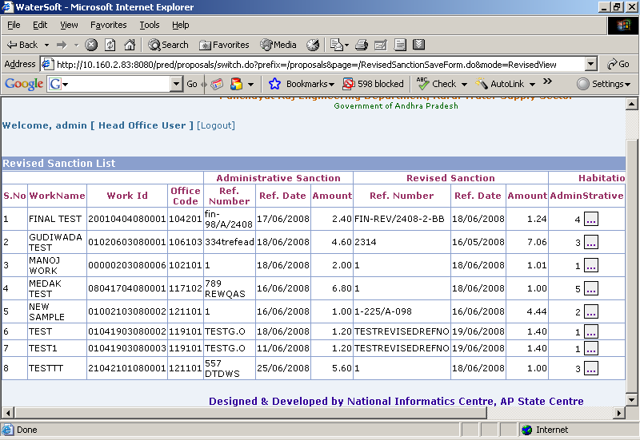
Figure. 19

Revised Sanction List

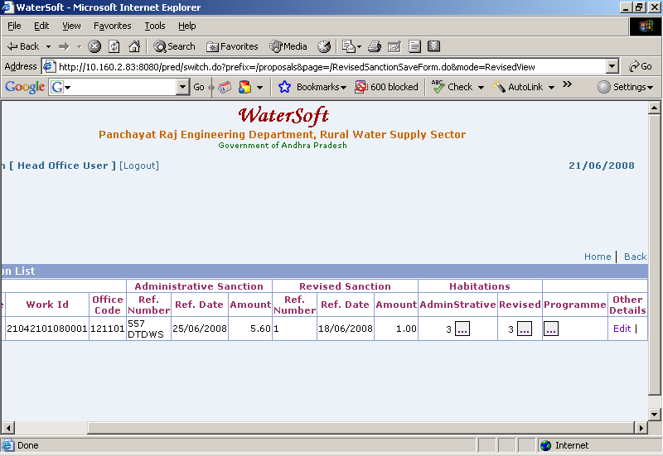
Figure 20.

Note X:-In Action – Select ‘ Edit ‘ to make Modifications - Revised Administrative Sanction Form is displayed.

In Action – Select ‘ Delete ’ to Delete Revised Administrative Sanctioned Works – This is a privileged option Enabled only for Selected User Logins.

For Entering the Revised Administrative Works which are Sanctioned under More than One Programme.

Update

- WorkName is Fixed
- WorkId is Fixed
- Select Programme
- Select Sub Programme
- Enter Sanctioned Amount
- Enter Admin Sanc No.
- Enter Admin Sanc Date
- Enter Revised Sanc No.
- Enter Revised Sanction Amount
- Enter Revised Sanction Date
- Click ‘Update’ to update Programmes

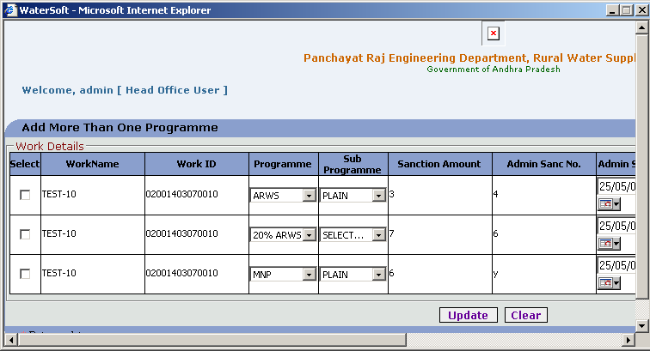
Figure. 21

Clear

- Click ‘Clear’ button

WorkFlow - > Works Monitoring - > Work Progress

Work Progress

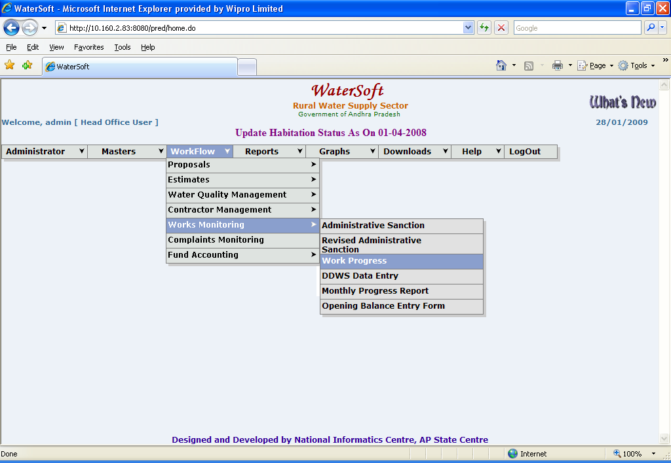
Figure. 22

Work Status Form

- Select Circle( Fixed ).
- Select Division.
- Select SubDivision.
- Select Plan /Non Plan
- Select MainScheme/Augmentation/Maintenance
- Select Work Category. ( Projects , Normal , District Level ).
- Select Programme.(Optional)
- Select SubProgramme. (Optional)
- Select Work.
- Scheme is displayed automatically.
- Select Work Stages

Work Stages

- Admin Sanction
- Technical Sanction
- Source Identification
- Contractor Management
- Program Schedule
- Work Expenditure
- Work Completion
- DDWS Data Entry

Work Status
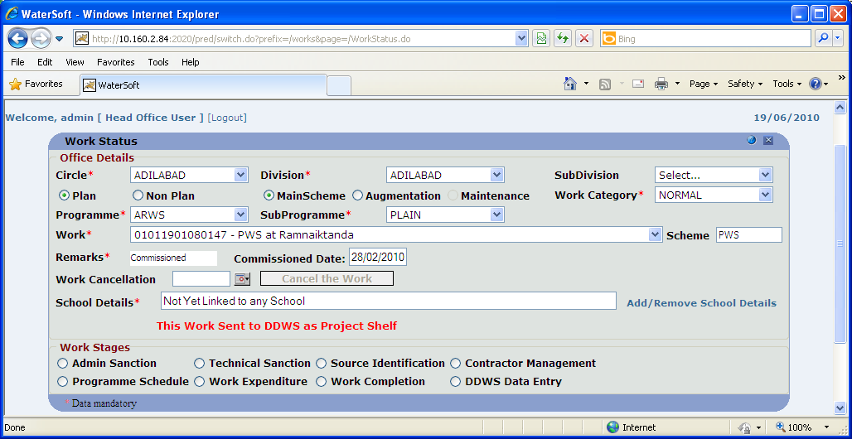
Figure. 23

Some important points for entering data for Work Progress

1.If work is sent to DDWS as ‘ Project Shelf ’ – the message is displayed as ‘ This Work Sent to DDWS as Project Shelf.

2. If work is not sent to DDWS as ‘ Project Shelf ’ – the message displayed as ‘ This Work Not Yet sent to DDWS as Project Shelf ’.

1.’ Technical Sanction Date ’ Should be greater than or equal to ‘ Administrative Sanction Date ‘.

2.If a work is not ‘ Technically Sanctioned ‘ there is no further navigation to ‘ Contractor Management ’.

3.’ Agreement Date ’ should be greater than or equal to ‘ Technical sanction Date ’.

4.’ Site Handing over Date ’ Should be greater or equal to ‘ Agreement Date ‘.
5.’ Stipulated Date of Completion ’ is automatically generated based on agreement date plus agreement duration in months.

6.’ Actual Date of Completion ‘ should be greater than or equal to ‘ start Date ‘.
7.’ Date of Commissioning’ should be greater than or equal to ‘ Actual date of Completion ‘.

8. ’ No Modifications ( Changes ) ‘ to any phase is alolowed -- if the work is ‘ Financially Completed i.e., f Financial Date of Completion is entered in work completion phase.

9. Cannot ‘ Edit ‘ Work Expenditure phase , Work Completion phase until the Work is Financially Completed.

10.Cannot Cancel the work if the work is already Completed(either Physically or Financially) or Commissioned and Work Cancellation done by Head Office only .

11.First enter for data for Technical Sanction ->Then enter data for Contractor Management phase
->Then Programme Schedule data can be entered->Later enter data for Expenditure & Work completion phases.

12.Source Identification is independent phase even the work is not Technically sanctioned then also enter the data for Source Identification.

13.Based on Work Start Date that is entered in Programme schedule, Financial Years are displayed in Work Expenditure phase ( For eg: work start date entered as 22/06/2006 then financial years starts from 2006-2007 – 2010-2011(current financial year) .

Series of steps ( 1…5) Explain the process of Linking Schools to Works .

Following Screen shots (Fig 24 – Fig 29. ) show how to link

Step 1

If the School is not linked with any work – message displayed as ‘ Not Yet Linked to any School ‘. ( Figure 24 ).

Step 2

Click on ‘ Add / Remove School Details ‘ . ( Figure 24 ).

Step 3

Select Mandals -> Click ‘ Get Habitations ’ button -> Habitations are displayed->’ Select all Habitations at a time ‘ -> Click ‘ Get Schools ‘ button. (Figure 25. & Figure 26.).

Step 4

Schools List for the Above Selected Habs are displayed ( Figure 27.) -> Select All the Schools at Once -> Click ‘ Add the Selected school this Work ‘ button. (Figure 27.)

Step 5

Now Work Already Linked to School(s)( Figure 28. ) – Click here to view School(s) (Figure 29.)

Add/Remove School Details

- Click ‘ Add/Remove School Details ‘ button

Figure 24.

Select Mandals -> Click ‘ Get Habitations ‘ button -> Habitations are displayed-> Select the Habitations -> Click ‘ Get Schools ‘ button

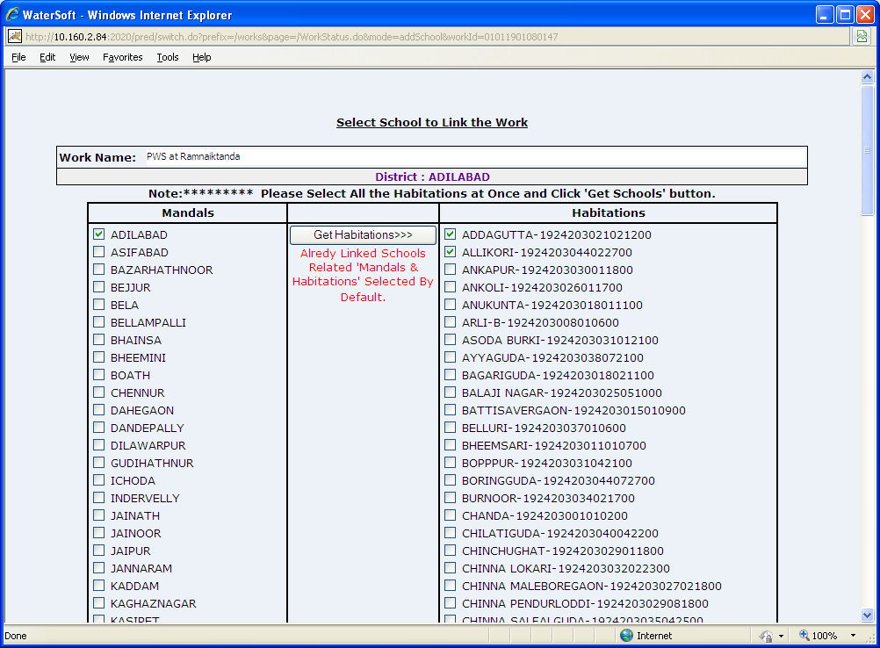
Figure 25.

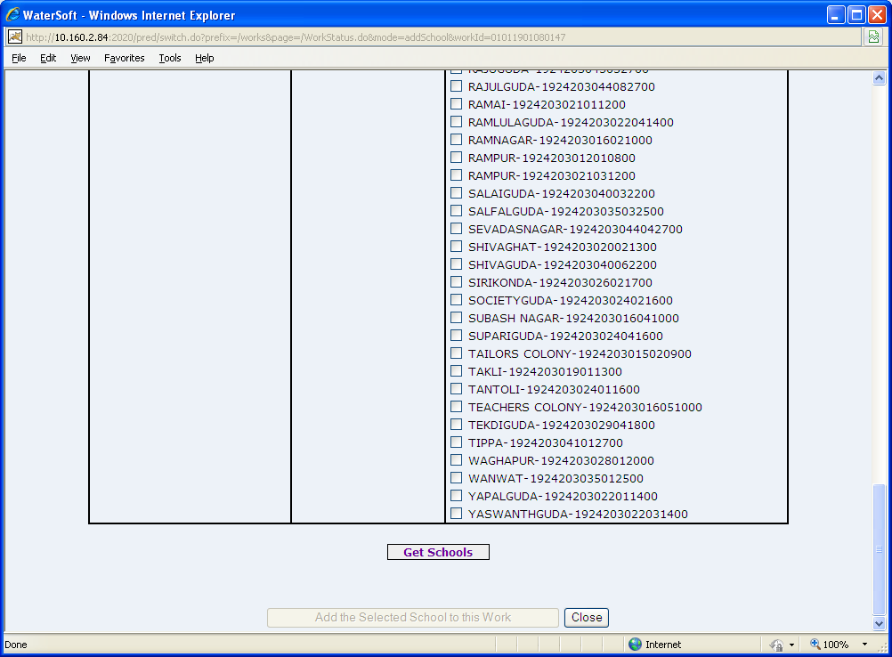
Figure 26.

List of Schools are displayed -> Select all the Schools -> Click ‘ Add the Selected School to this Work ‘ button.

Add the Selected School to this Work

- Click ‘ Add the Selected School to this Work ‘ button.

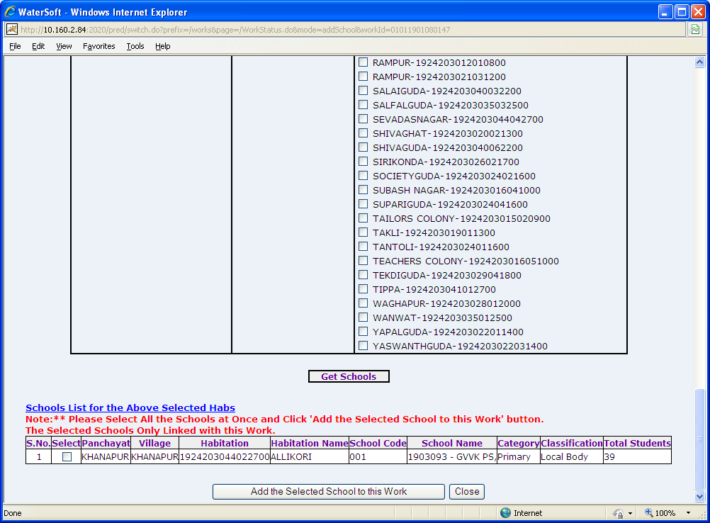
Figure 27.

Work Already Linked to School(s)-Click here to View School(s)

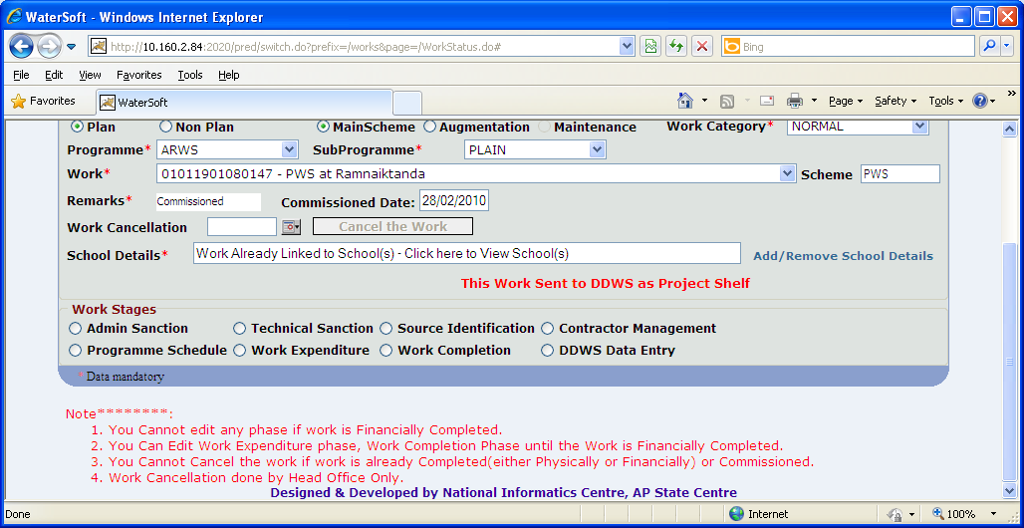
Figure 28.

The Linked Schools with this Work are displayed

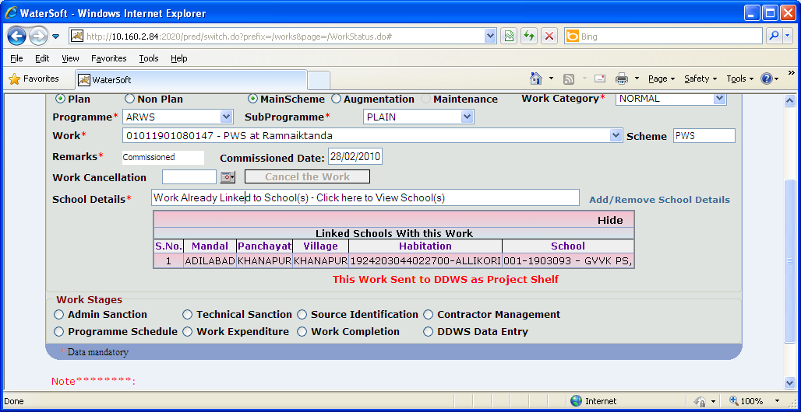
Figure 29.

Admin Sanction

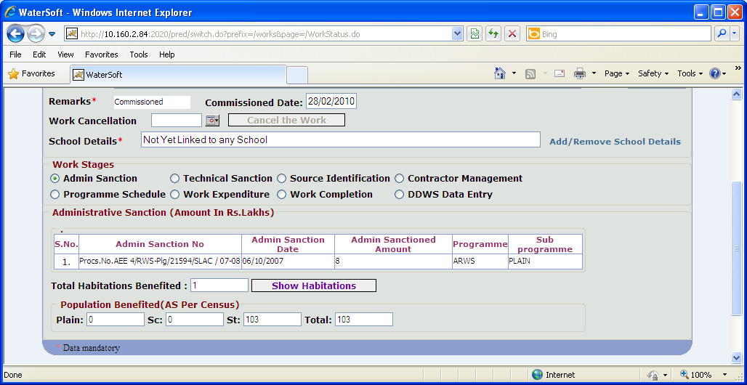
Figure. 30

For Administrative Sanction, if Revised Administrative Sanctions are present – details are displayed

Technical Sanction

Update

- Enter Technical Sanction Amount (Rs. In lakhs)
- Enter Technical Sanction Number
- Select Technical Sanction Date
- Select SSR Year. ( For Eg. 2008 – 2009 ).
- Total Habitations Benefited are displayed automatically
- Click ‘Update’ to save data.

Note XI:- Technical Sanction Date Should be greater than or equal to Administrative Sanction Date.

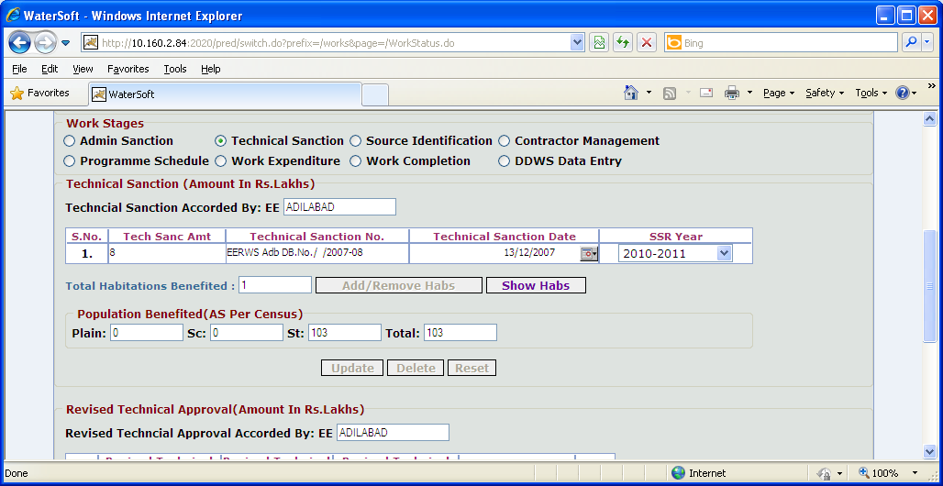
Figure. 31

Delete

- Click ‘ Delete ’ to delete technical sanction details.

Reset

- Click ‘Reset’ to reset data

Revised Technical Sanction
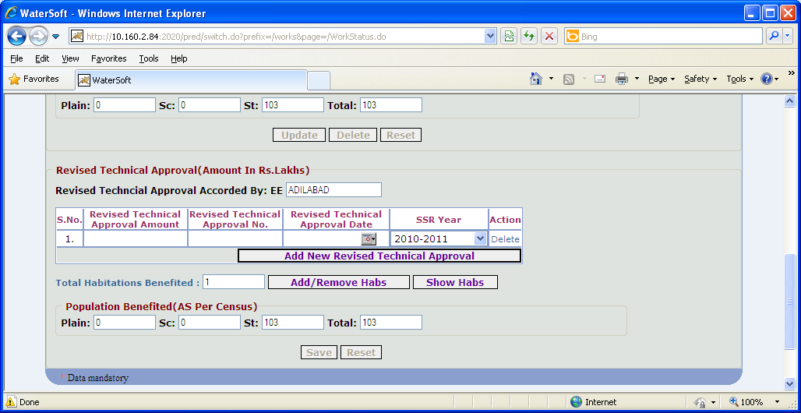
Figure 32

Save
- Enter Technical Approval Amount(Rs. In lakhs)
- Enter Revised Tech Sanction No.
- Select Revised Tech Sanction Date.
- Select SSR Year.
- Total Habitations Benefited are displayed automatically
- Click ‘Save’ button

Note XII:-In Action – Click ‘Delete’ button to delete Revised Technical Sanction Approval.

Reset
- Click ‘Reset’ button to Reset the data.

Source Identification

Save

- Select Mandal
- Select Source Habitation
- Select Source Type ( For Eg. SubSurface Source , Surface Source , Rain Water , Traditional , Others ).
- Select SubSource Type ( For Eg. Borewell , Rotary Borewell ).
- Select Existing Source or New Source.

Existing Source

- Select Source.( For Eg. 0302631003040100001HP003 – bordas house)
- Source Name is Fixed.

New Source

- Source is auto generated ( Depending on Selection ).
- Enter Source Name.

- Enter Site/Source Identified By. ( Enter Employee Code )
- Enter Source Site Handing Over Date.
- Enter Recommendations By Geologist.
- Click ‘Save’ to save data.

Note XIII:-In Source Identification Mandatory Fields/Columns:-

Source Name is compulsory column/Field after entering data then record will be saved in database.

In Source Identification Optional Fields/Columns:-

Site/Source Identified By , Source Site Handing Over Date , Recommendations By Geologist

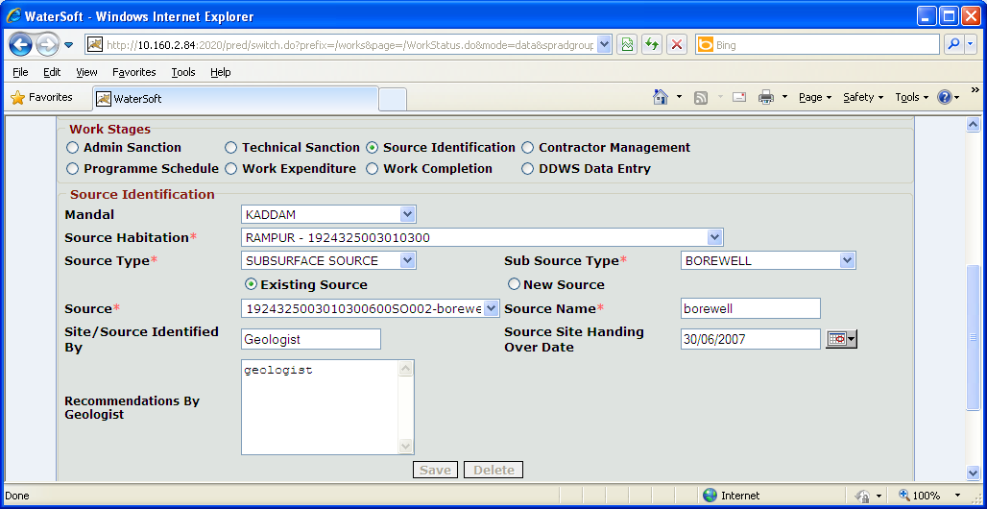
Figure. 33

Delete

- Click ‘Delete’ to delete data

Note XIV:-If a work is not technically sanctioned there is no further navigation to Contractor Management.

Contractor Management

Save

- Select Work Entrustment. (For Eg. Tender, Nomination).
- Enter Tender Notification Id (mandatory)
- Enter Tender Cost
- Enter Tender Percentage (For Less , Excess , Estimate Rates ).
- Enter Contractor/Firm Name
- Enter Tender Accepted Date
- Enter LOA Issued on Date
- Select Tender Committee or Competent Authority

Agreement Details

- Enter Agreement Reference No
- Enter Agreement Date
- Enter Agreement Duration in months
- Enter Agreement Value (Rs. In Lakhs)
- Enter Site Handing over Date
- Enter Stipulated Date of Completion

Note XV:- If Tender Percentage is selected as ’ Estimated Rates ‘ then Tender Percentage should not be entered.
Note XVI:- Agreement Date should be greater than or equal to Technical sanction Date.
Note XVII:- Site Handing over Date Should be greater or equal to Agreement Date
Note XVIII:- Stipulated Date of Completion should be greater than or equal to Site Handing over Date

Note XIX:- For Entering ‘Mile Stones’ Click ‘AddNew’ button
Note XX:- For Removing Mile Stones Click ‘Remove’ button

- Select Mile Stone
- Select Stage
- Select Target Date
- Enter %Completed
- Click ‘Save’ to save data

Delete

- Click on ‘Delete’ button

Contractor Management

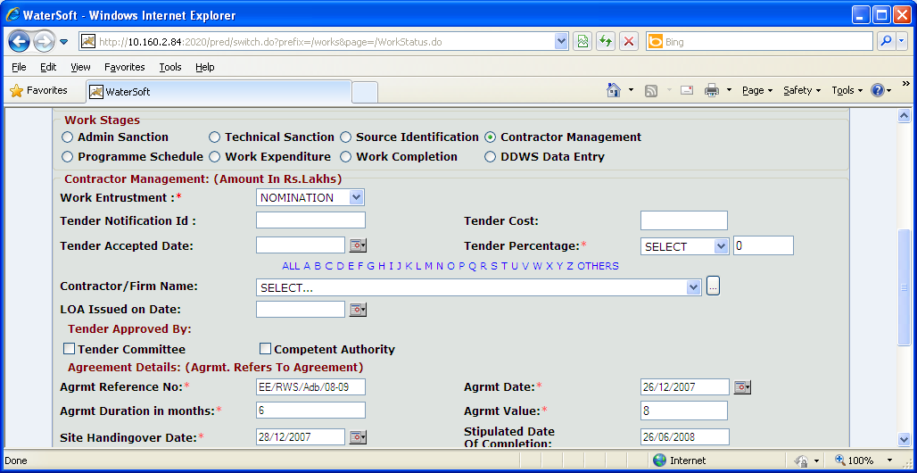
Figure. 34

Note XXI:-If Work Category selected as ‘Projects’ all the Contractors covered under ‘PROJECTS’ are listed in Contractor/Firm Name combo box.

Note XXII:- If Work Category selected as ‘Normal’ all the Contractors covered under ‘NORMAL’ for the selected DISTRICT are displayed in Contractor/Firm Name combo box.
Note XXIII:-If Work Category selected as ‘District Level’ – all the Contractors covered under ‘DISTRICT LEVEL’ for the selected DISTRICT are displayed in Contractor/Firm Name combo box.

Note XXIV:-Select option ‘ All’ – Contractors Names starting with A to Z are displayed in Contractor/Firm Name combo box.
Note XXV:-Select option Alphabets ‘ A – Z’ – Contractor Names starting with selected Alphabet are displayed in Contractor/Firm Name combo box.

Note XXVI:- To Enter ‘ Contractor Details ’ Click ‘ button ’ that is placed beside field Contractor/Firm Name combo box.

Once ‘ Name/Company ‘ data is entered and ‘ code ’ is auto generated record will be saved in the database.

Mandatory Fields/Columns in Contractor Entry Form:-

Name/Company

Optional Fields/Columns in Contractor Entry Form:-

Class, Rating, Contractor Contact details, Registration Details, Other Details, project details.

Save

- Enter Name/Company ( Mandatory Field ).
- Select Class. ( For Eg Super Class , I , II )
- Select Rating ( For Eg. Active , BackListed ).
- Enter Contractor Contact details.( Hno/Street , Area , City , Pincode ).
- Enter Registration details. ( Regn No , Registered At , Registration Dt , Validity From , Validity To )
- Enter Other details. ( Pan No , Tin No , Vat/ Cst No. )
- Enter Project details ( Projects Executed , Projects Completed in Time , Projects Abondoned , Projects in Hand , No. of Supplementary Agreement , No of Times Penalised , Specialised in , Projects Completed in Last Five Years , No. of EOAT’s , Remarks )
- Click ‘Save’ button.

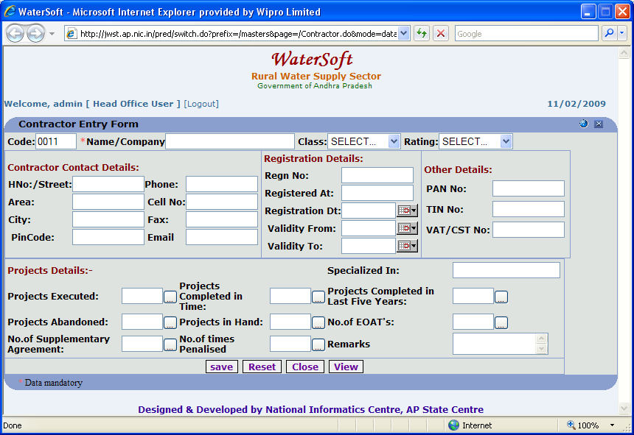
Figure. 35

Reset
- Click ‘Reset’ button.

View
- Click ‘View’ button.

Close
- Click ‘Close’ button.

Program Schedule

Save

- Select Sub Division Assigned to
- Enter Engineers Assigned to
- Select Work Start Date
- Click ‘Save’ button

Program Schedule

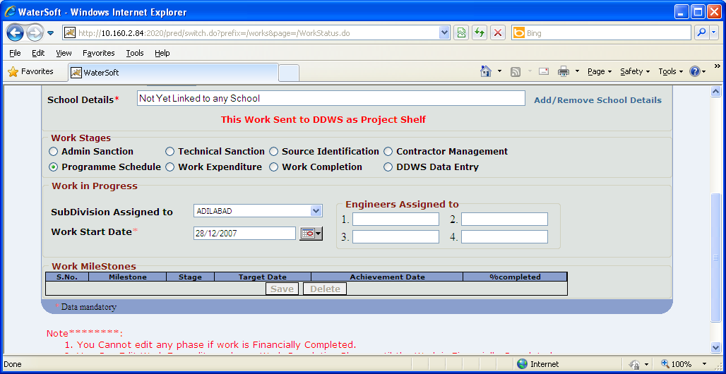
Figure 36

Delete

- Click ‘Delete’ button

Work Expenditure

Save

- Enter Expenditure Upto Last Financial Year for each Programme (2008 – 09) (for eg: if selected year is 2009-10) (in Rs Lakhs).
- Select Financial Year (For Eg. 2009 – 10).

Expenditure During the Selected Financial Year

- Select Programme.
- Select Month.
- Enter Upto the Previous Month
- Enter During the Month

Aggregate Expenditure

- Enter Value of Work done but not Paid
- Total Expenditure is displayed automatically.
- Click ‘Save’ to save data.

Note XXVII:-If Selected Month as June and Expenditure details are given and month June cannot be selected in next attempt ( i.e., by clicking on ‘ AddNew ’ button ) message displayed as Selection Already Exists.

Note XXVIII:-In current Financial Year i.e., 2009 – 10 , Expenditure details may be entered till Present month only.
(For Eg. Suppose Current Month is June and if July Month is selected this selection is not allowed ).
Message displayed as Selection of Month greater than current Month of Financial Year 2009-10 is not allowed.

Note XXIX:-In current Financial Year i.e., 2009 – 10 , Expenditure details cannot be entered for previous month.
(For Eg. Suppose Month selected as May and expenditure details are already entered. In next attempt ( by clicking on ‘AddNew’ button) Month April is selected , this going back of selecting previous month is not allowed.
Message displayed as Selection of Month less than already Existing Month of Financial Year is not allowed.

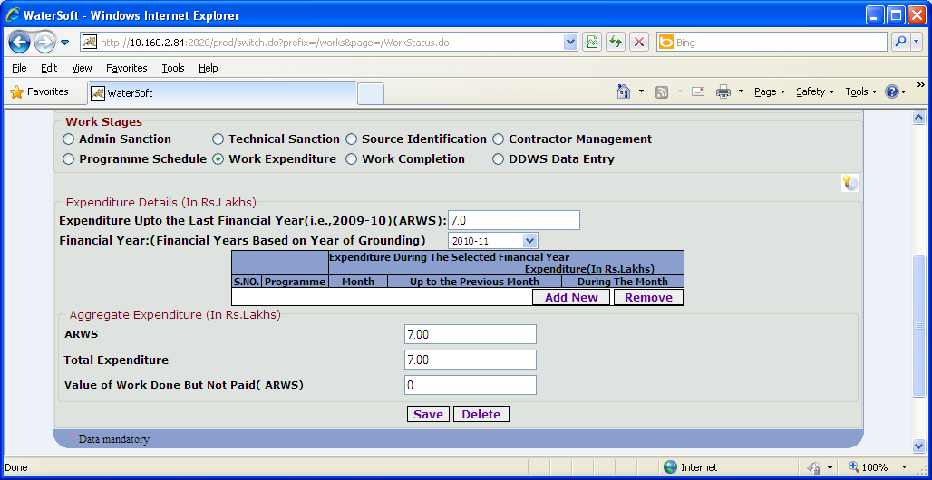
Figure. 37

AddNew

- Click ‘ Add New ‘ button to enter expenditure details for next month.

Remove

- Click ‘ Remove ‘ button to remove expenditure details.

Delete

- Click ‘ Delete ‘ button.

Work Completion

Save

- Start Date , Stipulated Date Of Completion are automatically displayed.
- Select Actual Date of Completion.
- Select Financial Date of Completion.
- Select Date of Commissioning.
- Habitations Benefited (No. ) is displayed automatically.
- Click ‘ Save ‘ button.

Note XXX :- Actual Date of Completion should be greater than or equal to start Date.
Note XXXI :- Date of Commissioning should be greater than or equal to Actual date of Completion.

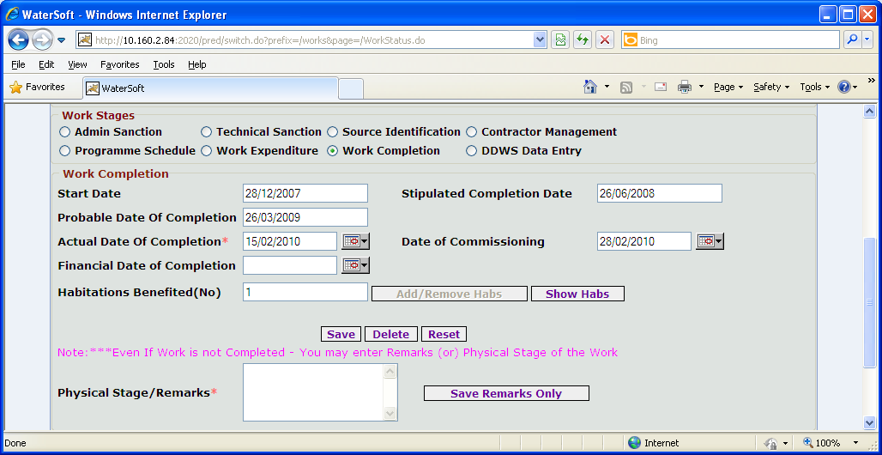
Figure. 38

Note XXXII:- Even If the work is not Completed enter Physical Stage/Remarks.

Save Remarks Only

- Click ‘ Save Remarks Only ’ button.

Reset

- Click ‘ Reset ’ button.

Delete
- Click ‘ Delete ’ button.

DDWS DATA ENTRY

Submit

- Select Approved Under ( Eg. Normal Coverage , Submission ( Water Quality ) , Sustainability ).

If Normal Coverage is Selected

- Estimate Capital Cost is auto generated.(Data carried from Administrative sanction)
- Enter GOI Share. ( In Rs. Lakhs )
- Enter State/Other Share ( In Rs. Lakhs )
- Enter Community Contribution Deposited ( Cash + Kind + Labour ).
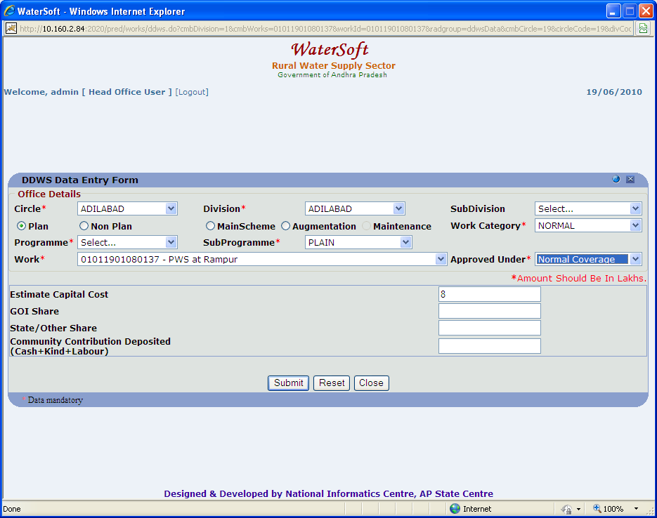

Figure . 39

If Submission (Water Quality) is selected

- Select Contamination Tackled ( Physical , Bacteriological , Chemical , Others )

Under Physical

- Select Turbidity

Under Chemical

- Select Arsenic or Iron or Nitrate or Calcium or Manganese or Salinity , Hardness or Alkalinity or Fluoride or Chloride or sulphates or Magnesium or Copper or TDS or Residual Chlorine

Under Bacteriological

- Select Faecal
- Select ColiForm

Under Others

- Select pH

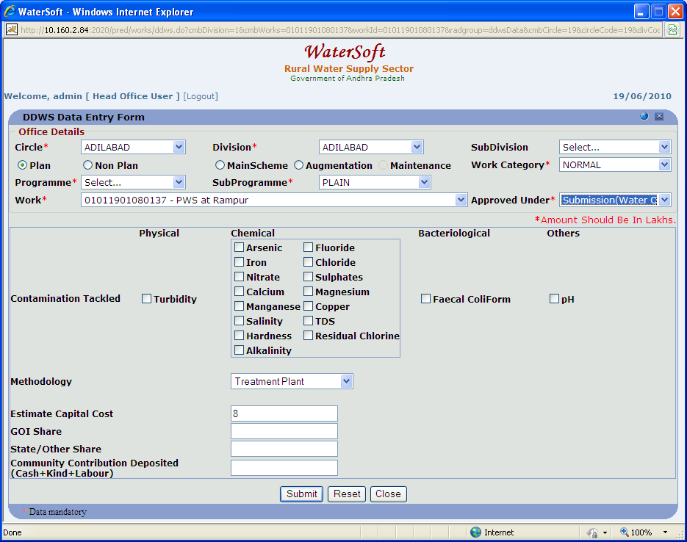
Figure 40

- Select Methodology ( For Eg. Treatment Plant , Alternative Safe Source ).
- Enter Estimate Capital Cost. ( In Rs. Lakhs )
- Enter GOI Share. ( In Rs. Lakhs )
- Enter State/Other Share ( In Rs. Lakhs )
- Enter Community Contribution Deposited ( Cash + Kind + Labour ).

If Sustainability is Selected

- Estimate Capital Cost is autogenerated.(Data carried from Administrative sanction or from Revised Administrative sanction)
- Enter GOI Share. ( In Rs. Lakhs )
- Enter State/Other Share ( In Rs. Lakhs )
- Enter Community Contribution Deposited ( Cash + Kind + Labour ).
- Click ‘ Submit ‘ button.

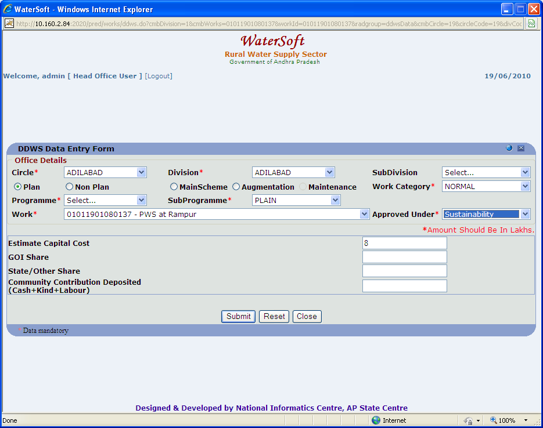
Figure 41

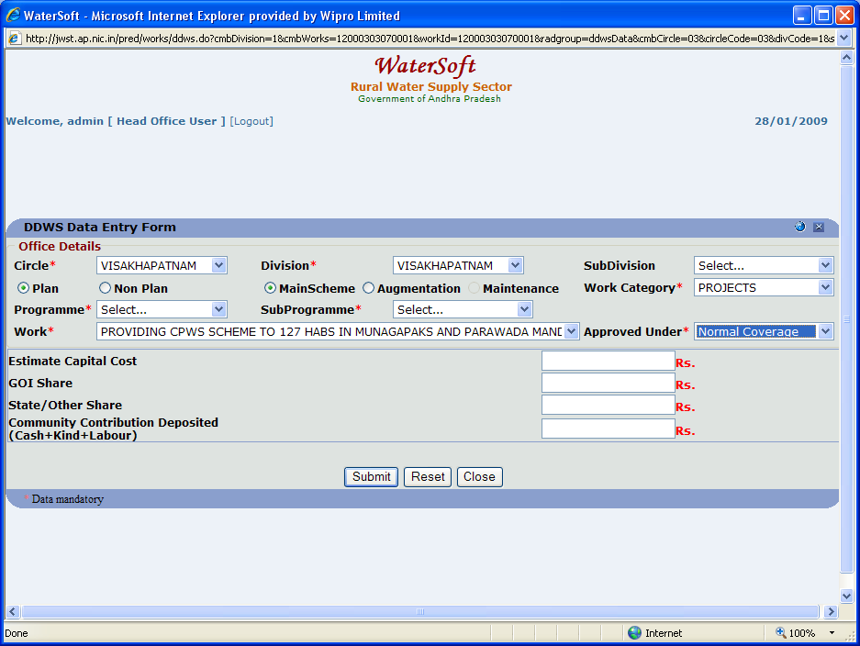
Figure 42

Reset

- Click ‘ Reset ‘ button.

Close

- Click ‘Close‘ button.

Work Flow->Works Monitoring->Update Action Plan

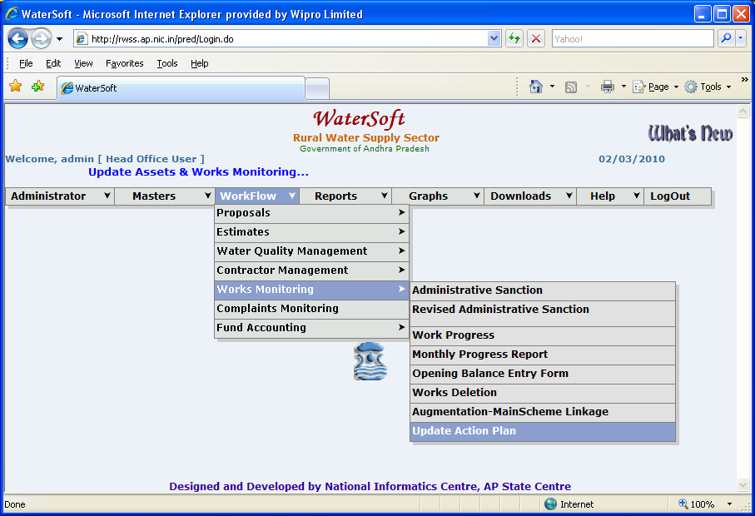
Figure 43

View Works

- Select Circle. ( For Eg. Adilabad).
- Select Division. ( For Eg. Adilabad).
- Select Work Category. ( For Eg. Normal ).
- Click ‘ View Works ’ button.

Works details are displayed as shown below.
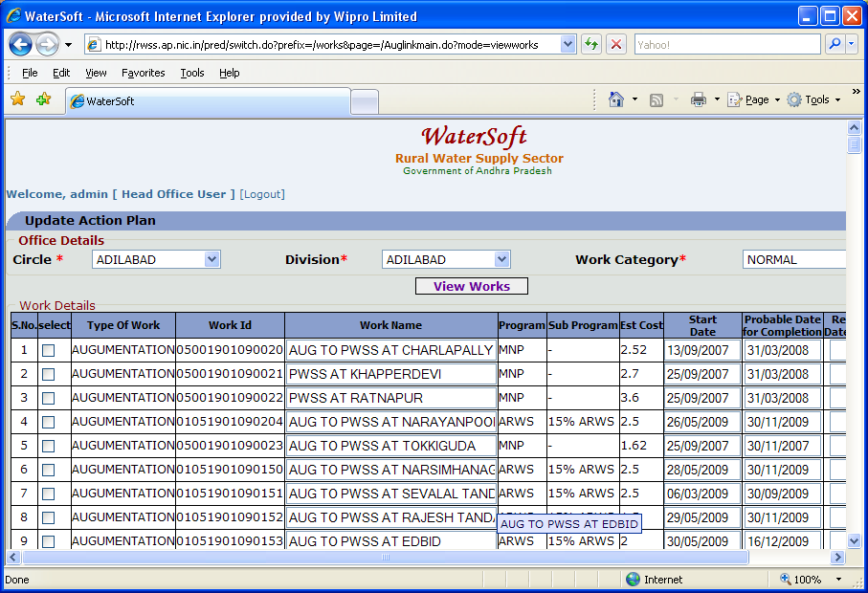
Figure 44

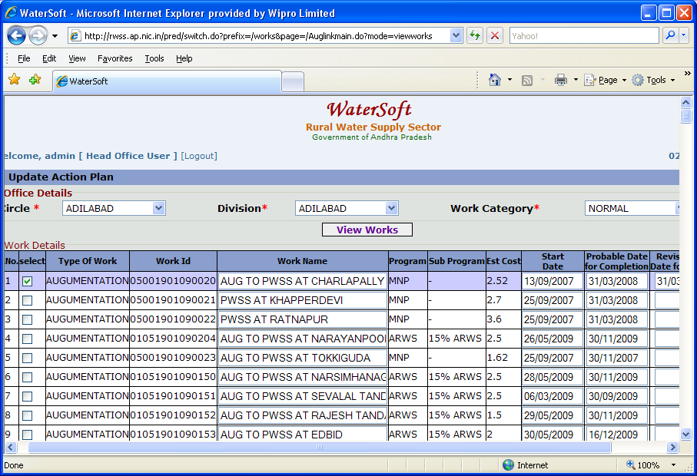
Figure 45

Figure 46: (Contd. of Figure 45).

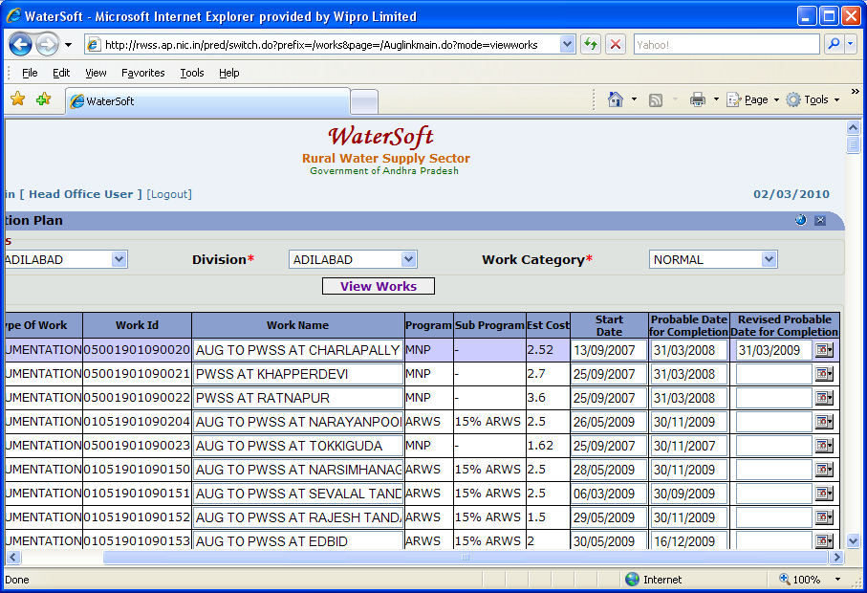
Figure 46

Update Works
- Select Work .( By selecting Check Box ).
- Select Revised Probable Date of Completion.
- Click ‘ Update Works ’ button.

Figure 41: (Contd. of Figure 40).
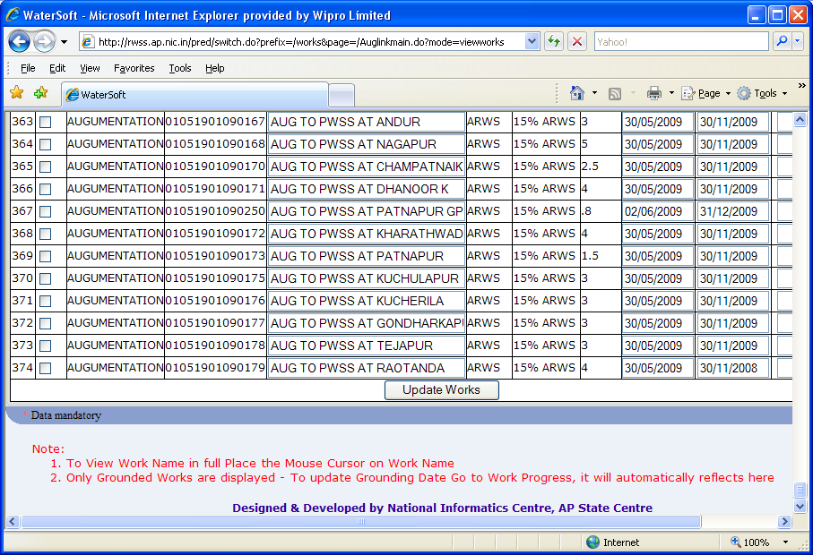
Figure 47

