USER MANUAL FOR ASSET MANAGEMENT

WaterSoft

(For the Department of Panchayati Raj & Engineering Department, Rural Water Supply Sector, Govt. of AP)

National Informatics Centre
Department of Information Technology
Ministry of Communications and Information Technology
Government of India
WebSite : www.ap.nic.in

PREPARED BY :

PROJECT TEAM ,
NIC APSC,
HYDERABAD.

REVIEWED BY:

HEAD OF THE DEPARTMENT,
NIC APSC,
HYDERABAD.

APPROVED BY :

STATE INFORMATICS OFFICER
NIC APSC,
HYDERABAD.

Amendment Log
Version Number | Date | Change Number | Brief Description | Sections Changed
1.0 | 1.1.2007 | - | First Release
1.1 | 20.3.2007 | - | Second  Release | Changes in all Modules based on User Requirements
1.2 | 24.4.2009 | - | Third  Release | Changes in Asset Sub Components based on User Requirements
1.3 | 15.7.2009 | - | Fourth Release | Changes in Asset Sub Components based on User Requirements.
1.4 | 18.9.2009 | - | Fifth Release | Addition of Asset Type eg: direct pumping etc based on User Requirements.
1.5 | 30.10.2009 | - | Sixth  Release | Addition of Remarks Label in Asset Entry Form based on User Requirements
1.6 | 20.11.2009 | - | Seventh Release | Addition of Water Supply(Yield) field for (Direct pumping) in Asset Entry Form based on User Requirements.
1.7 | 21.12.2009 | - | Eighth  Release | Changes in Navigation and Data Retrieval in ‘ View ’ button based upon on User Requirements.
1.8 | 07.01.2010 | - | Ninth  Release | Addition of ‘View and Update Program’ button based on User Requirements.
1.9 | 05.02.2010 | - | Tenth  Release | Addition of new feature in Habitation Linkage based on User Requirements.
2.0 | 23.01.2012 | - | Eleventh  Release | Addition of Latitude,Longitude,Elevation and Waypoint for Main Asset and for All  SubComponents

Sl No | CONTENTS | Page No
1 | Common Operations in the Software | 5
2 | Asset Master | 6 – 8
3 | Asset Entry Form | 9 – 21
4 | Habitation Linkage | 22 – 25
5 | Sources | 26 – 30
6 | Headworks | 31 – 55
7 | PipeLine | 56 – 66
8 | Sr.Reservoirs | 67 – 83
9 | Others | 84 – 87
10 | Pumping | 88 – 89
11 | HandPumps | 90 – 92
12 | Open Wells | 93 – 95
13 | Ponds | 96 – 98
14 | Shallow Handpumps | 99 – 101
15 | Others | 102 – 104

Common Operations in the Software:

Click the button to close the Form.

 Click the button for online context help.

Home Click the button for Main Page.

Back Click the button for Previous page.

Print Click the button for Printable Version.

Excel Click the button for Excel Version.

Amount will be considered in Lakhs throughout the Software

Asset Master

Main menu - >Masters -> Asset ->Asset Master .
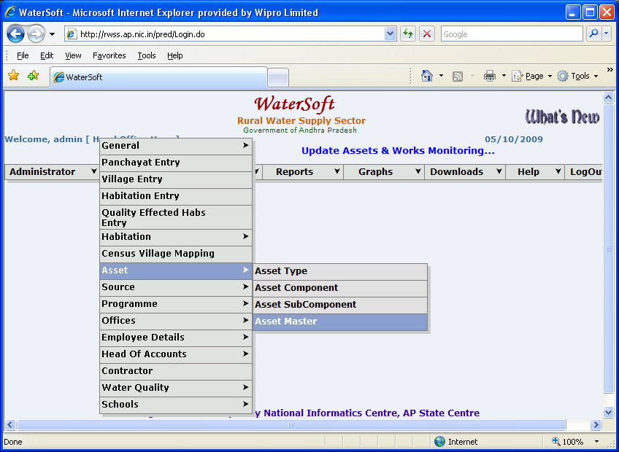
Figure 1.

Note:-

Steps to be followed for Existing Assets which were entered before 01/April/2009

Main Asset Types are as follows (PWS ,CPWS , MPWS, HANDPUMPS, DIRECT PUMPING, OPENWELLS, SHALLOW HANDPUMPS, OTHERS and PONDS)

Step 1 :

Select Circle->Select Division->Select SubDivision->Select Mandal->Select HabCode->Select Asset Type->Select Modify->Select AssetCode->Click ‘ View ’ button.

Step 2:
Asset details are displayed->Select an Asset->Click ‘ Edit ’ button

Step 3:

Enter data for Main Asset( Latitude ,Longitude ,Elevation ,Waypoint ) for Existing Assets and Click ‘ Save ’ button.

Step 4:Enter data for ( Latitude , Longitude, Elevation, Waypoint) for all Subcomponents under Main Asset.

The existing asset details are displayed and they can be modified and saved.
The various sub components of the assets are displayed along with their number against each of the sub component -> Click Here to enter details for SubComponents.

Note:- Asset Type selected as PWS , CPWS, MPWS

Update Latitude,Longitude,Elevation and Way point data in all Subcomponents below

- Service Reservoirs:-GLSR , GLBR , OHSR ,OHBR and CISTERNS

- Headworks:-SS Tank , SS Filters, RS Filters , RO Plants, Micro Filters

- Pumping :- Pumpsets

- Source :- SubSurface Source,Surface Source

Asset Type selected as DIRECT PUMPING

Update Latitude,Longitude,Elevation and Way point data in all Subcomponents below

- Pumping :- Pumpsets

- Source :- SubSurface Source,Surface Source

- Headworks:-SS Tank , SS Filters, RS Filters , RO Plants, Micro Filters

Asset Type selected as Handpumps

Update Latitude,Longitude,Elevation and Way point data in Borewell Subcomponents below

- Borewells

Asset Type selected as Open wells

Update Latitude,Longitude,Elevation and Way point data in Openwell Subcomponent below

- Open wells

Asset Type selected as Shallow Handpumps

Update Latitude,Longitude,Elevation and Way point data in ShallowHanpumps Subcomponent below

- Shallow Handpumps

Note:-

Similar process is followed for an Commissioned work which is converted into an Asset.

Note:-Fields Marked with ‘ * ‘ are Mandatory Fields . Data should be entered or selected for Mandatory Fields .

ASSET ENTRY FORM
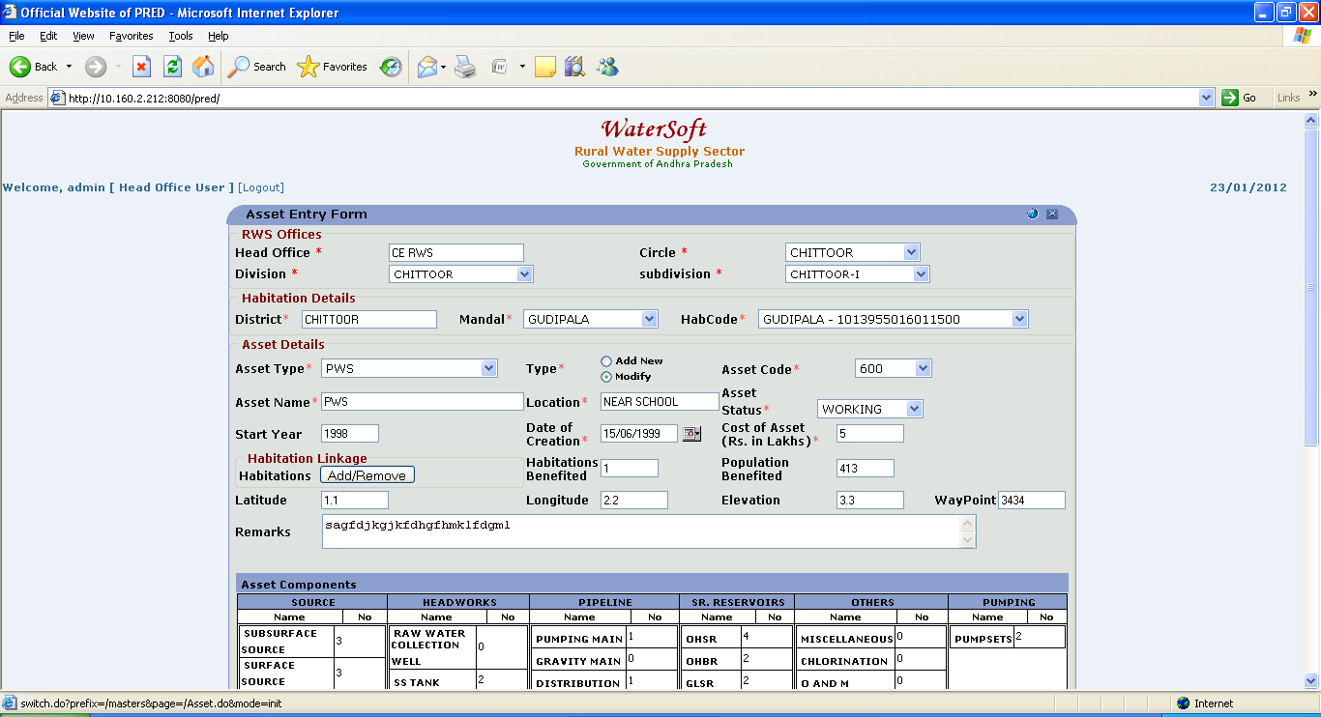
Figure 2.

Note:-The following screen shot Fig. 3.. is continuation of Fig 2.

ASSET ENTRY FORM
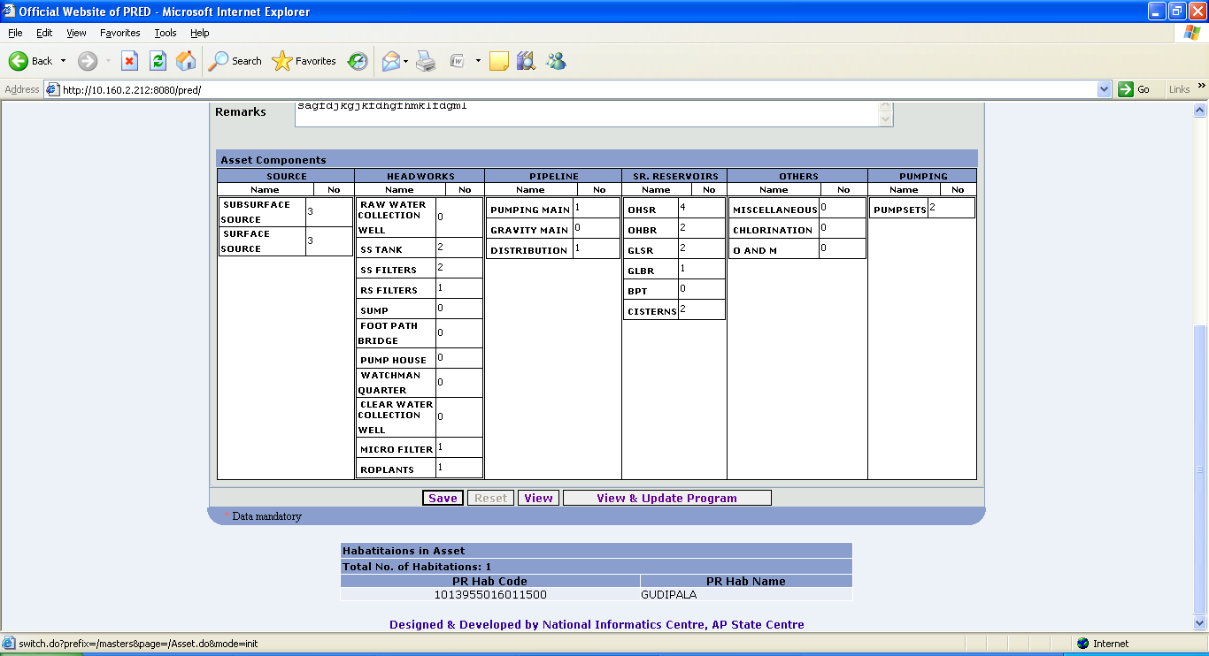
Figure 3.

- Head Office, Circle, Division, Sub Division are fixed based on login.
- Select Mandal.
- Select Panchayat.
- Select Village.
- Select Habitation Code.
- Select Asset Type (PWS, CPWS, HANDPUMPS, PONDS, SHALLOWHANDPUMPS, OTHERS, DIRECT PUMPING).

IF Asset Type is Selected as DIRECT PUMPING

The Components of DIRECT PUMPING are:

- Source.
- Headworks.
- PipeLine.
- Others.
- Pumping.

Note:-The following screen shot (Figure 4..) shows the components of DIRECT PUMPING

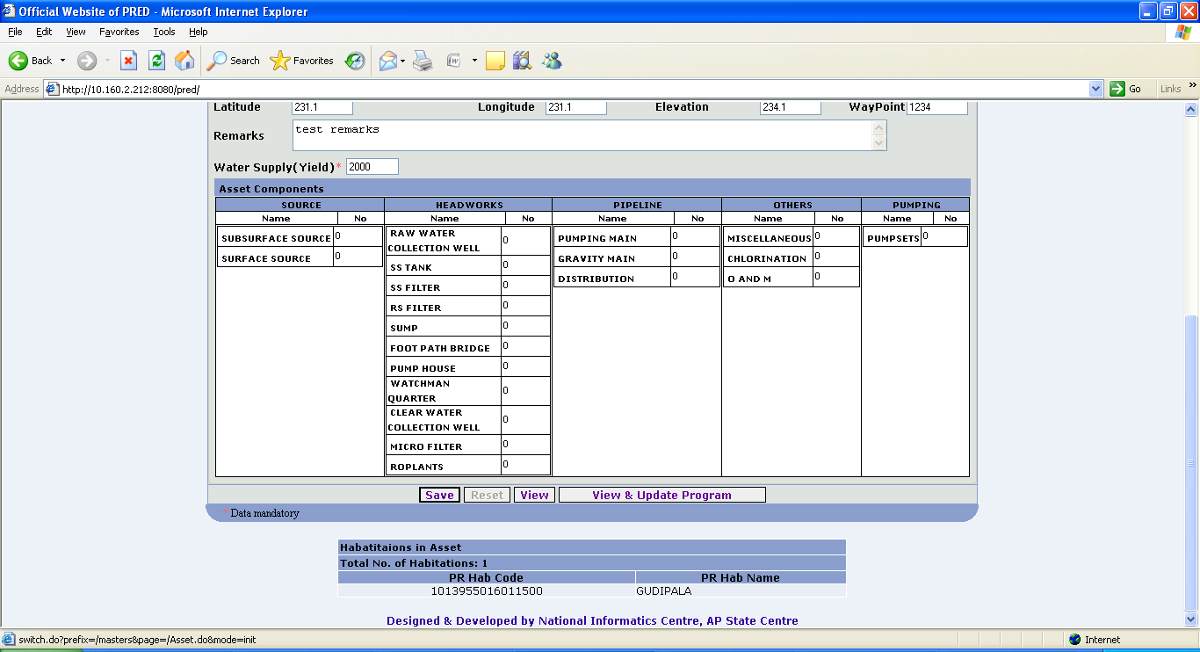
Figure 4.

If Asset Type selected as PWS or CPWS or MPWS

Asset Components:-

- Source
- Headworks.
- Pipeline.
- Sr.Reservoirs.
- Others
- Pumping

Note:-The following screen shot (Figure 5..) shows the components of PWS/MPWS / CPWS
Figure 5.

- Select Type (Add New, Modify).

Option Add New

- Asset Code is auto generated.
- Enter Asset Name.
- Enter Location.
- Select Asset Status.
- Enter Start Year.
- Enter Date of Creation.
- Enter Remarks.
- Enter Latitude.
- Enter Longitude.
- Enter Elevation.
- Enter Waypoint.

Note:-Enter Water supply( Yield ) when Asset Type selected as Direct Pumping.
- Enter Water Supply(Yield).

- Enter Cost of Asset (Rs. In Lakhs).
- No of Habitations Benefited is Fixed.
- Population Benefited is Fixed.
- Click on ‘Save’ button.

Option Modify

- Select AssetCode.
- Select Asset Sub Components.

Note:-Population Benefited Field data can be modified when selected Asset Type is HandPump , ShallowHandpump, Openwell , Ponds

Note:- The existing asset details are displayed and they can be modified and saved.
The various sub components of the assets are displayed along with their number against each of the sub component.

ASSET ENTRY FORM

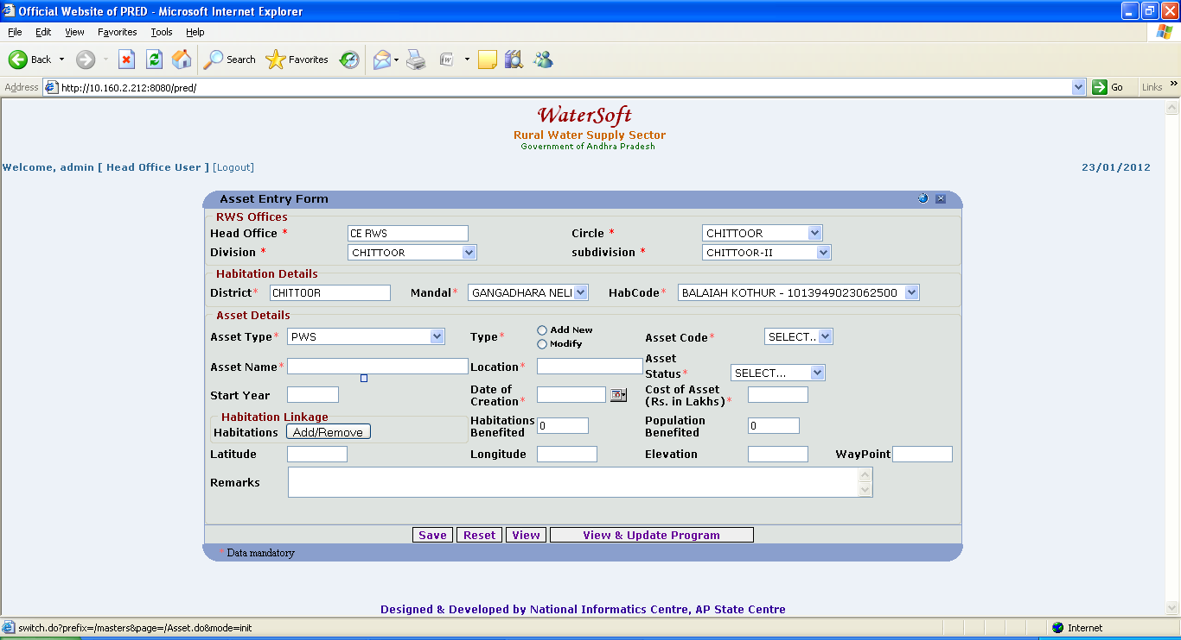
Figure 6.

Note:-If cursor is placed near Population Benefited – Message displayed as Please Select Habitation Linkage if Asset Type selected as PWS, CPWS , MPWS and DIRECT PUMPING other wise enter Population Benefited.

Note :- To View CPWS Assets , Select -> Circle -> Select -> Asset Type as CPWS Click ‘ View ’ button.

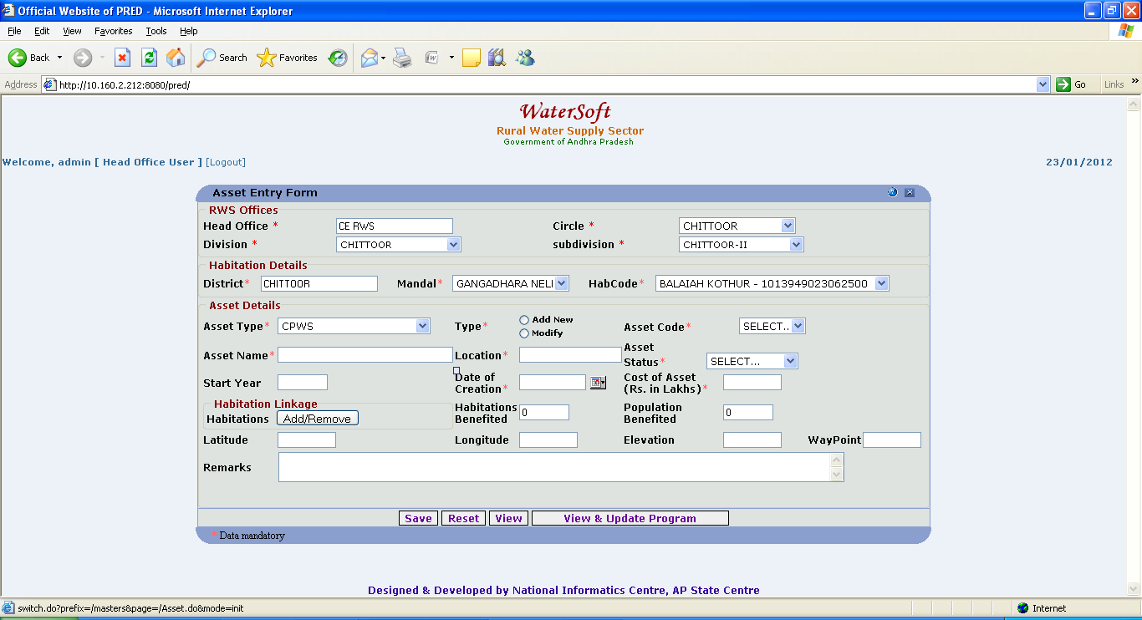
Figure 7.

View

- Click ‘ View ‘ button.

Asset Details are Displayed.

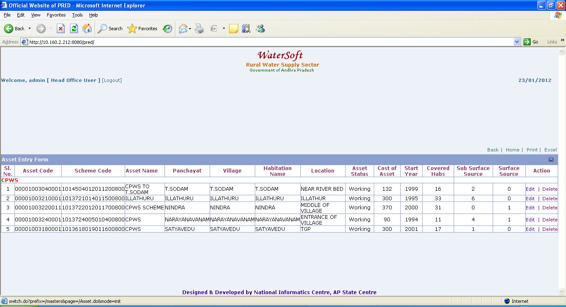
Figure 8.
Note I:- Click on ‘ Edit ’ to modify selected Asset.
Note II:- Click on ‘ Delete ’ to delete selected Asset.

Note :- To View PWS , MPWS , DIRECT PUMPING Assets. Select -> Circle , Select -> Division , Select -> SubDivision , Select-> Mandal -> Select -> Asset Type as PWS Click ‘ View ’ button .
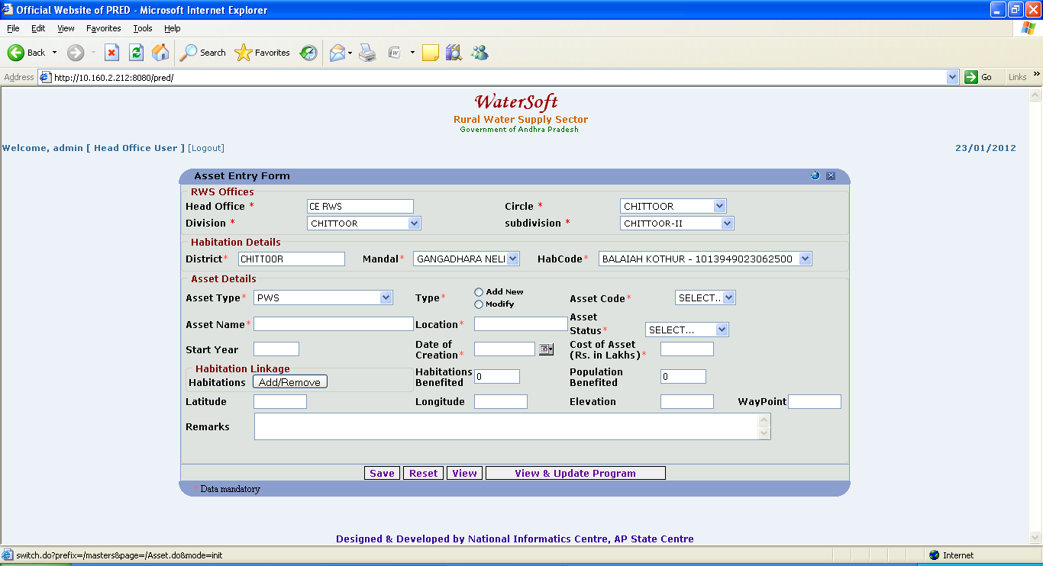
Figure 9.

View

- Click ‘ View ‘ button.

Asset Details are Displayed.

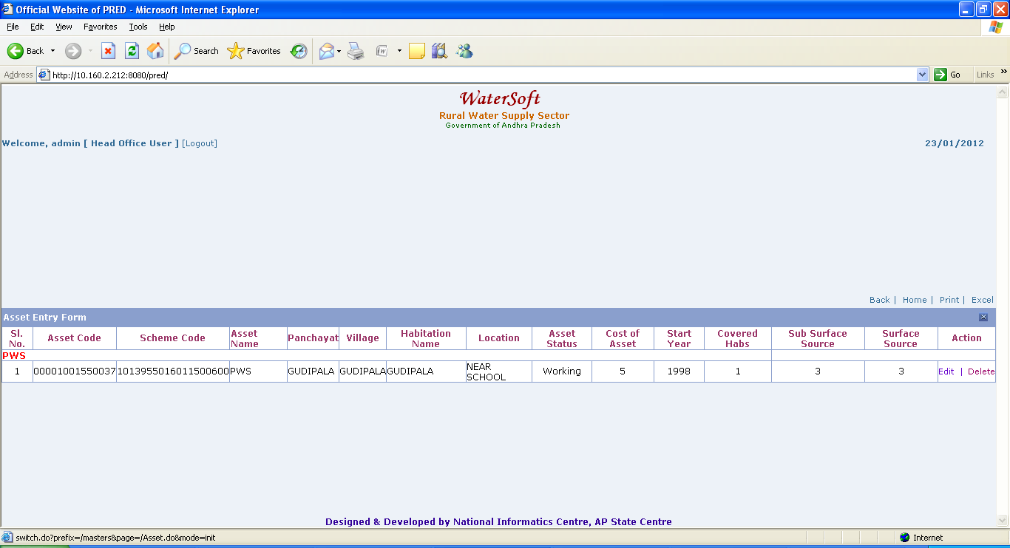
Figure 10.
Note I:- Click on ‘ Edit ’ to modify selected Asset.
Note II:- Click on ‘ Delete ’ to delete selected Asset.

Note :- To View HANDPUMPS , OPENWELLS , PONDS , SHALLOW HAND PUMPS Assets. Select -> Circle , Select -> Division , Select -> SubDivision , Select-> Mandal -> Select -> Asset Type as Handpumps Click ‘ View ’ button .
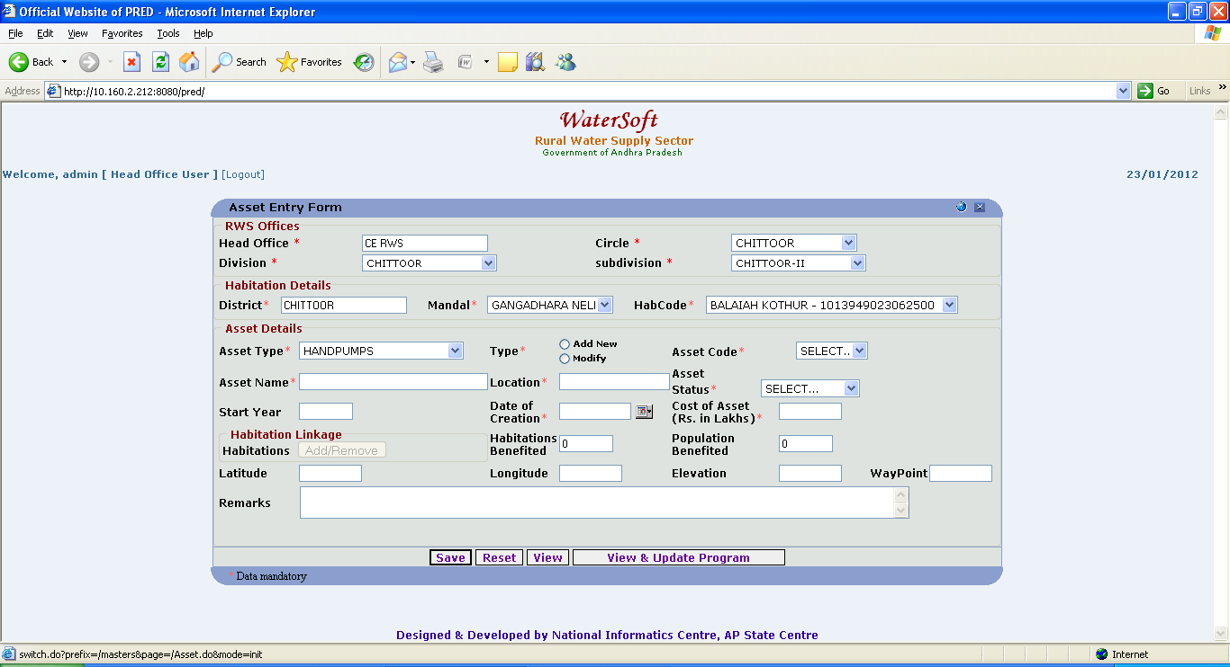
Figure 11.

View

- Click ‘ View ‘ button.

Asset Details are Displayed.

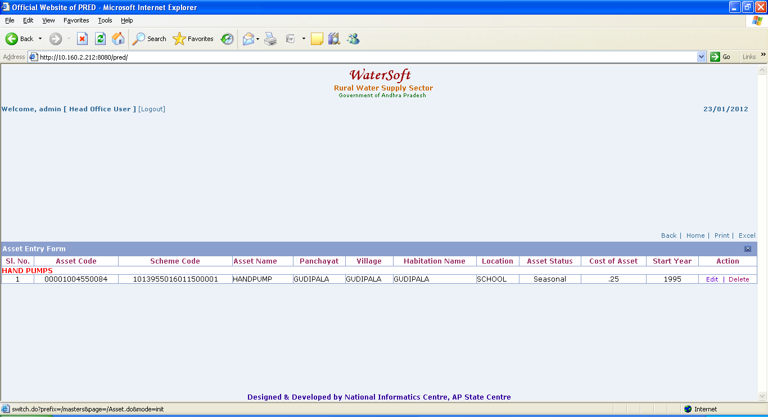
Figure 12.
Note I:- Click on ‘ Edit ’ to modify selected Asset.
Note II:- Click on ‘ Delete ’ to delete selected Asset.

View and Update Program
Figure 13.

View and Update Program

- Click ‘ View and Update Program‘ button.

Asset details are displayed

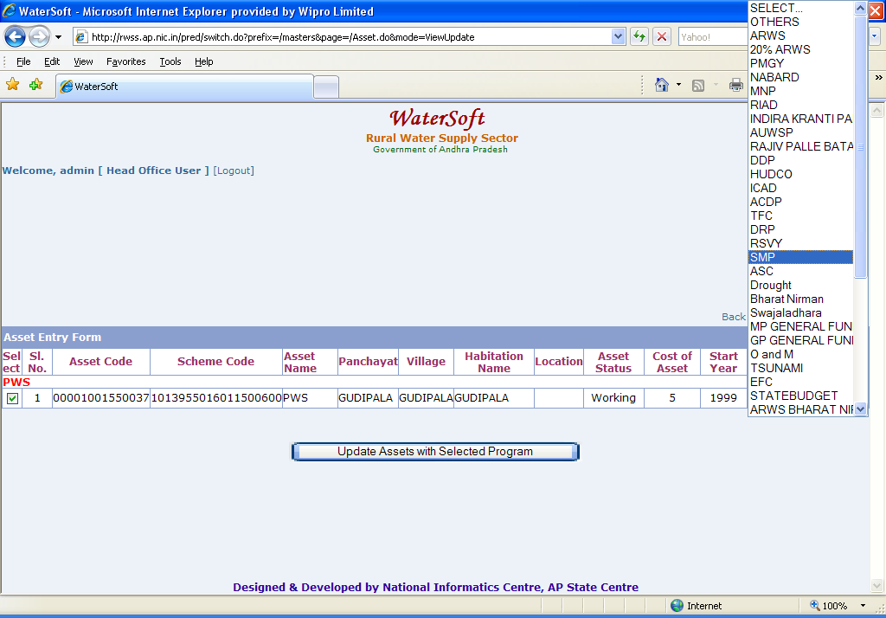
Figure 14.

Note:-Before Clicking on ‘ View and Update Program ‘ button select the check box for which the selected Asset requires updation of ‘ Program ‘.

Update Assets with Selected Program

- Select Check box ( Selected asset requires updation of ‘ Program ’ ).

- Select Program(For Eg. ARWS,Swajaladhara ).
- Click ‘ View and Update Program‘ button.

Habitation Linkage.

Note:-Habitation Linkage is enabled for CPWS, PWS, MPWS asset types only. To add habitations Click on Add & View button to add/view the habitations for CPWS, PWS, MPWS. Habitation Linkage is disabled for other Components.

Add/Remove

- Click ‘ Add/Remove ’ button

Note:- Select Districts ->Click button -> Mandals are displayed->Select any Mandal->Click button ->Habitations are displayed->Select Habitations->Click ‘Add Habitations’ button -> Habitations are Added successfully -> finally Click ‘Save’ button in Asset Entry Form to save Habitations.

The following screen shots(Figure 15 , 16 , 17 and 18 ) explain the process of Habitation Linkage

Based on User Login the District is Selected . Click button that is placed in 2nd column .

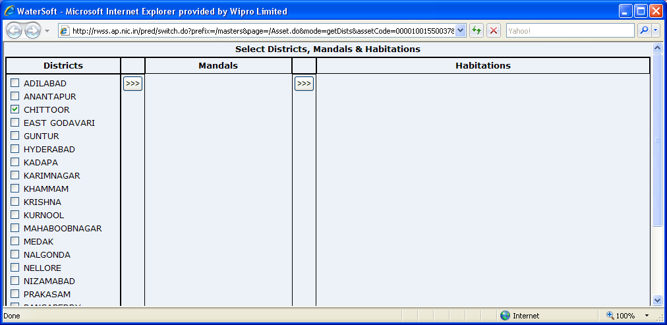
Figure 15.

Mandals are displayed according to selected district .Select any Mandal and click button that is placed in 4th column.

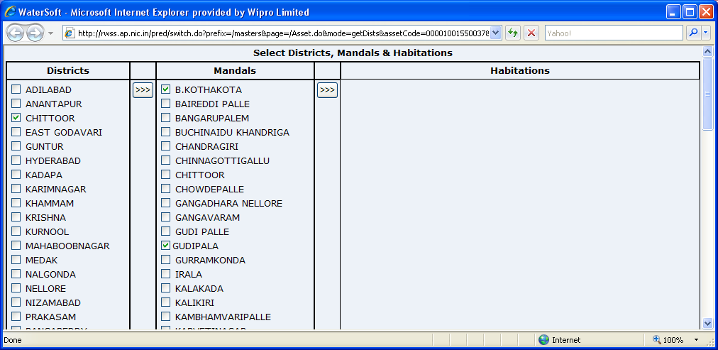
Figure 16.

Habitations are displayed according to selected Mandal . Select Habitations and click ‘Add Habitations’ button.
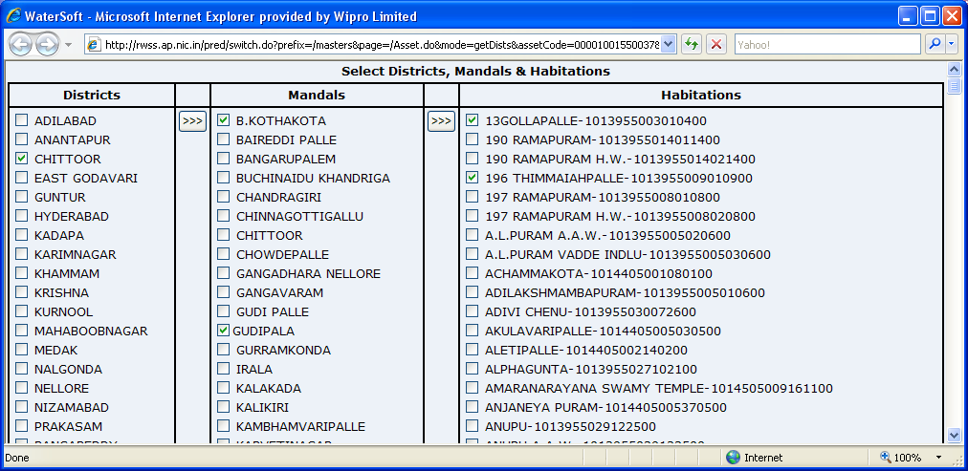
Figure 17.

Add Habitations

- Select Habitations.
- Click ‘ Add Habitations’ button.

The following Screen shot Figure 18 is continuation of Screen shot Figure 17
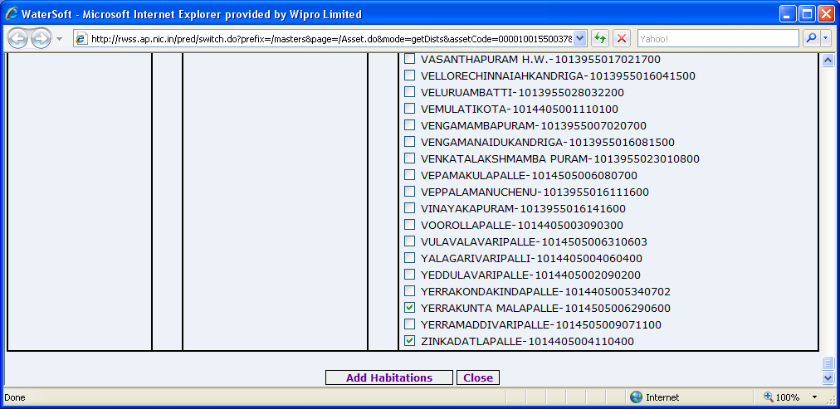
Figure 18.

Close

- Click ‘ Close’ button.

Note:- New Habitations are added along with existing Habitation.

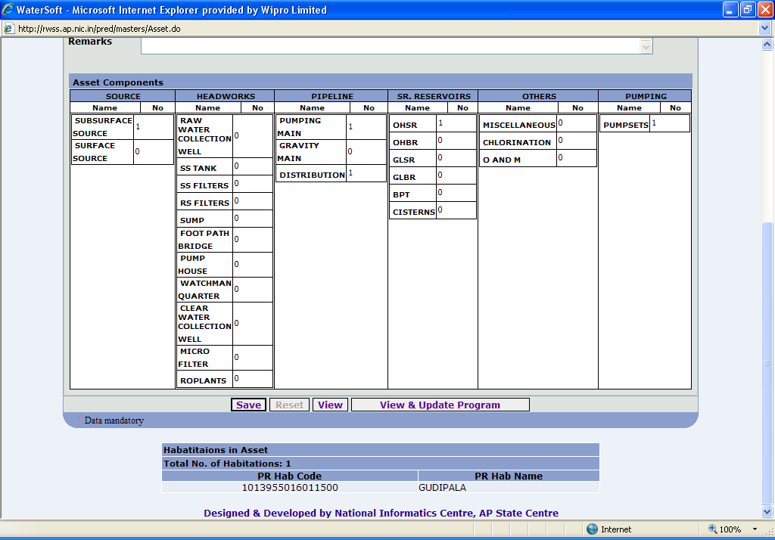
Figure 19.

Asset Sub Components

SOURCES

Subsurface Source

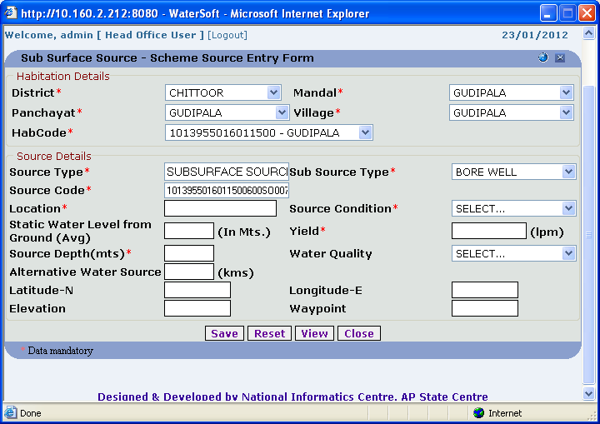
Figure 20.

Save

- District, Mandal, Panchayat, Village, Habitation Code are fixed.
- Source Type is fixed depending on selection.
- The Source code is auto generated.
- Select Sub Source Type.( For Eg. Borewell )
- Enter Location.
- Select Source Condition.
- Enter Static Water Level from Ground ( Avg ) ( In Mts . )
- Enter Yield.( lpm )
- Enter Source Depth ( mts ).
- Enter Alternative Water Source(kms).
- Select WaterQuality(Nss,SafeSource).
- Enter Latitude.
- Enter Longitude.
- Enter Elevation.
- Enter Waypoint.
- Click on ‘Save’ button.

Note:-If Alternative Water Source(In kms.) data is entered then choose either Sub-Surface source or Surface Source.

Reset

- Click on ‘Reset’ button.

Close

- Click on ‘Close’ button.

View

- Click on ‘View’ button.
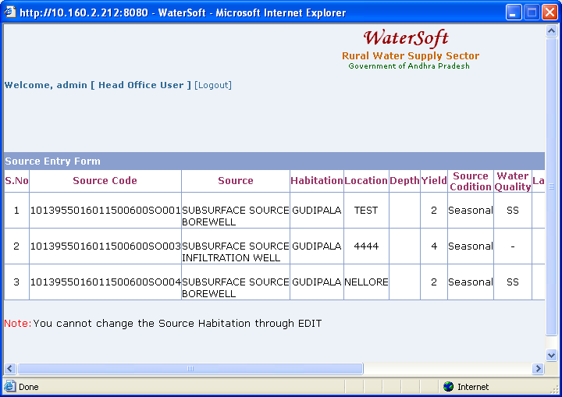
Figure 21.

SURFACE SOURCE

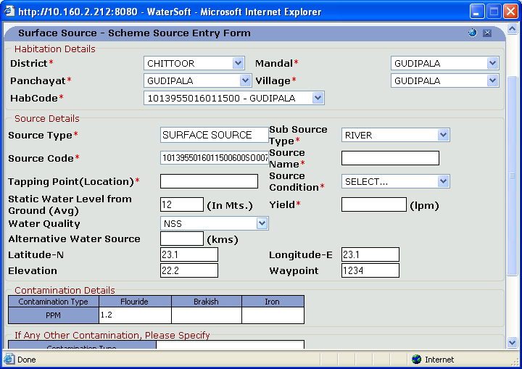

Figure 22.

Save

- District, Mandal, Panchayat, Village, Habitation Code are fixed.
- Source Type is fixed depending on selection.
- Source code is auto generated.
- Enter Source Name.
- Enter Tapping Point.( Location )
- Select Source Condition.
- Enter Static Water Level from Ground (Avg) (In Mts.)
- Select Sub Source Type.
- Select Yield( lpm ).
- Select Water Quality(Nss,SafeSource).
- Enter Alternative Water Source( kms ).
- Enter Latitude.
- Enter Longitude.
- Enter Elevation.
- Enter Waypoint.
- Click on ‘Save’ button.

Note:-If Alternative Water Source(In kms.) data is entered then choose eigher Sub-Surface source or Surface Source.

View

- Click on ‘View’ button.

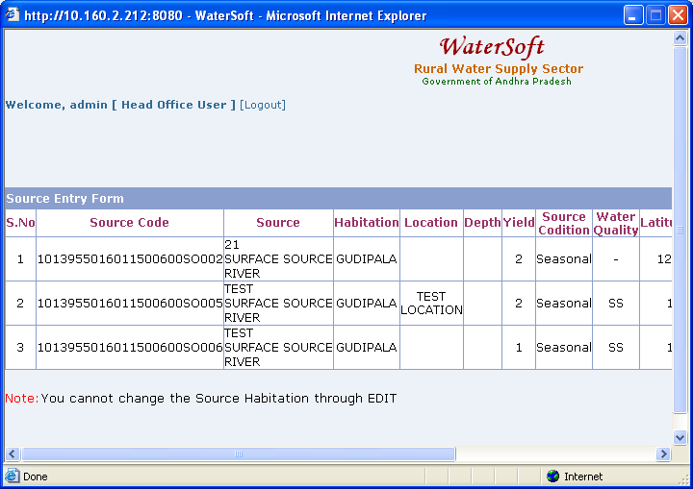
Figure 23.

Reset

- Click on ‘Reset’ button.

Close

- Click on ‘Close’ button.

HEADWORKS

RAW WATER COLLECTION WELL.

Add New RWC Well

- Select District.

- Select Mandal.

- Select Habitation Code.

- Click on ‘Save’ button.

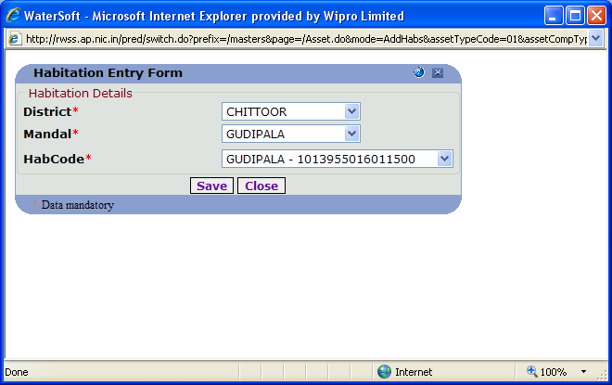
Figure 24.

RAW WATER COLLECTION WELL
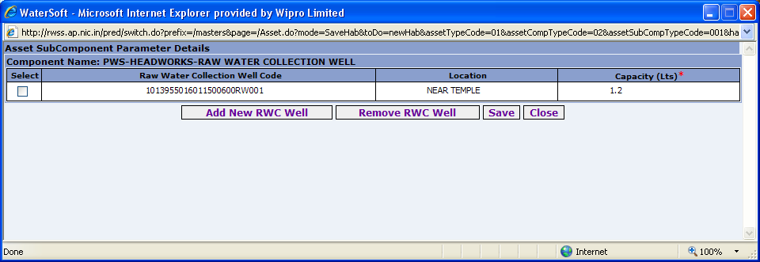
Figure 25.

Save

- Raw Water Collection Well Code is auto generated.
- Enter Location.
- Enter Capacity( Lts ).
- Click on ‘Save’ button.

Remove RWC Well

- Click on ‘Remove RWC Well’.

Close

- Click on ‘Close’ button.

HEADWORKS

SS TANK

Add New SS Tank

- Select District.
- Select Mandal.
- Select Habitation Code.
- Click on ‘Save’ button.

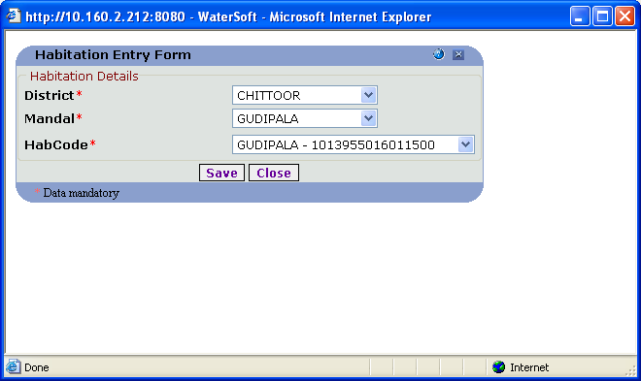
Figure 26.

SS TANK
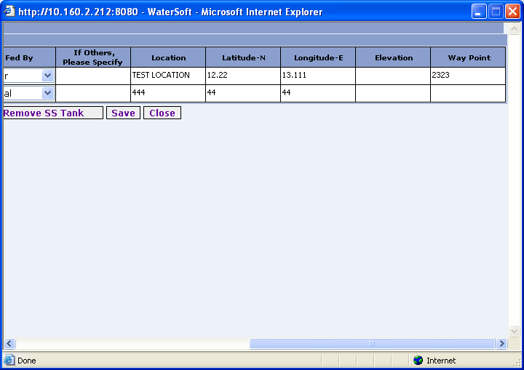

Figure 27.

Save

- SS Tank Code is auto generated.
- Enter SS Tank Area.
- Enter Depth( mts ).
- Enter No. of Days storage.
- Enter Capacity(in Mcum).
- Select Fed by.
- Enter If Others,please specify.
- Enter Location.
- Enter Latitude.
- Enter Longitude.
- Enter Elevation.
- Enter Waypoint.
- Click on ‘Save’ button.

Close

- Click on ‘Close’ button.

HEADWORKS

SS FILTERS

Add New SS Filter

- Select District.
- Select Mandal.
- Select Habitation Code.
- Click ‘Save’ button.

Figure 28.

SS FILTERS

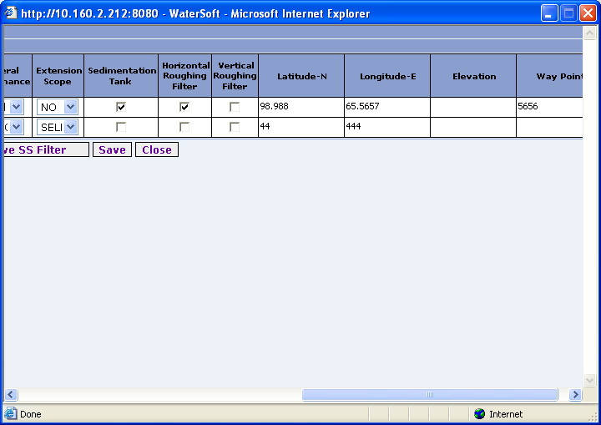
Figure 29.

Save

- WTP code is auto generated.
- Enter Location.
- Select Type of WTP.
- Enter Capacity In MLD.
- Enter No. of Units
- Enter No. of Hours of Usage.
- Enter Size of Units( Sq.Mts )
- Enter No. of Stand By Units.
- Enter Frequency of sand scrapping ( in Months ).
- Select General Performance.
- Select Extension Scope.
- Select Sedimentation Tank.
- Select Horizontal Roughing Filter.
- Select Vertical Roughing Filter.
- Enter Latitude.
- Enter Longitude.
- Enter Elevation.
- Enter Waypoint.
- Click ‘Save’ button.

Remove SS Filters

- Click ‘ Remove SS Filter ’ button.

Close

- Click ‘ Close ’ button.

HEADWORKS

RS FILTERS

Add New RS Filter

- Select District.
- Select Mandal.
- Select Habitation Code.
- Click on ‘Save’ button.

Figure 30.

RS FILTERS
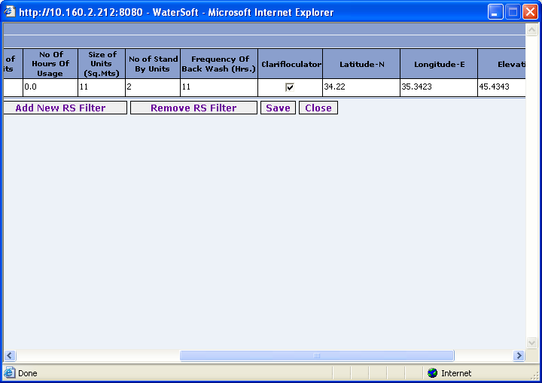
Figure 31.

Save

- WTP code is auto generated.
- Enter Location.
- Select Type of WTP.
- Enter Capacity in MLD.
- Enter No Of Units.
- Enter No of Hours of Usage.
- Enter Size of Units( Sq.Mts ).
- Enter No of Stand By Units.
- Enter Frequency of Back Wash( Hrs. ).
- Select Clarifloculator.
- Enter Latitude.
- Enter Longitude.
- Enter Elevation.
- Enter Waypoint.
- Click on ‘Save’ button.

Remove RS Filter

- Click on ‘Remove RS Filter’ button.

Close

- Click on ‘Close’ button.

HEADWORKS

SUMP

Add New Sump

- Select District.
- Select Mandal.
- Select Habitation Code.
- Click on ‘Save’ button.

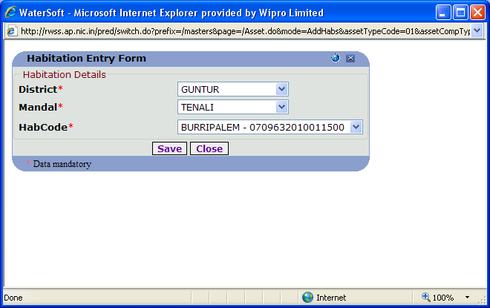
Figure 32.

SUMP

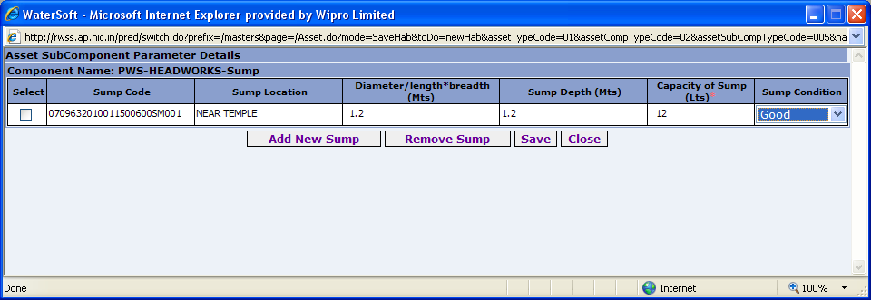
Figure 33.

Save

- Sump Code is auto generated.
- Enter Sump Location.
- Enter Diameter/length*breadth( Mts ).
- Enter Sump Depth( Mts ).
- Enter Capacity of Sump( Lts ).
- Enter Sump Condition.
- Click ‘Save’ button.

Remove Sump

- Click on ‘Remove Sump’ button.

Close

- Click on ‘Close’ button.

HEADWORKS

FOOT PATH BRIDGE

Add New Foot path Bridge

- Select District.
- Select Mandal.
- Select Habitation code.
- Click on ‘Save’ button.

Figure 34.

FOOT PATH BRIDGE

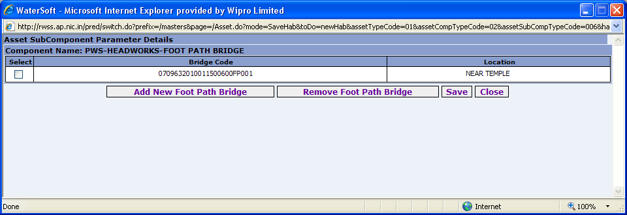
Figure 35.

Save

- Bridge code is auto generated.
- Enter Location.
- Click on ‘Save’ button.

Remove Foot Path Bridge

- Click on ‘Remove Foot Path Bridge’.

Close

- Click on ‘Close’ button

HEADWORKS

PUMPHOUSE

Add New Pump House

- Select District.
- Select Mandal.
- Select Habitation Code.
- Click ‘ Save ’ button.

Figure 36.

PUMP HOUSE
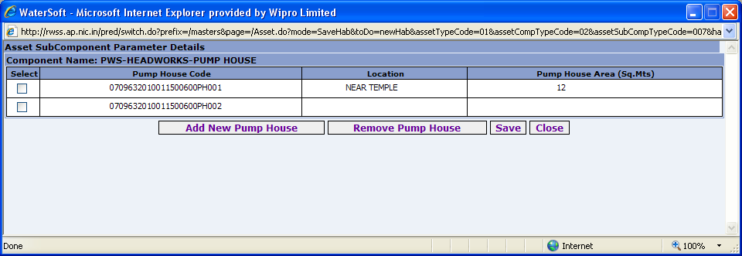
Figure 37.

Save

- Pump House code is auto generated.
- Enter Location.
- Enter Pump House Area( Sq.Mts ).
- Click on ‘Save’ button.

Remove Pump House

- Click on ‘Remove Pump house button’.

Close

- Click on ‘Close’ button.

HEADWORKS

WATCHMAN QUARTER

Add New Watchman Quarter

- Select District.
- Select Mandal.
- Select Habitation Code
- Click ‘Save’ button.

Figure 38.

WATCHMAN QUARTER

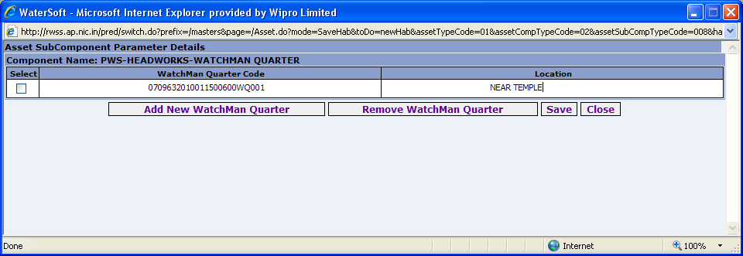
Figure 39.

Save

- Watchman Quarter code is auto generated.
- Enter Location.
- Click ‘Save’ button.

Remove Watchman Quarter

- Click on ‘Remove Watchman Quarter’.

Close

- Click on ‘Close’ button.

HEADWORKS

CLEAR WATER COLLECTION WELL

Add New Clear Water Collection well

- Select District.
- Select Mandal.
- Select Habitation Code.
- Click on ‘Save’ button.

Figure 40.

CLEAR WATER COLLECTION WELL
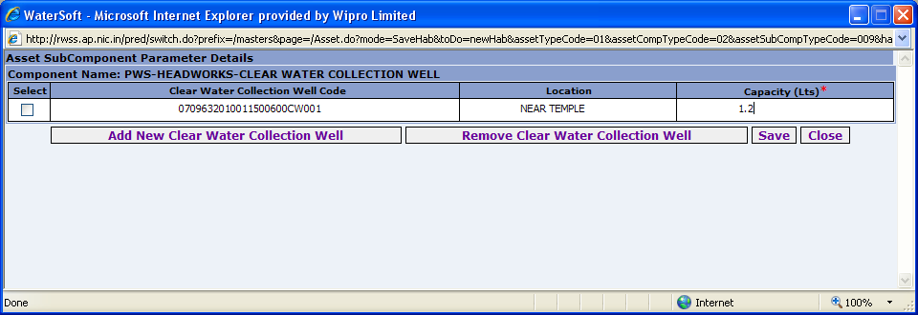
Figure 41.

Save

- Clear Water Collection Well Code is auto generated.
- Enter Location.
- Enter Capacity( Lts ).
- Click on ‘Save’ button.

Remove Clear Water Collection Well

- Click on ‘Remove Clear Water Collection Well’.

Close

- Click on ‘Close’ button.

HEADWORKS

MICRO FILTER

Figure 42.

Add New Micro Filter

- Select District
- Select Mandal
- Select Habitation Code.
- Click ‘ Save ’ button.

MICRO FILTER

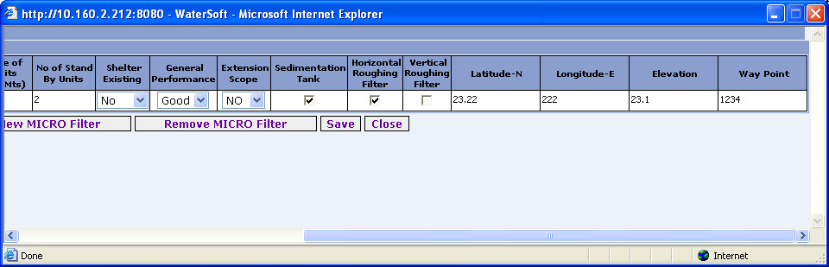
Figure 43.

Save

- WTP Code is auto generated
- Enter Location.
- Enter Capacity in MLD
- Enter No. of Units.
- Enter No. of Hours of Usage.
- Enter size of Units . ( Sq. Mts )
- Enter No. of Stand By Units.
- Select Shelter Existing
- Select General Performance.
- Select Extension Scope.
- Select Sedimentation Tank
- Select Horizontal Roughing Filter.
- Select Vertical Roughing Filter.
- Enter Latitude.
- Enter Longitude.
- Enter Elevation.
- Enter Waypoint.
- Click ‘ Save ‘ button.

Remove Micro Filter

- Click ‘ Remove Micro Filter ‘ button.

Close

- Click ‘ Close ‘ button.

HEADWORKS

RO PLANTS

Add New RO Plant

- Select District.
- Select Mandal.
- Select Habitation Code.
- Click ‘ Save ‘ button.

Figure 44.

ROPLANTS

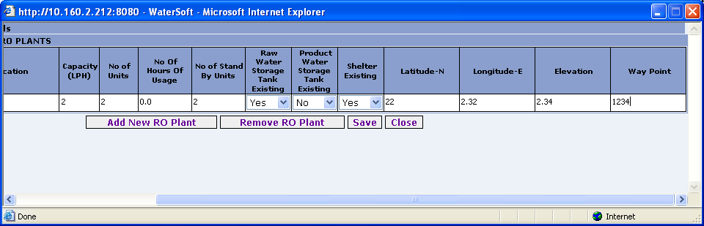
Figure 45.

Save

- WTP Code is auto generated.
- Enter Location.
- Enter Capacity ( LPH ).
- Enter No. of Units.
- Enter No. of Hours Of Usage.
- Enter No. of Stand By Units.
- Select Raw Water Storage Tank Existing.
- Select Product Water Storage Tank Existing.
- Select Shelter Existing.
- Enter Latitude.
- Enter Longitude.
- Enter Elevation.
- Enter Waypoint.
- Click ‘ Save ‘ button.

Remove RO Plant
- Click ‘ Remove RO Plant ‘ button.

Close

- Click ‘ Close ‘ button.

PIPELINE

PUMPINGMAIN

Add New

- Select District.
- Select Mandal.
- Select Habitation Code.
- Click on ‘Save’ button.

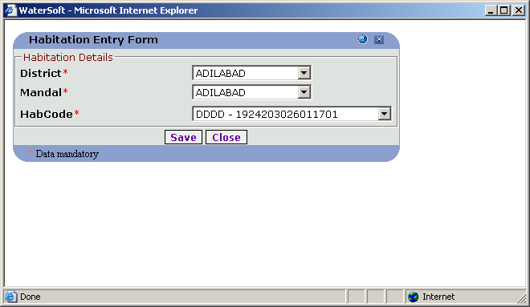
Figure 46.

PUMPING MAIN

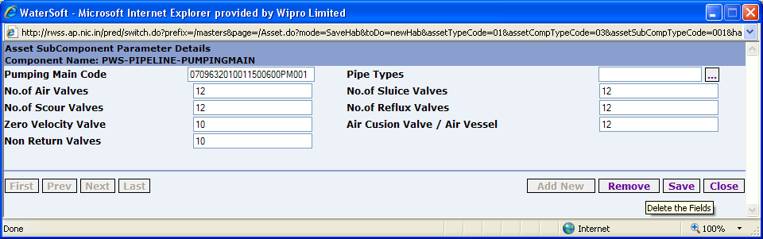
Figure 47.

Note:-Click on button near ‘ Pipe Types ‘ – New Pipe Details can be Entered.

Save

- Pumping Main Code is auto generated.
- Enter No. of Air Valves.
- Enter No. of Scour Valves.
- Enter Zero Velocity Valve.
- Enter Non Return valves.
- Enter Pipe Types.
- Enter No. of Sluice Valves.
- Enter Air Cusion Valve/Air Vessel.
- Click on ‘Save’ button.

Remove

- Click ‘ Remove ‘ button.

First

- Click on ‘First’ button for navigating to First Record.

Prev

- Click on ‘Prev’ button for navigating to Previous Record.

Next

- Click on ‘Next’ button for navigating to Next Record.

Last

- Click on ‘Last’ button for navigating to Last Record.

Close
- Click ‘ Close ’ button

PIPE TYPES

Add New Pipe Type
- Click ‘ Add New Pipe Type ‘ button.

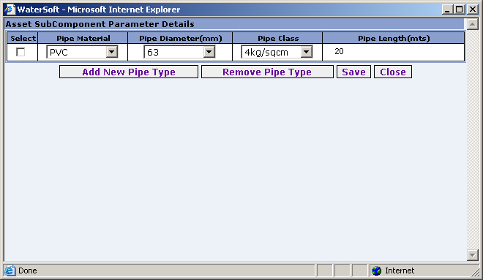
Figure 48.

Save
- Select Pipe Material
- Select Pipe Diameter( mm )
- Select Pipe Class
- Enter Pipe Length( mts ).
- Click ‘ Save ‘ button

Remove Pipe Type

- Click ‘ Remove Pipe Type ‘ button.

Close

- Click on ‘Close’ button.

PIPELINE.

GRAVITYMAIN

Add New Gravity Main

- Select District.
- Select Mandal.
- Select Habitation Code.
- Click on ‘Save’ button.

Figure 49.

GRAVITY MAIN

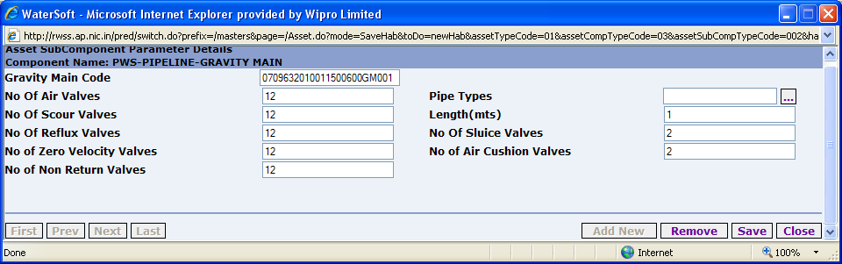
Figure 50.

Note:-Click on button near ‘ Pipe Types ‘ – New Pipe Details can be Entered.

Save

- Gravity Main Code is auto generated.
- Enter No Of Air Valves.
- Enter No. of Scour Valves.
- Enter No. of Reflux Valves.
- Enter No. of Zero Velocity Valves.
- Enter No of Non Return Valves
- Enter Pipe Types.
- Enter Length ( mts ).
- Enter No. Of Sluice Valves.
- Enter No. Air Cushion Valves.
- Click on ‘Save’ button.

Remove

- Click on ‘Remove’ button.

Close

- Click on ‘Close’ button.

First

- Click on ‘First’ button for navigating to First Record.

Prev

- Click on ‘Prev’ button for navigating to Previous Record.

Next

- Click on ‘Next’ button for navigating to Next Record.

Last

- Click on ‘Last’ button for navigating to Last Record.

PIPE TYPES

Add New Pipe Type
- Click ‘ Add New Pipe Type ‘ button.

Figure 51.

PIPELINE

DISTRIBUTION

Add New Distribution

- Select District.
- Select Mandal.
- Select Habitation Code.
- Click on ‘Save’ button.

Figure 52.

DISTRIBUTION

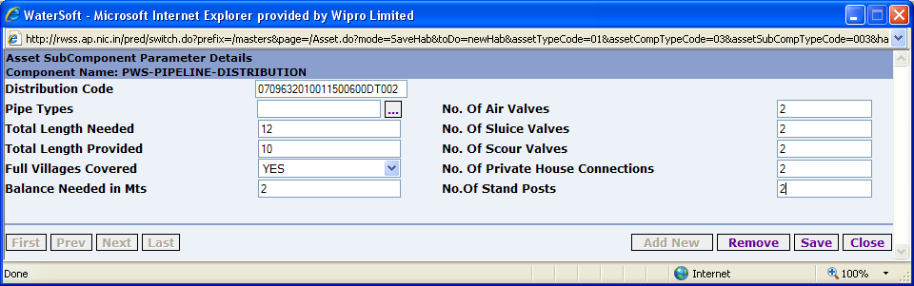
Figure 53.

Note:-Click on button near ‘ Pipe Types ‘ – New Pipe Types can be Entered.

Save

- Distribution code is auto generated.
- Enter Pipe Types.
- Enter Total Length Needed.
- Enter Total Length Provided.
- Select Full Villages Covered.
- Balance Needed in Mts.( automatically calculated).
- Enter No of Air Valves.
- Enter No. of Sluice Valves.
- Enter No. of Scour Valves.
- Enter No. of Private House Connections.
- Enter No. of Stand Posts.
- Click on ‘Save’ button.

Remove

- Click on ‘Remove’ button.

Close

- Click on ‘Close’ button.

First

- Click on ‘First’ button for navigating to First Record.

Prev

- Click on ‘Prev’ button for navigating to Previous Record.

Next

- Click on ‘Next’ button for navigating to Next Record.

Last

- Click on ‘Last’ button for navigating to Last Record.

PIPE TYPES

Add New Pipe Type

- Click ‘ Add New Pipe Type ‘ button.

Figure 54.

SR.RESERVOIRS

Note:- For GLSR , OHSR , CISTERNS – selection of more than one habitation is possible when clicking on ‘ Habitation Linkage ‘.

For GLBR , OHBR , BPT – no ‘ Habitation Linkage’.

OHSR

Add New OHSR

- Select District.
- Select Mandal.
- Select Habitation Code.
- Click ‘Save’ button.

Figure 55.

OHSR
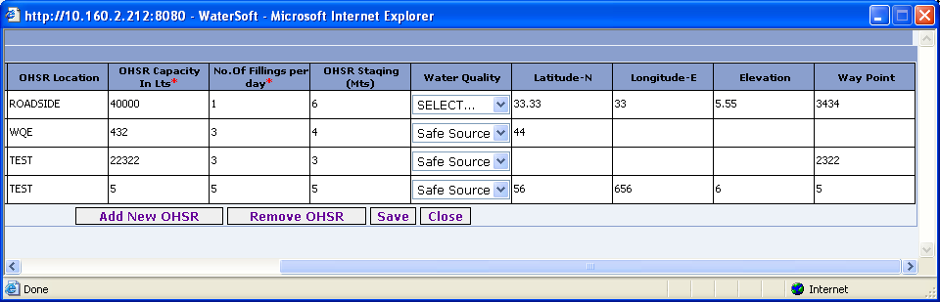

Figure 56.

Save

- OHSR code is auto generated.
- Select Habitation Linkage.
- Enter OHSR Location.
- Enter OHSR Capacity in Lts.
- Enter No. of Fillings per day.
- Enter OHSR Staging( Mts ).
- Select WaterQuality.( For Eg. NSS , SAFE SOURCE ).
- Enter Latitude.
- Enter Longitude.
- Enter Elevation.
- Enter Waypoint.
- Click on ‘Save’ button.

Remove OHSR

- Click on ‘Remove OHSR button’.

Close

- Click on ‘Close’ button.

Note:-Click on ‘Habitation Linkage’ to add Habitations, the following screen shot explain the process , select habitations-> click ‘ADD’ button.

Habitation Linkage
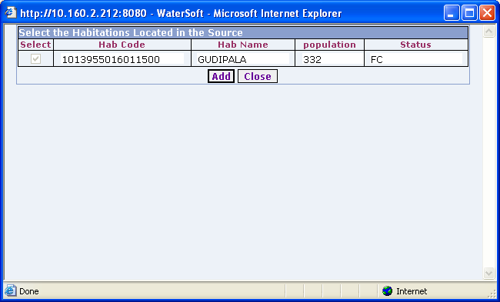

Figure 57.

Add
- Click ‘Add’ button.

SR.RESERVOIRS.

OHBR

Add New OHBR

- Select District.
- Select Mandal.
- Select Habitation Code.
- Click on ‘Save’ button.

Figure 58.

OHBR
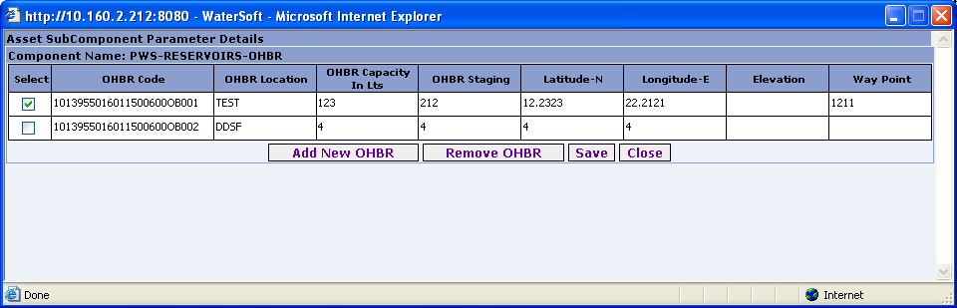

Figure 59.

Save

- OHBR code is auto generated.
- Enter OHBR Location.
- Enter OHBR Capacity( Lts ).
- Enter OHBR Staging.
- Enter Latitude.
- Enter Longitude.
- Enter Elevation.
- Enter Waypoint.
- Click on ‘Save’ button.

Remove OHBR

- Click on ‘Remove OHBR button’.

Close

- Click on ‘Close button’.

SR.RESERVOIRS.

GLSR

Add New GLSR

- Select District.
- Select Mandal.
- Select Habitation Code.
- Click on ‘Save’ button.

Figure 60.

GLSR
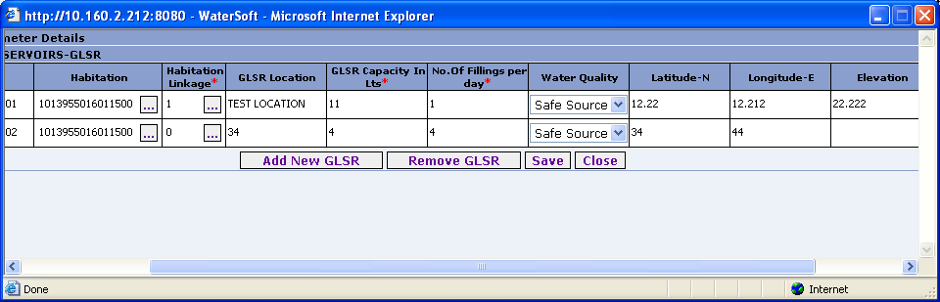

Figure 61.

Save

- GLSR code is auto generated.
- Select Habitation.
- Select Habitation Linkage.
- Enter Glsr Location.
- Enter Glsr Capacity In Lts.
- Enter No. Of Filling per Day.
- Select Water Quality.( For Eg. NSS , SAFE SOURCE ).
- Enter Latitude.
- Enter Longitude.
- Enter Elevation.
- Enter Waypoint.
- Click on ‘Save’ button.

Remove GLSR

- Click on ‘Remove GLSR button’.

Close

- Click on ‘Close’ button.

Note:-Click on ‘Habitation Linkage’ to add Habitations, the following screen shot explain the process , select habitations-> click ‘ADD’ button.

Habitation Linkage

Figure 62.

Add

- Click ‘Add’ button.

SR.RESERVOIRS

GLBR

Add New GLBR

- Select District.
- Select Mandal.
- Select Habitation Code.
- Click on ‘Save’ button.

Figure 63.

GLBR

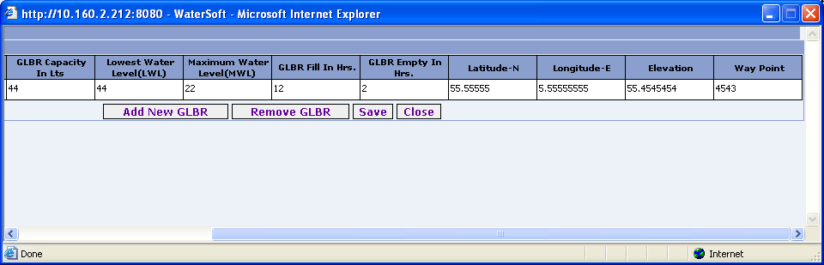

Figure 64.

Save

- GlBR code is auto generated.
- Enter GLBR Location.
- Enter GLBR Capacity in Lts.
- Enter Lowest Water Level( LWL ).
- Enter Maximum Water Level( MWL ).
- Enter GLBR Fill in Hrs.
- Enter GLBR Empty in Hrs.
- Enter Latitude.
- Enter Longitude.
- Enter Elevation.
- Enter Waypoint.
- Click on ‘Save’ button.

Remove GLBR

- Click on ‘Remove GLBR button’.

Close

- Click on ‘Close’ button.

SR.RESERVOIRS

BPT

Add New BPT

- Select District.
- Select Mandal.
- Select Habitation Code.
- Click on ‘Save’ button.

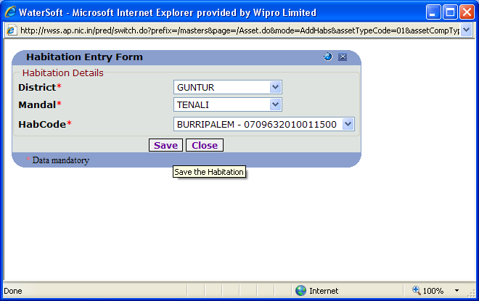
Figure 65.

BPT

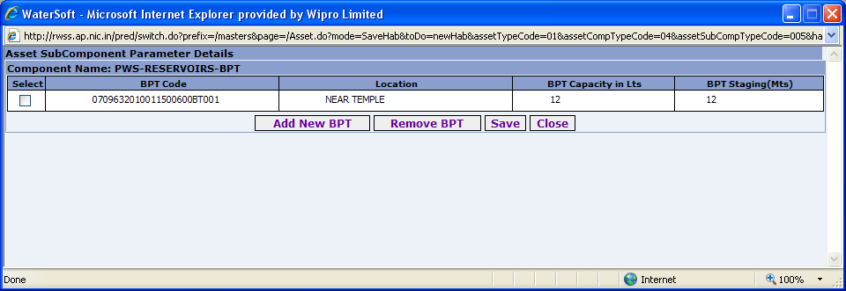
Figure 66.

Save

- BPT code is auto generated.
- Enter Location.
- Enter BPT Capacity ( in Lts ).
- Enter BPT Staging( Mts ).
- Click on ‘Save’ button.

Remove BPT

- Click on ‘Remove BPT button’.

Close

- Click on ‘Close’ button.

SR.RESERVOIRS

CISTERNS

Add New Cistern

- Select District.
- Select Mandal.
- Select Habitation Code.
- Click on ‘Save’ button.

Figure 67.

CISTERNS

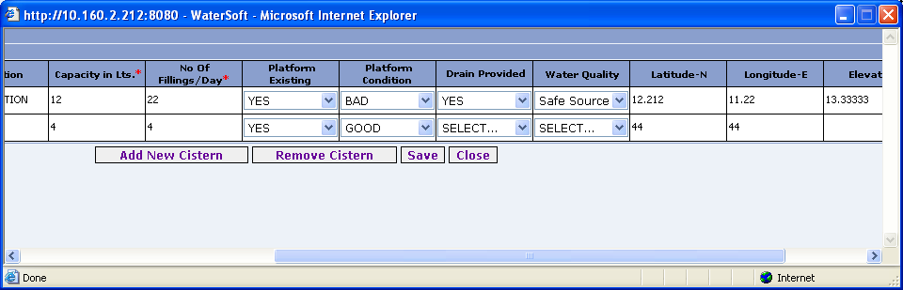
Figure 68.

Save

- Cistern code is auto generated.
- Select Habitation.
- Enter Location.
- Select Habitation Linkage.
- Enter Capacity in Lts.
- Select Cistern Condition.
- Enter No. Of Fillings / Day
- Select Platform Existing.
- Select Platform Condition.
- Select Drain Provided.
- Select Water Quality ( For Eg. NSS , SAFE SOURCE).
- Enter Latitude.
- Enter Longitude.
- Enter Elevation.
- Enter Waypoint.
- Click on ‘Save’ button.

Remove Cistern

- Click on ‘Remove Cistern button’.

Close

- Click on ‘Close’ button.

Note:-Click on ‘Habitation Linkage’ to add Habitations, the following screen shot explain the process , select habitations-> click ‘ADD’ button.

Habitation Linkage

Figure 69.

Add

- Click ‘Add’ button.

OTHERS

MISCELLANEOUS

Add New

- Select District.
- Select Mandal.
- Select Habitation Code.
- Click on ‘Save’ button.

Figure 70.

MISCELLANEOUS

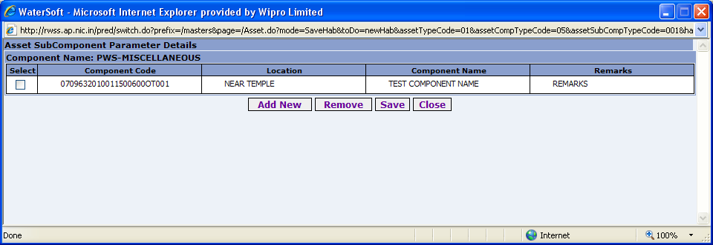
Figure 71.

Save

- Component code is auto generated.
- Enter Location
- Enter Component Name.
- Enter Remarks.
- Click ‘ Save ’ button.

Close

- Click ‘Close’ button.

Remove

- Click on ‘ Remove ’ button.

OTHERS

CHLORINATION

Add New

- Select District.
- Select Mandal.
- Select Habitation Code.
- Click on ‘Save’ button.

Figure 72.

CHLORINATION

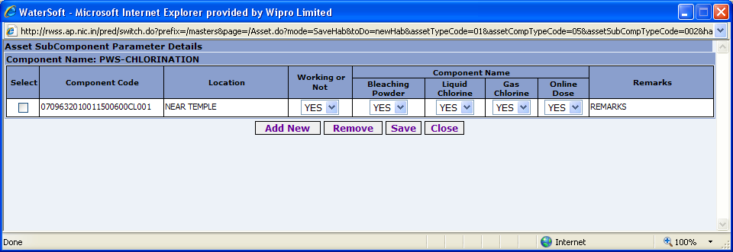
Figure 73.

Save
- Component Code is autogenerated.
- Enter Location.
- Select Working or Not
- Select Bleaching Powder.
- Select liquid Chlorine.
- Select Gas Chlorine
- Select Online Dose
- Enter Remarks.
- Click ‘ Save ‘ button.

Remove
- Click ‘ Remove ‘ button.

Close
- Click ‘ Close ‘ button.

O AND M

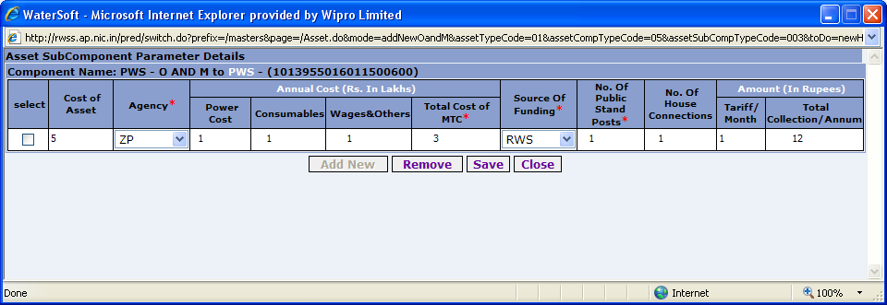
Figure 74.

Save

- Cost of Asset is fixed and it is carry forwarded from asset cost of the asset form.
- Select Agency
- Enter Power Cost (Rs. In Lakhs).
- Enter Consumables (Rs. In Lakhs).
- Enter Wages & Others (Rs. In Lakhs).
- Total Cost of MTC is fixed. (PowerCost+Consumables+Wages&Others).
- Select Source Of Funding.
- Enter No. Of Public Stand Posts.
- Enter No. Of House Connections.
- Enter Tariff/Month. (Rs. In Lakhs).
- Total Collection/Amount is fixed (House Connections* (Tariff/Month*12)).
- Click ‘ Save ’ button

Remove

- Click ‘ Remove ’ button.

Close

- Click ‘ Close ’ button.

PUMPING

PUMPSETS
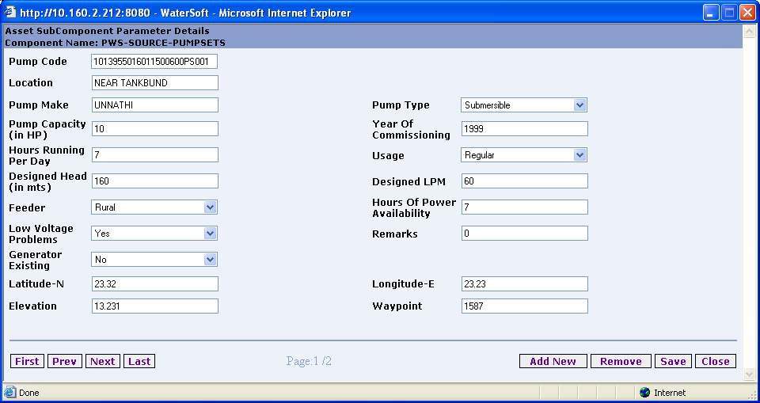

Figure 75.

Save

- Pump Code is autogenerated.
- Enter Location.
- Enter Pump Make.
- Enter Pump Capacity ( in HP ).
- Enter Hours Running Per Day.
- Enter Designed Head ( in mts ).
- Select Feeder.
- Select Low Voltage Problems.
- Select Generator Existing.
- Select Pump Type
- Enter Year Of Commissioning.
- Select Usage.
- Enter Designed LPM.
- Enter Hours Of Power Availability.
- Enter Remarks.
- Enter Latitude.
- Enter Longitude.
- Enter Elevation.
- Enter Waypoint.
- Click ‘ Save ‘ button.

Remove

- Click ‘ Remove ‘ button.

Close

- Click ‘ Close ‘ button.

First

- Click ‘ First ‘ button.

Previous

- Click ‘ Previous ‘ button.

Next

- Click ‘ Next ‘ button.

Last

- Click ‘ Last ‘ button.

HANDPUMPS

BOREWELL

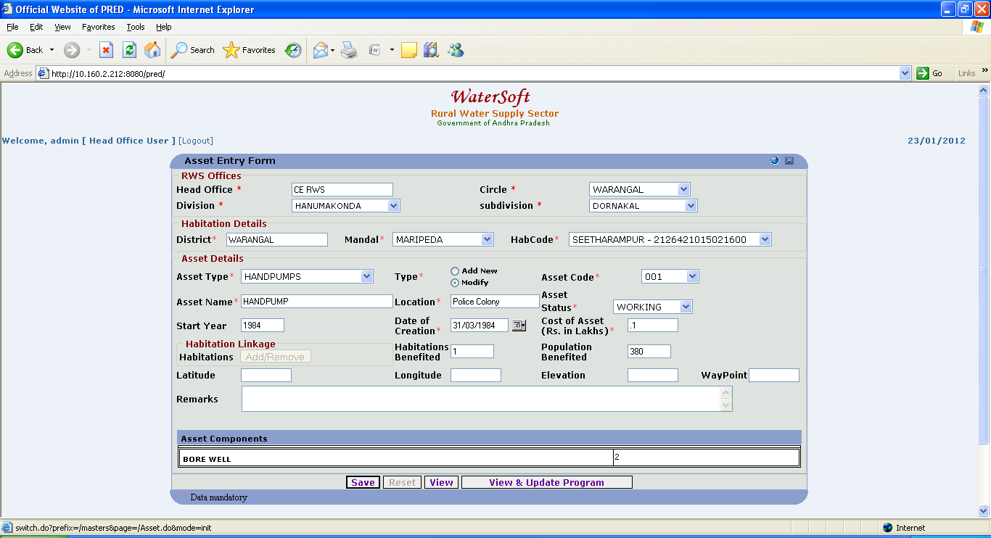
Figure 76.

BOREWELL
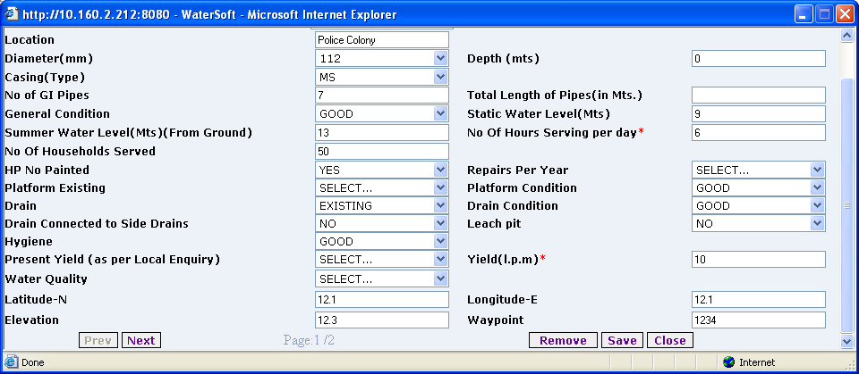
Figure 77.

Save

- Pump code is auto generated.
- Location details are carried forward from Asset Entry Form .
- Select Diameter( mm ).
- Select Casing( Type ).
- Enter No of GI Pipes.
- Select General Condition.
- Enter Summer Water Level ( Mts ) ( From Ground )
- Enter No . of HouseHolds Served.
- Select HP No Painted.
- Select Platform Existing.
- Select Drain.
- Select Drain Connected to Side Drains.
- Select Hygiene.
- Select Present Yield ( as Per Local Enquiry ).
- Select Water Quality. ( For Eg. NSS , SAFESOURCE ).
- Enter Contamination Details. ( only when WaterQuality selected as NSS ).
- Enter Depth ( mts. ).
- Enter Total Length of Pipes ( In Mts .)
- Enter Static Water Level ( Mts ).
- Enter No. Of Hours Serving per day.
- Select Repairs Per Year.
- Select Platform Condition.
- Select Drain Condition.
- Select Leach pit.
- Enter Yield.(l.p.m).
- Enter Latitude.
- Enter Longitude.
- Enter Elevation.
- Enter Waypoint.
- Click on ‘Save’ button.

Note:-If Water Quality is Selected as NSS the Following Screen Shot explain the process of Entering data – Contamination details should be entered , For SafeSources , Contamination Details are Not Required
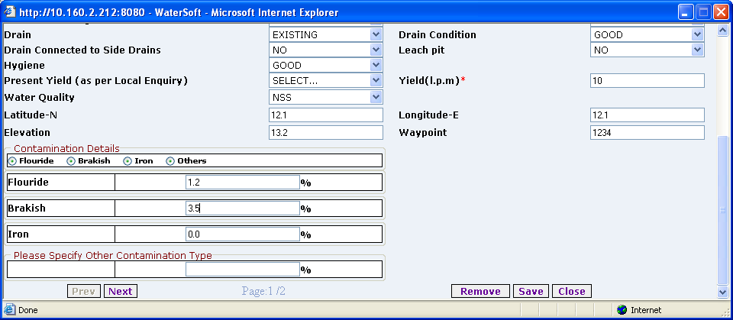
Figure 78.

Close

- Click on ‘Close’ button.

Remove

- Click ‘Remove’ button.

Prev

- Click ‘Prev’ button.

Next

- Click ‘Next’ button.

OPEN WELLS
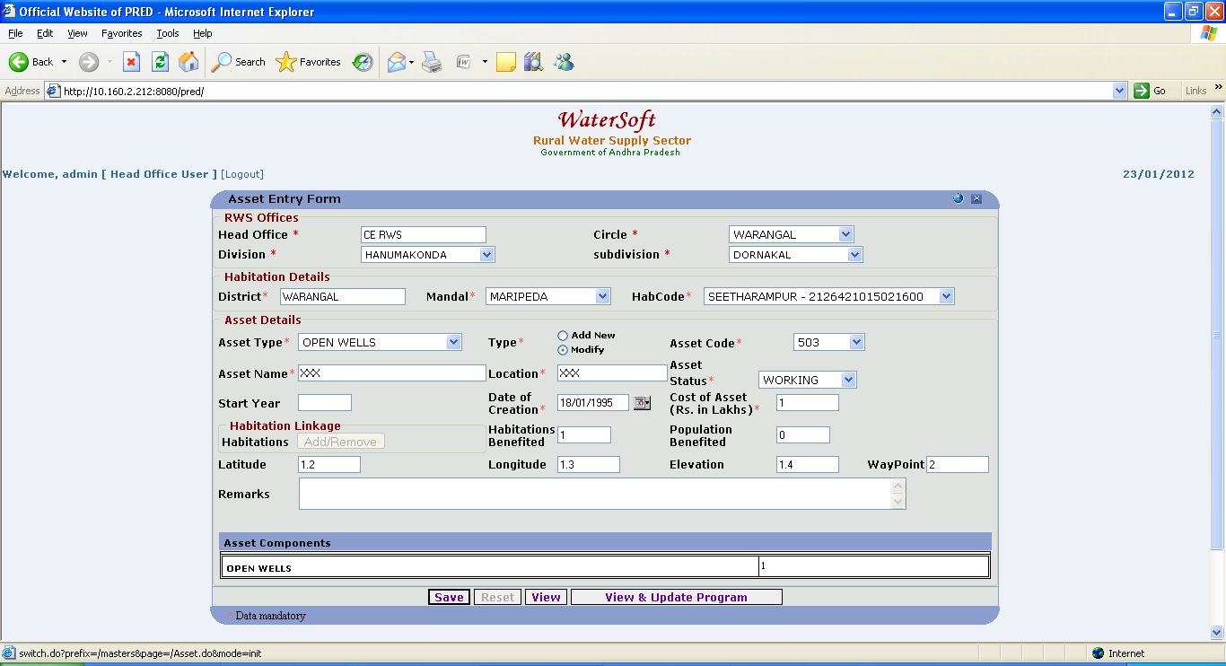

Figure 79.

OPENWELLS
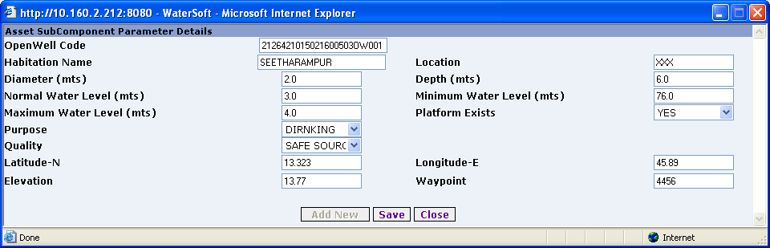
Figure 80.

Save

- OpenWell code is auto generated.
- Enter Diameter. (mts ).
- Enter Normal Water Level. (mts )
- Enter Maximum Water Level. (mts ).
- Enter Purpose.
- Select Quality.( For Eg. NSS , SAFESOURCE ).
- Enter Contamination Details ( only when WaterQuality selected as NSS ).
- Enter Location.
- Enter Depth.( mts ).
- Enter Minimum Water Level. ( mts ).
- Select Platform Exists.
- Enter Latitude.
- Enter Longitude.
- Enter Elevation.
- Enter Waypoint.
- Click on ‘Save’ button.

Note:-If Quality is Selected as NSS the following screen shot explain the process of entering data – Contamination details should be Entered. Water Quality is Selected as SAFE SOURCE - Contamination Details are not Required.

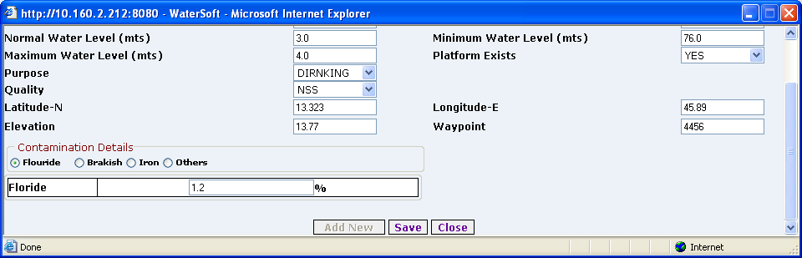
Figure 81.

Close

- Click on ‘Close’ button.

PONDS

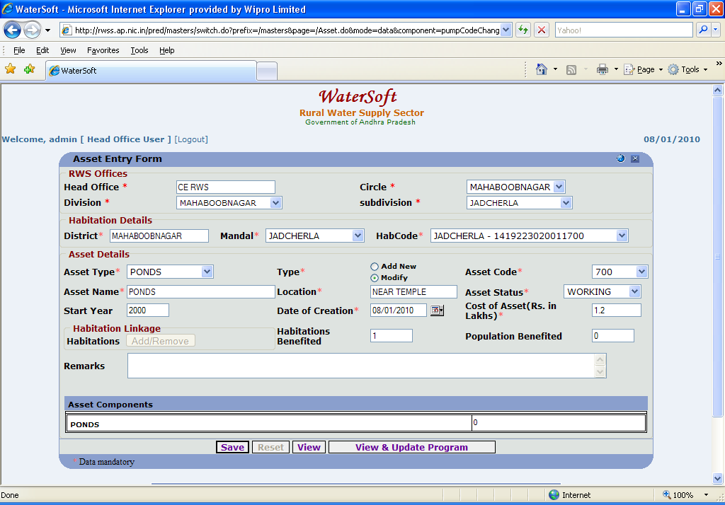
Figure 82.

PONDS

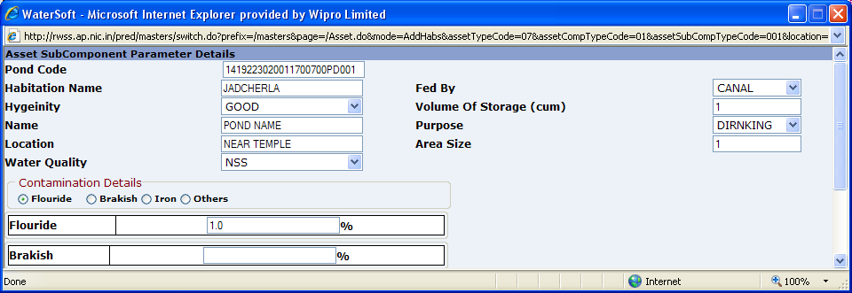
Figure 83.

Save

- Pond code is auto generated.
- Enter Habitation Name
- Select Hygeinity.
- Enter Name.
- Enter Location.
- Enter Area Size.
- Select Water Quality.( For Eg. NSS , SAFE SOURCE ).
- Enter Contamination Details ( only when Water Quality selected as NSS )
- Select Fed By.
- Enter Volume Of Storage( cum ).
- Select Purpose.
- Click on ‘Save’ button.

Note:-If Water Quality is Selected as NSS the following screen shot explain the process of entering data – Contamination details should be Entered. Water Quality is Selected as SAFE SOURCE - Contamination Details are not Required.

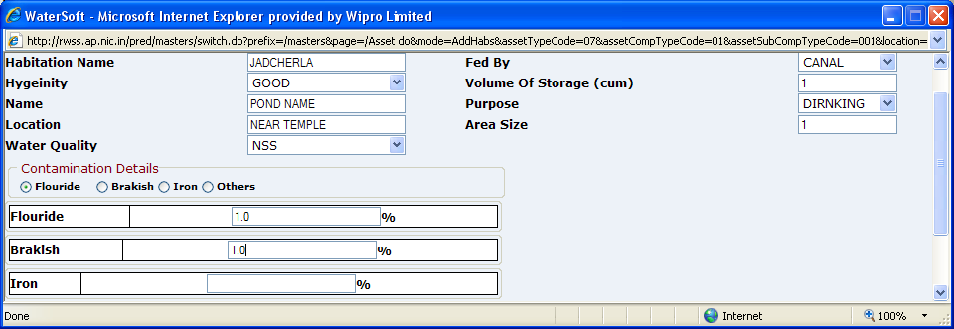
Figure 84.

Close

- Click on ‘ Close’ button.

SHALLOW HANDPUMPS
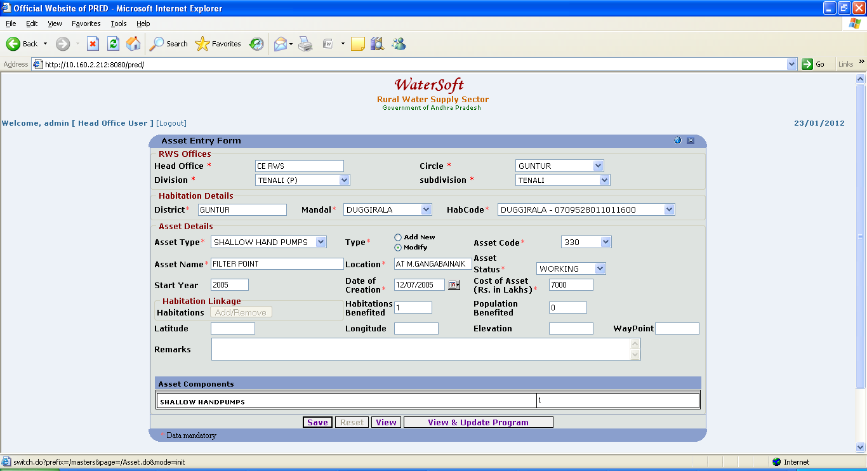
Figure 85.

SHALLOW HANDPUMPS
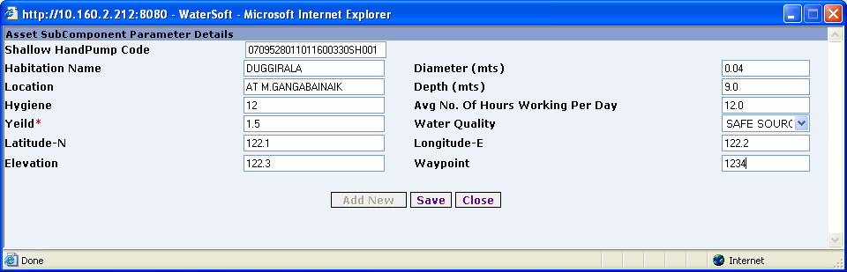
Figure 86.

Save

- Shallow HandPump code is auto generated.
- Select Habitation Name.
- Enter Diameter ( mts ).
- Enter Hygiene.
- Enter Location.
- Enter Depth. ( mts ).
- Enter Avg No. of Hours Working Per Day.
- Enter Yeild.
- Select Water Quality. ( For Eg. NSS , SAFESOURCE ).
- Enter Contamination Details ( Only when WaterQuality selected as NSS ).
- Enter Latitude.
- Enter Longitude.
- Enter Elevation.
- Enter Waypoint.
- Click on ‘Save’ button.

Note:-If Water Quality is selected as NSS – the following screen shot explain the process of entering Contaminations details .If WaterQuality is selected as SAFESOURCE – No need of entering contamination details.
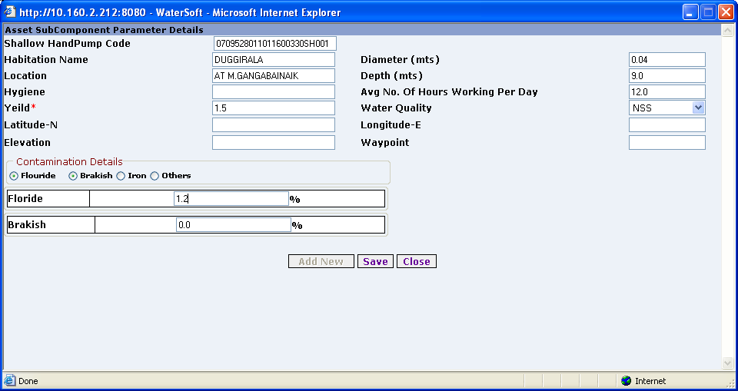
Figure 87.

Close

- Click on ‘Close’ button.

OTHERS
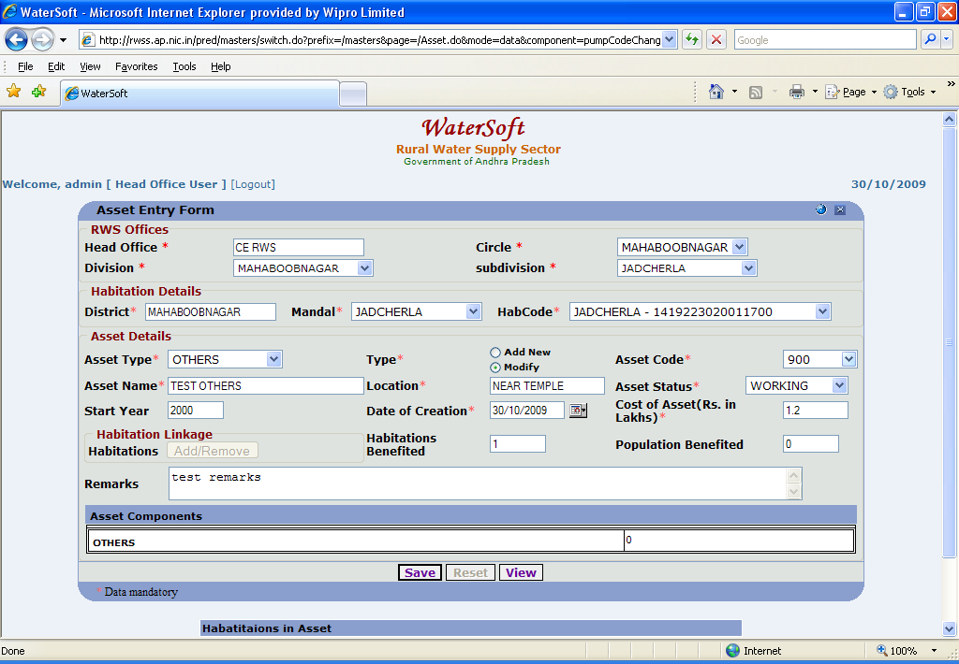
Figure 88.

OTHERS

AddNew

- Select District.
- Select Mandal.
- Select Habitation Code.
- Click ‘ Save ‘ button.

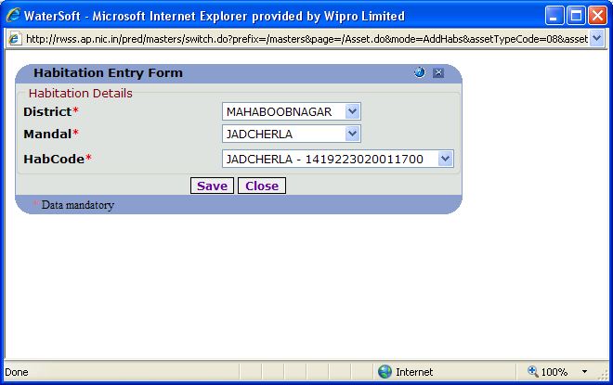
Figure 89.

OTHERS

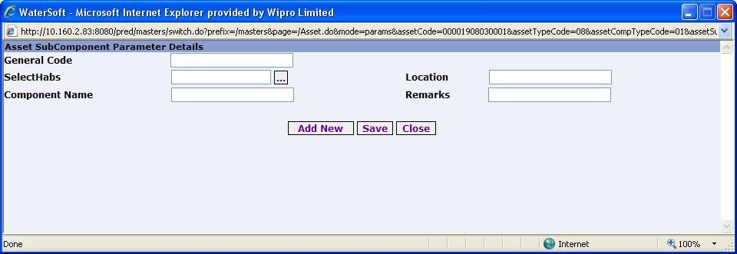
Figure 90.

Save

- General Code is autogenerated.
- Select SelectHabs
- Enter Component Name.
- Enter Location.
- Enter Remarks.
- Click ‘ Save ‘ button.

Close
- Click ‘ Close ‘ button.

Note:-

- Same Operations are Applicable for PWS,MPWS,DIRECT PUMPING.
- Only Difference is Selection of AssetType.

