Masters - > Panchayat Entry

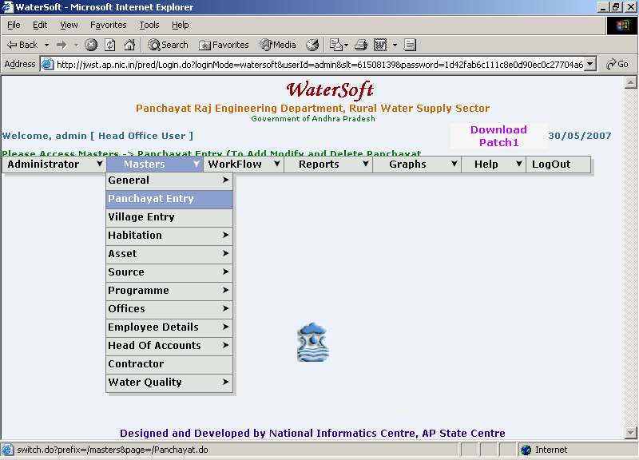

To Add New Panchayat

Add New

- Select District.
- Select Mandal.
- Click ‘Add New’ button.

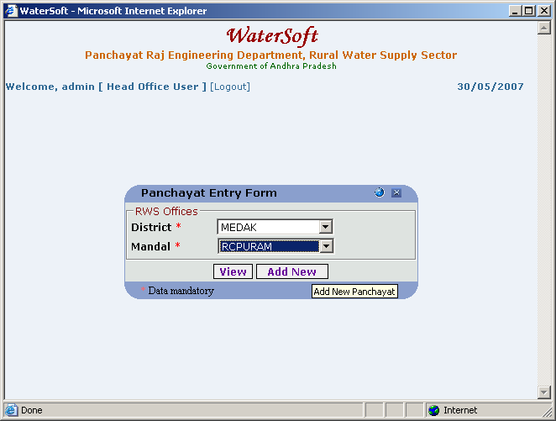

Note:- After Clicking on Add New button – Panchayat Entry Form is displayed

Panchayat Entry Form

Save

- Select District.
- Select Mandal.
- Enter Panchayat Code.
- Enter Panchayat Name.
- Click ‘Save’ button.

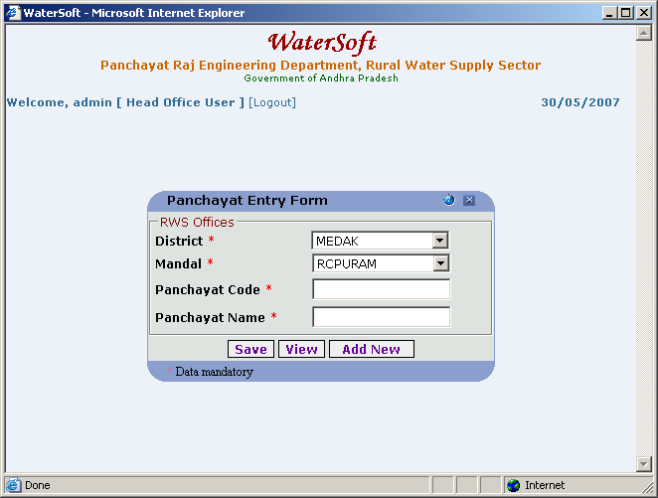

To View Panchayats

Panchayat Entry Form

View

- Select District.(For Eg. Medak)
- Select Mandal.(For Eg. RCPURAM).
- Click ‘View’ button.

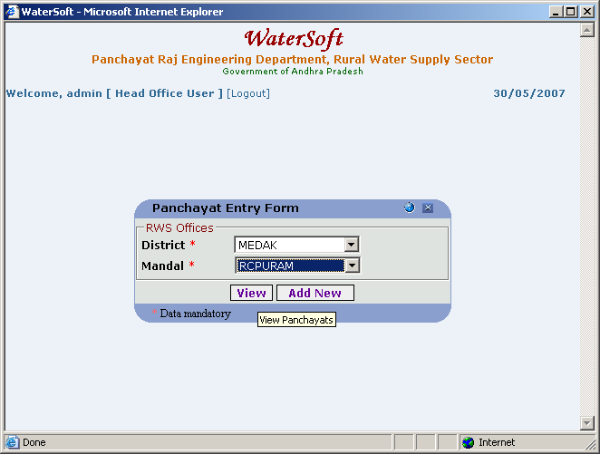

To View the Panchayat List

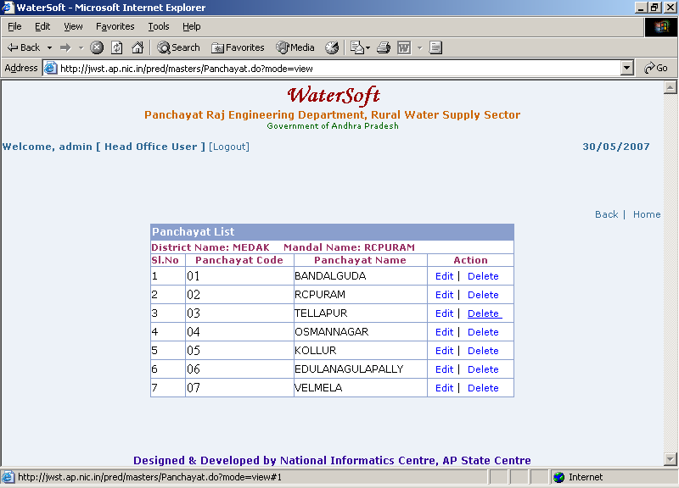

Note I:- In Action – Select Edit to make Modifications for Selected Panchayat – Panchayat Entry Form is displayed.

Note II :-In Action – Select Delete to delete Selected Panchayat.

Panchayat Entry Form

Save

- Select District.
- Select Mandal.
- Panchayat Code is Fixed.
- Enter Panchayat Name.
- Click ‘Save’ button.

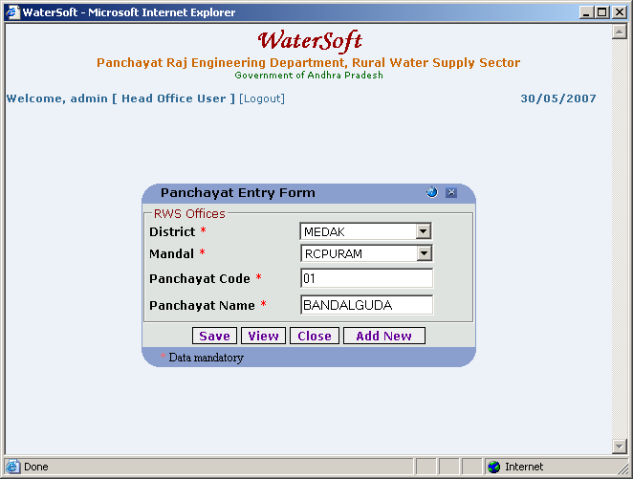

Close

- Click ‘Close’ button.

Masters - > Village Entry

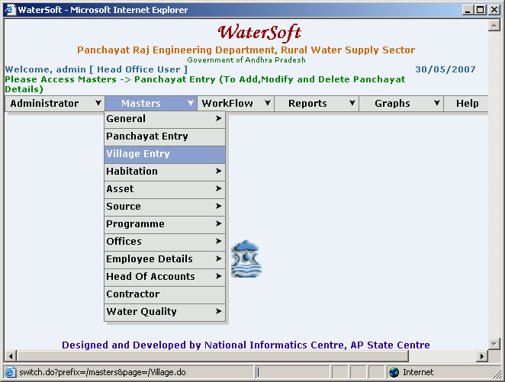

To Add New Villages

Add New

- Select District.
- Select Mandal.
- Select Panchayat.
- Click ‘Add New’ button.

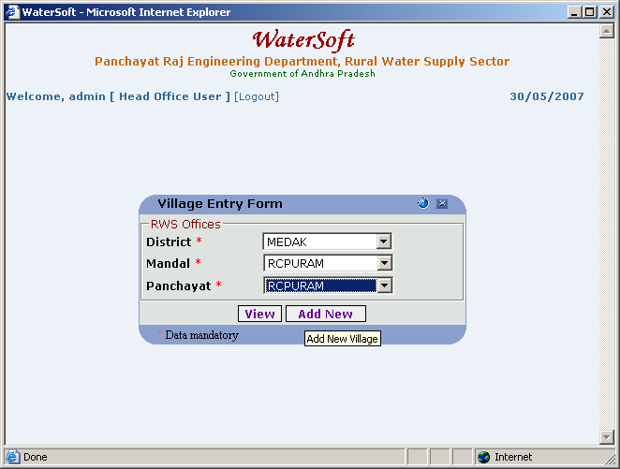

Village Entry Form

Save

- Select District.
- Select Mandal.
- Select Panchayat.
- Enter Village Code.
- Enter Village Name.
- Click ‘Save’ button.

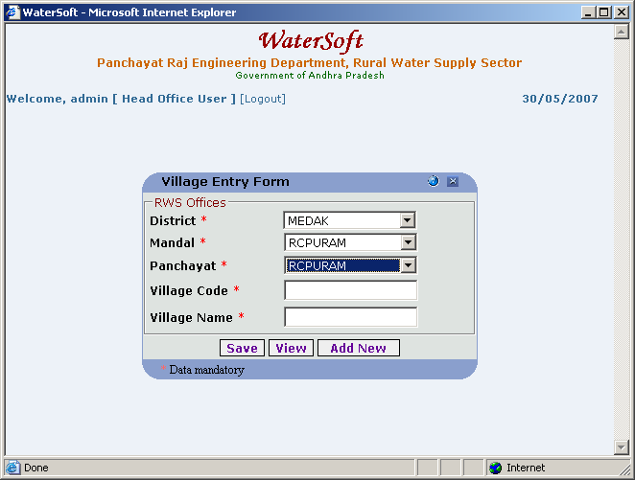

To View the Villages

Village Entry Form

View

- Select District.
- Select Mandal.
- Select Panchayat.
- Click ‘View’ button.

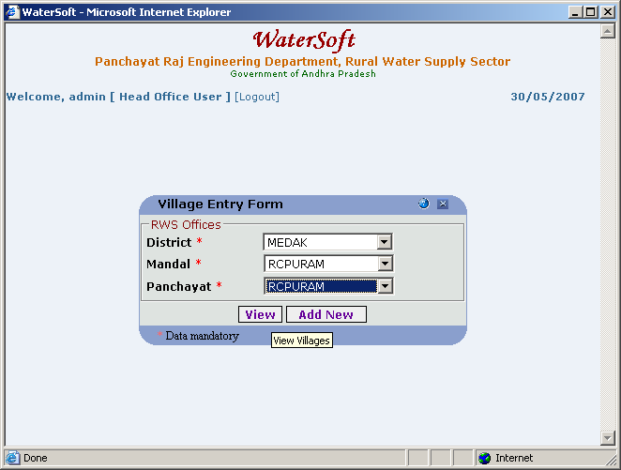

To View Village List

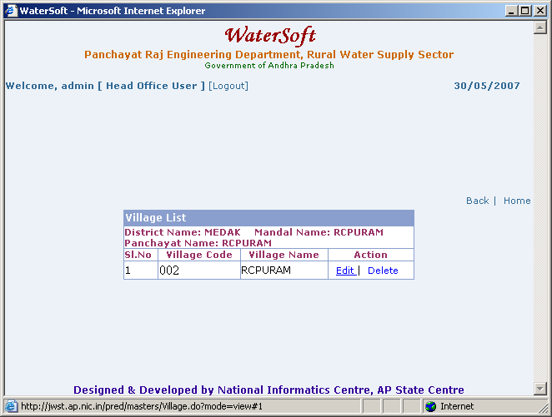

Note I:-In Action – Select Edit to make modifications for selected Village - Village Entry Form is displayed.

Note II:-In Action – Select Delete to delete selected Village.

Village Entry Form

Save

- Select District.
- Select Mandal.
- Select Panchayat.
- Village Code is Fixed.
- Enter Village Name.
- Click ‘Save’ button.

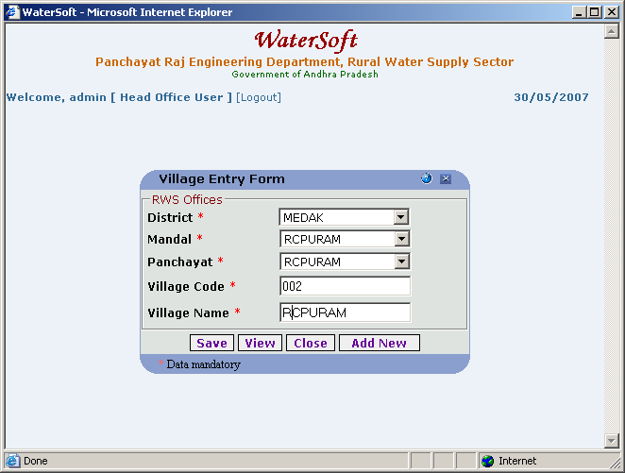

Close

- Click ‘Close’ button.

