USER MANUAL FOR SCHEME INTEGRATION WITH ASSET

WaterSoft Phase II

(For the Department of Panchayati Raj & Engineering Department, Rural Water Supply Sector, Govt. of AP)

National Informatics Centre
Department of Information Technology
Ministry of Communications and Information Technology
Government of India
WebSite : www.ap.nic.in

PREPARED BY :

PROJECT TEAM ,
APDVIII, NIC APSC,
HYDERABAD.

REVIEWED BY:

HEAD OF THE DEPARTMENT,
APDVIII, NIC APSC,
HYDERABAD.

APPROVED BY :

STATE INFORMATICS OFFICER
NIC APSC,
HYDERABAD.

Amendment Log

Version Number | Date | Change Number | Brief Description | Sections Changed
1.0 | 22-04-2010 | - | First Release

Sl No | CONTENTS | Page No
1 | Common Operations in the Software | 5
2 | Scheme Integration with Asset | 6 - 15

Common Operations in the Software:

Click the button to close the Form.

 Click the button for online context help.

Home Click the button for Main Page.

Back Click the button for Previous page.

Print Click the button for Printable Version.

Excel Click the button for Excel Version.

Amount will be considered in Lakhs throughout the Software

Fields marked with ‘ * ‘ are Mandatory Fields.

Selection of Circle , Division is fixed depending on User Login.

Scheme Asset Integration

Works Flow->Works Monitoring->Scheme Asset Integration

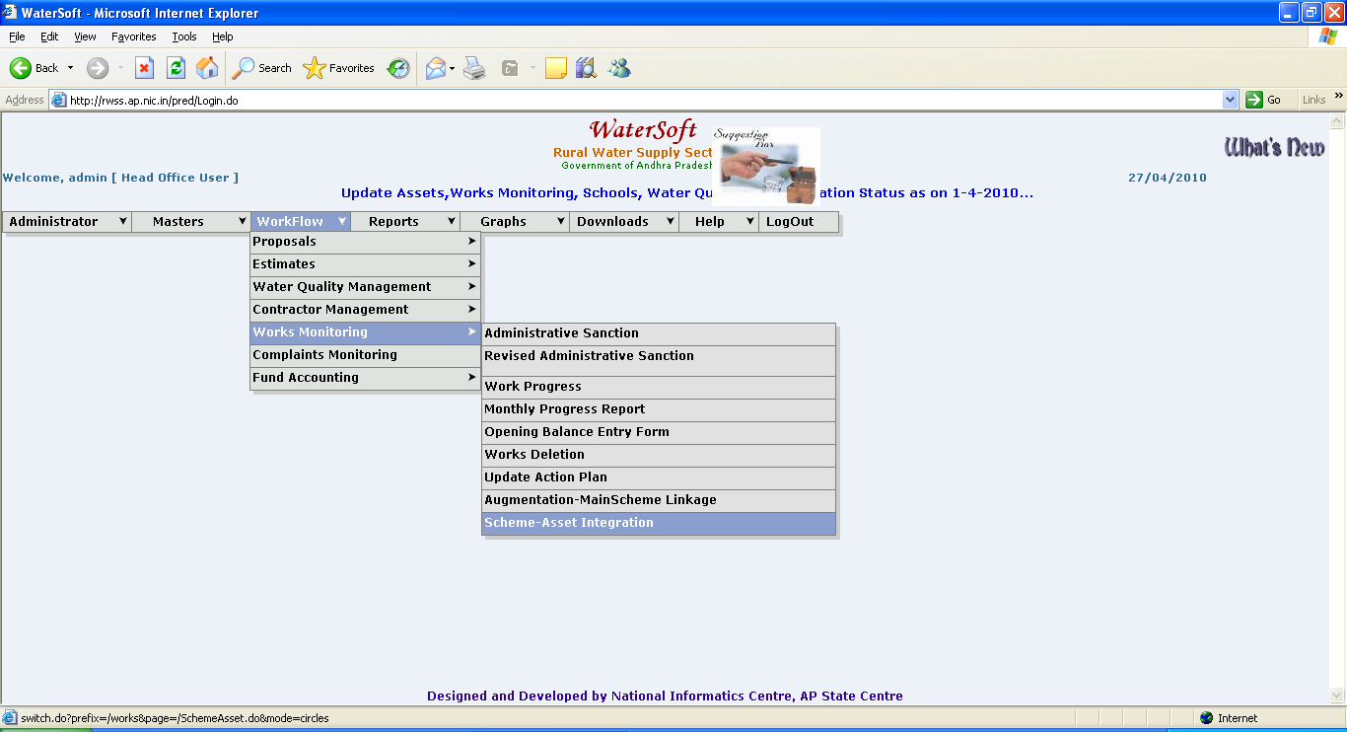
Figure 1.

Basic operation required for entering data

- Select Circle.
- Select Division.
- Select SubDivision.
- Select Plan or Non Plan.
- Select Main Scheme or Augumentation.( For Eg Main Scheme ).
- Select Work Category (For Eg. Normal , District Level , Projects ).
- Select Programme.
- Select SubProgramme.
- Select Commissioned Works (only works that are physically completed and commissioned are displayed).

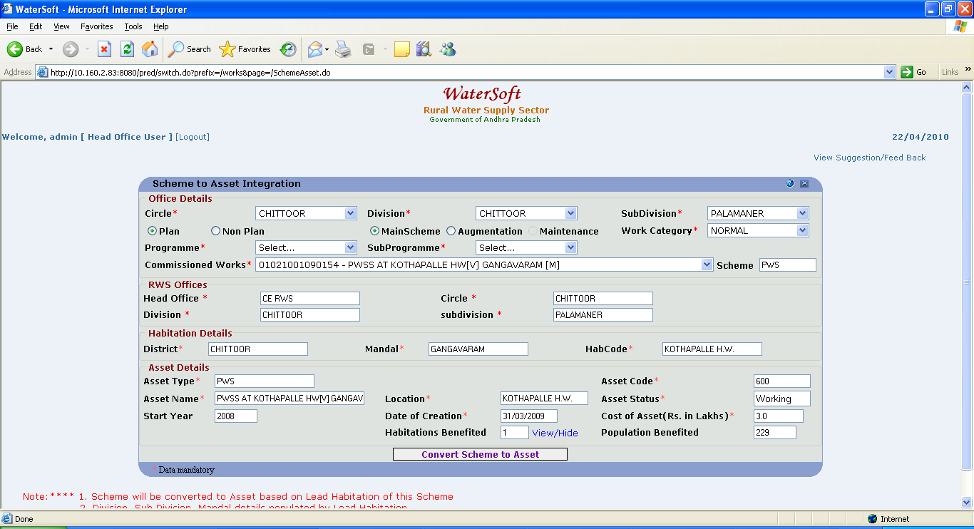
Figure 2.

Case 1: When lead Habitation is present – The data relevant to the scheme is populated. There is only one editable field i.e., Location which by default is habitation name , the user may change based on the requirement.

- For Mainscheme Works – Conversion process

Convert Scheme to Asset

- Click ‘ Convert Scheme to Asset ’ button. (in Figure 2.)

Note:- Click ‘ Convert Scheme to Asset ‘ button –>Message displayed ’ Do you want to convert scheme to Asset’-> Click ‘ OK ’ to convert-> Message displayed ‘ Scheme successfully converted to Asset Please Add Subcomponents ’ Screen shot similar to (Figure 5.) is displayed.

(The following screen shots (Fig. 3 , Fig. 4 , Fig. 5 , Fig. 5) explain the series of steps involved in converting scheme to asset )
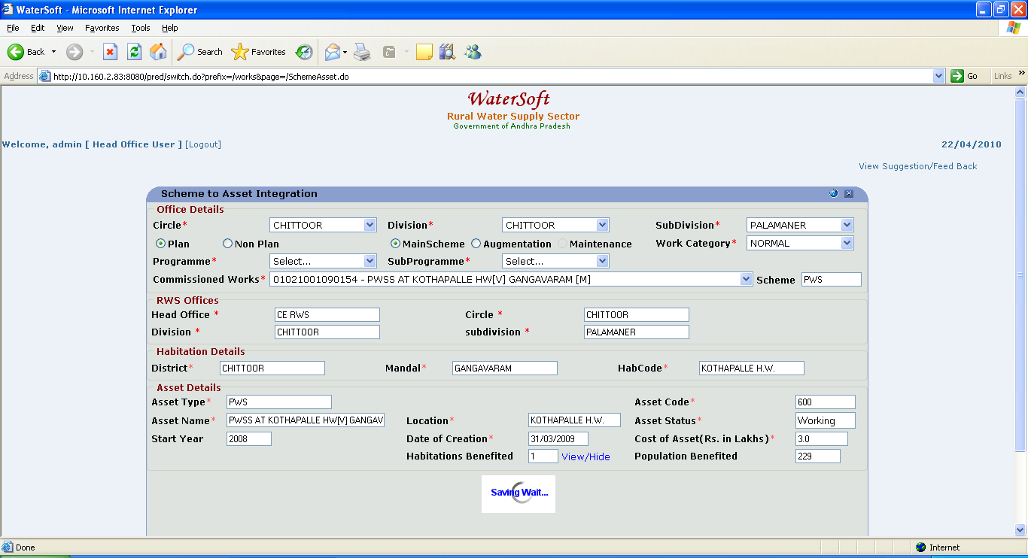
Figure 3.

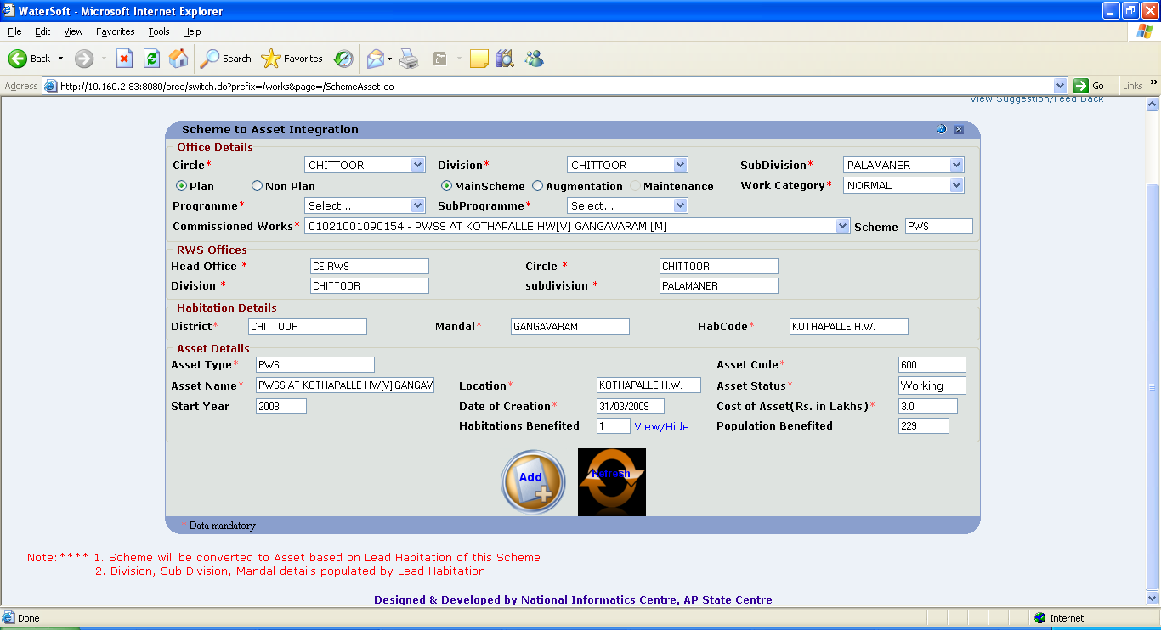
Figure 4.

Note:-Click ‘ Add ‘ button to Add Subcomponents.( This screen is similar to Asset management screen)

Note:-Click ‘ Add ‘ button->The following screen shot ( Figure 5. ) is displayed.

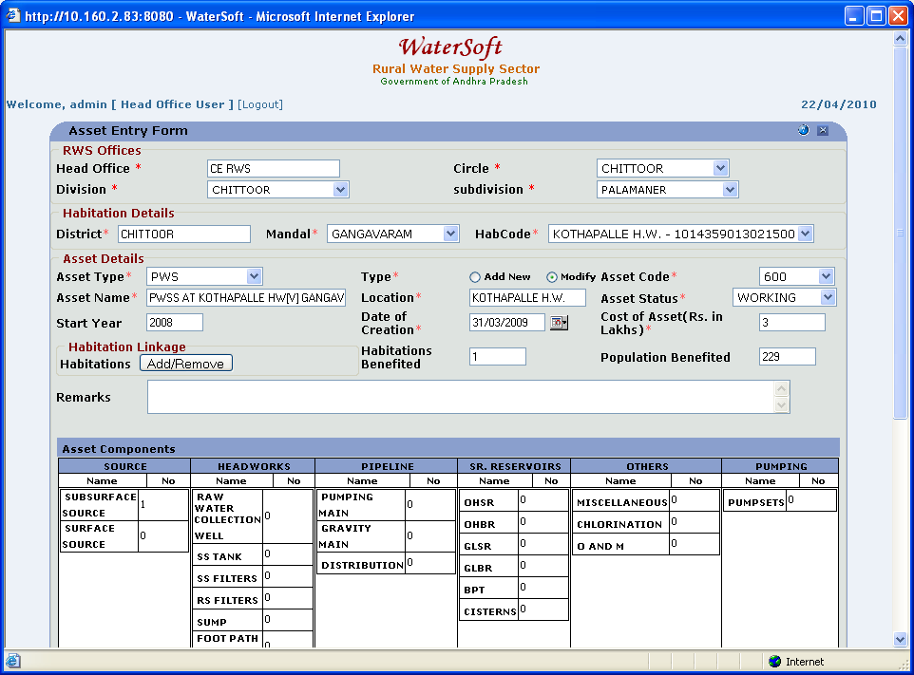
Figure 5.

Note:-Select any Subcomponent -> Enter data for selected subcomponent -> Screen shot similar to (Figure 6.) is displayed.

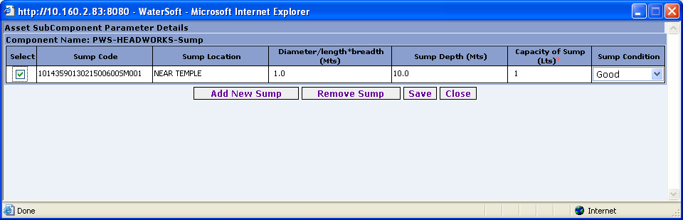
Figure 6.
Note:-Click ‘ Refresh ‘ button ( Fig. 4 ) -> Total number of subcomponents for onverted Asset are displayed
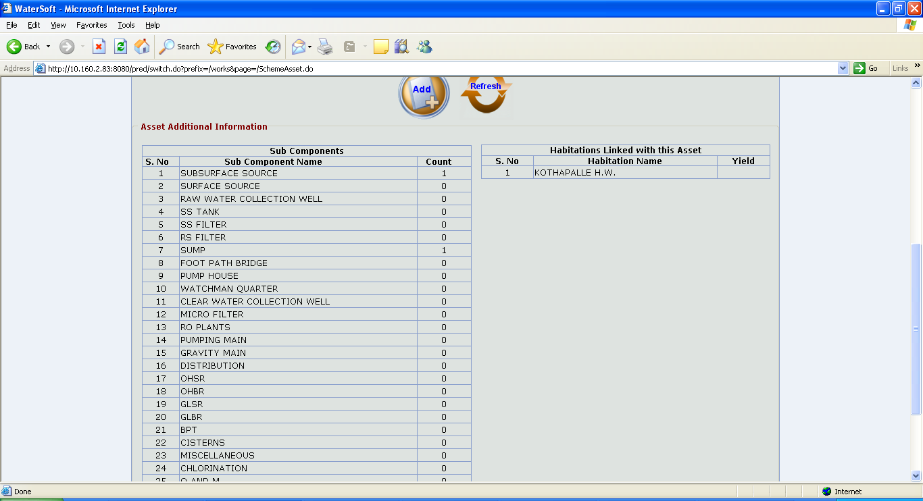
Figure 7.

Case 2:When lead Habitation is not present for commissioned work

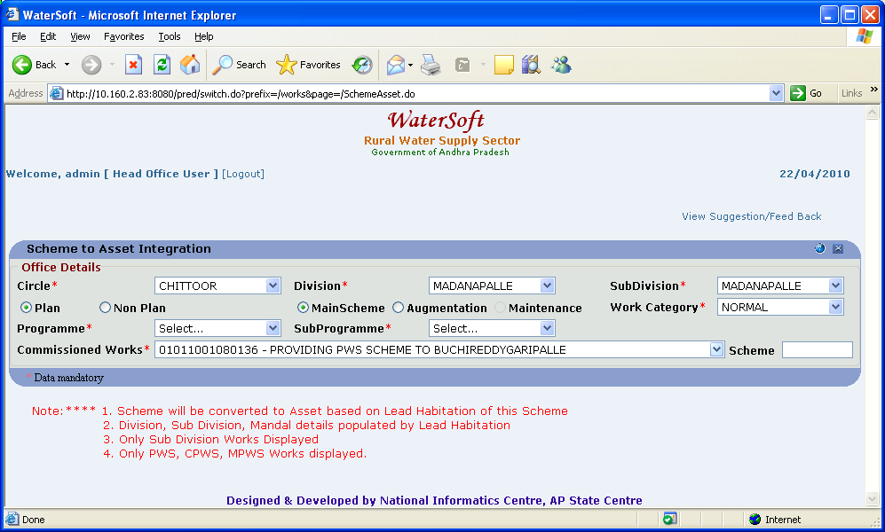
Figure 8.

Case 2 :If Lead Habitation is not present for Commissioned Work then a Message displayed ‘ Unable to convert Scheme – Please Select Lead Habitation ‘.

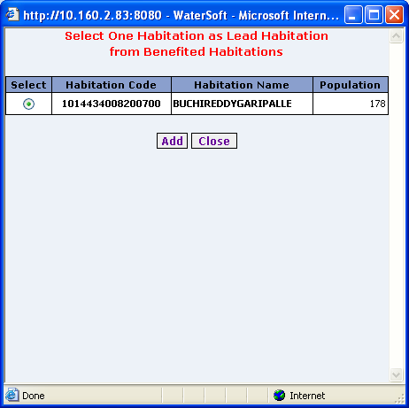
Figure 9.

Add

- Select one Habitation as Lead Habitation.
- Click ‘ Add ’ button.

Close

- Click ‘ Close ’ button.

- For Augmentation Works – Conversion process

Case 1: When augmentation work is to be treated as new work ->
Process is the same as that of conversion to main scheme explained earlier in ( A. For Mainscheme Works Conversion process )

Case 2 : When augmentation work is not linked to any main scheme
->Select Work Flow → Works Monitoring → Augmentation-Main Scheme Linkage and link the augmentation work to main scheme.

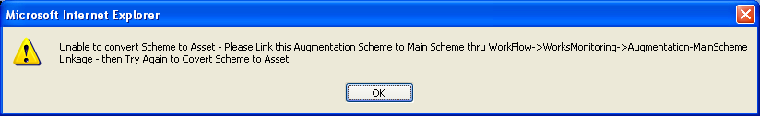

Case 3: When augmentation work is linked to mainscheme but the linked main scheme is not converted to asset

First convert the main scheme to asset as explained above in ( A. For Mainscheme Works Conversion process )



Now the augmentation conversion for mainscheme can be done by adding components of the augmentation work to the main scheme work . The cost of the asset now will be projected as main scheme + augmentation cost.

