USER MANUAL FOR WORKS AND ASSETS MOBILE APP

WaterSoft

(For the Department of Panchayat Raj & Engineering Department, Rural Water Supply Sector, Govt. of AP)

National Informatics Centre
Department of Information Technology
Ministry of Communications and Information Technology
Government of India
WebSite : www.ap.nic.in

PREPARED BY :

PROJECT TEAM ,
NIC APSC,
HYDERABAD.

REVIEWED BY:

HEAD OF THE DEPARTMENT,
NIC APSC,
HYDERABAD.

APPROVED BY :

STATE INFORMATICS OFFICER
NIC APSC,
HYDERABAD.

Common Operations in the Software:

Click the button to close the Form.

 Click the button for online context help.

Home Click the button for Main Page.

Back Click the button for Previous page.

Print Click the button for Printable Version.

Excel Click the button for Excel Version.

Amount will be considered in Lakhs throughout the Software

- Registration Form(RWSS):

Mobile →Mobile Entry→ Registration Form:

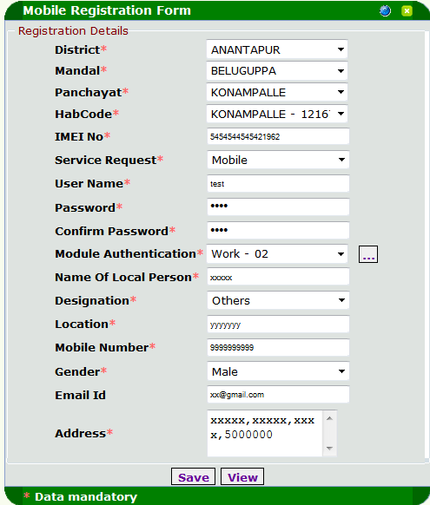

- Select District, Mandal, Panchayat and HabCode(all are mandatory)
- Enter 1st slot IMEI no
- Select Service Request as “Mobile” for Mobile Apps and “SMS” for sms and “Both” for both Apps and sms.
- Enter Username,Password,Confirm Password
- Select Mobile Authentication as “Works and Assets-02”
- Select Designation
- Enter location (within the habitation)
- Enter 10 digit mobile no eg : 9899999999
- Select Gender
- Enter Email id
- Enter Address of the local person
- Click “Save” Button to save the data

Note:
1. * Indicates mandatory column
2. Only one mobile registration is allowed for a habitation
3. For IMEI Number Dial *#06# on your Phone or Tab.

2.Works and Assets Mobile App installation:

Mobile →SMS & Mobile Reports →Detailed Reports →

Find the link as “Download Works and Assets Mobile App”

→ Install the downloaded .apk in your android tab (or) Mobile

3.WORKS AND ASSETS (MOBILE APP INTERFACE SCREENS):

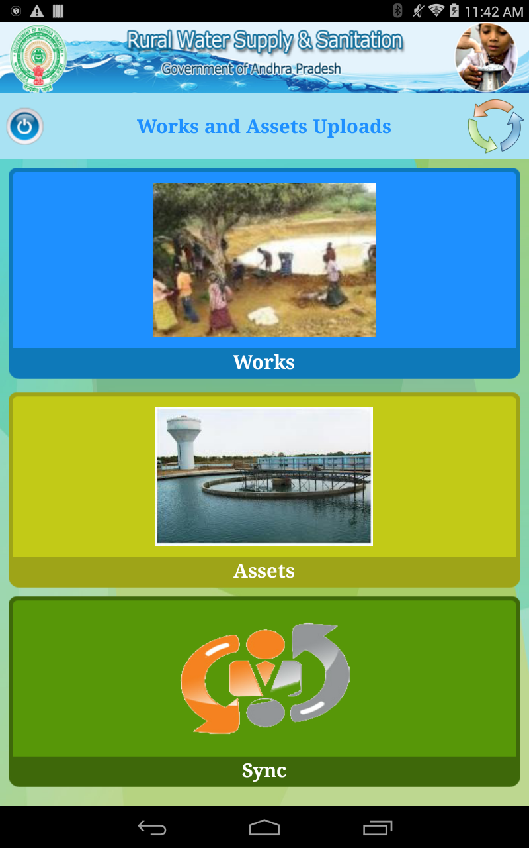
1.After installation you should click on this icon (this is one time operation which is mandatory to download the habitations , tanker , sources or assets data to the local server)
2. Mandatory : You should enable GPS to get the latitude and longitude of that particular place.
3.Select Assets for upload asset image or component image.
4.Select Works for upload work image.

For Assets:

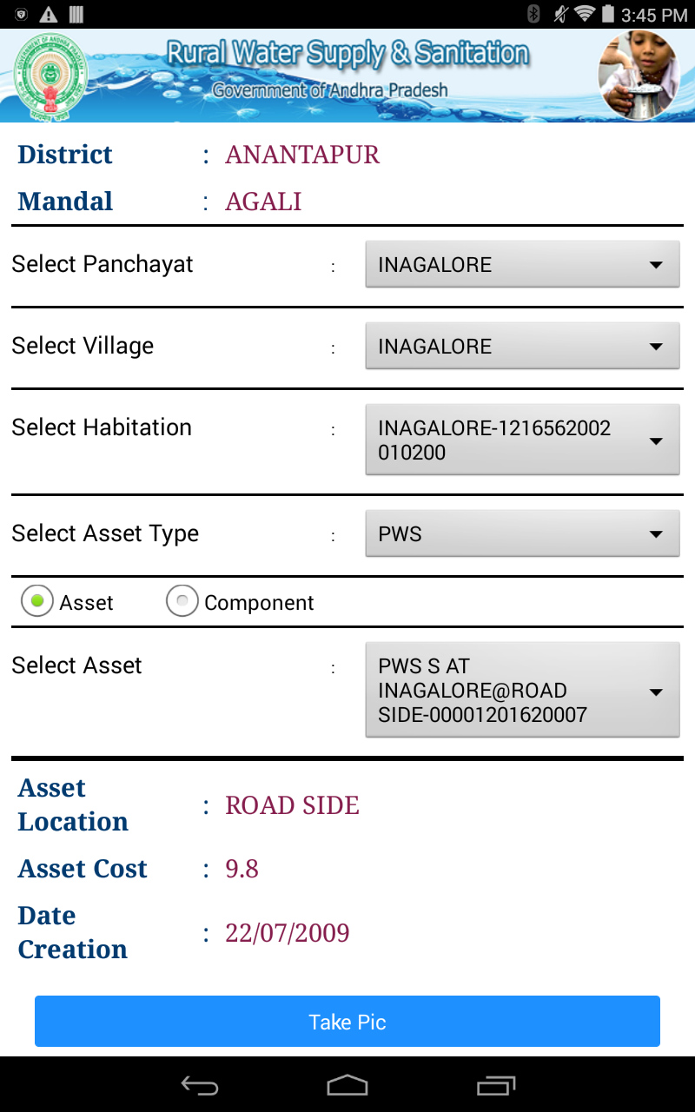

- Select Panchayat.
- Select Village
- Select Habitation
- Select Asset Type
- Check Asset
- Select Asset
- Click “Take Pic” button to capture asset image and upload that image.

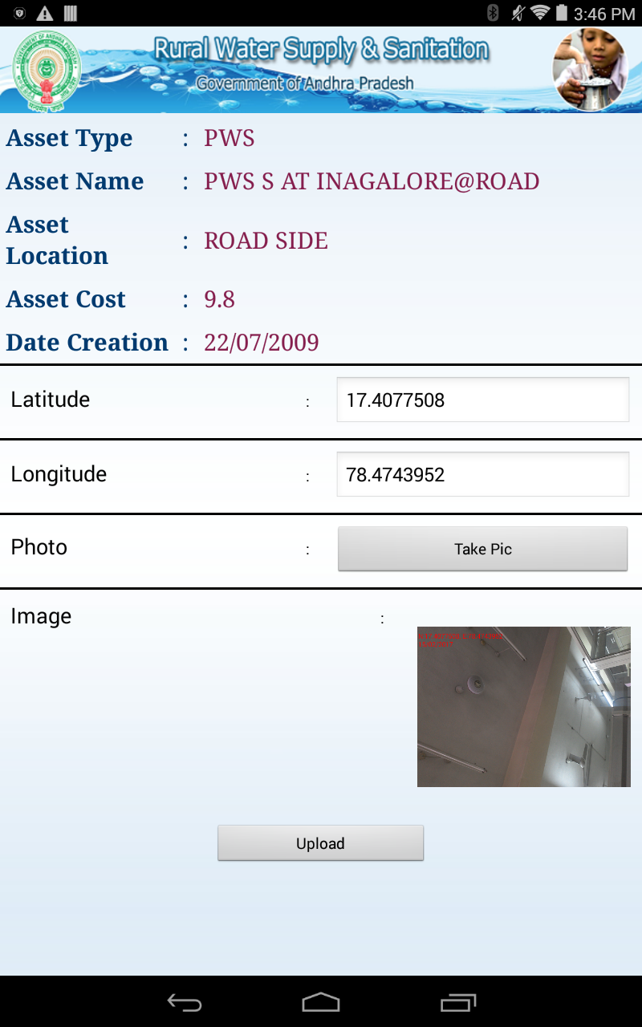

8. Click “Take Pic” button to capture the image
9. To upload image click “Upload” button.

For Components:

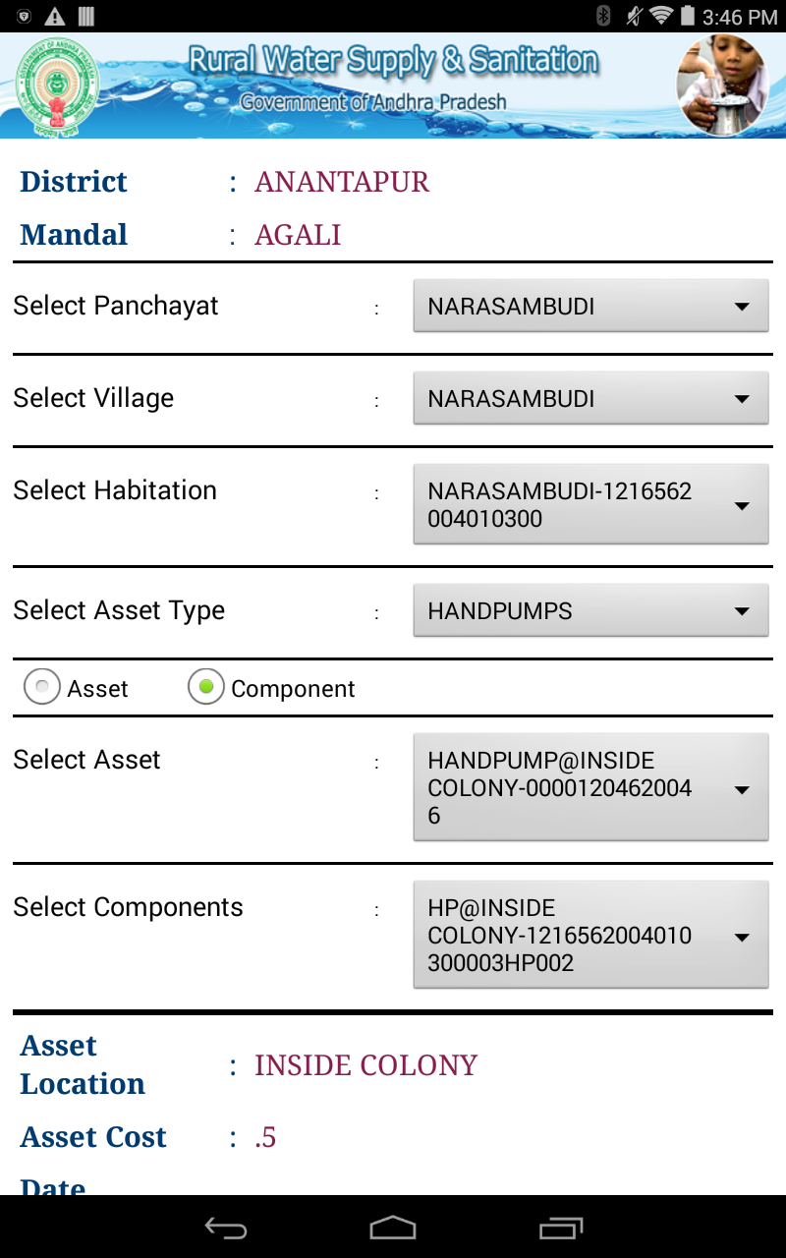

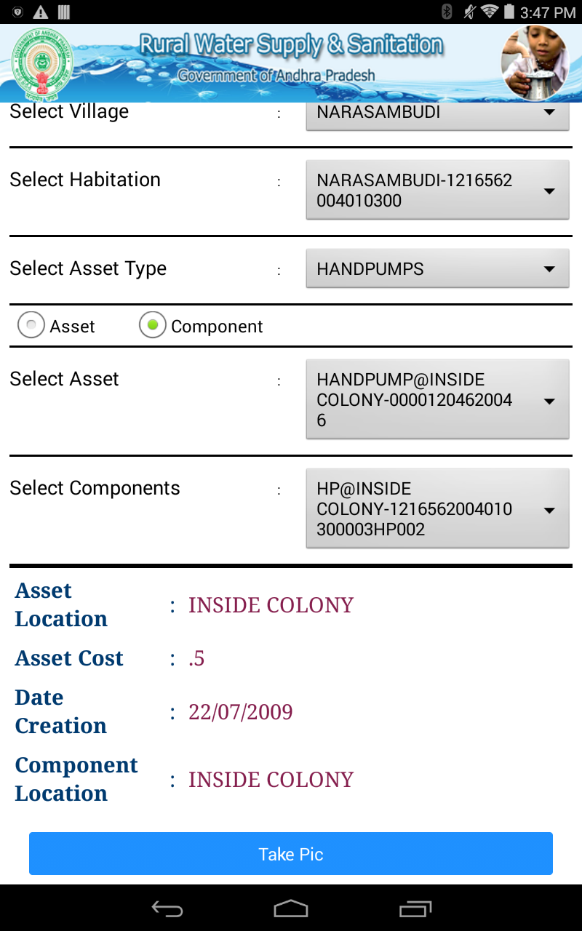

- Select Panchayat.
- Select Village
- Select Habitation
- Select Asset Type
- Check Component
- Select Components
- Click “Take Pic” to capture component image and upload that image.

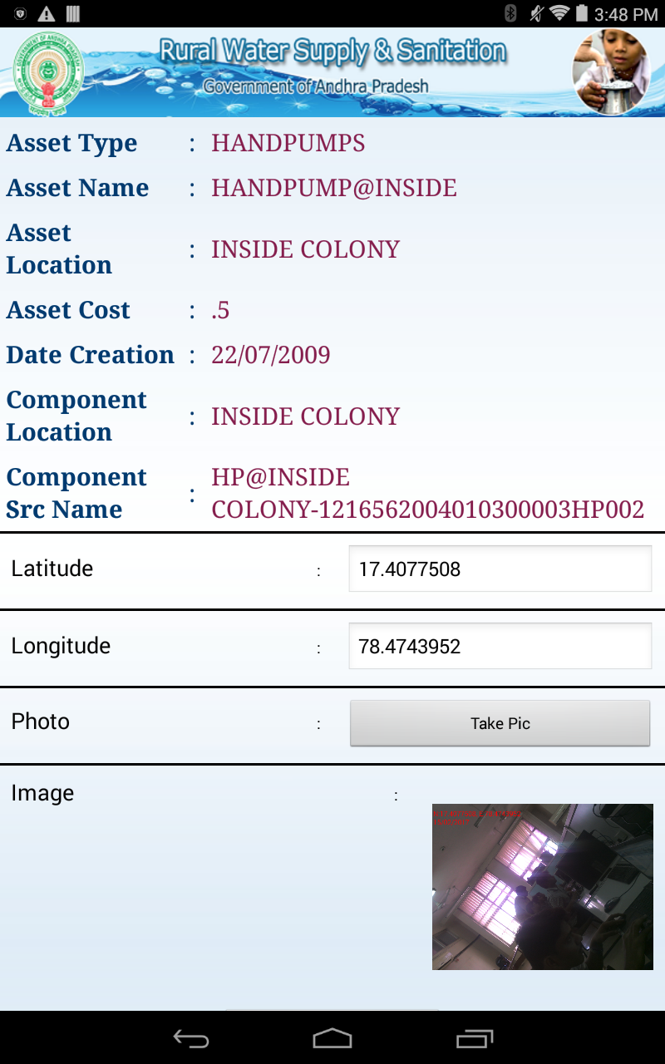

8. Click “Take Pic” button to capture image
9. To upload image click “Upload” button.

For Woks:

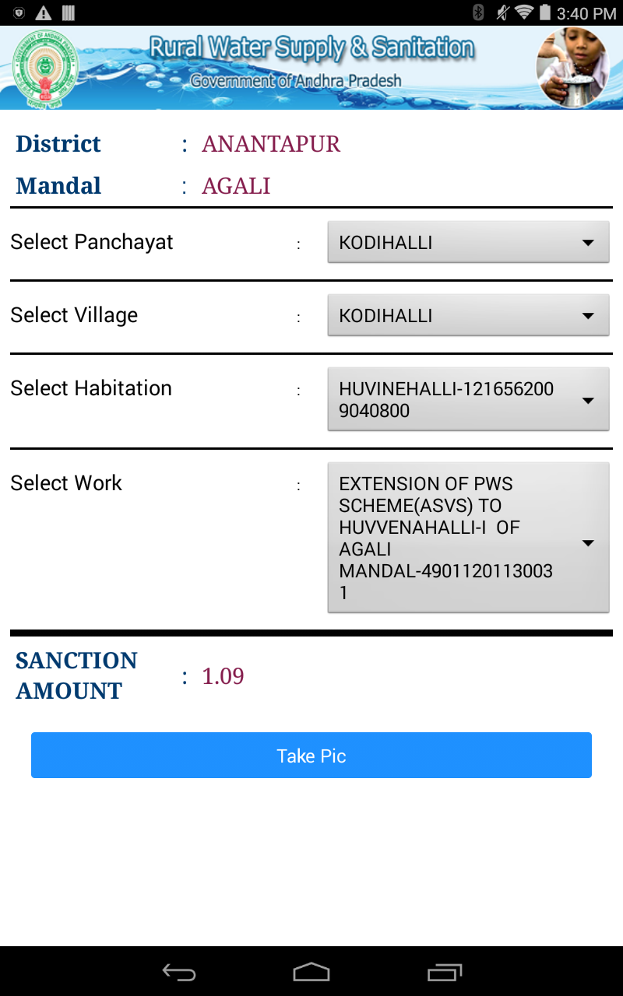

- Select Panchayat.
- Select Village
- Select Habitation
- Select Work
- Click “Take Pic” to capture work image and upload that image .

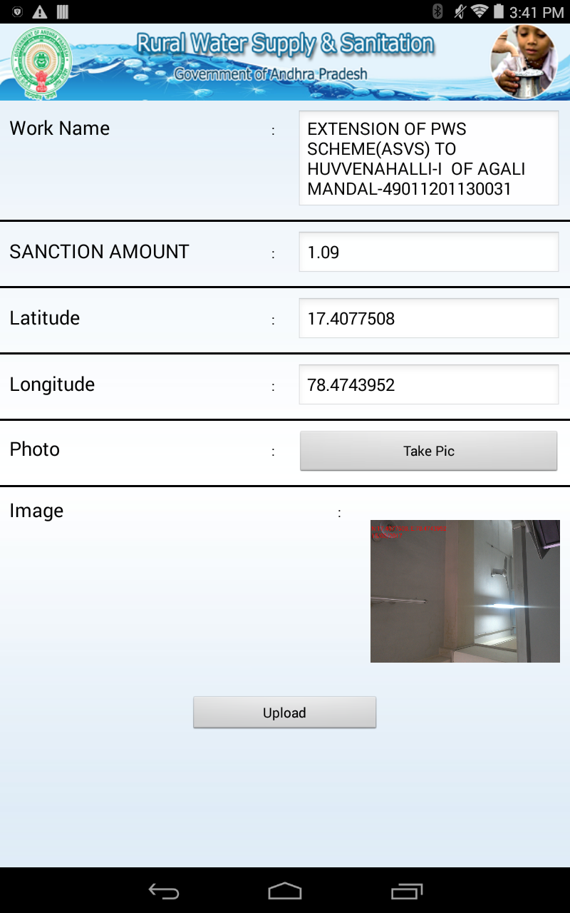

8. Click “Take Pic” button to capture image
9. To upload image click “Upload” button.

