To disable the pop-up blocker(Enabling the Pop-up Windows) in Internet Explorer
- Open the Tools menu, select the Pop-up Blocker option
- Select the Turn Off Pop-up Blocker option (as shown below):
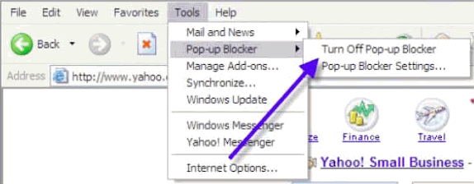
Once this is done, then you should be able to use the online system properly and you are allowed to view POP-UP windows.

