USER MANUAL FOR FUND ACCOUNTING

WaterSoft

(For the Department of Rural Water Supply Sector and Sanitation , Govt. of AP)

National Informatics Centre
Department of Information Technology
Ministry of Communications and Information Technology
Government of India
WebSite : www.ap.nic.in

PREPARED BY :

PROJECT TEAM ,
APDVIII, NIC APSC,
HYDERABAD.

REVIEWED BY:

HEAD OF THE DEPARTMENT,
APDVIII, NIC APSC,
HYDERABAD.

APPROVED BY :

STATE INFORMATICS OFFICER
NIC APSC,
HYDERABAD.

Amendment Log

Version Number | Date | Change Number | Brief Description | Sections Changed
1.0 | 13.09.2010 | - | First Release

Sl No | CONTENTS | Page No
1 | Common Operations in the Software | 5
2 | Bro Details Entry Form (Accessed By HeadOffice user) | 6 - 10
3 | Loc Details Entry Form (Accessed By HeadOffice user) | 11 – 17
4 | Bills (Accessed by DAO & EE ) | 18 - 22
5 | Vouchers (Accessed by DAO & EE ) | 23 - 37

Common Operations in the Software:

Click the button to close the Form.

 Click the button for online context help.

Home Click the button for Main Page.

Back Click the button for Previous page.

Print Click the button for Printable Version.

Excel Click the button for Excel Version.

Note : Amount is to be considered in Rs lakhs

Fields marked with ‘ * ‘ are mandatory Fields

BRO:Budget Release Order

Note :-

- Budget Release Order (BRO) and Letter of Credit (LOC) Forms are accessed only by Head Office User with their respective userid and password.

WorkFlow->Fund Accounting->BRO details

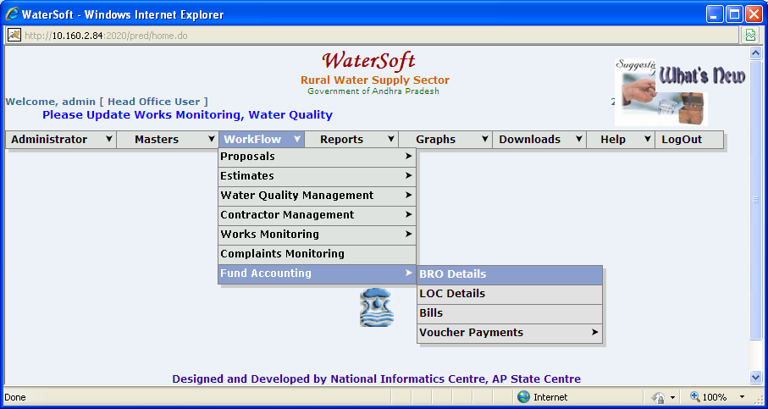
Figure 1.

BRO Details Entry form

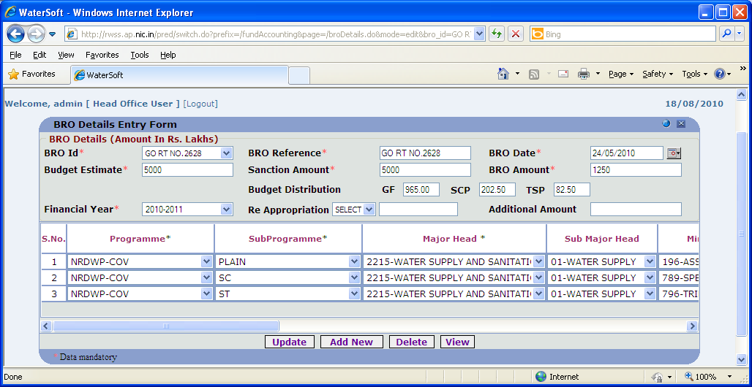
Figure 2.

AddNew

- Click ‘ Add New ’ button to add brodetails

Common operations for adding New BRO details

- Enter Bro Id.
- Enter BRO Reference.
- Select BRO Date.
- Enter Budget Estimate.
- Enter Sanction Amount.
- Enter BRO Amount.
- Budget Distribution will be done automatically.
- Select Financial Year.
- Select Re Appropriation ( ‘ + ‘ , ‘ - ‘)
- Enter Additional Amount.

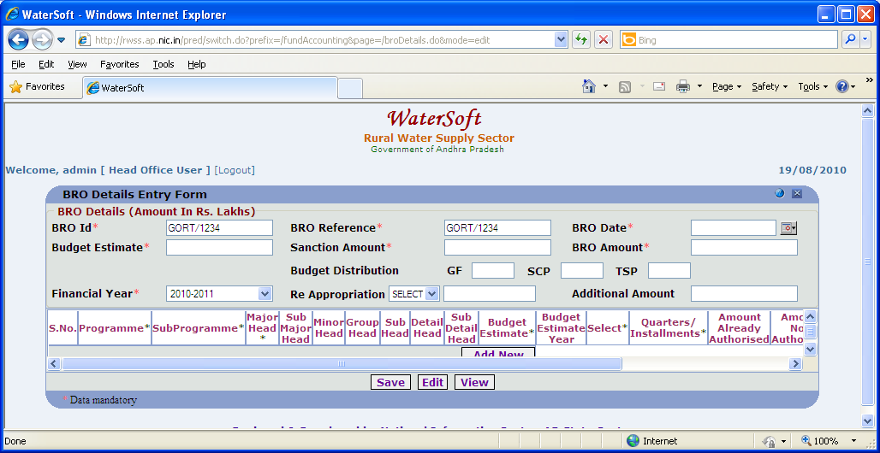
Figure 3.

Save

- Select Programme.
- Select SubProgramme.
- Select Major Head.
- Select Sub Major Head.
- Select MinorHead.
- Select GroupHead.
- Select SubHead.
- Select DetailHead.
- Select SubDetailHead.
- Enter Budget Estimate.
- Budget Estimate Year is fixed.
- Select Select ( State , Central ).
- Select Quarterly installments.
- Enter Amount Already Authorized.
- Enter Amount now Authorised.
- Enter Procedure of Drawl.
- Enter Drawing Officer.
- Enter Remarks.
- Click ‘ Save ‘ button.

Update

- Click ‘ Update ‘ button

View

- Click ‘ View ‘ button

Bro details are displayed

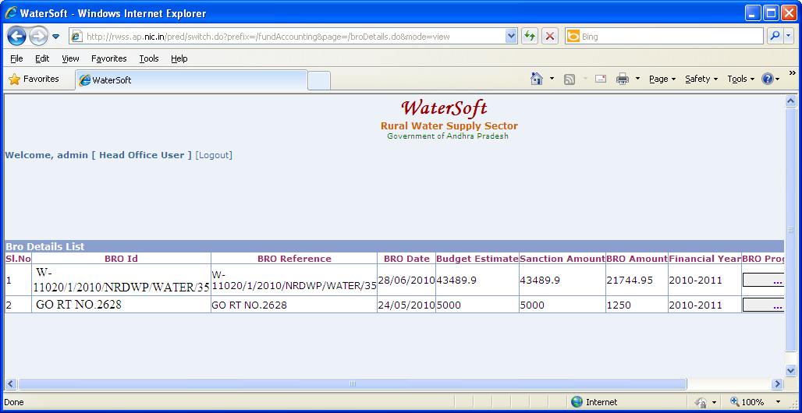
Figure 4.

Note :-

- In Action Click ‘ Edit ‘ to make Modifications - Bro details entry form is displayed.
- In Action Click ‘ Delete ‘ to delete selected Bro details.
- Click ‘ button ‘ placed in column ‘ BRO Progs List ‘ (in Figure 4 ) ->BRO Program List is displayed in ( Figure 5 )

Bro Program Details are displayed

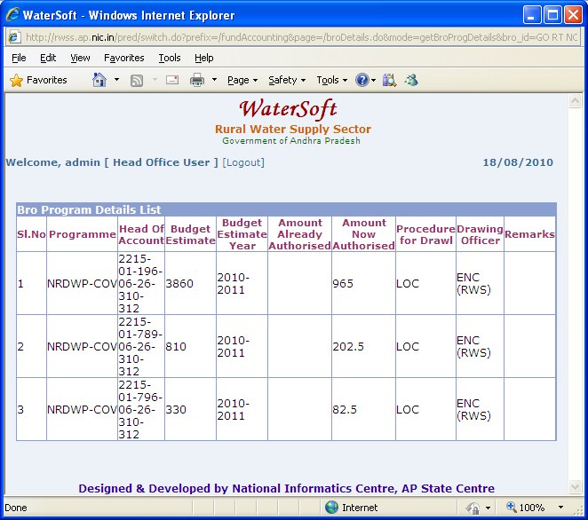
Figure 5.

LOC : Letter of Credit

LOC Details

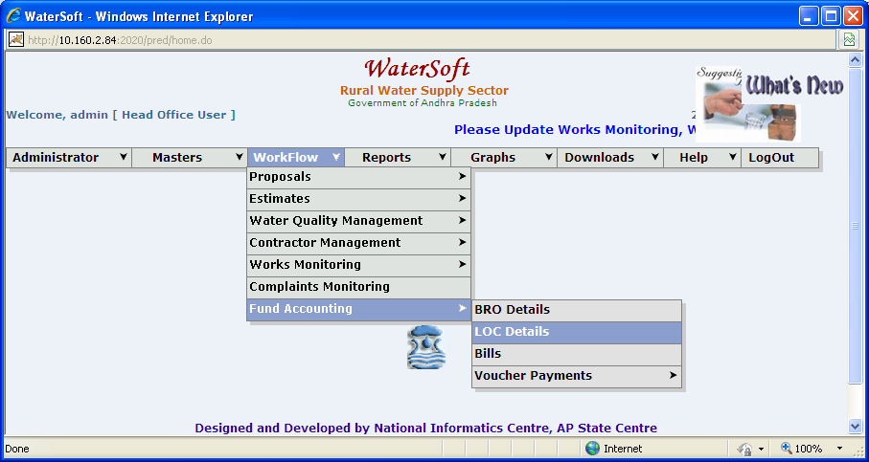
Figure 6

LOC Details Entry Form

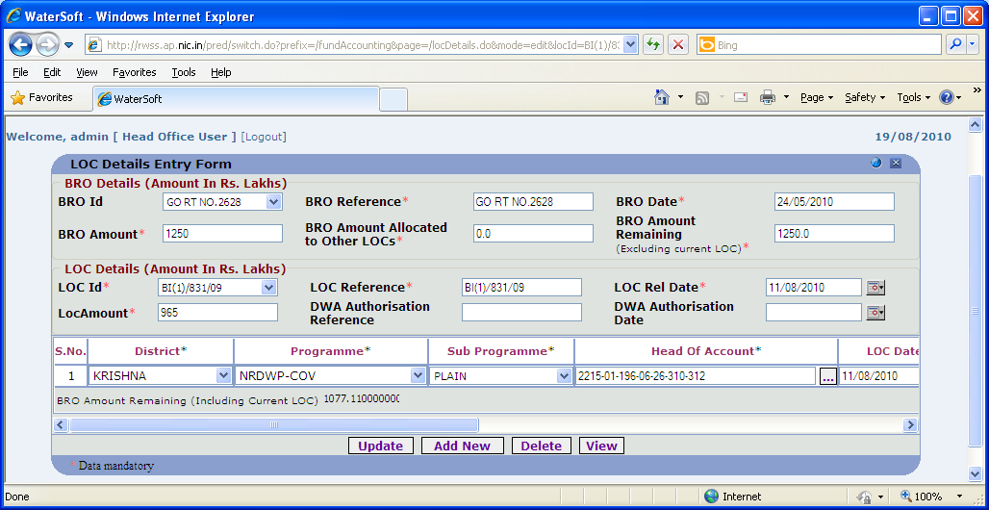
Figure 7

Add New

- Click ‘ Add New ‘ button. ( to Add LOC details )

Note:-
- Here LOC is created for already existing BRO , so select BRO Id -> Bro details are displayed->Click ‘ AddNew ‘ button.
- There can be ‘ n ‘ number of BRO’s
- For one BRO there can be ‘ n ‘ number of LOC’s

Common operations for adding New LOC details

- Enter LOC Id.
- Enter LOC reference.
- LOC ref. Date.
- Enter LOC Amount.
- Enter DWA Authorisation Reference.
- Enter DWA Authorisation Date.

Save

- Select District.
- Select Programme.
- Select SubProgramme.
- Select Head of Account.
- Select LOC Date.
- Select Project ( By selecting checkbox ).

If project is selected

- Select WorkName.

If project is not selected ( No need to select WorkName )

- Enter LOC Amount.
- Select Division.
- Select Place.
- Select PAO / APAO.
- Enter Remarks.
- Click ‘ Save ‘ button.

Update

- Click ‘ Update ‘ button

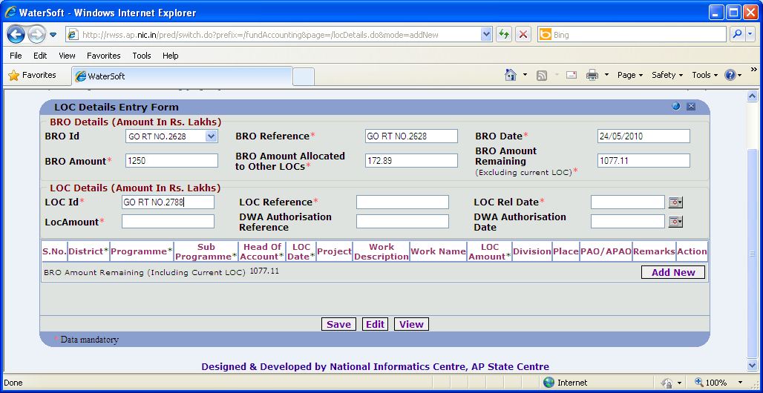
Figure 8.

View

- Click ‘ View ‘ button.

LOC Details are displayed

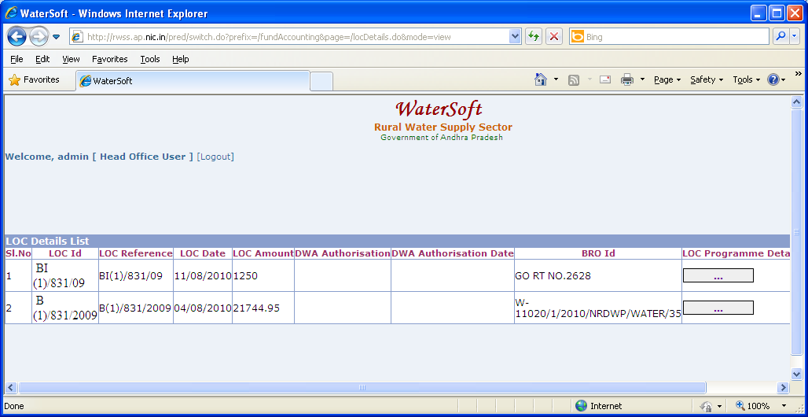
Figure 9

Note :-
- In Action Click ‘ Edit ‘ to make Modifications - LOC details entry form is displayed.
- In Action Click ‘ Delete ‘ to delete selected LOC details.
- Click ‘ button ‘ placed in column ‘ LOC Progs List ‘ ( in Figure 9 ) -> LOC Programme List is displayed in ( Figure 10.)

LOC Program Details List
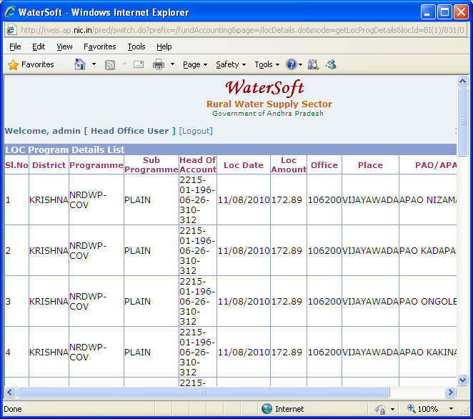
Figure 10

Bills

Note:-Bills and Vouchers can be accessed only by DAO and EE when they login with their respective userid and password .

WorkFlow->FundAccounting->Bills

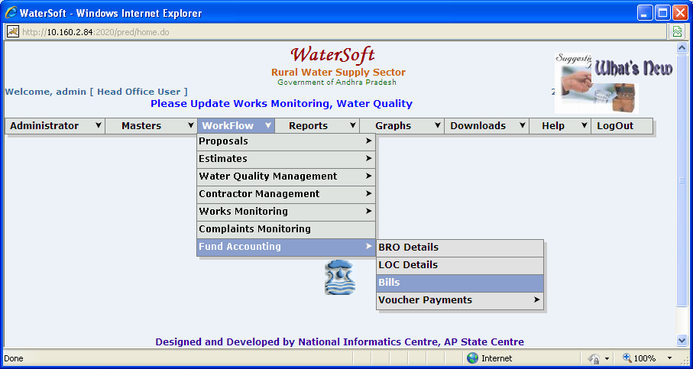
Figure 11.

Bills

Note:-

- Enter the Bills for the works which are having Mile Stones Information.

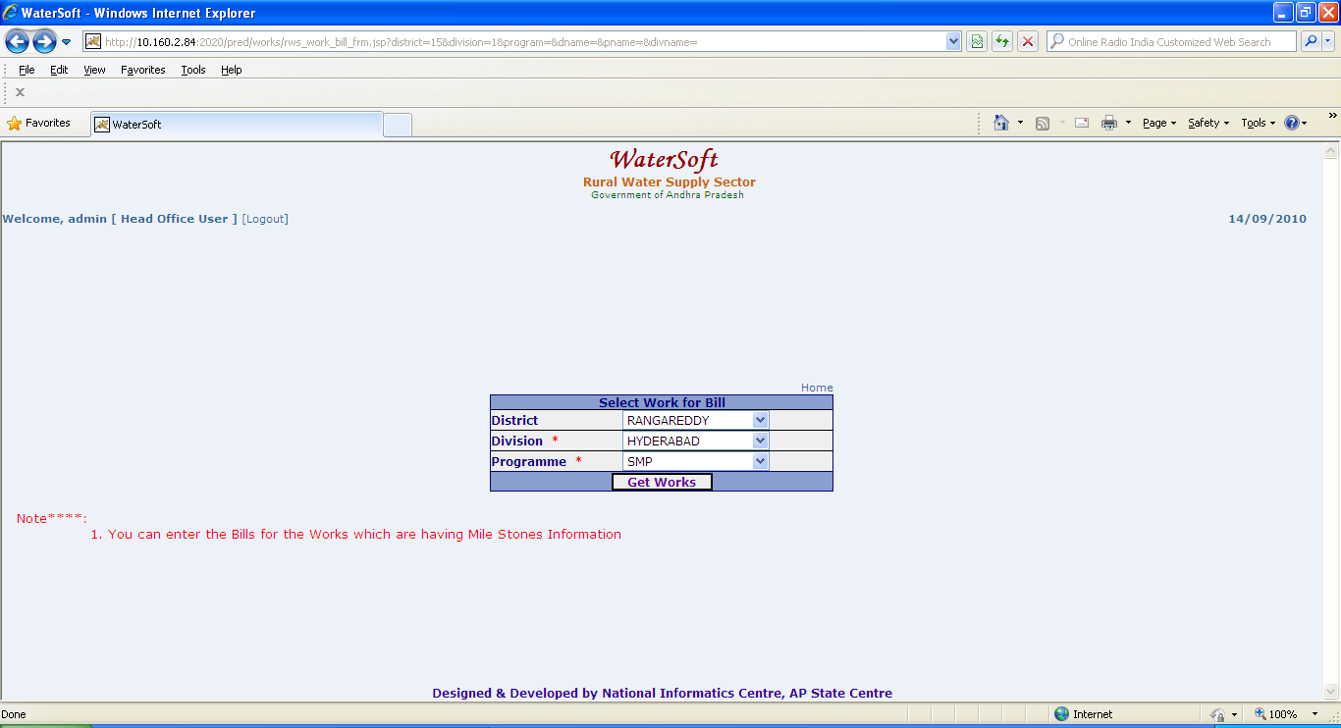
Figure 12.

Get Works

- Select District.
- Select Division.
- Select Programme.
- Click ‘ Get Works ‘ button

List of Works are displayed

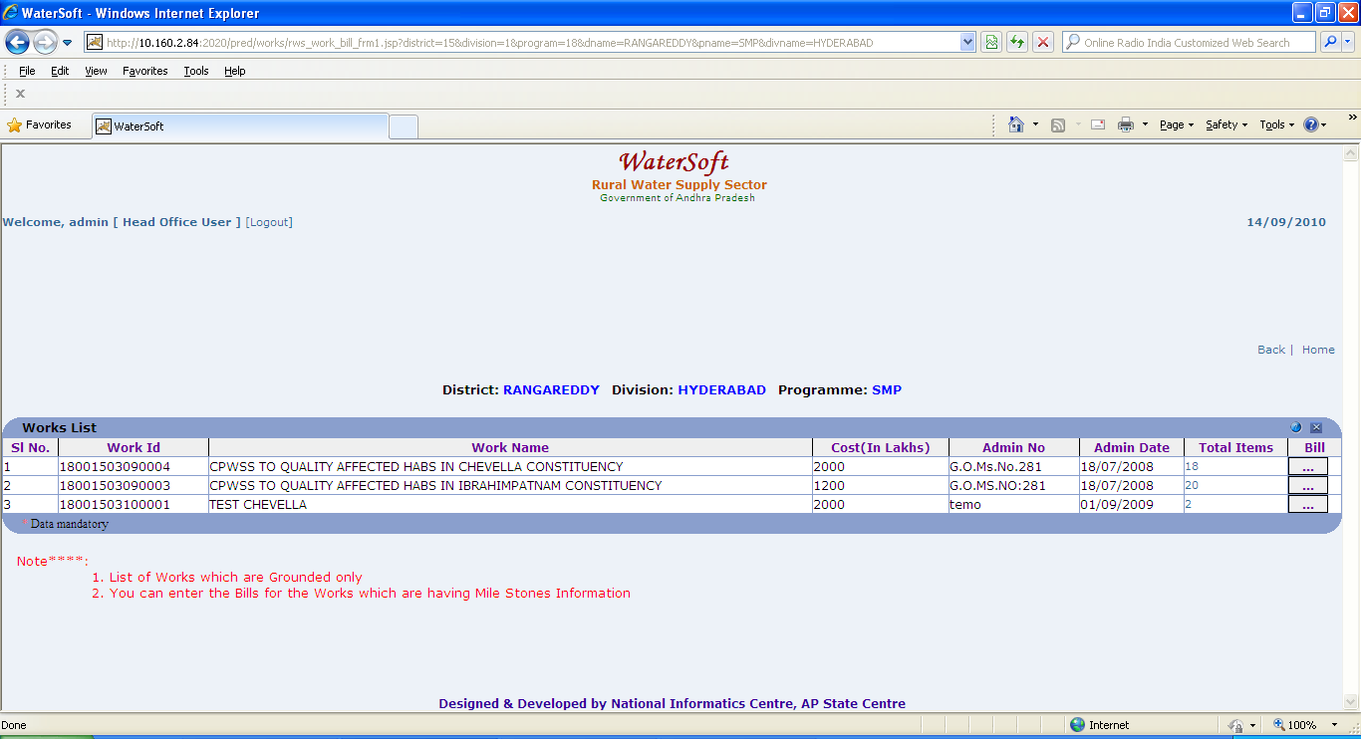
Figure 13

Note:-
- Works which are Grounded only are displayed
- Enter the Bills for the Works which are having MileStone Information.
- Click ‘ Total Items ’ column ( in Figure 13 ) -> MileStones with items details are displayed in (Figure 14)
- Click ‘ button ‘ placed in column Bill ( in Figure 13 ) -> To add Bill details in ( Figure 15)

MileStone details with items are displayed as below

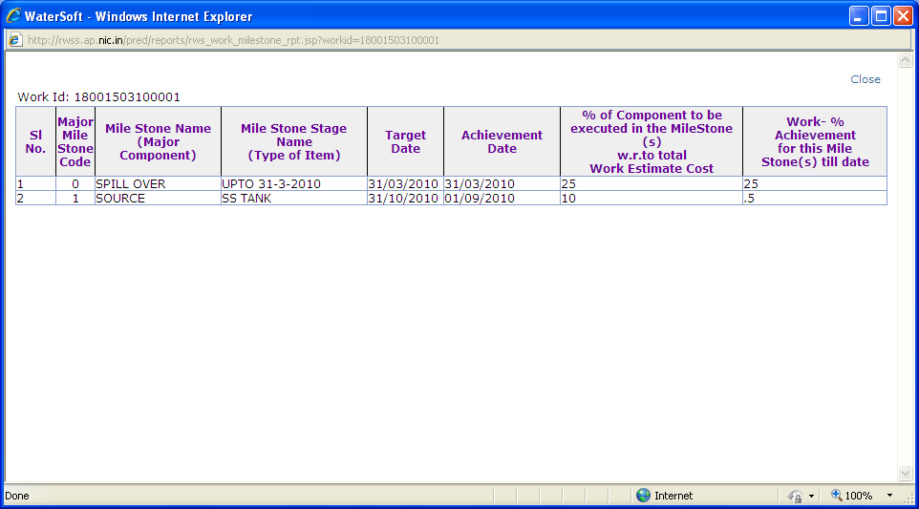
Figure 14

Bill Details are displayed as follows

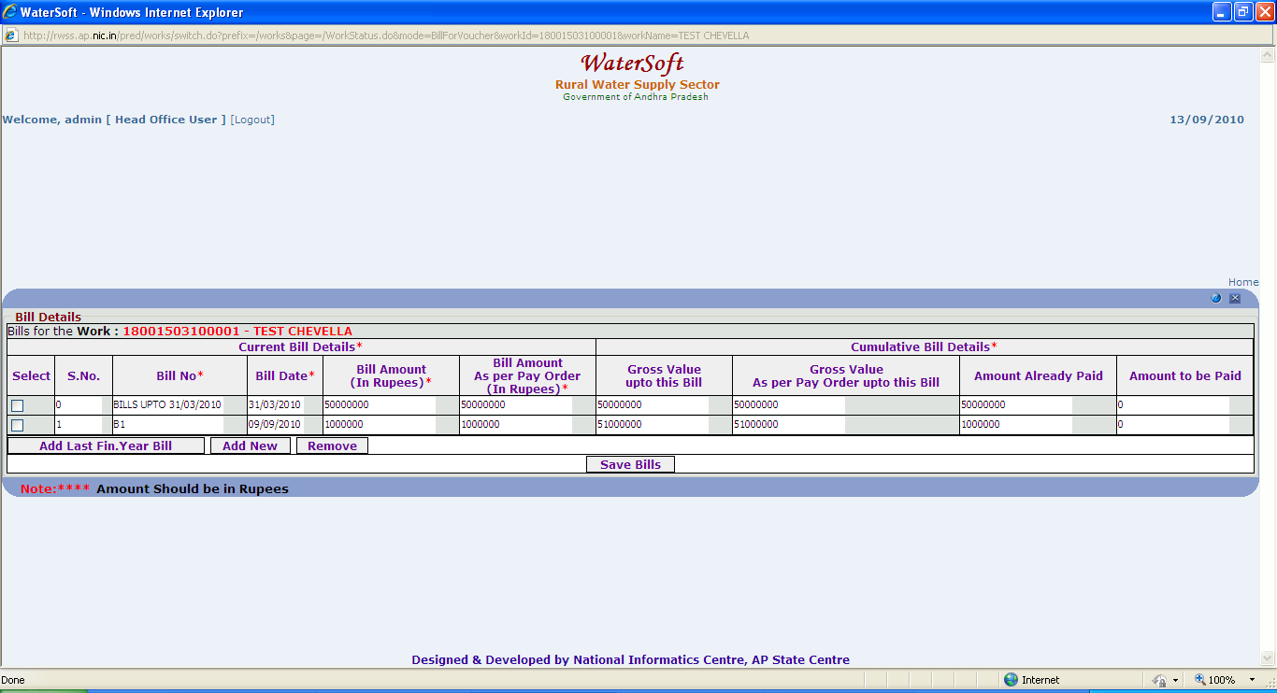
Figure 15

Note:-

- Amount Should be in Rupees.
- The bill amount automatically carried from ‘Achievement Amount’ under programme schedule phase.
- The new bill amount is calculated as Total Achievement Amount – Gross value upto this bill for the work.
- Bill for ‘Spill over Item’ under milestones should be first entry by clicking the ‘ Add Last Financial Year Bill‘. Then only you can enter current financial year related bills by clicking ’ AddNew’ ‘ button.
- Cannot generate more than one Bill on same date
- Before ‘ Save Bills ‘ or ‘ Remove ‘ button is clicked – select combo box and check it.
Add Last Fin. Year Bill

- Click ‘ Add Last Fin. Year Bill ‘ button to add Last Financial Year details.

Add New

- Click ‘ Add New ‘ button to add bill details

Remove

- Click ‘ Remove ‘ button to remove bill details.

Save Bills

- Enter Bill No
- Select Bill Date
- Enter Bill Amount ( in Rupees )
- Enter Bill Amount As per Pay order ( in Rupees )
- Click ‘ Save Bills ‘ button

Voucher Payments

Work Flow->Fund Accounting->Direct Voucher Payments

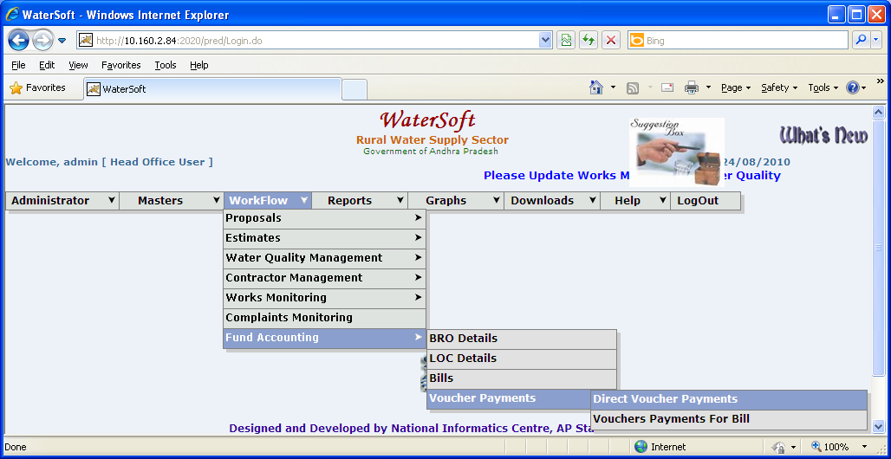
Figure 16
.
Direct Vouchers Payments

1.Enter Vouchers for the Works which are completed before 01/04/2010

2.Remaining Works should enter through ‘ WORK PROGRESS ’ form

Direct Voucher Payments
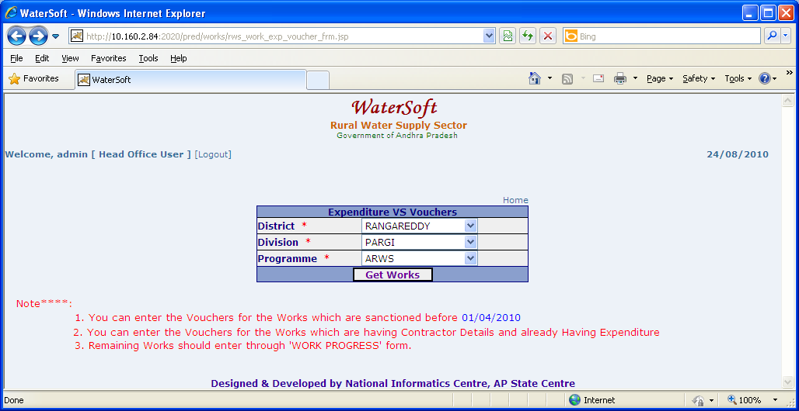
Figure 17.

GetWorks

- Select District.
- Select Division.
- Select Programme.
- Click ‘ Get Works ‘ button.

Works are displayed

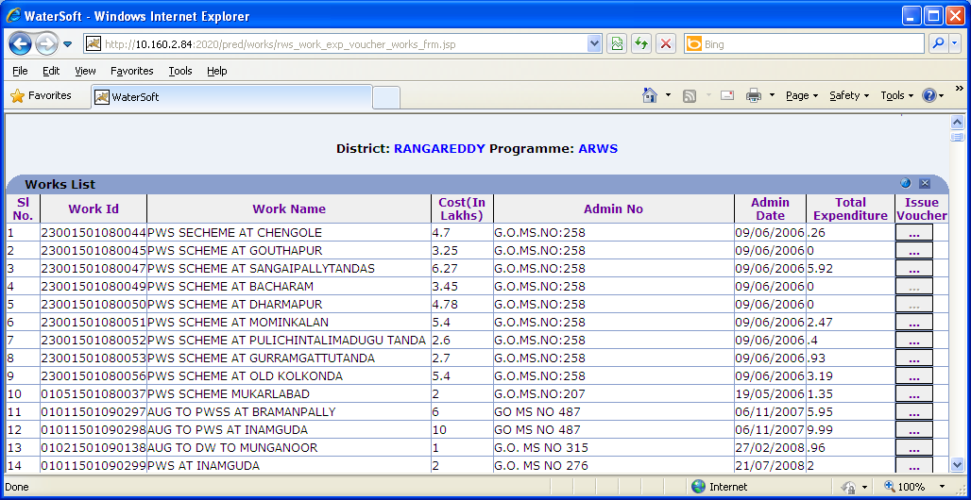
Figure 18.

Note :

- Click ‘ button ‘ placed in column Issue Voucher ( in Figure 18 ) to Issue Vouchers ( in Figure 19 ).
- Vouchers should be entered in Chronological Order By Recorded Date.
- Recorded By List Contains “ AE , AEE , DEE Employees in that District.
- Check Measured By List Contains “ DEE,EE “ Employees in that District.
- Super Check Measured By List Contains “ EE and Above” Employees in that District.
- Before saving data or Removing data – select combo box and check it.

Work Expenditures Vs Vouchers 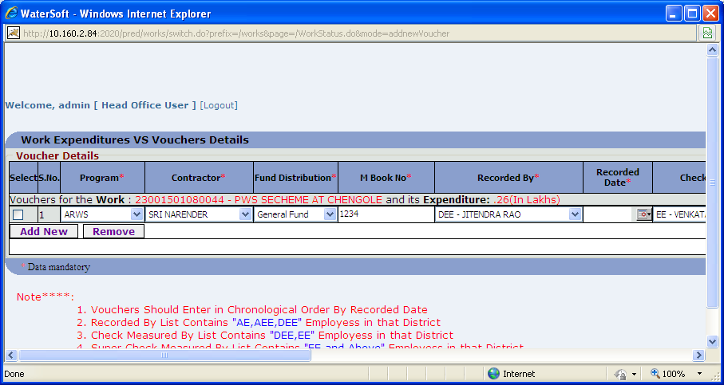
Figure 19.

Add New

- Click ‘ Add New ‘ button to add voucher details.

( Figure 20 are contd.. of Figure 19 )
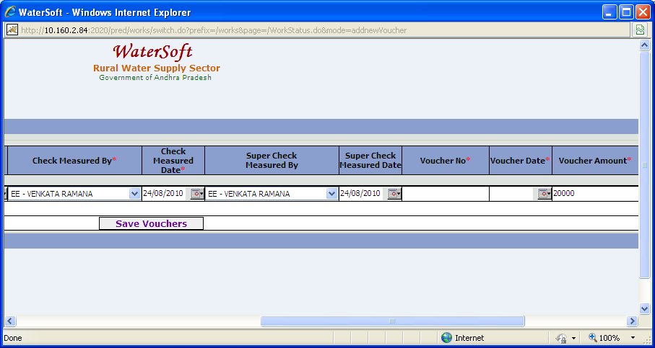
Figure 20.

Note:-
- Select Checkbox before ‘ Save Vouchers ‘ or ‘ Remove ’ operation

Remove

- Click ‘ Remove ‘ button.

Figure 21 is contd… Figure 19
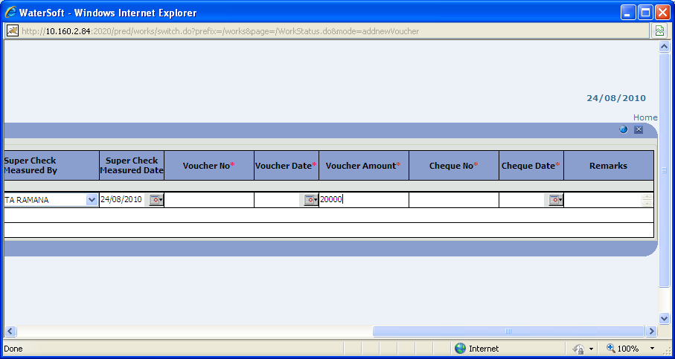
Figure 21.

Save Vouchers

- Select Program
- Select Contractor
- Select Fund Distribution
- Enter MBookNo
- Select RecordedBy
- Select RecordedDate
- Select Check MeasuredBy
- Select Check Measured Date
- Select Super Check Measured By
- Select Super Check Measured Date
- Enter Voucher No
- Select Voucher Date
- Enter Voucher Amount
- Enter Check No.
- Select Check Date
- Enter Remarks
- Click ‘ Save Vouchers ‘ button.

Vouchers Payments For Bill

WorkFlow->Voucher Payments->Vouchers Payments For Bill

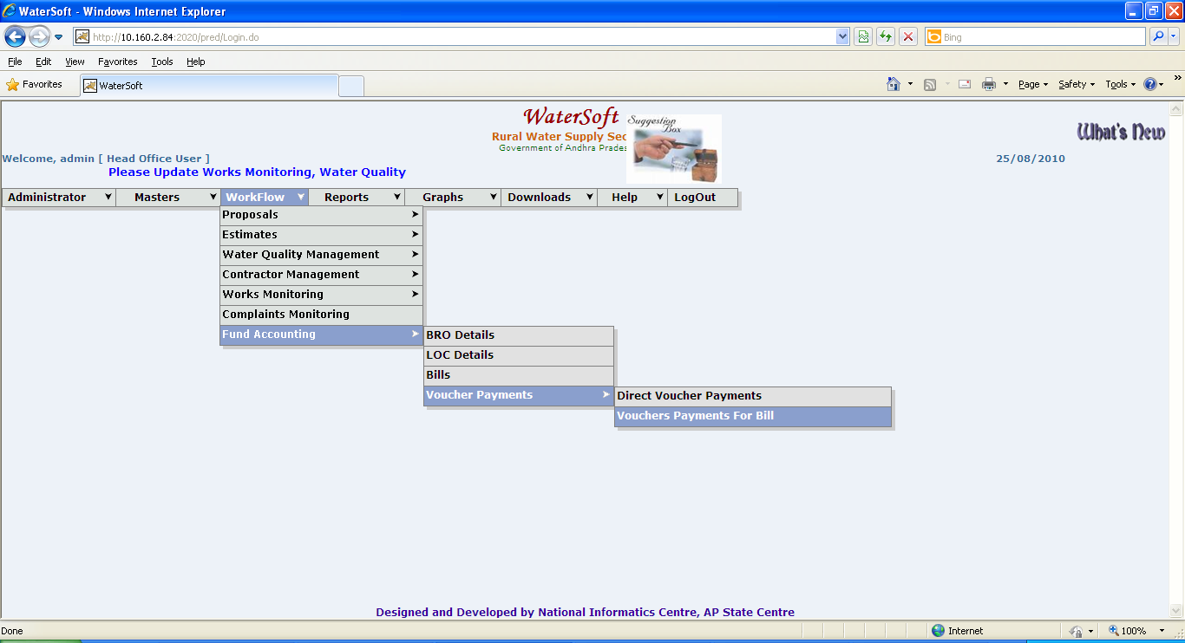
Figure 22.

Vouchers payments For Bill
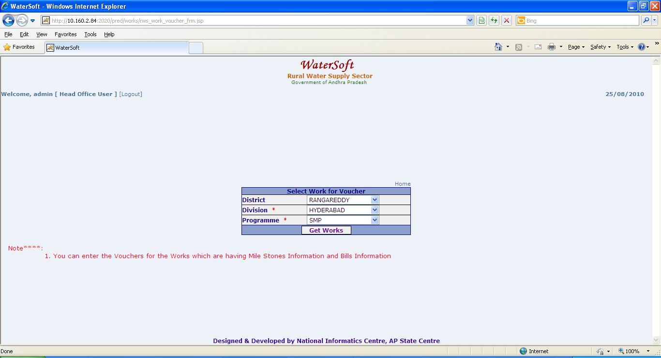
Figure 23.

Note:-
- Enter Vouchers for the Works which are having Mile Stones Information and Bills Information.

Get Works

- Select District.
- Select Division.
- Select Programme.
- Click ‘ Get Works ‘ button.

Works are displayed as follows

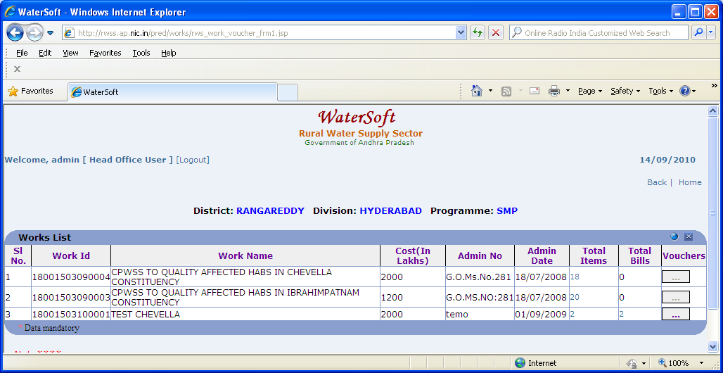
Figure 24.

Note:-
- List Works which are Grounded only are displayed.
- Enter Vouchers for the Works which are having Mile Stones Information and Bills
- Click ‘ TotalItems ‘ in ( Figure 24 )->MileStone Item details are displayed ( In Figure 25)
- Click ‘ Bills ‘ in ( Figure 24 ) -> Bill Details are displayed ( In Figure 26 )
- Click ‘ button ‘ placed in column Vouchers in ( Figure 24 ) -> ( Figure 27 ) is displayed.

MileStone Item details are displayed as follows

Figure 25.

Bill Details are displayed as follows

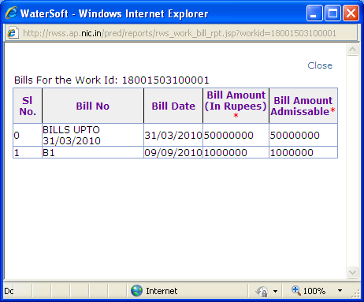
Figure 26.

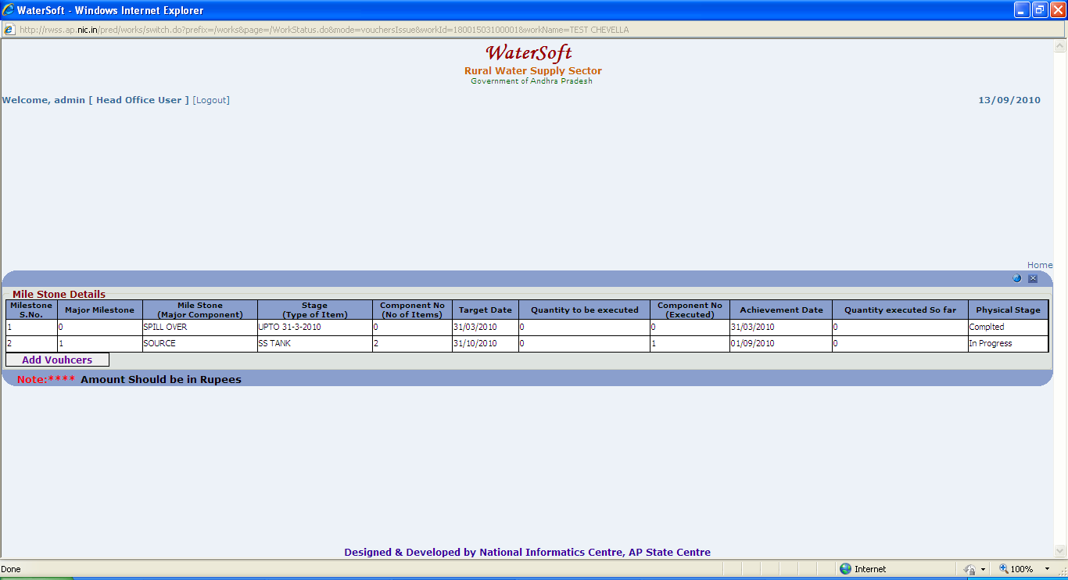
Figure 27.

Note:-
- Click ‘Add Vouchers ‘(in Figure 27 ) -> Enter Voucher Details in ( Figure 28 )
- Mile Stone Items details are brought from programme schedule phase

Voucher Details

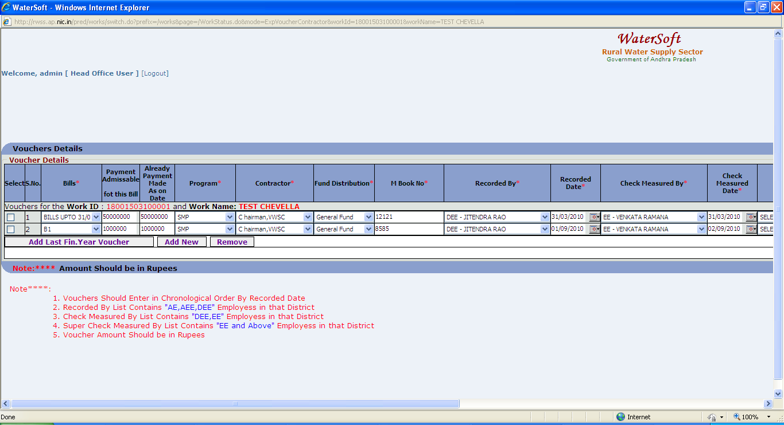
Figure 28.

Note:-

- Voucher for ‘Spill over Item’ under milestones should be first entry by clicking the ‘ Add Last Financial Year Voucher‘. Then only you can enter current financial year related vouchers by clicking ’ AddNew’ ‘ button.
- If payment is made to any other contractor other than main contractor mentioned select ‘ Other Contractor ‘ as contractor
- Before ‘ Save Vouchers ‘ or ‘ Remove ‘ button is clicked – select combo box and check it.
- Super Check Measured By , super Check Measured date columns are entered by EE( Executive Engineer ) when Executive Engineer login with his respective userid and password.

Add Last Fin. Year Voucher

- Click ‘ Add Last Fin. Year Voucher ‘ button to add Last Financial Voucher details.

Add New

- Click ‘ Add New ‘ button to add voucher details.

Remove

- Click ‘ Remove ‘ button to delete voucher details.

Save Vouchers

- Select Bills
- Enter Payment Admissable for this Bill
- Enter Already Payment As on Date
- Select Program
- Select Other Contractor
- Select Fund Distribution
- Enter MBookNo
- Select RecordedBy
- Select RecordedDate
- Select Check MeasuredBy
- Select Check Measured Date
- Select Super Check Measured By
- Select Super Check Measured Date
- Enter Voucher No
- Select Voucher Date
- Enter Voucher Amount
- Enter Check No.
- Select Check Date
- Enter Remarks
- Click ‘ Save Vouchers ‘ button.

