Masters - > Habitation Entry

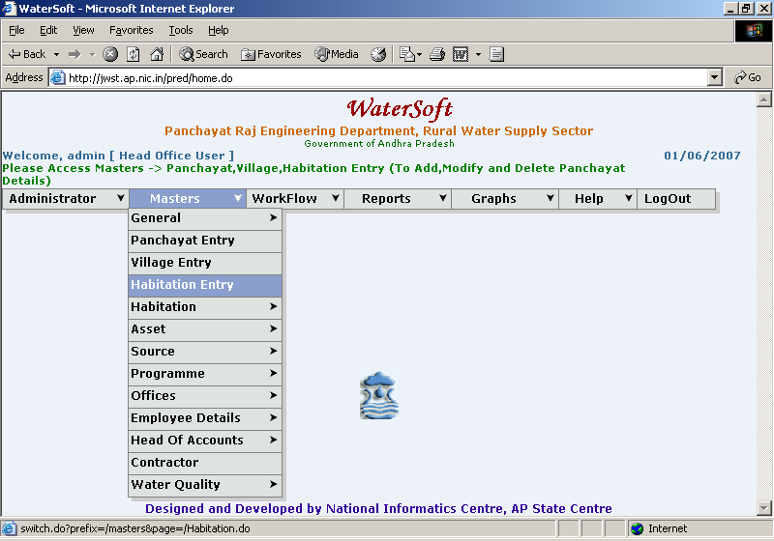

Habitation Entry

To add New Habitations

Add New

- Select District.
- Select Constituency.
- Select Mandal.
- Select Panchayat.
- Select Village.
- Enter Hcode.
- Enter PRCode
- Enter Habitation Code.
- Enter PRHab Name.
- Click ‘Save’ button.

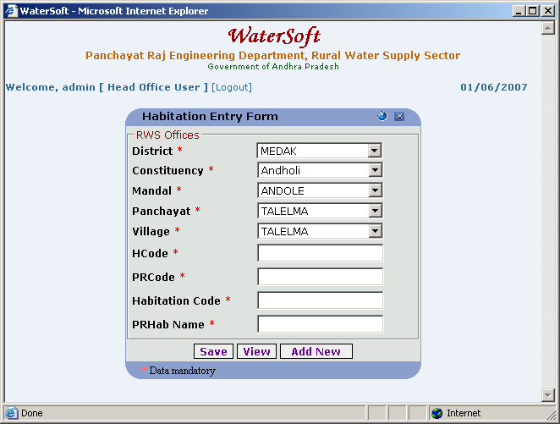

Close

- Click ‘Close’ button.

To View the Habitations

View

- Select District.
- Select Constituency.
- Select Mandal.
- Select Panchayat.
- Select Village.
- Select Habitation Code.
- Click ‘View’ button.

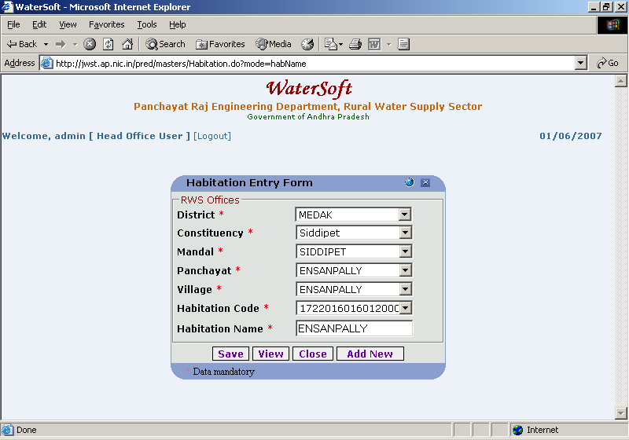

To View the Habitations

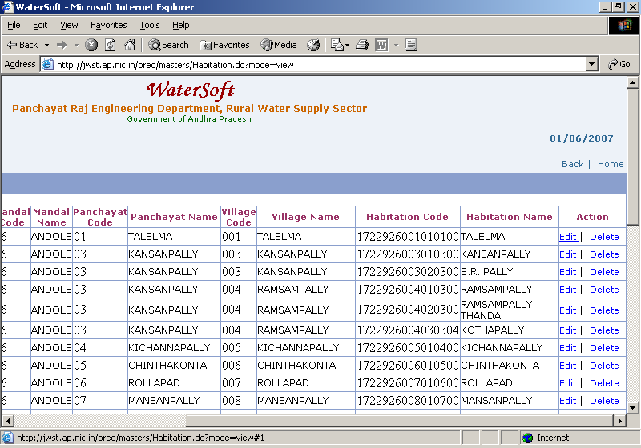

Note I:- In Action – Click on Edit to make modifications – Habitation Entry Form is displayed.

Note II:- In Action – Click on Delete to make Deletions.

