USER MANUAL FOR HABITATION STATUS

WaterSoft

(For the Department of Panchayati Raj & Engineering Department, Rural Water Supply Sector and Sanitation, Govt. of AP)

National Informatics Centre
Department of Information Technology
Ministry of Communications and Information Technology
Government of India
WebSite : www.ap.nic.in

PREPARED BY :

PROJECT TEAM ,
NIC APSC,
HYDERABAD.

REVIEWED BY:

HEAD OF THE DEPARTMENT,
NIC APSC,
HYDERABAD.

APPROVED BY :

STATE INFORMATICS OFFICER
NIC APSC,
HYDERABAD.

Amendment Log

Version Number | Date | Change Number | Brief Description | Sections Changed
1.0 | 1.1.2007 | - | First Release
1.1 | 20.3.2007 | - | Second  Release | Changes in all Modules based on User Requirements
1.2 | 5.2.2008 | - | Third  Release | Changes in Habitation Status based on User Requirements in Figure 2.
1.3 | 4.6.2009 | - | Fourth  Release | Changes in Habitation Status based on User Requirements in Figure 2.
1.4 | 6.3.2010 | - | Fifth  Release | Safe LPCD of Drinking & Cooking added based on User Requirements.
1.5 | 29.5.2010 | - | Sixth  Release | Minority Dominated,Left Wing Extremism(LWE)/Naxal Affected Area added based on User Requirements.
1.6 | 04.11.2010 | - | Seventh Release | Habitation SC/ST/Minority Status added based on User Requirements
1.7 | 21.1.2012 | - | Eighth  Release | Addition of Latitude,Longitude,Elevation,Waypoint,Plain HouseConnections,SC House Connections,ST HouseConnections,Plain House Holds,SC House Holds,ST HouseHolds and Landmark as per User Requirements
1.8 | 16.2.2012 | - | Ninth  Release | Additions of in Habitation SubType- Minority , Minority HouseConnections, Minority Households , Minority Pop Covered as per User Requirements

Sl No | CONTENTS | Page No
1 | Common Operations in the Software | 5
2 | Habitation Status | 7 - 17
3 | Panchayat Entry | 18 – 23
4 | Village Entry | 24 - 28
5 | Habitation Entry | 29 – 33
6 | Habitation SC/ST/Minority Status | 39 – 45

Common Operations in the Software:

Click the button to close the Form.

 Click the button for online context help.

Home Click the button for Main Page.

Back Click the button for Previous page.

Print Click the button for Printable Version.

Excel Click the button for Excel Version.

Amount will be considered in Lakhs throughout the Software

Masters - > Habitation - > Habitation Status

Note :-For Existing Habitations follow series of steps.

Step 1:Select District->Select Mandal

Step 2:Click->’ View ’ button->Habitation details are displayed based on selection.

Step 3:Now Click->’ Edit ’ button

Step 4:

HouseHolds and House Connections

Enter data for Plain HouseHolds , SC HouseHolds, ST HouseHolds, Minority HouseHolds , Plain House Connections, SC House Connections, ST House Connections , Minority House Connections details.

Gis details

Enter data for Latitude, Longitude, Elevation, Waypoint and Landmark details -> Click ‘ Save ’ button.

Note:-

Follow the same process for New Habitations.

Newly added columns

1.Habitation Sub Type – Minority -> Select Habitation Sub Type-> if habitation is Minority.

2.Enter Data for Minority Pop Covered

Habitation Status

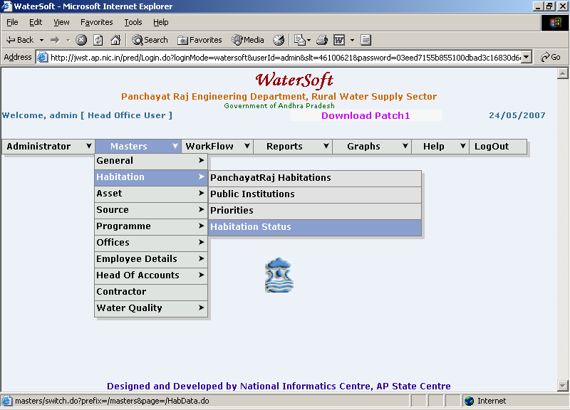
Figure 1.

Note I:-Select Mandal directly and Click on ‘View’ button.

Habitation Directory Entry Form

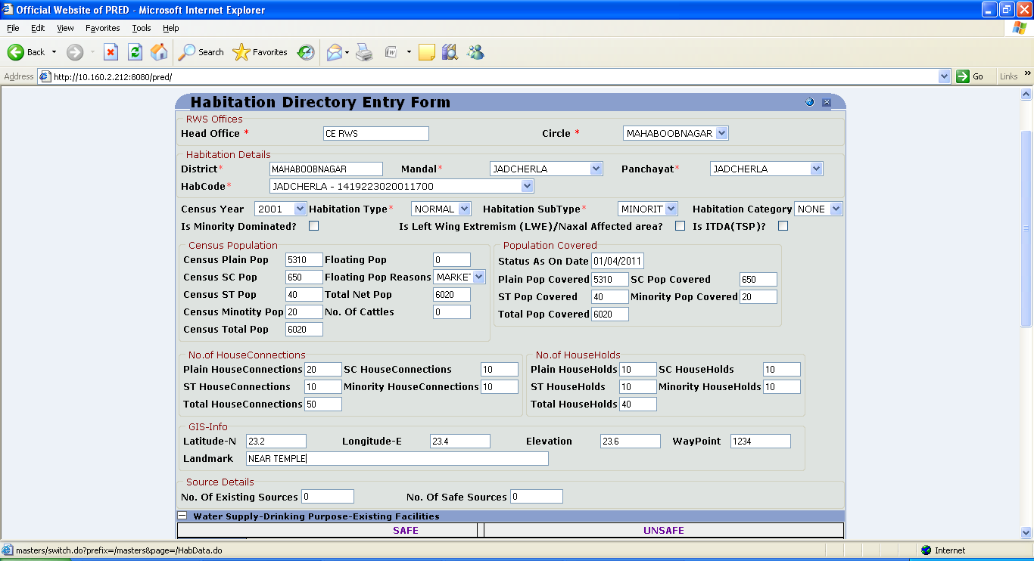
Figure 2.

View button

- Head Office is Fixed(depending on login).
- Select Circle.(For Eg. KURNOOl)
- District is Fixed (depending on Circle).
- Select Mandal Directly(For Eg. Adoni).
- Click ‘View’ button.

To View the Habitations

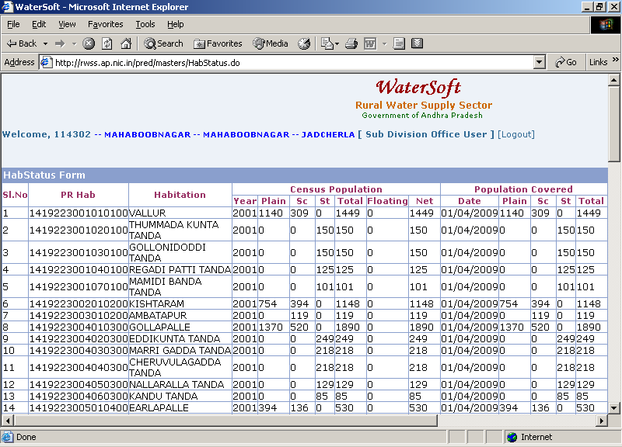
Figure 3.

Note II : - Click ‘ Edit ‘ to make modifications - Habitation Directory Entry Form is displayed again.

Note III:-

Select ( + ) to Expand the Details in a Form

- Water Supply – Drinking Purpose – Existing Facilities
- Public Institution Details

Select ( - ) to collapse the details in a Form.

- Water Supply – Drinking Purpose – Existing Facilities
- Public Institution Details

Habitation Directory Entry Form

To Update Habitation Status Enteries.

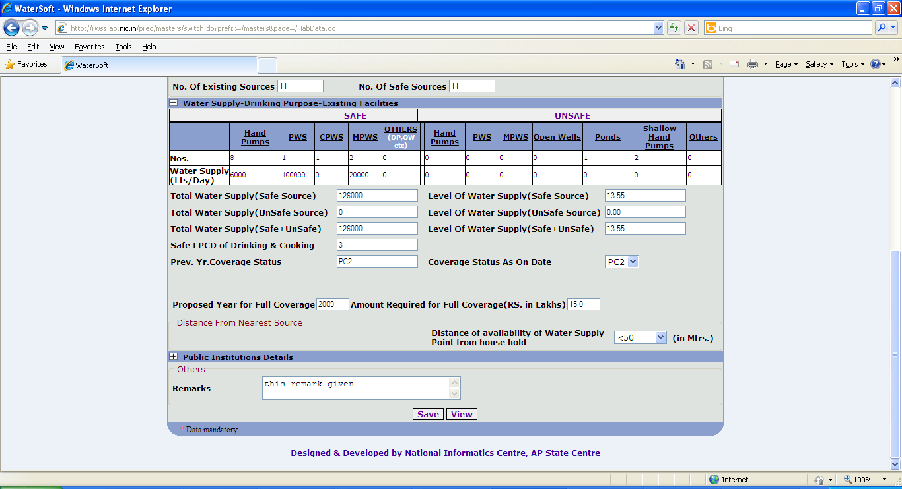
Figure 4.
Save button.

- Select Census Year.(For Eg. 2001).
- Select Habitation Type (NORMAL , AGENCY , COASTAL ) by default NORMAL will be selected.
- Select Habitation Sub Type ( PLAIN , SC , ST , MINORITY ).
- Select Habitation Category ( NONE , HILLY , DDP ) by default NONE will be selected.
- ( Tick ) the Checkbox if the Habitation is Minority Dominated? .
- ( Tick ) the Checkbox if the Habitation is Left Wing Extremism ( LWE ) /Naxal Affected Area?.
- ( Tick ) the Checkbox if the Habitation is ITDA(TSP)?.

Census Population (in Numeric Format)

Census Tot Pop = Census Plain Pop + Census SC Pop + Census ST Pop + Census Minority pop

Total Net Pop = Census Tot Pop + Floating Pop

- Enter Census Plain Pop.
- Enter Census SC Pop.
- Enter Census ST Pop.
- Enter Census Minority Pop.
- Census Tot Pop is calculated depending on data entered.
- Enter Floating Pop.
- Select Floating Pop Reasons. (For Eg. Market, Temple etc.)
- Total Net Pop is calculated depending on data entered.
- Enter No. Of Plain House Connections.
- Enter No. Of SC House Connections.
- Enter No. Of ST House Connections.
- Enter No. Of Minority House Connections.
- Enter No. Of Plain HouseHolds.
- Enter No. Of SC HouseHolds.
- Enter No. Of ST HouseHolds.
- Enter No. Of Minority HouseHolds.

Total HouseHolds=No. Of Plain HouseHolds+ No. Of SC HouseHolds+ No. Of ST HouseHolds + Minority HouseHolds.

Total HouseConnections=No. Of Plain HouseConnections+ No. Of SC HouseConnections+ No. Of ST HouseConnections + No. Of Minority HouseConnections.

- Enter No. Of Cattle’s.

Population Covered (in Numeric Format)

Total Pop Covered = Plain Pop Covered + SC Pop Covered + ST Pop Covered

- Status on Date is fixed.
- Enter Plain Pop Covered.
- Enter SC Pop Covered.
- Enter ST Pop Covered.
- Enter Minority Pop Covered.
- Total Pop Covered is calculated depending on data entered.

Gis Details

- Enter Latitude.
- Enter Longitude.
- Enter Elevation.
- Enter Waypoint.
- Enter Landmark.

Source Details:

- Enter No. Of Existing Sources.
- Enter No. Of Safe Sources.

Water Supply – Drinking Purpose – Existing Facilities

Safe Sources

- Enter Nos.( Handpumps , Pws , Cpws , Mpws , Others ( DP , OW etc ).
- Enter Water Supply in Lts/Day(for Handpumps , Pws , Cpws , Mpws , Others ( DP , OW etc).

UnSafe Sources

- Enter Nos.(Handpumps( UnSafe ) , Pws , Mpws , Openwells , Ponds , Shallow Handpumps ,others )
- Enter Water Supply in Lts/Day(for Handpumps( UnSafe ) , Pws , Mpws , Openwells , Ponds , Shallow Handpumps ,Others).

Total Water Supply( Safe Sources ) = Water Supply in Lts/Day( Handpumps + Pws + Cpws + Mpws + Others ( DP , OW etc )

Total Water Supply ( UnSafe Sources ) = Water Supply in Lts/Day ( Handpumps ( UnSafe ) + Pws + Mpws + Openwells + Ponds + Shallow Handpumps + Others )

- Total Water Supply will be Calculated automatically (Depending on Data Entered)

LevelofWaterSupply=TotalWaterSupply/(TotalPopulation*1.01)^{current year - census year}

- Level of Water Supply (Lpcd). - Calculated Automatically(Depending on Data Entered).

Note IV:-Coverage Status As on Date Field data can be modified only by privileged Admin Users.

Note V:-

- levelofwatersupply ( lpcd ) is calculated only for SafeSources

- Safe LPCD of Drinking & Cooking is calculated automatically as (Actual LPCD Value )/4.

- Previous Coverage Status is Fixed.

If Total Water supply ( UnSafe Sources) is greater than Zero and Total Water Supply (Safe Sources) equal to Zero - Coverage status As on Date is NSS the following screen shot , Figure 5 explain the process of entering data.

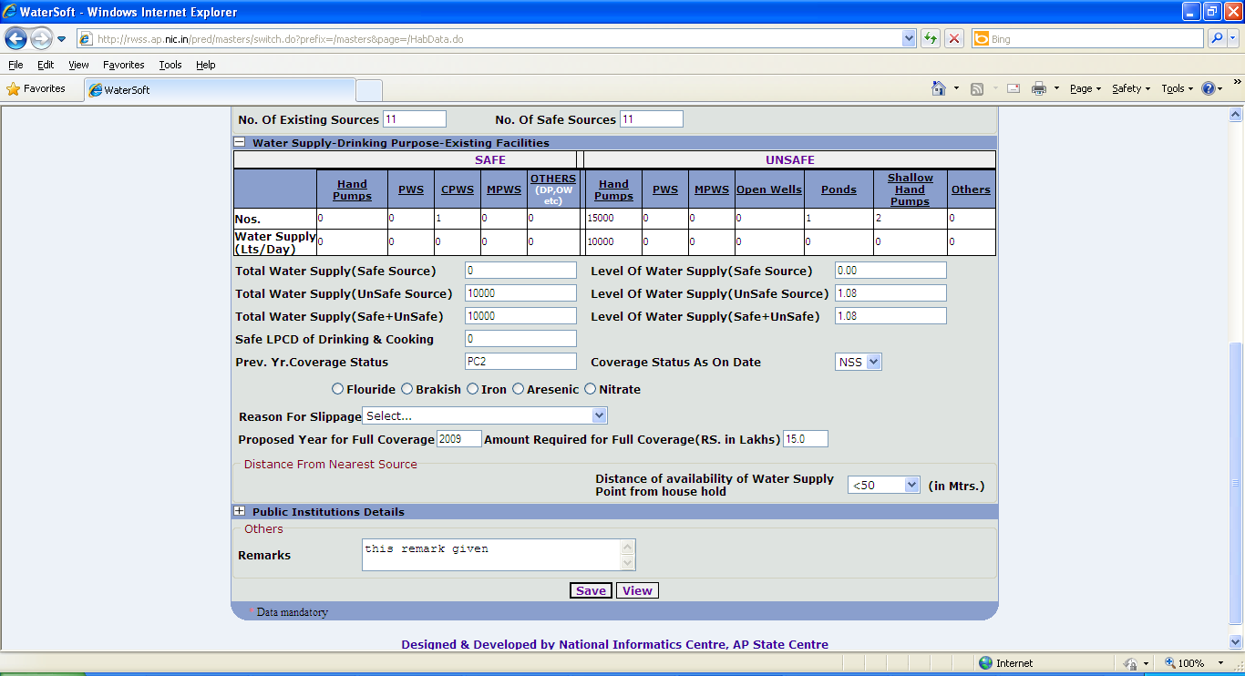
Figure 5.

- Enter Flouride ( PPM ).
- Enter Brakish ( PPM ).
- Enter Iron ( PPM ).
- Enter Arsenic ( PPM ).
- Enter Nitrate ( PPM ).
- Select Reason For Slippage.
- Enter Proposed Year for Full Coverage.
- Enter Amount Required for Full Coverage ( RS. In Lakhs ).
- Select Nearest Available Source.
- Select Distance of availability of Water Supply Point from habitation(in Mtrs. ).

Note VI:- If Prev. Yr. Coverage Status is FC , PC1 , PC2 , PC3 , PC4 – presently Slipped back to PC1 or PC2 or PC3 or PC4 or NC or NSS then select Reason For Slippage.

Options for ‘Reason for Slippage’ are:

- Poor Operation & Maintenance.
- Seasonal Slippage ( Temporary ).
- Less Supply ( at PWS delivery points ).
- Age of Systems.
- Shortage of Electricity.

If Total Water supply ( UnSafe Sources , Safe Sources ) is equal Zero Coverage status As on Date is NC the following screen shot , Figure 6 explain the process of entering data.

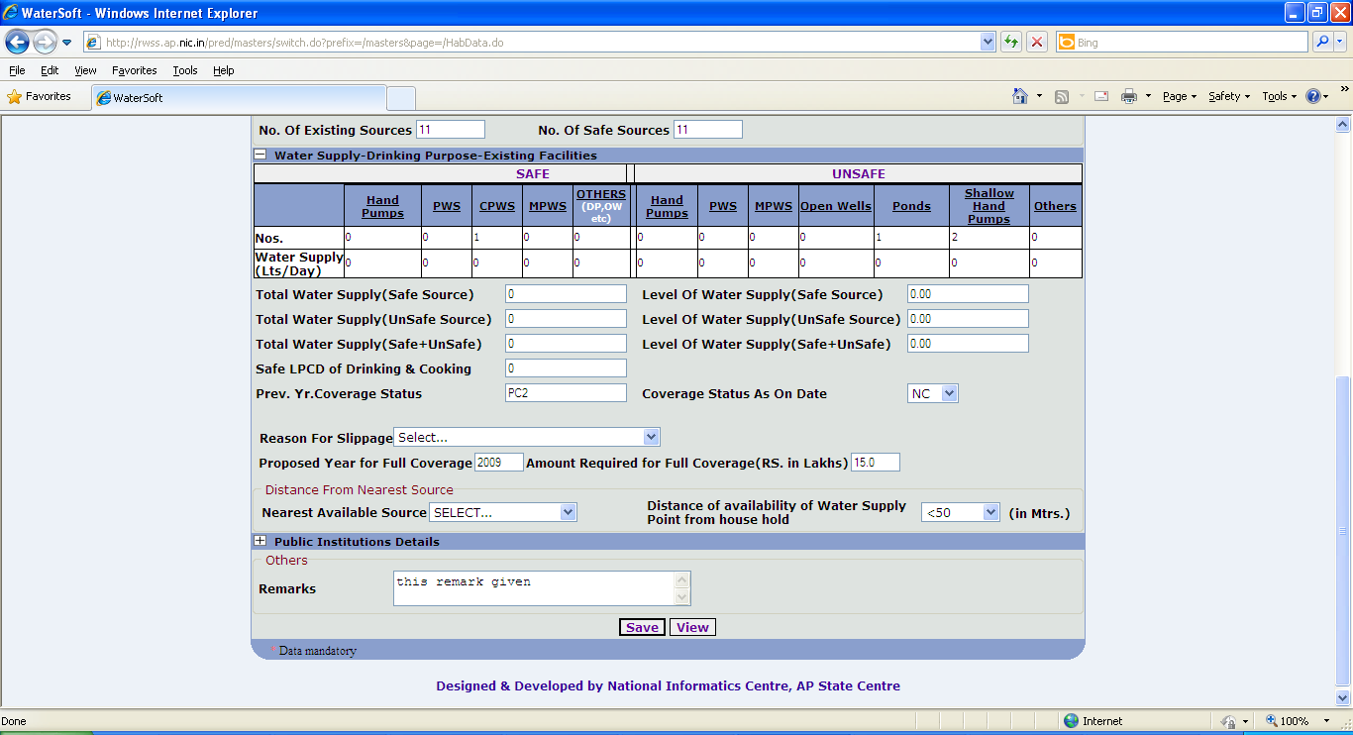
Figure 6.

- Select Reason For Slippage.
- Enter Proposed Year For Full Coverage.
- Amount Required for Full Coverage ( Rs. In Lakhs)
- Select Nearest Available Source.
- Distance of availability of Water Supply Point from habitation (in Mtrs.)

If Coverage status as on Date is displayed automatically as FC or PC1 or PC2 or PC3 or PC4 the following screen shot , Figure 7 explain the process of entering data.

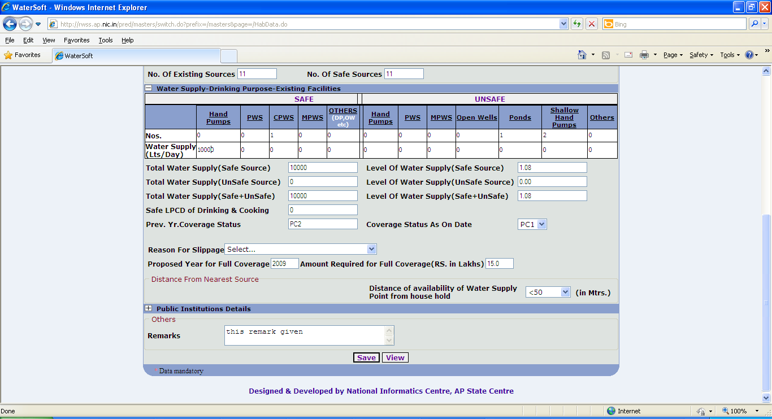
Figure 7.

- Enter Proposed Year for Full Coverage.
- Enter Amount Required for Full Coverage ( Rs. In Lakhs )
- Select Distance of availability of Water Supply Point from furthest house hold ( in Mtrs. )

Public Institution Details

- Enter Total No (For Primary School)
- Enter No. Covered with drinking Water(For Primary School).
- Enter Working(For Primary School).
- Enter Not Working(For Primary School)

Similarly Enter Public Institution details for Primary Health Center,Anganwadi center,library,community Hall,U.P School,High School,B.C.Hostel,S.C.Hostel,S.T Hostel.
- Enter Remarks.
- Click ‘Save’ button.

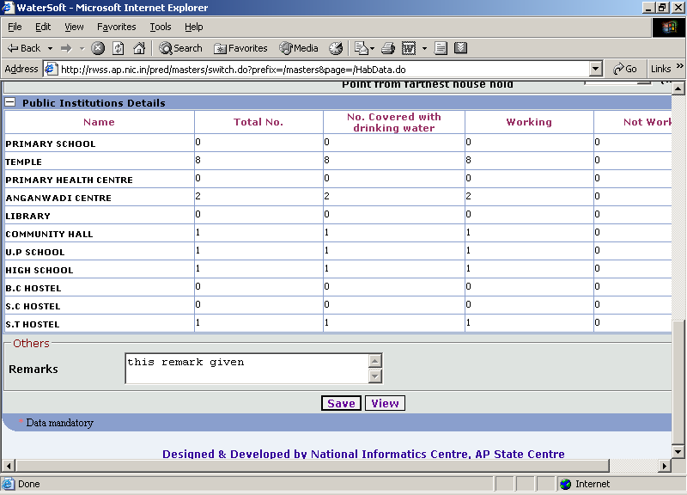
Figure 8.

Masters - > Panchayat Entry

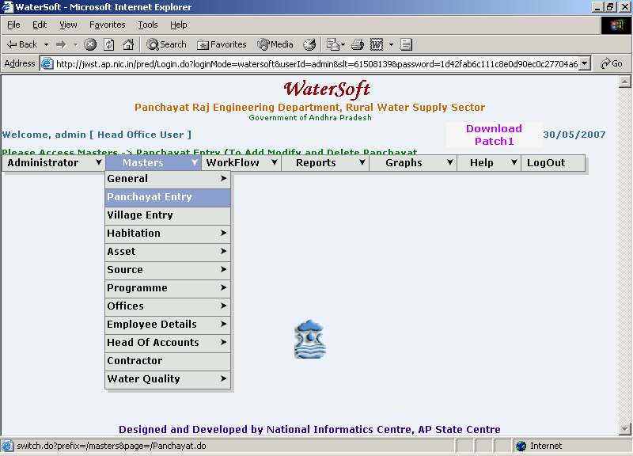
Figure 9.

To Add New Panchayat

Add New

- Select District.
- Select Mandal.
- Click ‘Add New’ button.

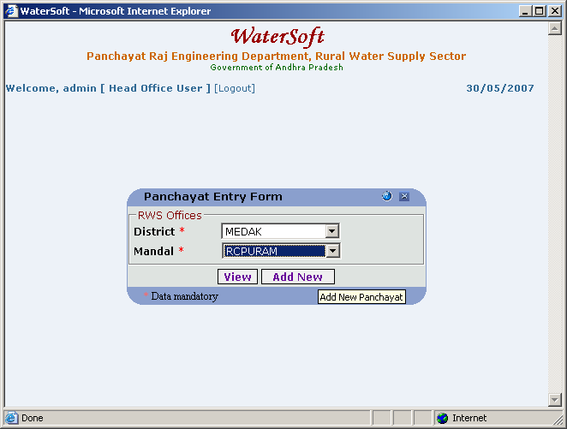
Figure 10.

Note:- After Clicking on Add New button – Panchayat Entry Form is displayed

Panchayat Entry Form

Save

- Select District.
- Select Mandal.
- Enter Panchayat Code.
- Enter Panchayat Name.
- Click ‘Save’ button.

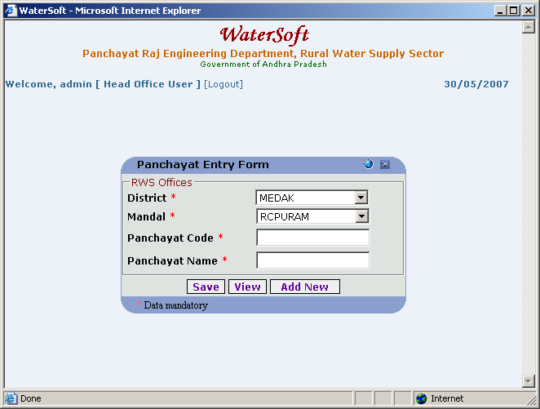
Figure 11.

To View Panchayats

Panchayat Entry Form

View

- Select District.(For Eg. Medak)
- Select Mandal.(For Eg. RCPURAM).
- Click ‘View’ button.

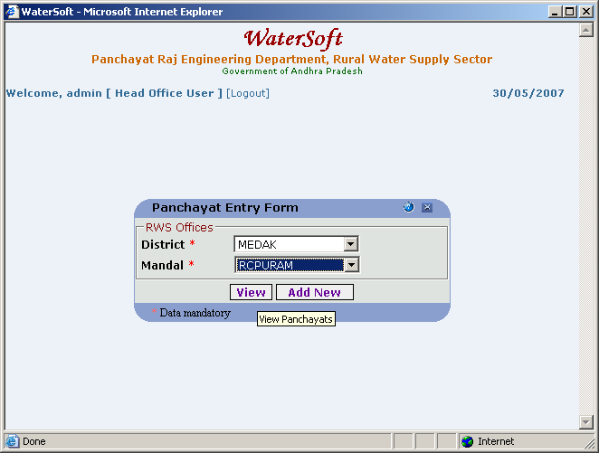
Figure 12.

To View the Panchayat List

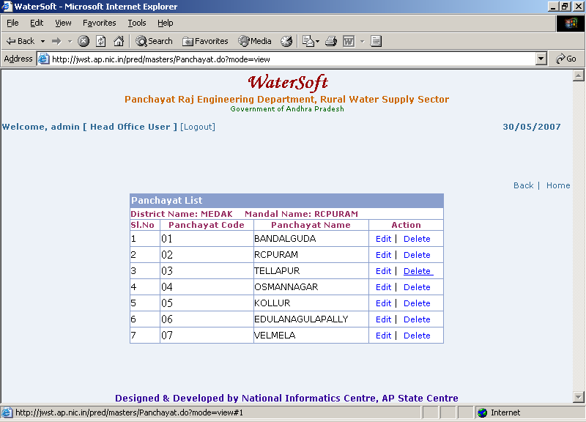
Figure 13.

Note I:- In Action – Select Edit to make Modifications for Selected Panchayat – Panchayat Entry Form is displayed – Panchayat Name can be Modified

Note II :-In Action – Select Delete to delete Selected Panchayat.

Panchayat Entry Form

Save

- Select District.
- Select Mandal.
- Panchayat Code is Fixed.
- Enter Panchayat Name.
- Click ‘Save’ button.

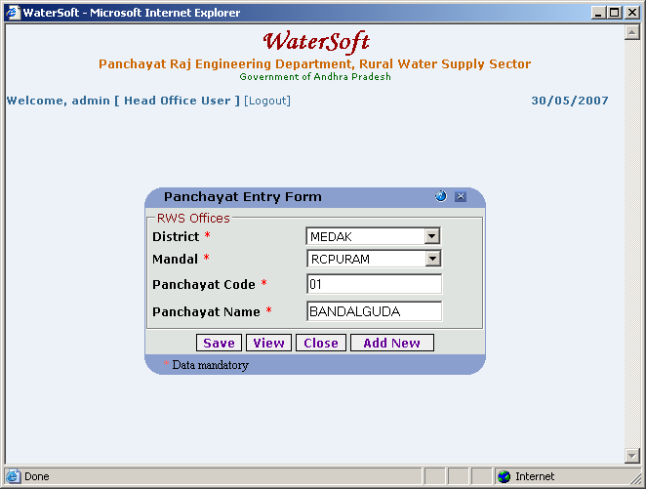
Figure 14.

Close

- Click ‘Close’ button.

Masters - > Village Entry

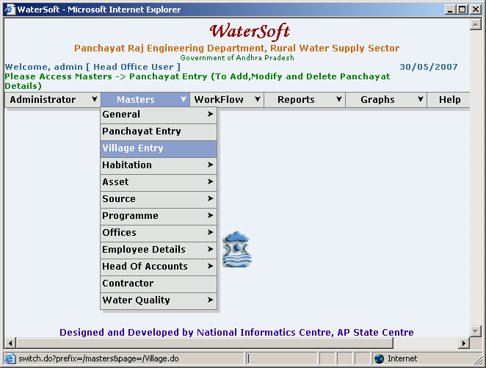
Figure 15.

To Add New Villages

Add New

- Select District.
- Select Mandal.
- Select Panchayat.
- Click ‘Add New’ button.

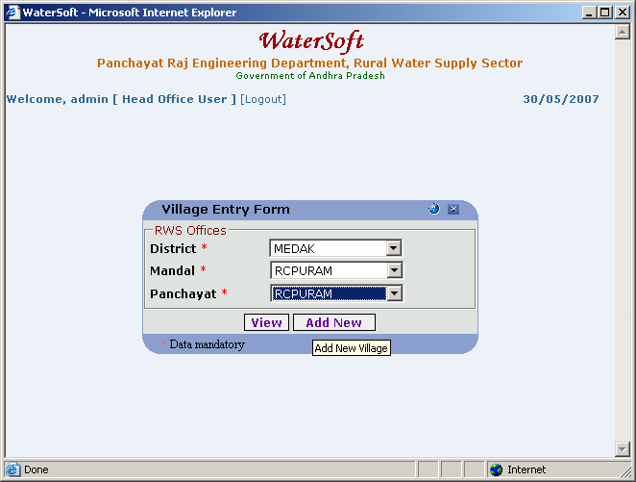
Figure 16.

Village Entry Form

Save

- Select District.
- Select Mandal.
- Select Panchayat.
- Enter Village Code.
- Enter Village Name.
- Click ‘Save’ button.

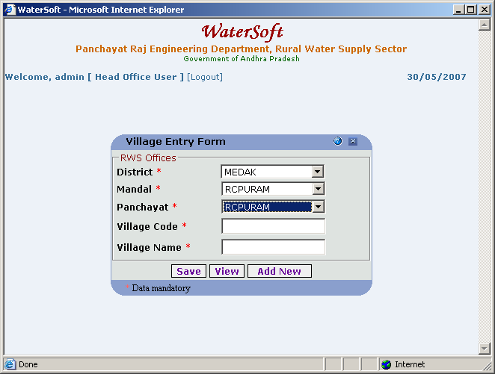
Figure 17.

To View the Villages

Village Entry Form

View

- Select District.
- Select Mandal.
- Select Panchayat.
- Click ‘View’ button.

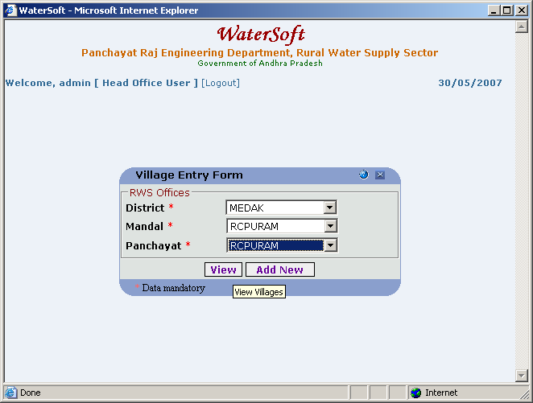
Figure 18.

To View Village List

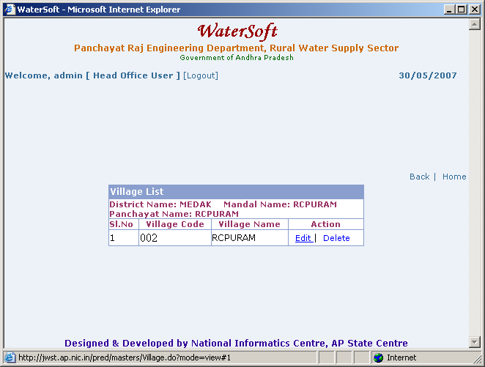
Figure 19.

Note I:-In Action – Select Edit to make modifications for selected Village - Village Entry Form is displayed – Village Name can be Modified

Note II:-In Action – Select Delete to delete selected Village.

Masters - > Habitation Entry

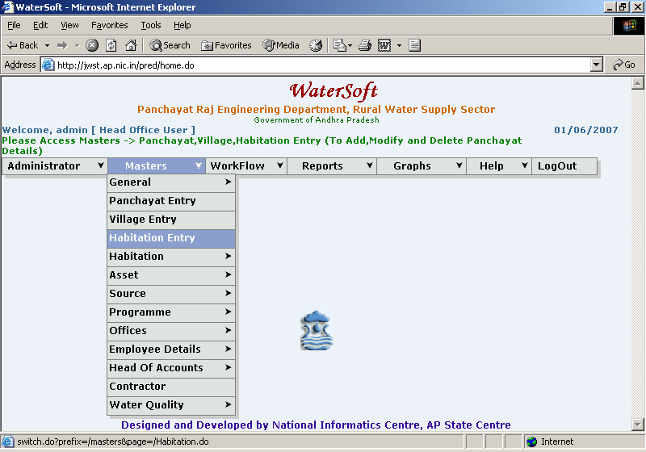
Figure 20.

Habitation Entry

To add New Habitations

Add New

- Select District.
- Select Constituency.
- Select Mandal.
- Select Panchayat.
- Select Village.
- Enter Hcode.
- Enter PRCode
- Habitation Code is Autogenerated
- Enter PRHab Name.
- Click ‘Save’ button.

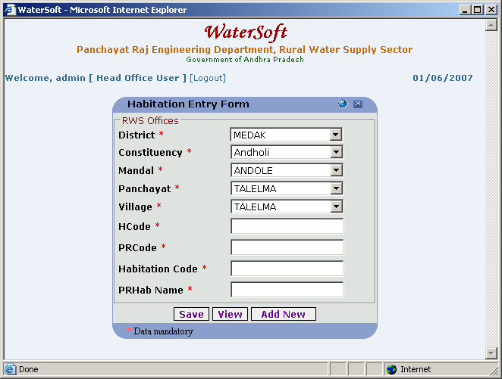
Figure 21.

Close

- Click ‘Close’ button.

To View the Habitations

View

- Select District.
- Select Constituency.
- Select Mandal.
- Select Panchayat.
- Select Village.
- Select Habitation Code.
- Click ‘View’ button.

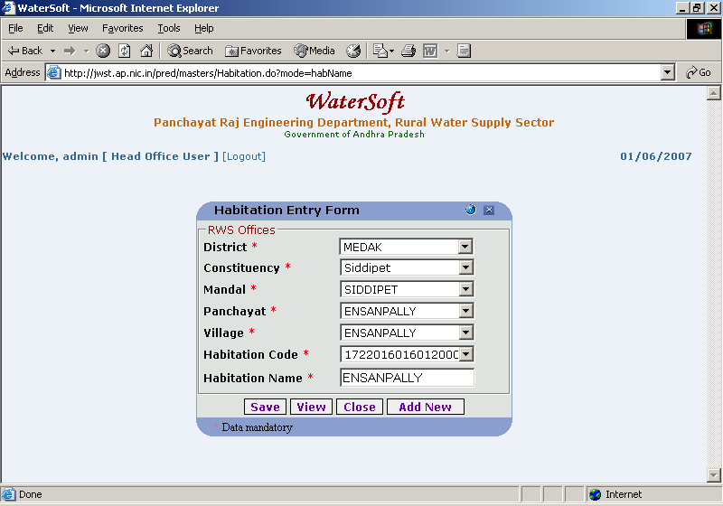
Figure 22.

To View the Habitations

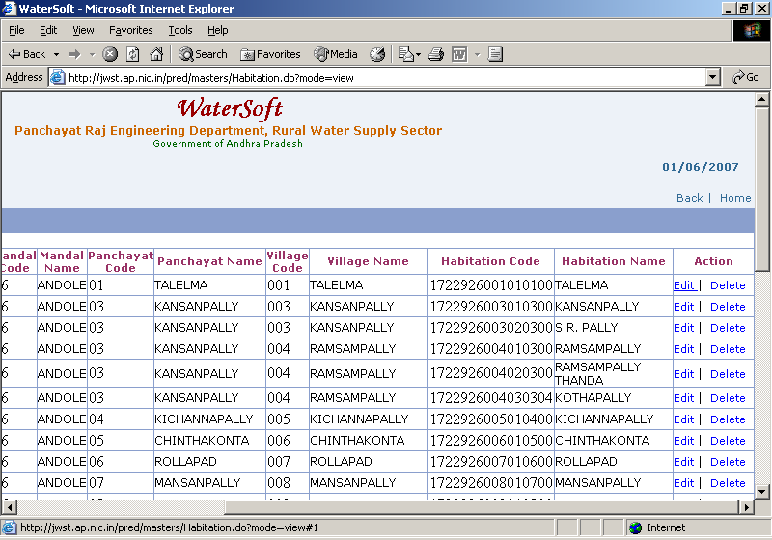
Figure 23.

Note I:- In Action – Click on Edit to make modifications – Habitation Entry Form is displayed – Habitation Name can be Modified.

Note II:- In Action – Click on Delete to make Deletions.

Habitation SC/ST/Minority Status

Masters->Habitation->Habitation SC/ST/Minority Status

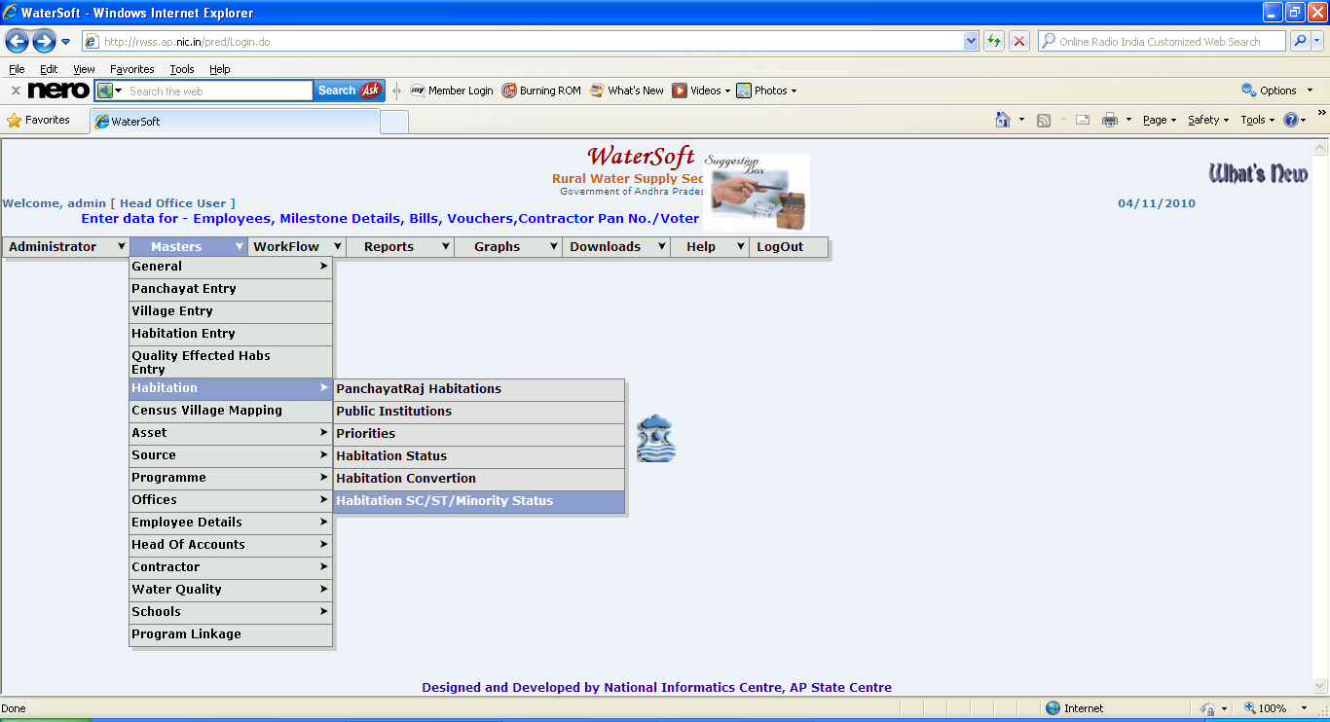
Figure 24.

Get Habitations

- Select District.( Compulsory Selection, Mandatory).
- Select Mandal. ( Compulsory Selection, Mandatory).
- Select Panchayat.
- Select Village.
- Select Habitation.
- Click ‘ Get Habitations ‘ button.

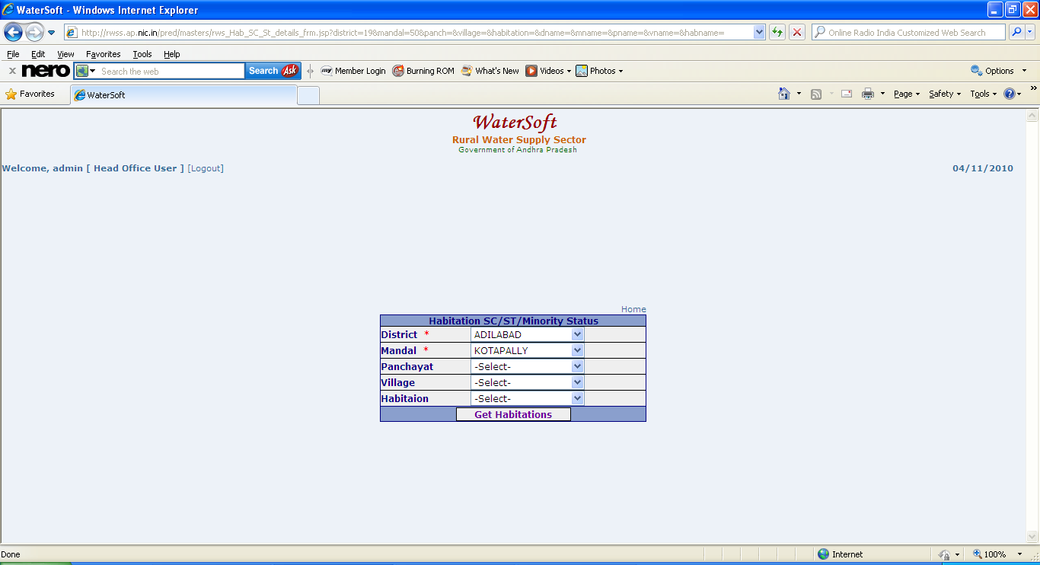
Figure 25.

Habitations are displayed
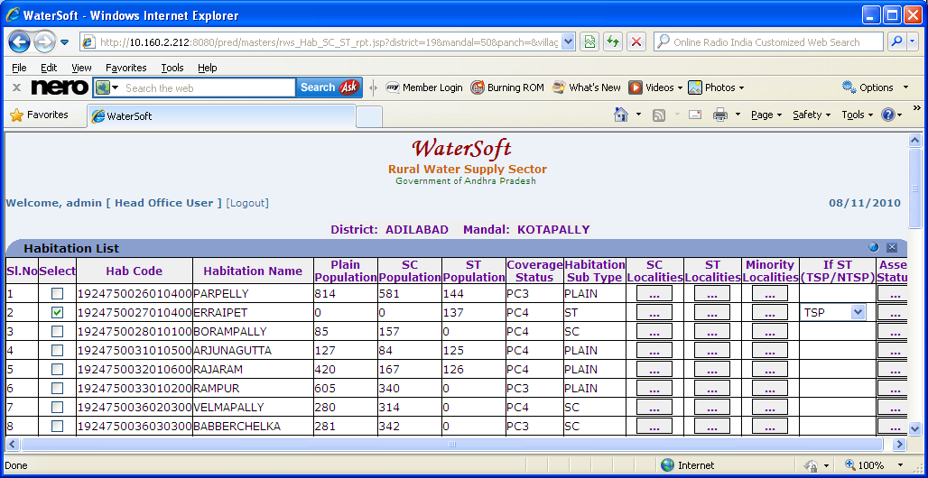
Figure 26.

(Figure 27. is contd.. of Figure 26.)
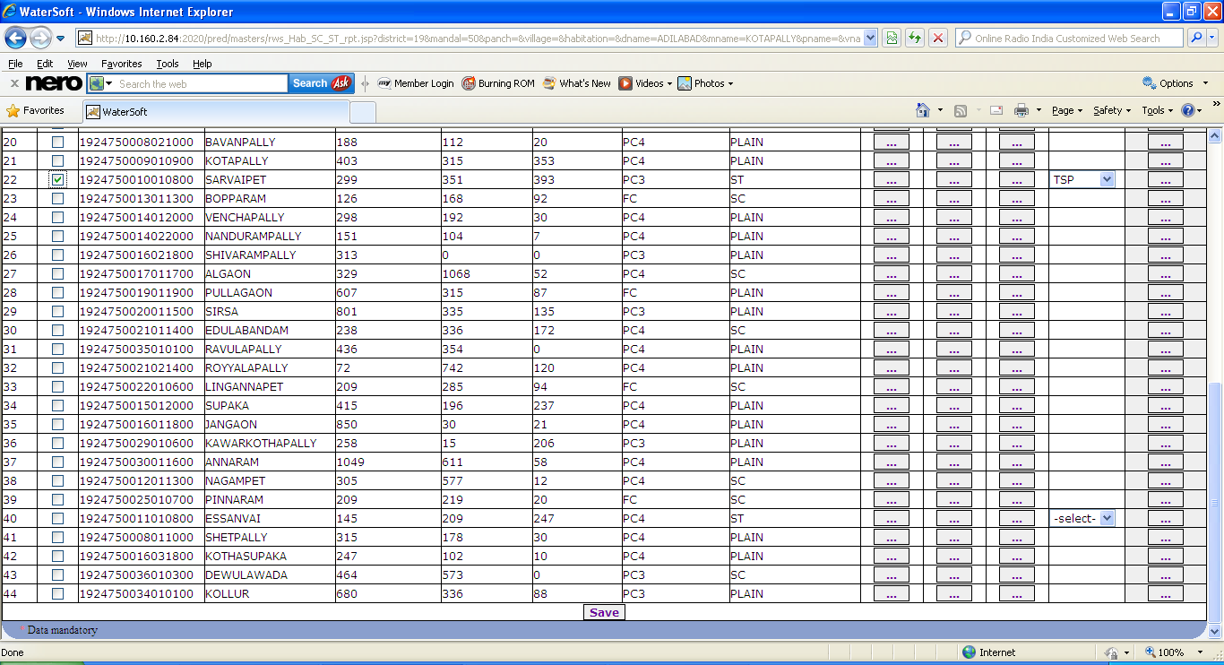
Figure 27.

Note:- If ‘ HabitationSubType ‘ column data displayed as ST ( In Figure 26. ) -> Select TSP/NTSP ->Select the Checkbox(by selecting it) ->Click ‘ Save ‘ button .( In Figure 27.)

Click ‘ button ‘ placed in ‘ SC localities ‘ column ( In Figure 26. )-> ( Figure 28. is displayed ).

Click ‘ button ‘ placed in ‘ ST localities ‘ column ( In Figure 26. )-> ( Figure 29. is displayed ).

Click ‘ button ‘ placed in ‘ Minorities localities ‘ column ( In Figure 26. )-> ( Figure 30. is displayed ).

Click ‘ button ‘ placed in ‘ Asset Status ‘ column ( In Figure 26. )-> ( Figure 31. is displayed ).

SC Localities

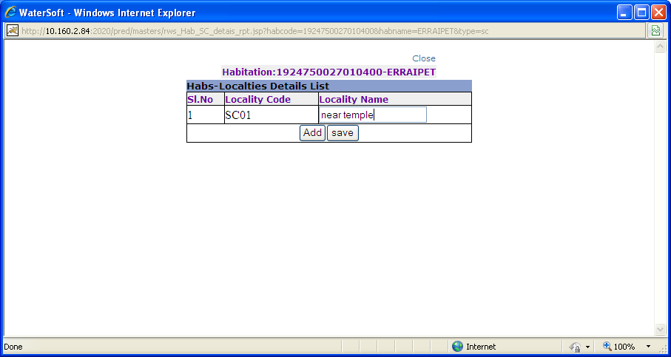
Figure 28.

Add
- Click ‘ Add ‘ button.

Save

- Locality Code is auto generated.
- Enter Locality Name.
- Click ‘ Save ‘ button.

ST Localities
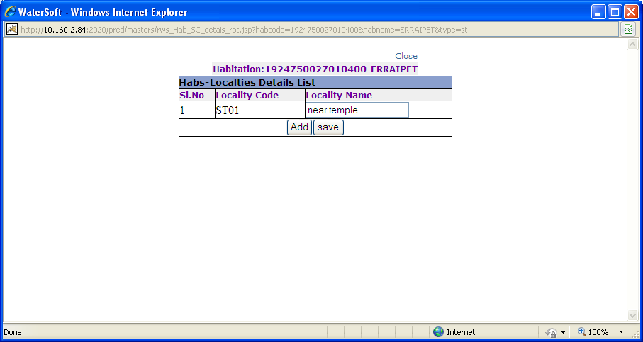
Figure 29.

Add
- Click ‘ Add ‘ button.

Save

- Locality Code is auto generated.
- Enter Locality Name.
- Click ‘ Save ‘ button.

Minority Localities
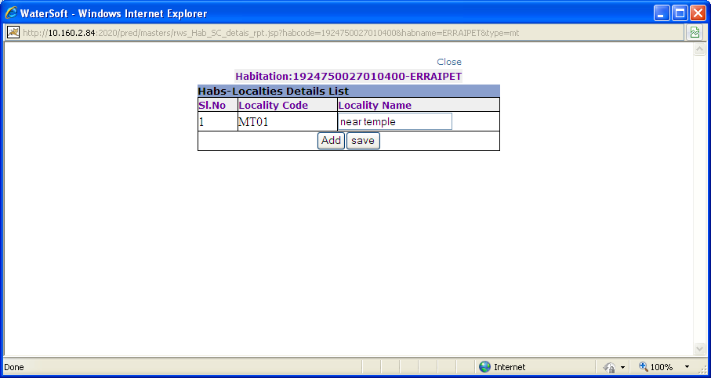
Figure 30.

Add
- Click ‘ Add ‘ button.

Save

- Locality Code is auto generated.
- Enter Locality Name.
- Click ‘ Save ‘ button.

Asset Status
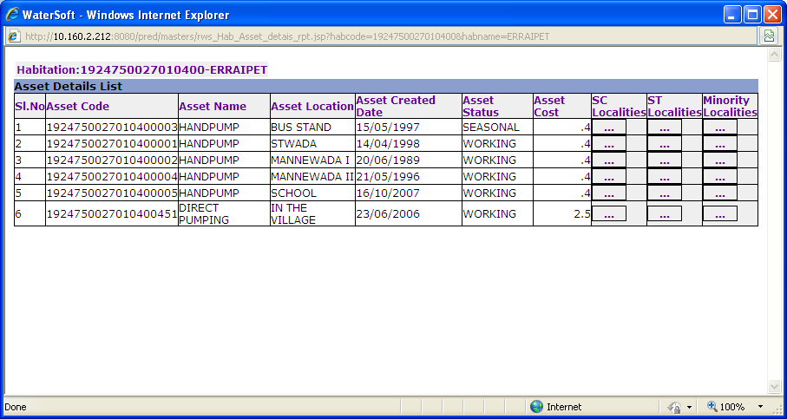
Figure 31.

Note:-

Click ‘ button ‘ placed in ‘ SC localities ‘ column ( In Figure 31. )-> (Figure 32. is displayed).

Click ‘ button ‘ placed in ‘ ST localities ‘ column ( In Figure 31. )-> ( Figure 33. is displayed ).

Click ‘ button ‘ placed in ‘ Minorities localities ‘ column ( In Figure 31. )-> ( Figure 34. is displayed ).

Population Served should be entered in Asset localities for SC,ST and Minorities localities.

Asset locality List
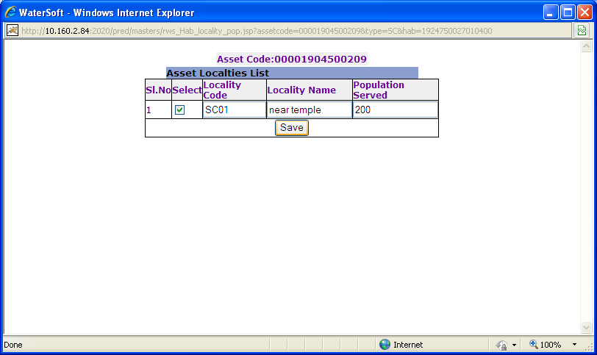
Figure 32.

Note:-Before selecting checkbox enter ‘Population Served’->Click ‘ Save ’ button.

Save
- Enter Population Served.
- Click ‘ Save ‘ button.

Asset locality List
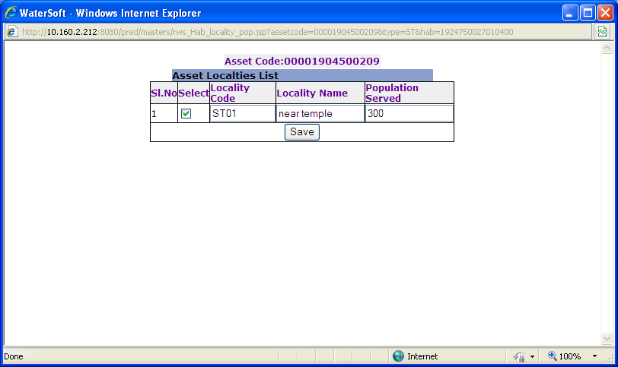
Figure 33.

Note:-Before selecting checkbox enter ‘Population Served’->Click ‘ Save ’ button.

Save
- Enter Population Served.
- Click ‘ Save ‘ button.

Asset locality List

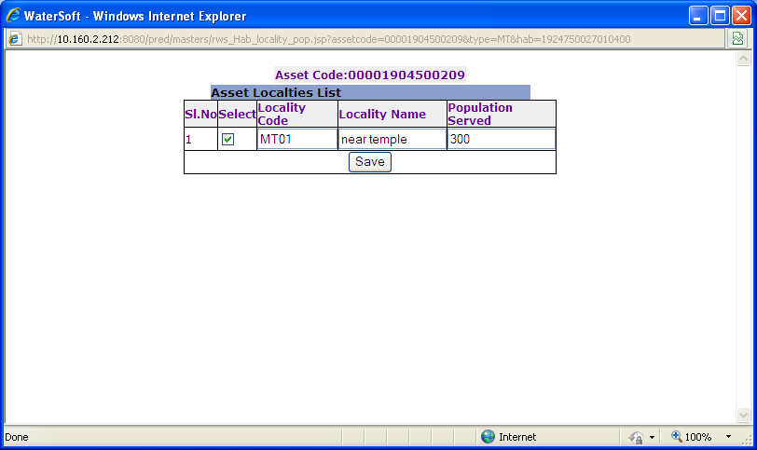
Figure 34.

Note:-Before selecting checkbox enter ‘Population Served’->Click ‘ Save ’ button.

Save
- Enter Population Served.
- Click ‘ Save ‘ button.

