USER MANUAL For WATER QUALITY MANAGEMENT

WaterSoft Software

(For the Department of Panchayati Raj & Engineering Department, Rural Water Supply Sector, Govt. of AP)

National Informatics Centre
Department of Information Technology
Ministry of Communications and Information Technology
Government of India
WebSite : www.ap.nic.in

PREPARED BY :

PROJECT TEAM ,
APDVIII, NIC APSC,
HYDERABAD.

REVIEWED BY:

HEAD OF THE DEPARTMENT,
APDVIII, NIC APSC,
HYDERABAD.

APPROVED BY :

STATE INFORMATICS OFFICER
NIC APSC,
HYDERABAD.

Amendment Log

Version Number | Date | Change Number | Brief Description | Sections Changed
1.0 | 1.1.2007 | - | First Release
1.1 | 20.3.2007 | - | Second  Release | Changes in all Modules based on User Requirements.
1.2 | 03.3.2009 | - | Third  Release | Changes in Sample Collection lab/FTK ,FTK Sample Status , Lab Sample Status based upon user Requirements.
1.4 | 29.7.2009 | - | Fourth  Release | Changes in Sample Collection lab/FTK based upon user Requirements.
1.5 | 23.3.2010 | - | Fifth  Release | Changes in Entry for parameters in Quality Tests(in Water Quality Parameter list) based upon user Requirements.

Sl No | CONTENTS | Page No
1 | Common Operations in the Software | 5
2 | Sample Collection Lab/FTK | 7 – 20
3 | Quality Tests | 21 – 25
4 | FTK Sample Status | 26 – 29
5 | Lab Sample Status | 30 - 34

Common Operations in the Software:

Click the button to close the Form.

 Click the button for online context help.

Home Click the button for Main Page.

Back Click the button for Previous page.

Print Click the button for Printable Version.

Excel Click the button for Excel Version.

Amount will be considered in Lakhs throughout the Software

WorkFlow - > Water Quality Management -> Sample Collection Lab/FTK

Water Quality Management

- Click ‘WorkFlow’
- Select Water Quality Management from Dropdown Menu.
- Select Sample Collection Lab/FTK.

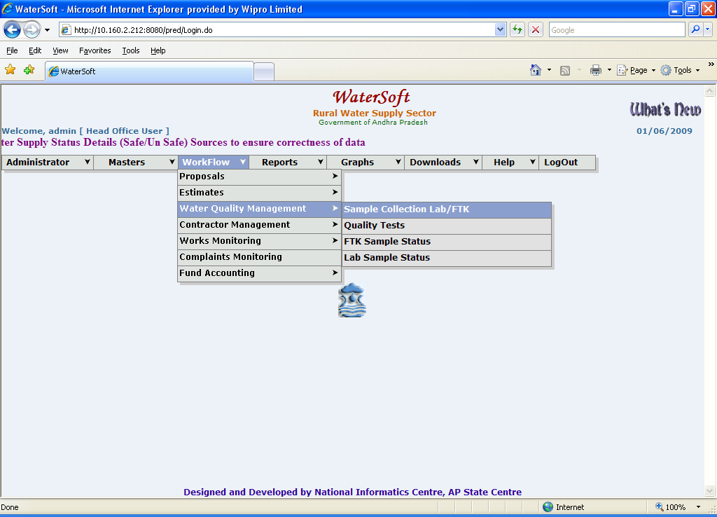
Figure 1.

Sample Collection Lab/FTK

Note:-Selection of Circle , Division , SubDivision is Fixed depending on Login.

Select Circle -> Select Division -> Select SubDivision -> Select Type Of test.

Note :- Fields marked with ‘ * ‘ are Mandatory Fields . ( Compulsory Selection )

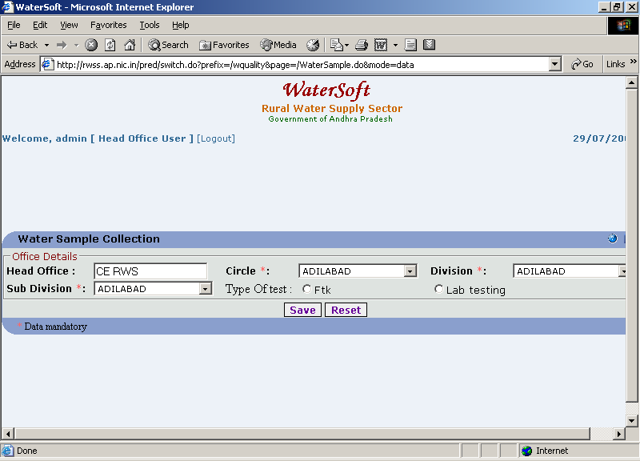
Figure 2.

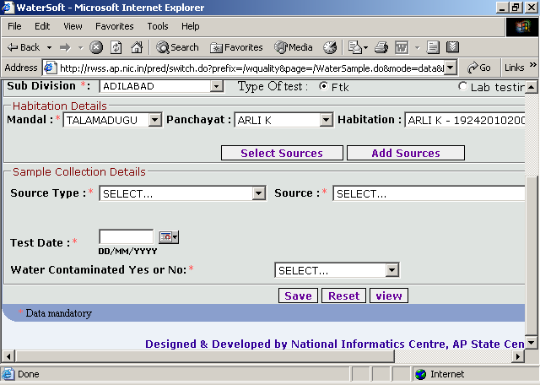
Figure 3.

If Ftk is selected

- Select Mandal.
- Select Panchayat.
- Select Habitation.
- Click ‘ Select Sources ‘ button.

Select Sources

Note :-Select Mandal then click ‘ Select Sources ‘ button the Sources that are existing in selected Mandal are displayed

Note :-Select Mandal ->select Panchayat->Select Habitation then click ‘ Select Sources ‘ button the Sources that are existing in selected Habitation are displayed.

Select Sources

- Click ‘ Select Sources ‘ button.

Sources List details are displayed

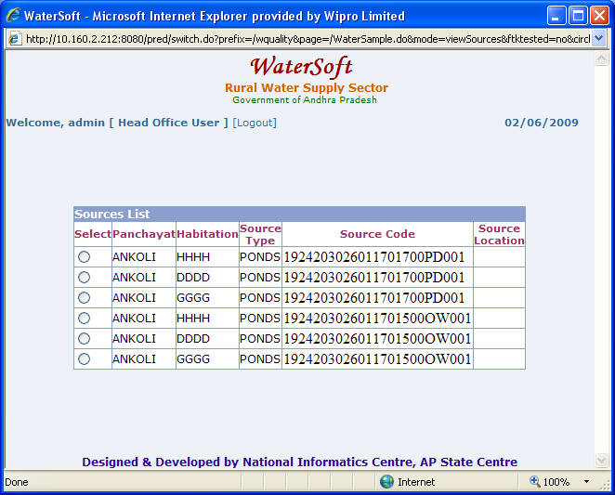

Figure 4.

Note :- Select any Source from list , the selected source will be fixed automatically in place of Source Type and Source.

Note:- Select SourceType and Source when not clicking on ‘Select Sources‘ button.

Save

- Select Source Type.
- Select Source.
- Select Test Date.
- Select Water Contaminated ( For Eg. Yes or No ).
- Click ‘ Save ‘ button.

Note:-Test Date Should be less than or equal to Current Date.

If Water Contaminated Selected as ‘ NO ’ the following screen shot ( Figure 5..) explain the process of saving the Source in Database. This source neither contaminated nor forwarded to lab.

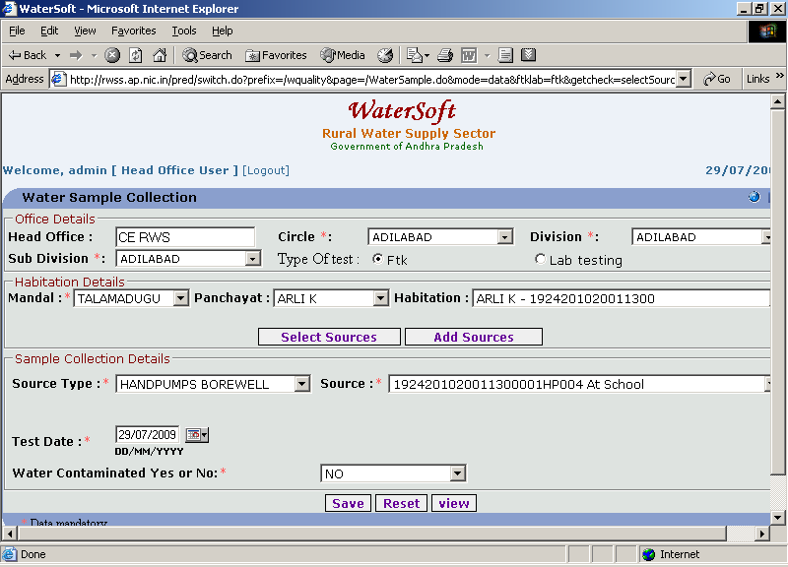
Figure 5.

If Water Contaminated is selected as ‘ YES ’ the following screen shot ( Figure 6..) explain the process of saving the Source in Database.

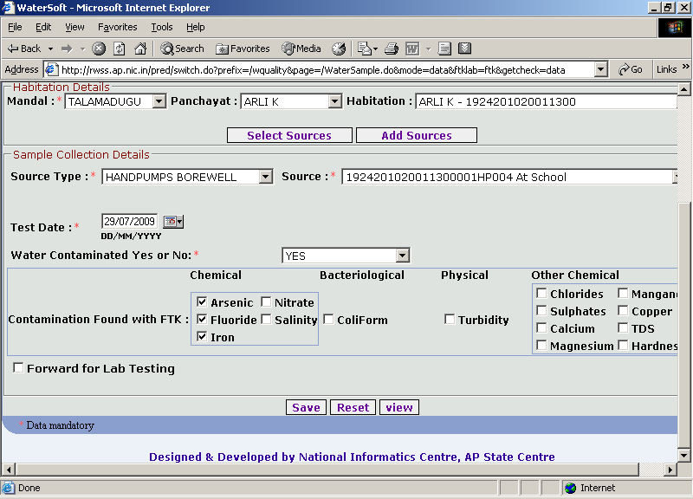
Figure 6.

- Select Contamination Found with FTK ( For Eg. Chemical) .
- Click ‘ Save ‘ button.

Note:- If Forward For Lab Testing is not checked the Source details are saved in Database and this source not forwarded to lab.

Note:-If Forward For Lab Testing is checked the same Source Details are Forwarded for Lab Testing.

The Following screen shot (Figure 7..) explain the process of saving source details in Database.

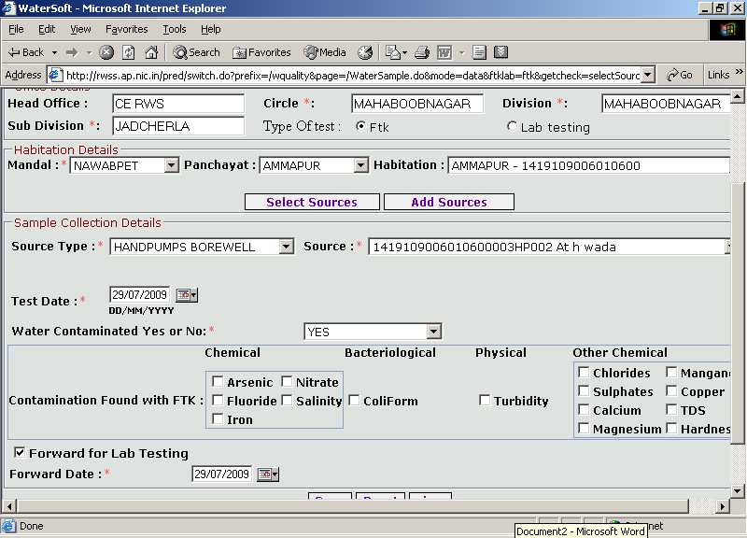
Figure 7.

Note:-Forward Date should be less than or equal to Current Date and Forward Date should be less than or equal to Test Date.

- Select Forward Date.
- Click ‘ Save ‘ button.

The following screen shot( Figure 8..) explain the process of forwarding the FTK Tested source for Lab Testing
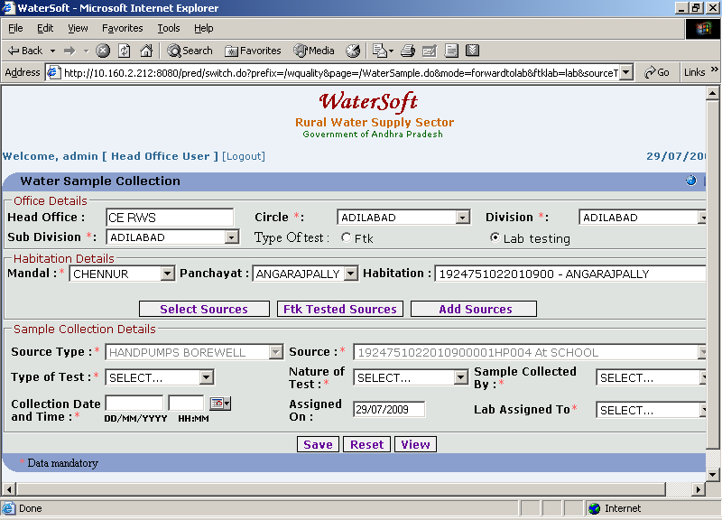
Figure 8.

Save
- Select Type Of Test . ( For Eg. Physico Chemical , Bact at Lab ).
- Select Nature Of Test. ( For Eg. Routine , Seasonal , Quarterly ).
- Select Sample Collected By ( For Eg. AEE , AE ).
- Select Collection Date and Time.
- Select Lab Assigned To. ( For Eg. MahaboobNagar , Tenali (p) ).
- Click ‘ Save ‘ button.

Reset
- Click ‘ Reset ‘ button.

Note:-Select ‘ Mandal ‘ for FTK Testing ‘ View ‘ button.

View

- Click ‘ View ‘ button.

Source Details are Displayed

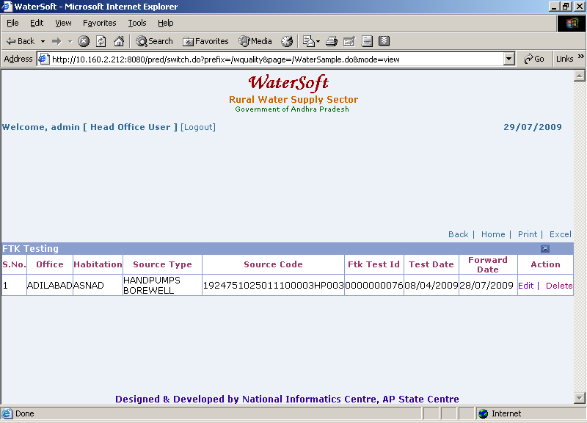
Figure 9.

Note I:- Click ‘ Delete ’ to Delete a Selected Source.
Note II:-Click ‘ Edit ‘ to make Modifications to Selected Source .

FTK Tested Sources

Note:- If Source is FTK Tested but not yet tested in lab then the Source details are available in FTK Tested Sources.

Note:- If Source is FTK Tested and Lab Tested then the Source details are not available in FTK Tested Sources.

FTK Tested Sources

- Click ‘ FTK Tested Sources ‘ button.

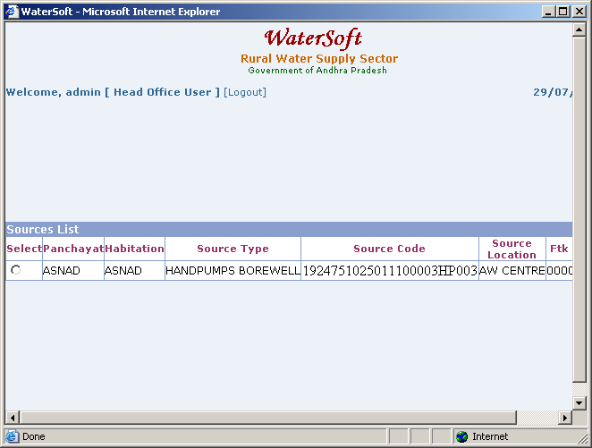

Figure 10.

In Water Sample Collection Form If Lab Testing is selected directly without selecting FTK Testing. This source will be saved in lab testing.

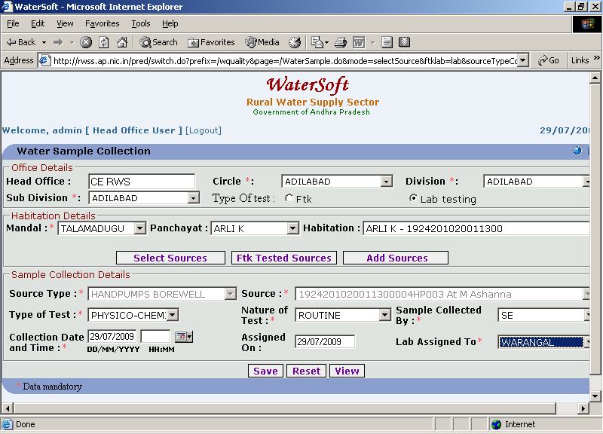
Figure 11.

Save
- Select Mandal.
- Select Panchayat.
- Select Habitation.
- Click ‘ Select Sources ‘ button.

Note:- Select SourceType and Source when not clicking on ‘ Select Sources ‘ button

- Select Source Type
- Select Source.
- Select Type Of Test . ( For Eg. Physico Chemical , Bact at Lab ).
- Select Nature Of Test. ( For Eg. Routine , Seasonal , Quarterly ).
- Select Sample Collected By ( For Eg. AEE , AE ).
- Select Collection Date and Time.
- Select Lab Assigned To. ( For Eg. MahaboobNagar , Tenali (p) ).
- Click ‘ Save ‘ button.

Reset button.

- Click on ‘Reset’ button.

View button.

- Click on ‘View’ button.

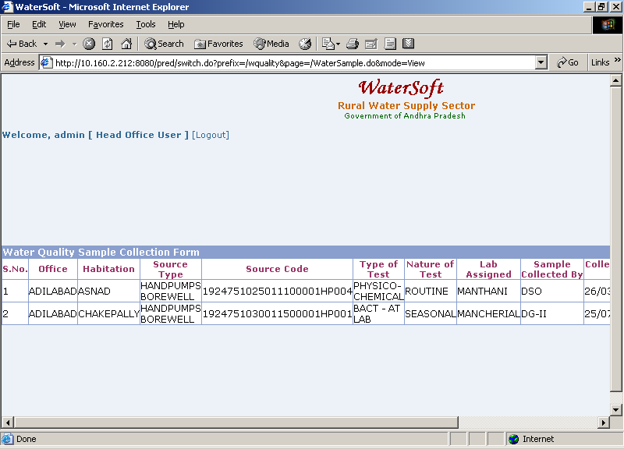

Figure 12.

Note I:- Click ‘ Delete ’ to Delete Selected Source
Note II:-Click ‘ Edit ‘ to make Modifications to Selected Source.

Add Sources

Note :- For ‘ Add Sources ‘ button , Select -> Panchayat -> Habitation ->click on

‘ Add Sources ‘ button.

- Click on ‘ Add Sources ’ button.

Note:-Asset Entry Form will be displayed – New Sources can be created by using this Form .

Asset Entry Form

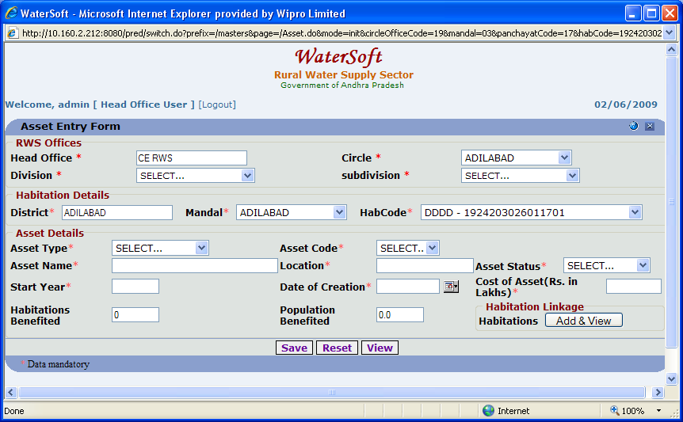
Figure 13.

Save

- Select Asset Type (PWS, CPWS, HANDPUMPS, PONDS, SHALLOWHANDPUMPS, OTHERS).
- Select Type ( Add New, Modify ).

Option Add New

- Asset Code is auto generated.
- Enter Asset Name.
- Enter Location.
- Select Asset Status.
- Enter Start Year.
- Enter Date of Creation.
- Enter Cost of Asset (Rs. In Lakhs).
- Enter No of Habitations Benefited.
- Enter Population Benefited.
- Click on ‘Save’ button.

Option Modify

- Enter Asset Name.
- Enter Location.
- Select Asset Status.
- Enter Start Year.
- Enter Date Of Creation.
- Enter Cost Of Asset ( Rs. In Lakhs ).
- Click ‘ Save ‘ button.

Note:- New Source details can be entered by selecting ‘ AddNew ‘ option . Select ‘ Modify ‘ option and then Enter data for any Component of the Source.
These sources will be displayed by selecting ‘ Select Sources ‘ button in Water Sample Collection Form. Newly added Source details will be displayed automatically.

Quality Tests

WorkFlow -> Water Quality Management -> Quality Tests

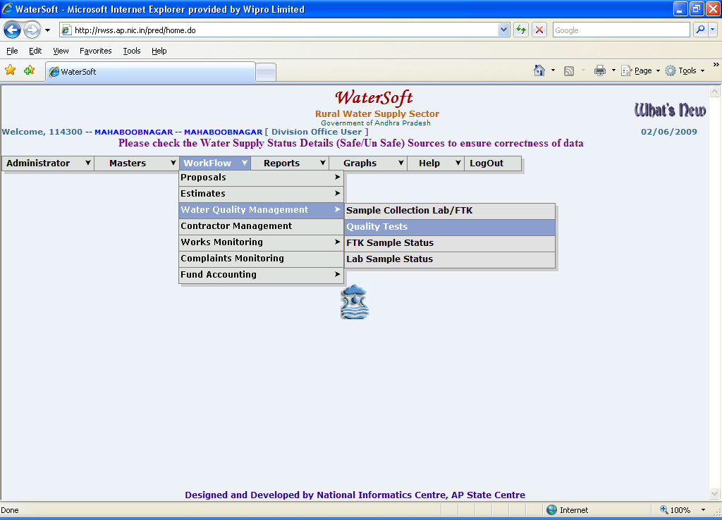

Figure 14.

Water Sample Test Result

Submit button.

- Select Test.
- Select update Source data.
- Select Portable.
- Select Forwarded on.
- Enter Recommendations.
- Click on ‘Submit’ button.

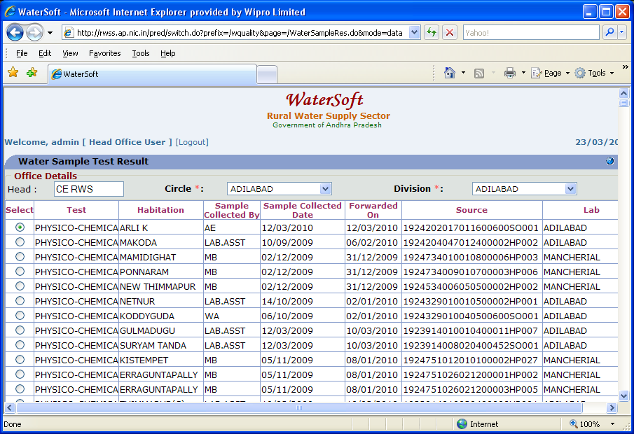
Figure 15.

Note:-Select any Test For Entering Test Results Water Quality Parameter List Form will be displayed , Enter Result for selected Test , click ‘ Save ‘ button (Water Quality Parameter List Form ) , Test Results will not be saved until clicking on ‘ Submit ‘ button in (Water Sample Test Result Form).

Note: -When entering results against Parameters

Case 1: Physico-chemical test

Mandatory Parameters: - PH range, Dissolved solids, Total Hardness, chloride, Alkalinity and Fluoride. For these parameters results entry is mandatory

Ranges:

  - PH 6 - 9
  - Fluoride 0 – 20
  - Nitrate 0 – 999
  - Iron 0 –10
  - Manganese 0 - 99
  - Residual Chlorine 0 – 9
  - Calcium range should be less than Total Hardness.
  - Magnesium range should be less than Total Hardness.
  - Total Hardness should be less than Dissolved solids
  - Sum of Total Hardness, Chloride must be less than Dissolved solids.

Case 2:Bact-at Lab test

Mandatory Parameters: - MPN Coliform Bacteria per 100 ml parameter results should be entered (Compulsory).

Ranges: -

  - MPN coliform Bacteria per 100 ml 0 – 1609
  - E-coli per 100 ml 0 - 24

Water Quality Parameter List

- Select Test (Water Sample Test Result Form.)
- Enter Result for each Test.(According to Range).
- Click on ‘Save’ button.

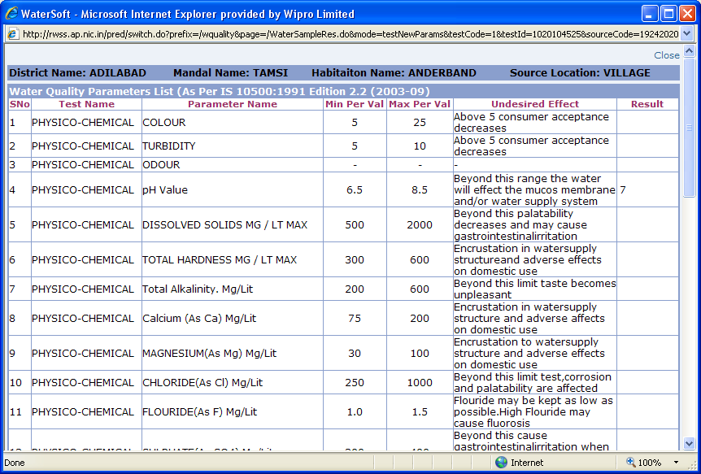

Figure 16.

Water Sample Test Result
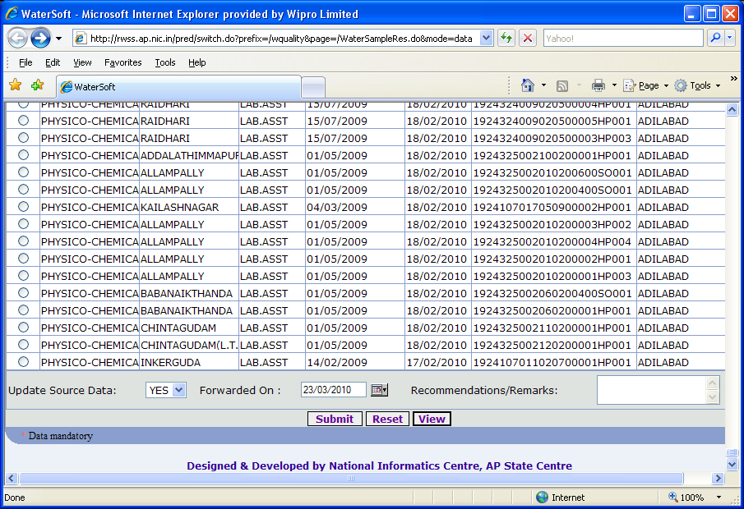

Figure 17.

Reset button.

- Click on ‘Reset’ button.

View button.

- Click on ‘View’ button.

Water Sample Test Result Lists are displayed

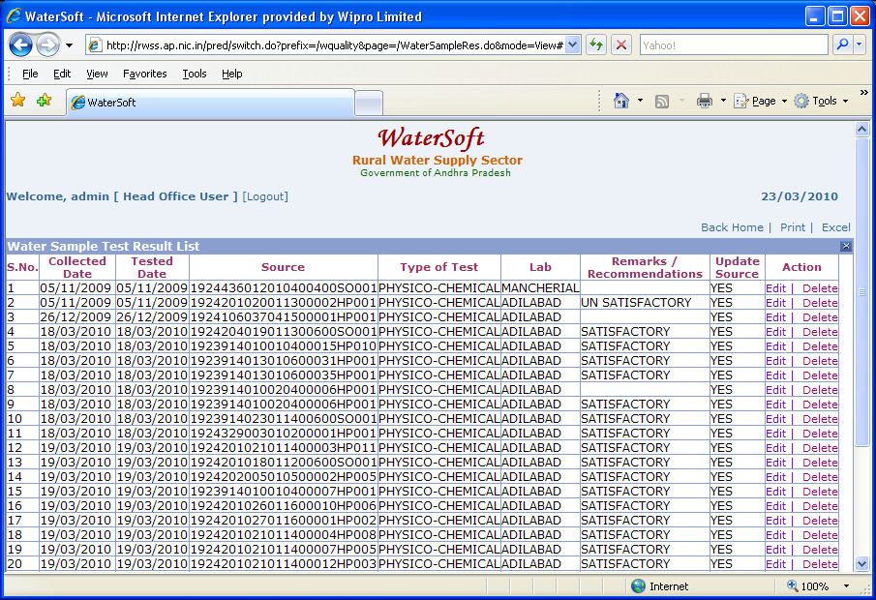
Figure 18.

Note I:-Click on ‘ Delete ‘ – to Delete a selected Source.
Note II:-Click on ‘ Edit ‘ - Water Sample Test Result Form is displayed to make Modifications to selected Source.

FTK Sample Status

WorkFlow -> Water Quality Management -> FTK Sample Status

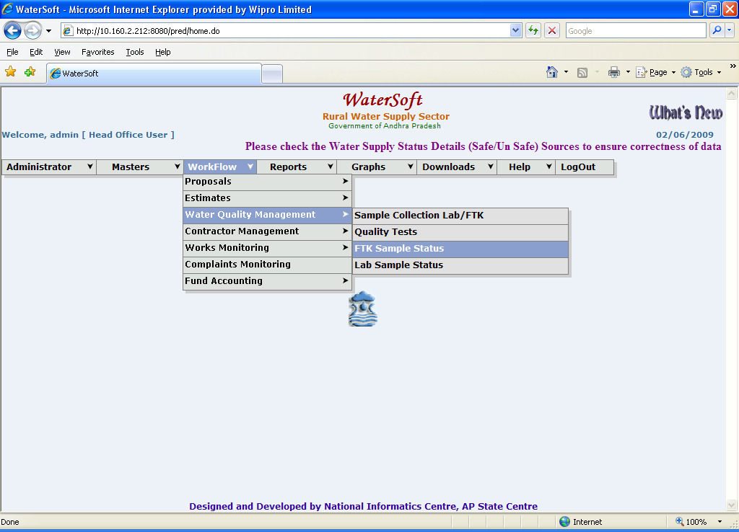

Figure 19.

Note I:- Select Circle -> Mandal - To get details of Water Samples Ftk tested and not Forwarded to lab

Note II:- Select Circle -> Mandal -> Year -> Month ->Click on ‘ GetData ‘ –To get details of Water Sample Ftk tested and forwarded to Lab (awaiting lab test)

Water Sample Ftk Test Results are displayed

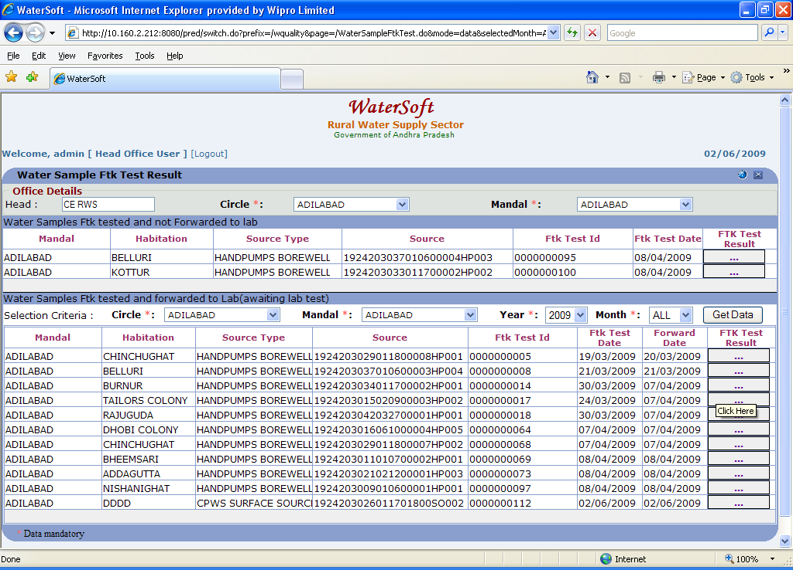
Figure 20.

Note:- Click on FTK Test Results – FTK Test Results are displayed

FTK Test Results are displayed

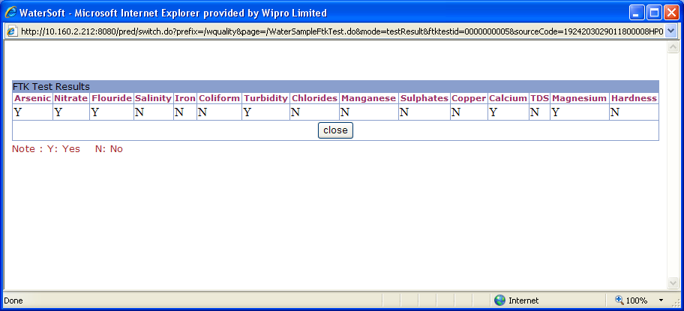

Figure 21.

Lab Sample Status

WorkFlow - > Water Quality Management -> Lab Sample Status

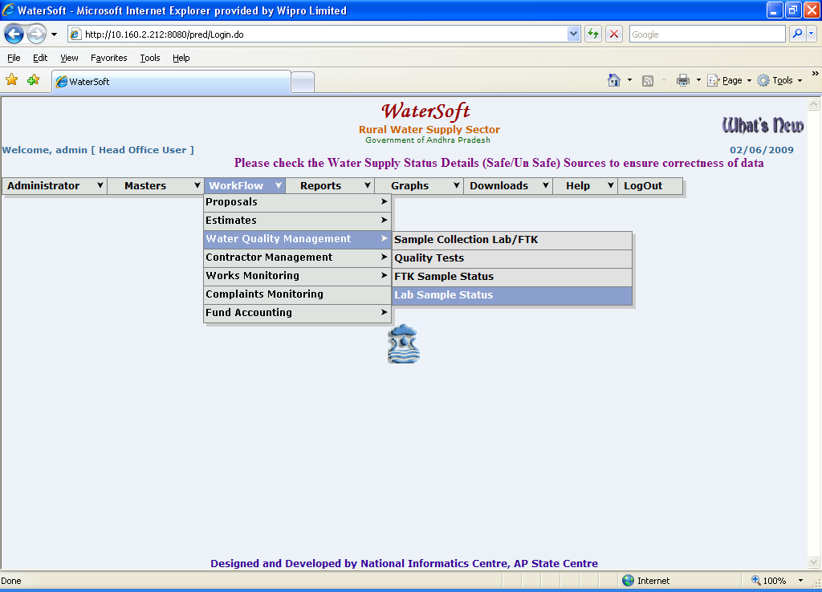

Figure 22.

Water Sample Test Results are displayed

Water Sample Test Result

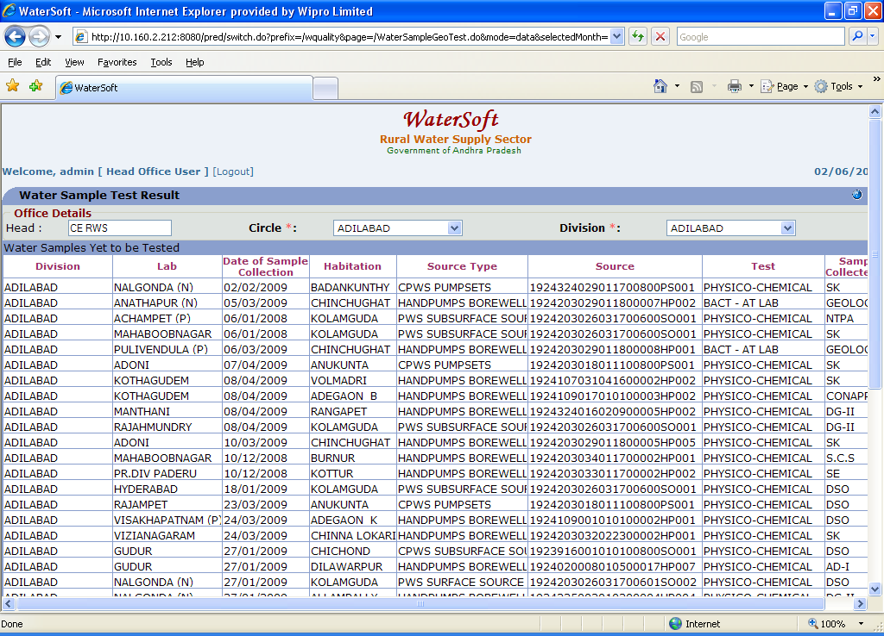

Figure 23.

Water Sample Test Result

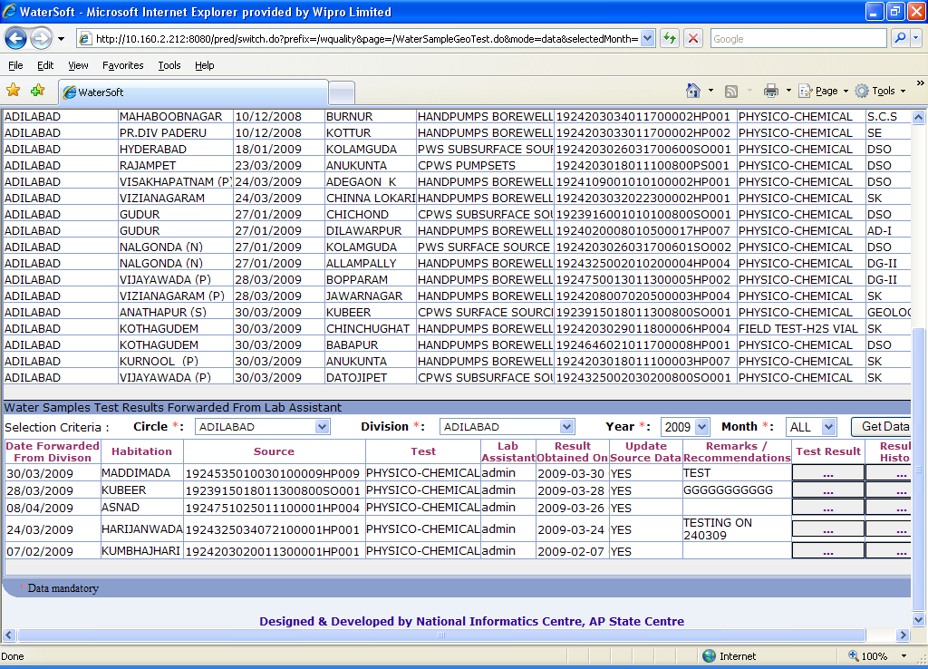

Figure 24.

Note I:- Click on ‘ Test Result ‘ – Test Results are displayed

Note II:- Click on ‘ Results History ‘ – Results History are displayed

Test Results are displayed

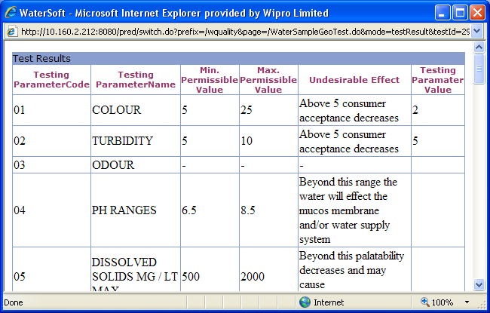
Figure 25.

Results History details are displayed

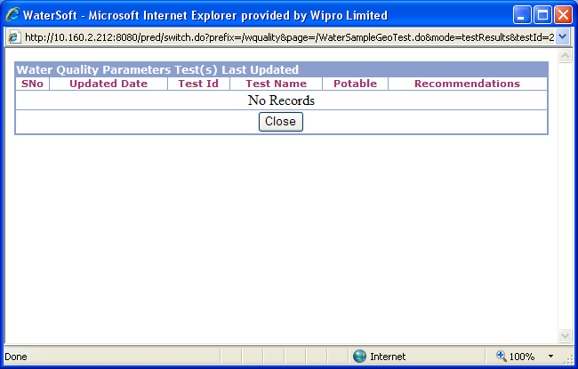

Figure 26.

