USER MANUAL FOR DROUGHT MONITORING

WaterSoft

(For the Department of Panchayati Raj & Engineering Department, Rural Water Supply Sector and Sanitation, Govt. of AP)

National Informatics Centre
Department of Information Technology
Ministry of Communications and Information Technology
Government of India
WebSite : www.ap.nic.in

PREPARED BY :

PROJECT TEAM ,
NIC APSC,
HYDERABAD.

REVIEWED BY:

HEAD OF THE DEPARTMENT,
NIC APSC,
HYDERABAD.

APPROVED BY :

STATE INFORMATICS OFFICER
NIC APSC,
HYDERABAD.

Amendment Log

Version Number | Date | Change Number | Brief Description | Sections Changed
1.0 | 31.03.2012 | - | First Release

Sl No | CONTENTS | Page No
1 | Common Operations in the Software | 5
2 | Scarcity Master | 6 – 9
3 | Habitations for Drought | 10 – 12
4 | Transportation of Drinking Water Entry | 13 - 15
5 | Flushing Deepening of Borewells | 16 - 18
6 | Drought SS Tanks Entry | 19 - 21

Common Operations in the Software:

Click the button to close the Form.

 Click the button for online context help.

Home Click the button for Main Page.

Back Click the button for Previous page.

Print Click the button for Printable Version.

Excel Click the button for Excel Version.

Amount will be considered in Lakhs throughout the Software

Masters->Drought Scarcity Master->Scarcity Reasons
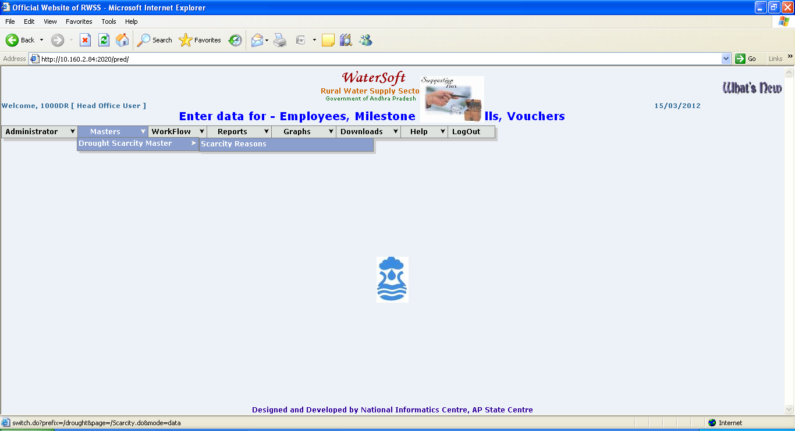
Figure 1.

Scarcity Entry Form
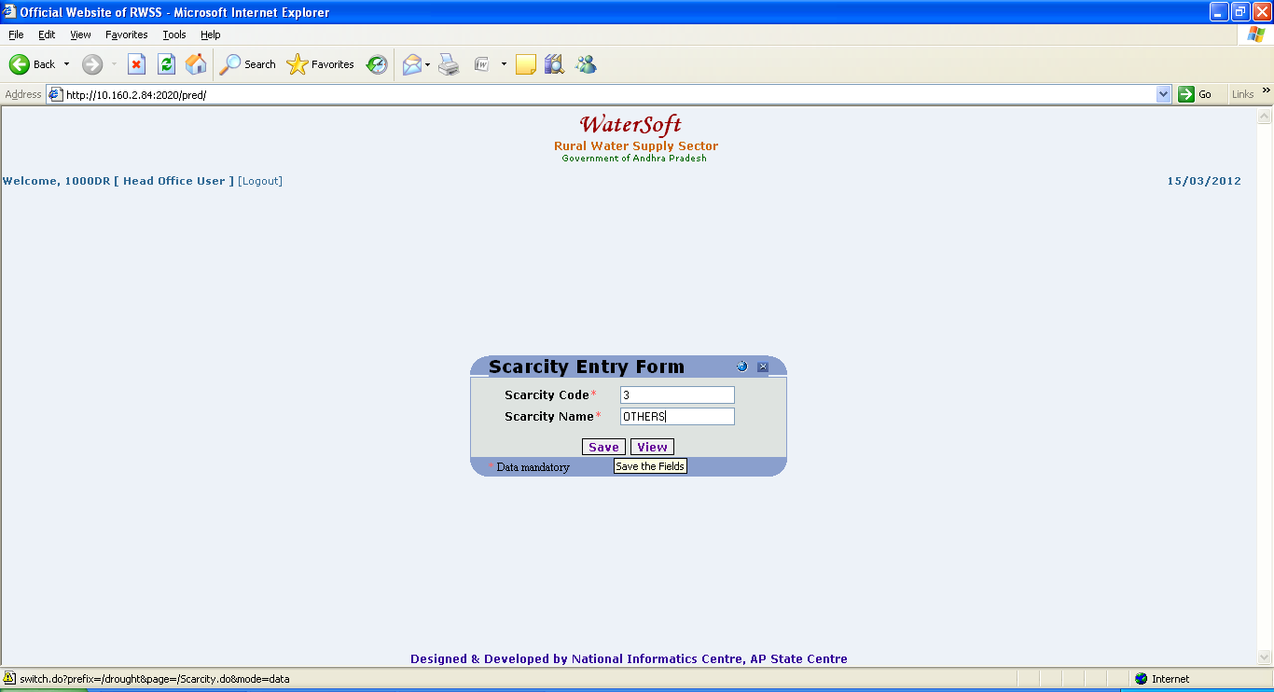
Figure 2.

Save button

- Scarcity Code is autogenerated.
- Enter Scarcity Name
- Click ‘Save’ button.

View button

- Click ‘ View ’ button.

Scarcity Reasons are displayed
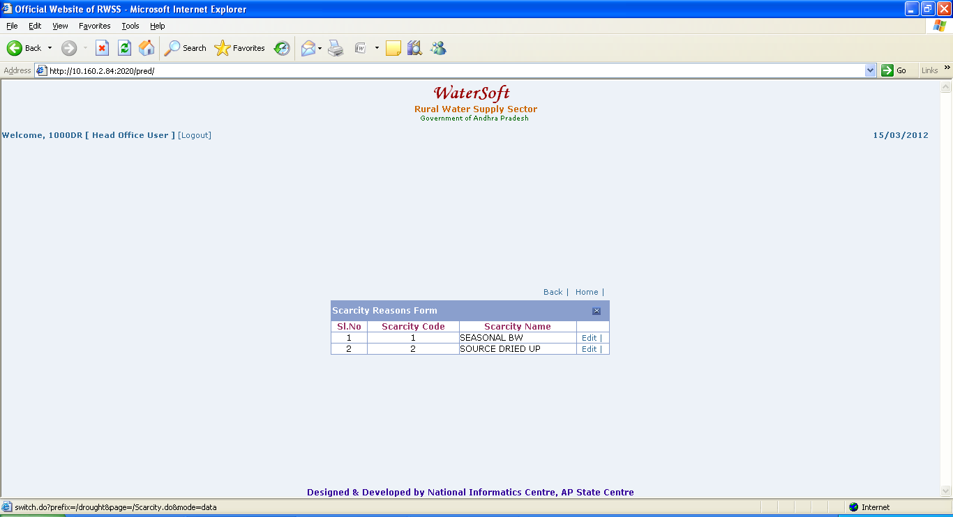
Figure 3.
Note:-Click ‘ Edit ‘ button to make modifications-> Scarcity Edit Entry Form is displayed -> Change Scarcity Name-> Click ‘ Update ‘ button.

Scarcity Edit Entry Form
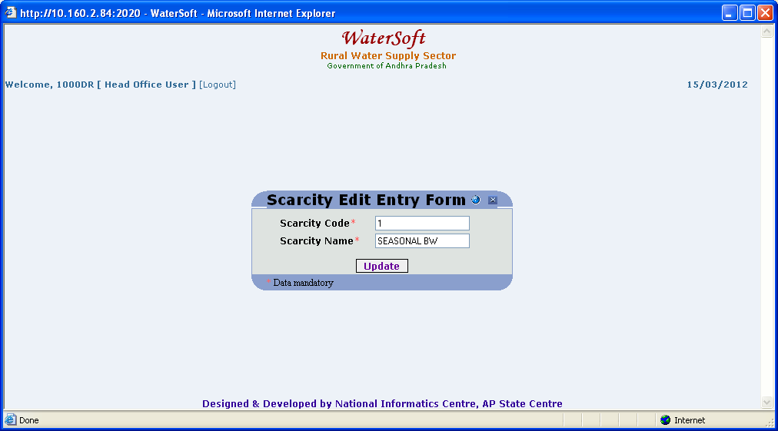
Figure 4.

Update button

- Scarcity code is fixed( Read only / No Modification ).
- Enter Scarcity Name.
- Click ‘ Update ’ button.

WorkFlow - > Drought Monitoring - > Habitations for Drought

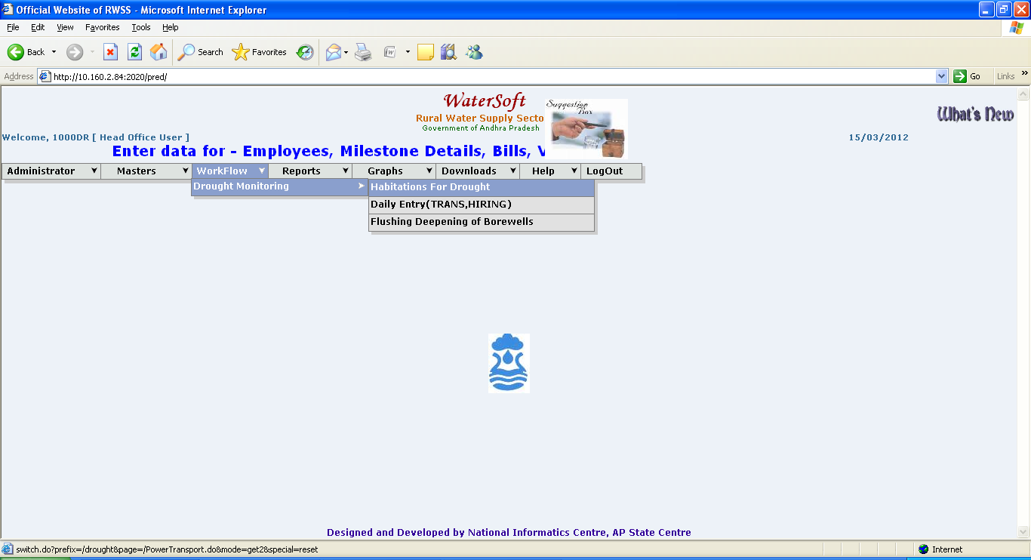
Figure 5.

Submit button
- Select District.
- Select Mandal.
- Click ‘ Submit ’ button.

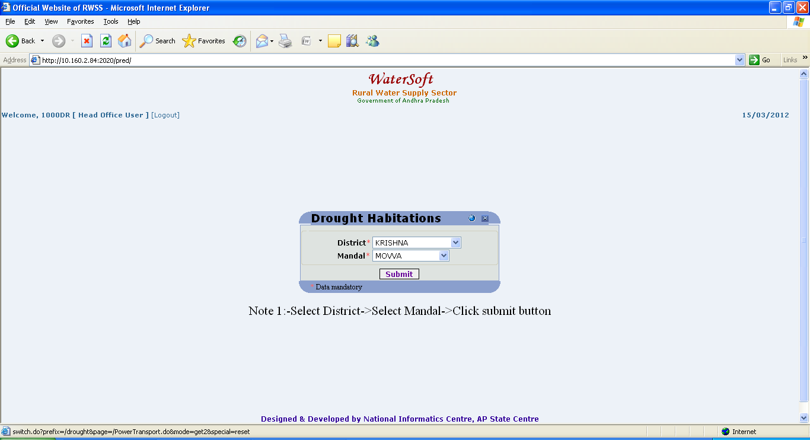
Figure 6.

Habitations are displayed

Note:- Amount Should be entered in ( Rs. Lakhs ).

Note:- Select CheckBox before Clicking on Save button.

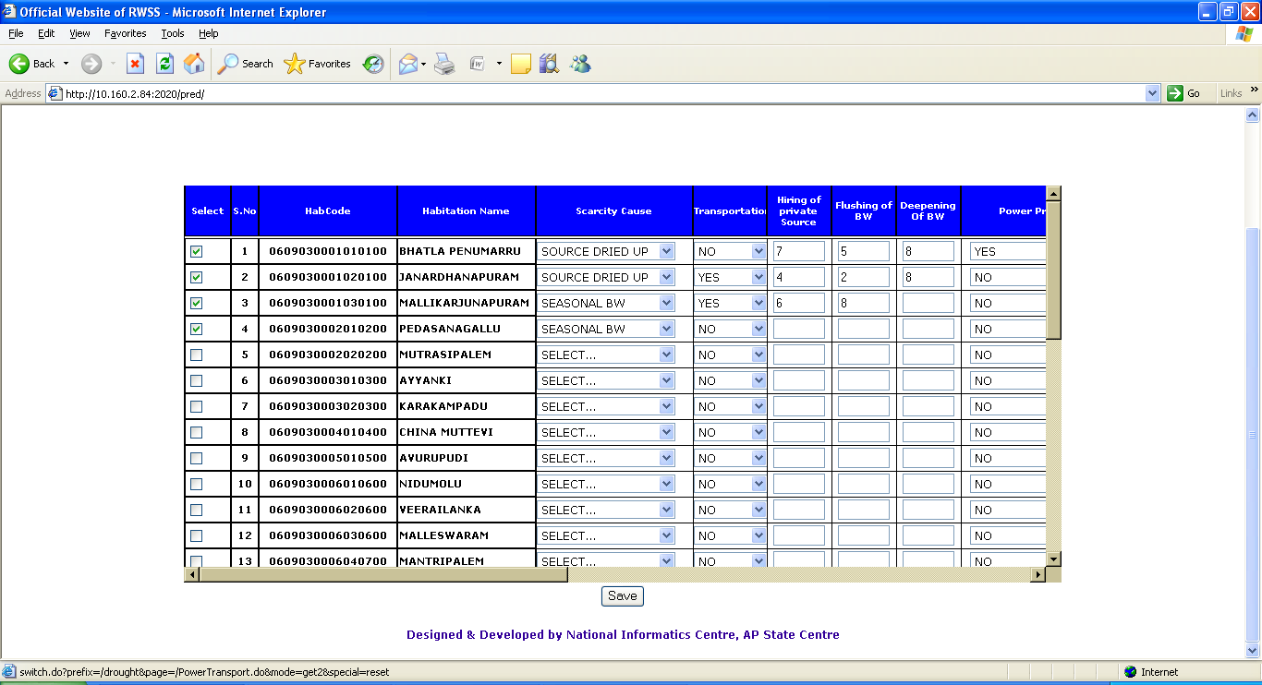
Figure 7.

Save button

- Select Scarcity Cause.( For Eg Seasonal BW , Source Dried up etc..)
- Select Transportation ( For Eg. Yes/No - default No is selected)
- Enter Hiring of Private Source.
- Enter Flushing of BW.
- Enter Deepening of BW.
- Select Power Problem (For Eg. Yes/No - default No is selected))
- Select FromDate.
- Select ToDate.
- Enter Transport Estimate.
- Enter Hiring of Private Source Estimate.
- Enter Flushing of BW Estimate.
- Enter Deepening of BW Estimate.
- Enter Power Estimate.

Measures to tackle Scarcity Permanently.

- Select Type of Work (For Eg. AUG , PWS etc..).
- Enter Work Estimate Cost.
- Click ‘ Save ’ button

WorkFlow->Drought Monitoring->Daily Entry(Transport/Hiring)

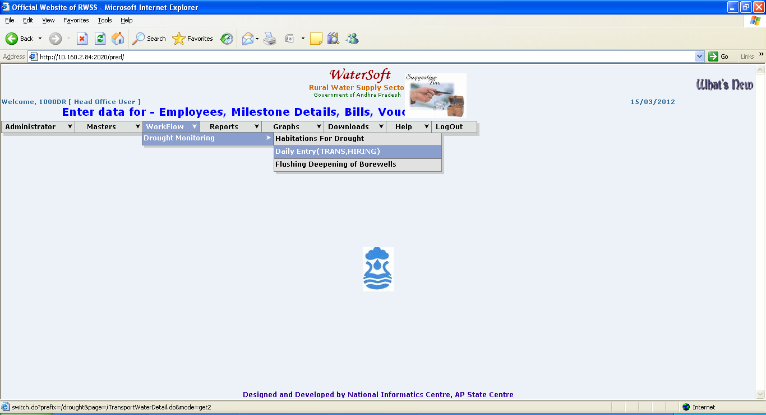
Figure 8.

Transportation of drinking Water Entry

Note:- Select CheckBox before Clicking on Save button.

Note:- Amount Should be entered in ( Rs. Lakhs ).

Select District->Select Mandal ->Transport/Private Sources /Power Supply details are displayed.

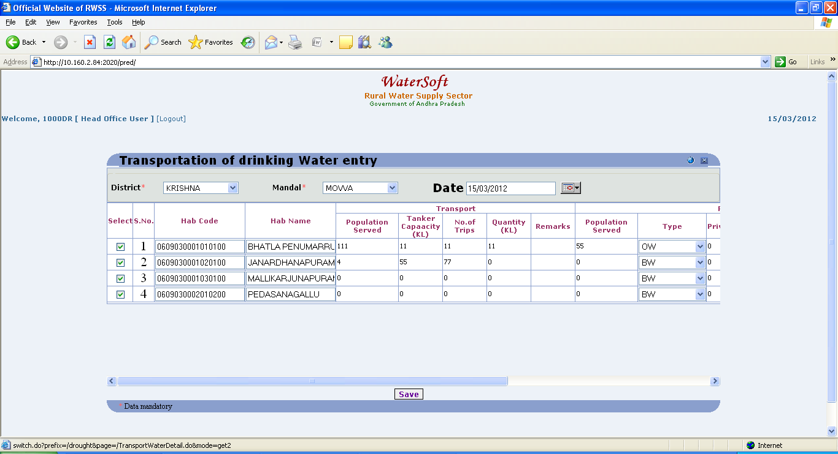
Figure 9.

Save button

Enter Transport data
- Enter Population Served.
- Enter Tanker Capacity(Kilo Litres).
- Enter No. of Trips.
- Enter Quantity(Kilo Litres).
- Enter Remarks.

Enter Private Sources data
- Enter Population Served.
- Select Type (For Eg . OW , BW etc..).
- Enter No. of Private Sources Hired.
- Select Mode of Supply from hired Sources.( For Eg. Existing Scheme ,None etc..).
- Enter Quantity Supplied (In Kilo Litres).
- Enter Remarks.

Enter Power Supply data
- Select Irregular power supply (For Eg. Insufficient Power ,Low Voltage etc..).
- Enter Remarks.

Flushing Deepening of Borewells

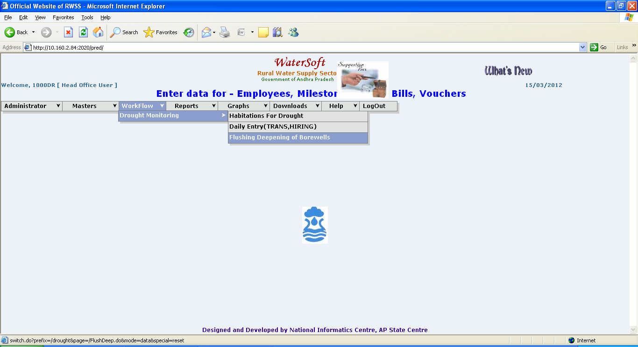
Figure 10.

Flushing Deepening of Borewells

Note:- Select CheckBox before Clicking on Save button.

Select District->Select Mandal->select Panchayat->Select Village->Select Habitation->Borewell details are displayed->Enter Data ->Click ‘Save’ button.

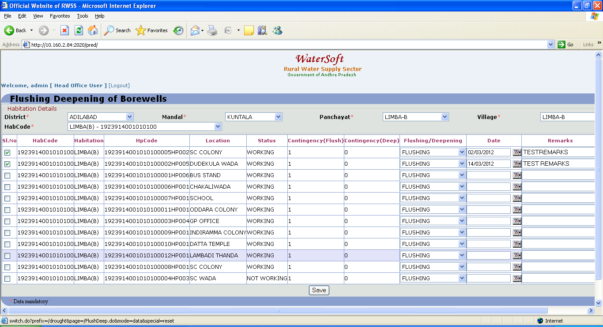
Figure 11.

Save button

- HabCode , HabName , HpCode , Location ,Status ,Contingency (Deep), Contingency (Flush) are displayed automatically based on selection of Habitation.
- Select Flushing / Deepening.
- Select Date.
- Enter Remarks.
- Enter Depth(In Metres).
- Click ‘ Save ‘ button.

WorkFlow->Drought Monitoring->Drought SS Tanks

Drought SS Tanks

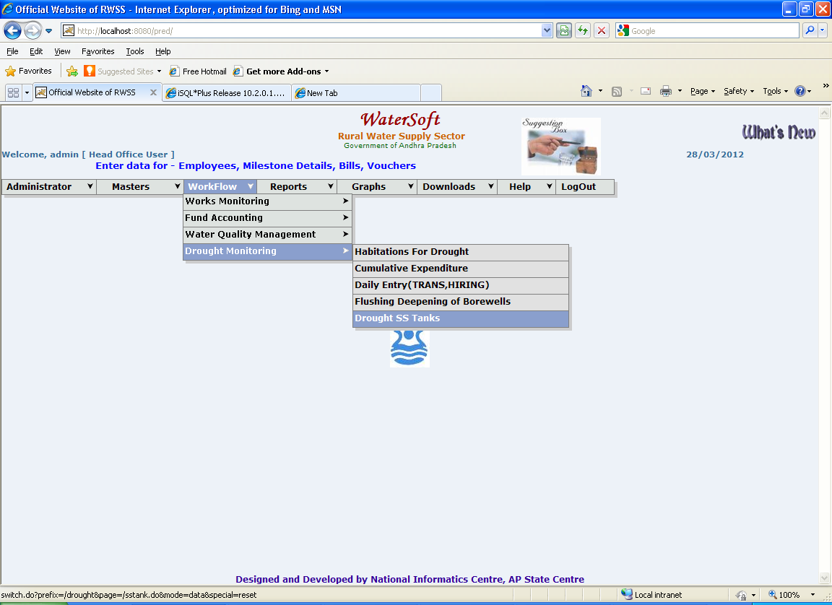
Figure 12.

Note:- Select CheckBox before Clicking on Save button.

SS Tank Entry

Select District->Select Mandal->Select Panchayat->Select Village->Select Habitation->Select Date ->SS Tanks present in selected habitation are displayed>Enter data ->Click ‘ Save ’ button
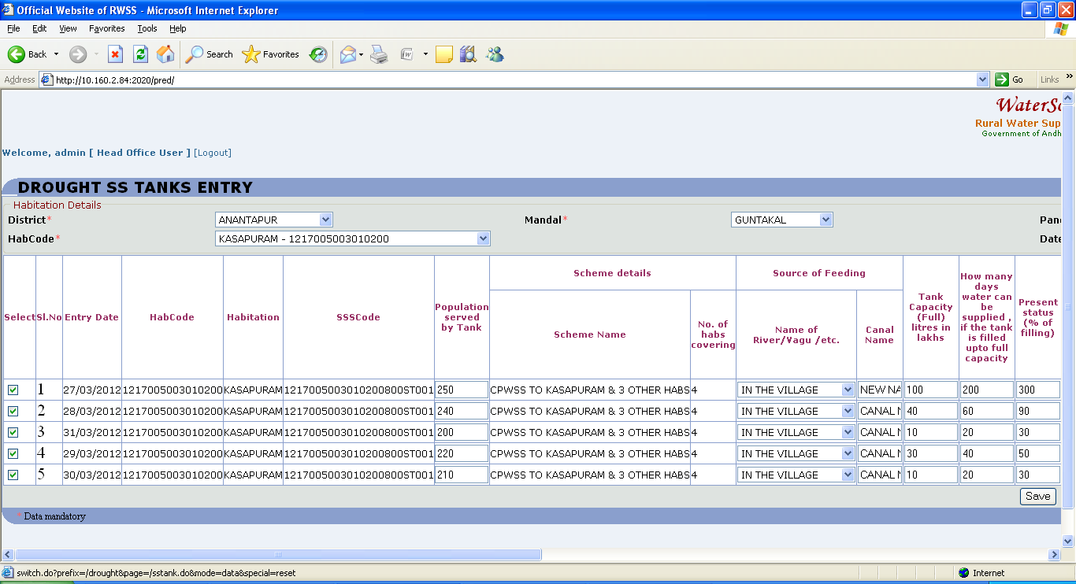
Figure 13.

(Figure 14. Is contd.. of Figure 13.)
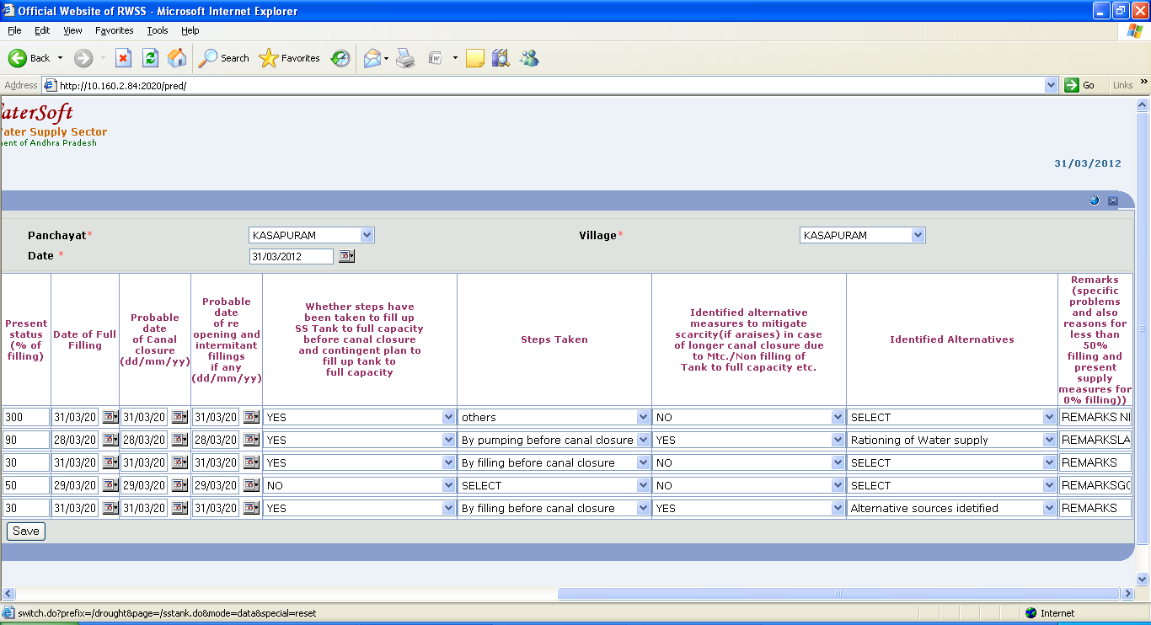
Figure 14.

Save button

- HabCode , Habitation , SSSCode , Scheme Name No of Habs Covering are displayed automatically based on selection of Habitation.
- Enter Population Served by Tank.

Source of Feeding

- Select Name of River / Vagu /etc.
- Canal name is displayed automatically
- Enter Tank Capacity(Full)( Litres in Lakhs).
- Enter How many days water can be supplied if the tank is filled upto full capacity.
- Enter How many days water can be supplied if the tank is filled upto full capacity.
- Enter Present Status(% of filling).
- Date of Full Filling.
- Select Probable date of Canal Closure(dd/mm/yy).
- Select Probable date of reopening and intermitant fillings if any(dd/mm/yy).
- Select Whether steps have been taken to fill up SS Tank to full capacity before canal closure and contingent plan to fill up tank to full capacity.( For Eg. Yes / No ).

If Yes is selected the following options can be selected

1.Select Yes, By filling before canal closure
2.Select Yes, By pumping before canal closure.
3.Select Yes, others

If No is selected there are no options to select
1.Select No

- Select Identified alternative canal closure due to Mtc./Non filling of Tank to full capacity etc.( For Eg. Yes / No ).

If Yes is selected the following options can be selected

1. Select Yes, Transportation of Drinking water
2. Select Yes, Hand pumps
3. Select Yes, Shallow Hand Pumps
4. Select Yes, Scheme with Bore well Source
5. Select Yes, Rationing of Water supply
6. Select Yes, Alternative sources idetified
7. Select Yes, Connected with CPWSS
8.Select Yes, others
9. Select No Problem.

If No is selected there are no options to select.
1.Select No.

- Remarks (specific problems and also reasons for less than 50% filling and present supply measures for 0% filling).
- Click ‘Save’ button.

