SCHOOL OF COMPUTER SCIENCE AND ARTIFICIAL INTELLIGENCE |  |  |  |  | DEPARTMENT OF COMPUTER SCIENCE ENGINEERING
Program Name: B. Tech |  |  |  | Assignment Type: Lab |  |  | Academic Year:2025-2026
Course Coordinator Name |  |  |  | Dr. Rishabh Mittal
CourseCode |  |  | 23CS002PC304 | Course Title |  | AI Assisted Coding
Year/Sem |  |  | III/II | Regulation |  | R23
Date and Day  of Assignment |  |  | Week9 – Monday | BATCH |  | B-47_B
NAME |  |  | V.SUSHMITHA | H.T.NO |  | 2303A54055
Assignment Number: 18.1
 | Q.No. | Question |  |  |  |  |  | Expected Time  to complete
 | 1 | Lab 18 – API Integration: Connecting to External Services with Error Handling  Lab Objectives:  - Learn how to integrate Python programs with external REST APIs.  - Understand API request/response handling using requests or similar libraries.  - Implement proper error handling for failed API calls (timeouts, invalid responses, rate limits).  - Practice extracting and displaying meaningful information from API responses.  Task 1 – Weather API Integration  Connect to a Weather API to fetch current weather details for a given city.  Instructions:  - Prompt AI to generate Python code using the requests library.  - Handle errors: invalid city name, API key errors, and network failures.  - Display temperature, humidity, and weather description in a readable format.  PROMPT : Explain how to integrate a Weather API in Python to fetch real-time weather data for a given city. Describe how API requests are sent, responses are processed, and how error handling is implemented for invalid inputs and network failures.  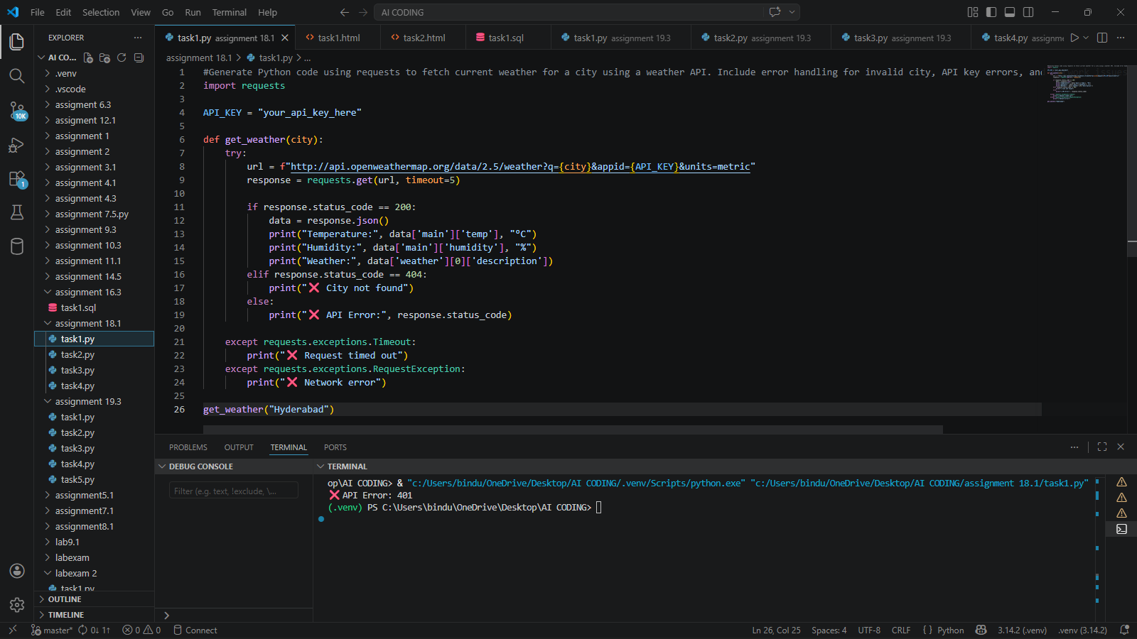  Expected Output: ❌ API Error: 401  EXPLANATION : In this task, we connect a Python program to an external Weather API using the requests library. The API sends back data in JSON format when we provide a city name and API key.The program extracts useful details such as temperature, humidity, and weather description from the response. Error handling is very important here:  This ensures the program runs smoothly without crashing and gives meaningful messages to the user.  Task 2 – Currency Exchange Rates  Integrate a Currency Exchange API to convert INR to USD, EUR, and GBP.  Instructions:  - Use AI to generate API request code.  - Validate user input for amount and currency codes.  - Implement error handling for invalid responses and API downtime.  - Show conversion results clearly in tabular format.  PROMPT : Describe how to use a Currency Exchange API to convert INR into multiple currencies. Explain input validation, API request handling, and error management for incorrect inputs and API failures.  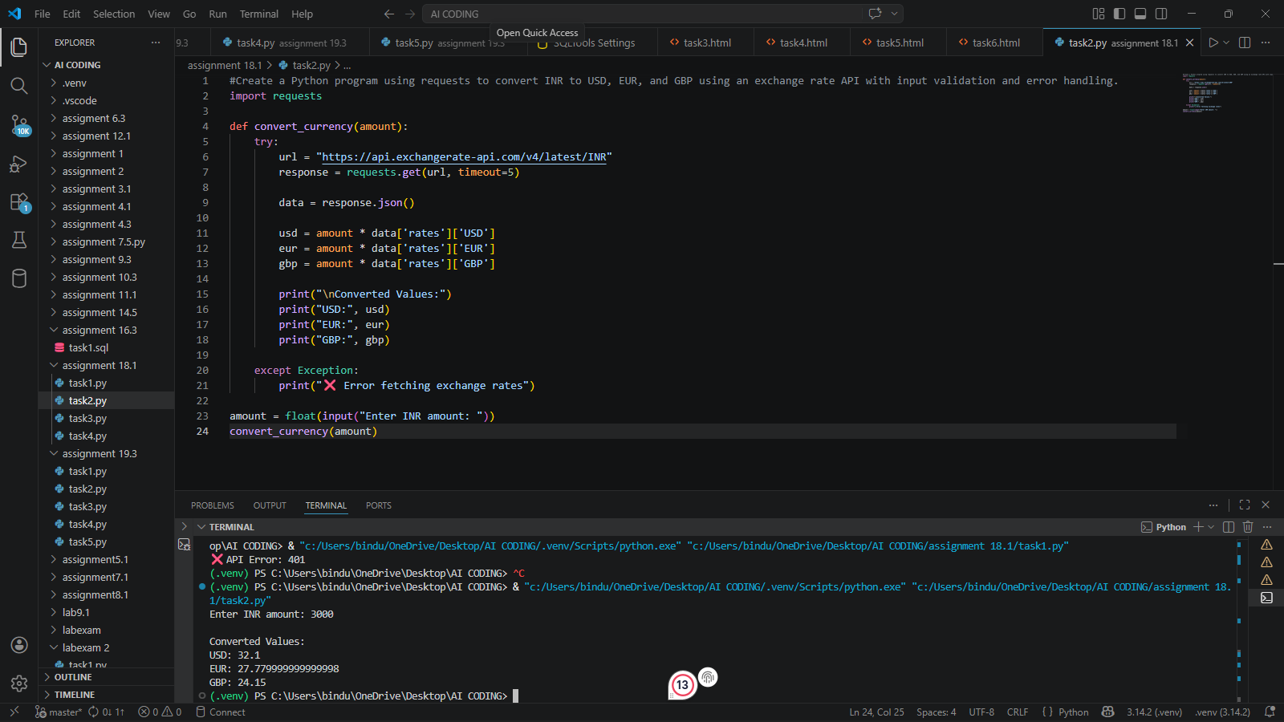  Expected Output:  Enter INR amount: 3000  Converted Values:  USD: 32.1  EUR: 27.779999999999998  GBP: 24.15  EXPLANATION : This task focuses on converting Indian Rupees (INR) into currencies like USD, EUR, and GBP using an external API.  Steps involved:  - Take user input (amount in INR)  - Validate input (must be numeric and positive)  - Send API request to get exchange rates  - Perform conversion using received rates  Error handling includes:  - Invalid input (non-numeric values)  - API downtime or failure  - Incorrect currency codes  The result is displayed clearly in a structured format (like a table), making it easy to understand.  Task 3 – GitHub Repository Info Fetcher  Connect to the GitHub API to fetch details of a repository (e.g., stars, forks, issues).  Instructions:  - Prompt AI to write a Python function to send GET requests to GitHub API.  - Handle rate limit errors, 404 (repo not found), and invalid input.  - Display repository name, description, stars, forks, and open issues.  PROMPT : Explain how to fetch repository details from GitHub API using Python. Describe how GET requests work and how errors like rate limits, invalid repositories, and missing data are handled.  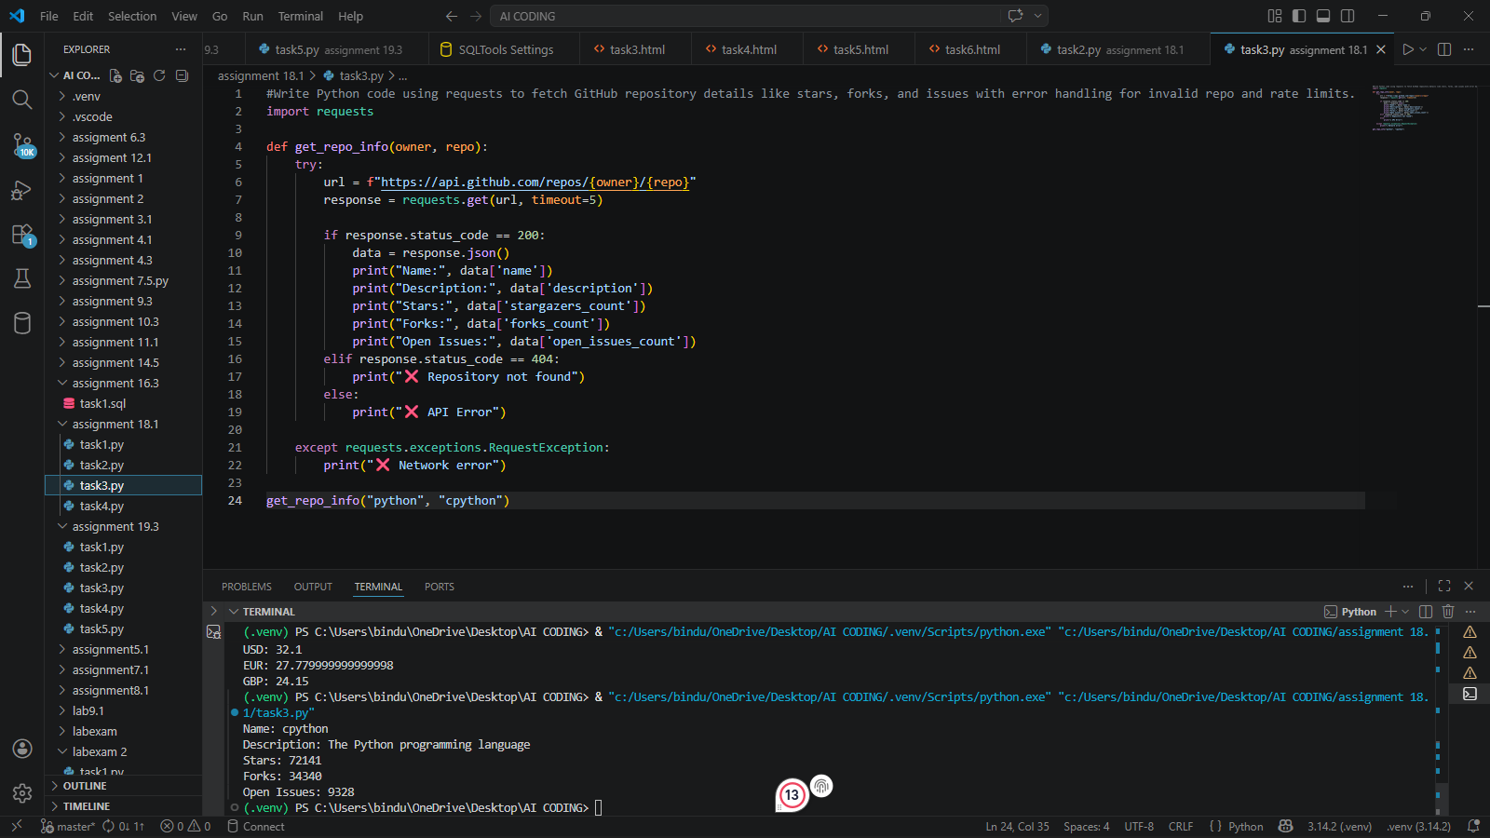  Expected Output:  Name: cpython  Description: The Python programming language  Stars: 72141  Forks: 34340  Open Issues: 9328  EXPLANATION : In this task, we use the GitHub API to retrieve repository information such as:The Python program sends a GET request to the GitHub API endpoint. The response is in JSON format, from which required details are extracted.  Task 4 – Real-Time Application: News Headlines Aggregator  Scenario: Build a News Aggregator using a free News API.  Requirements:  - Fetch top 5 headlines for a given category (sports, technology, health).  - Handle errors like invalid category, missing API key, and request failures.  - Display headlines in a user-friendly numbered list format.  - Include a retry mechanism if the first request fails.  PROMPT : Explain how to build a news aggregator application using a News API. Discuss fetching headlines, handling errors, and implementing retry mechanisms for failed requests.  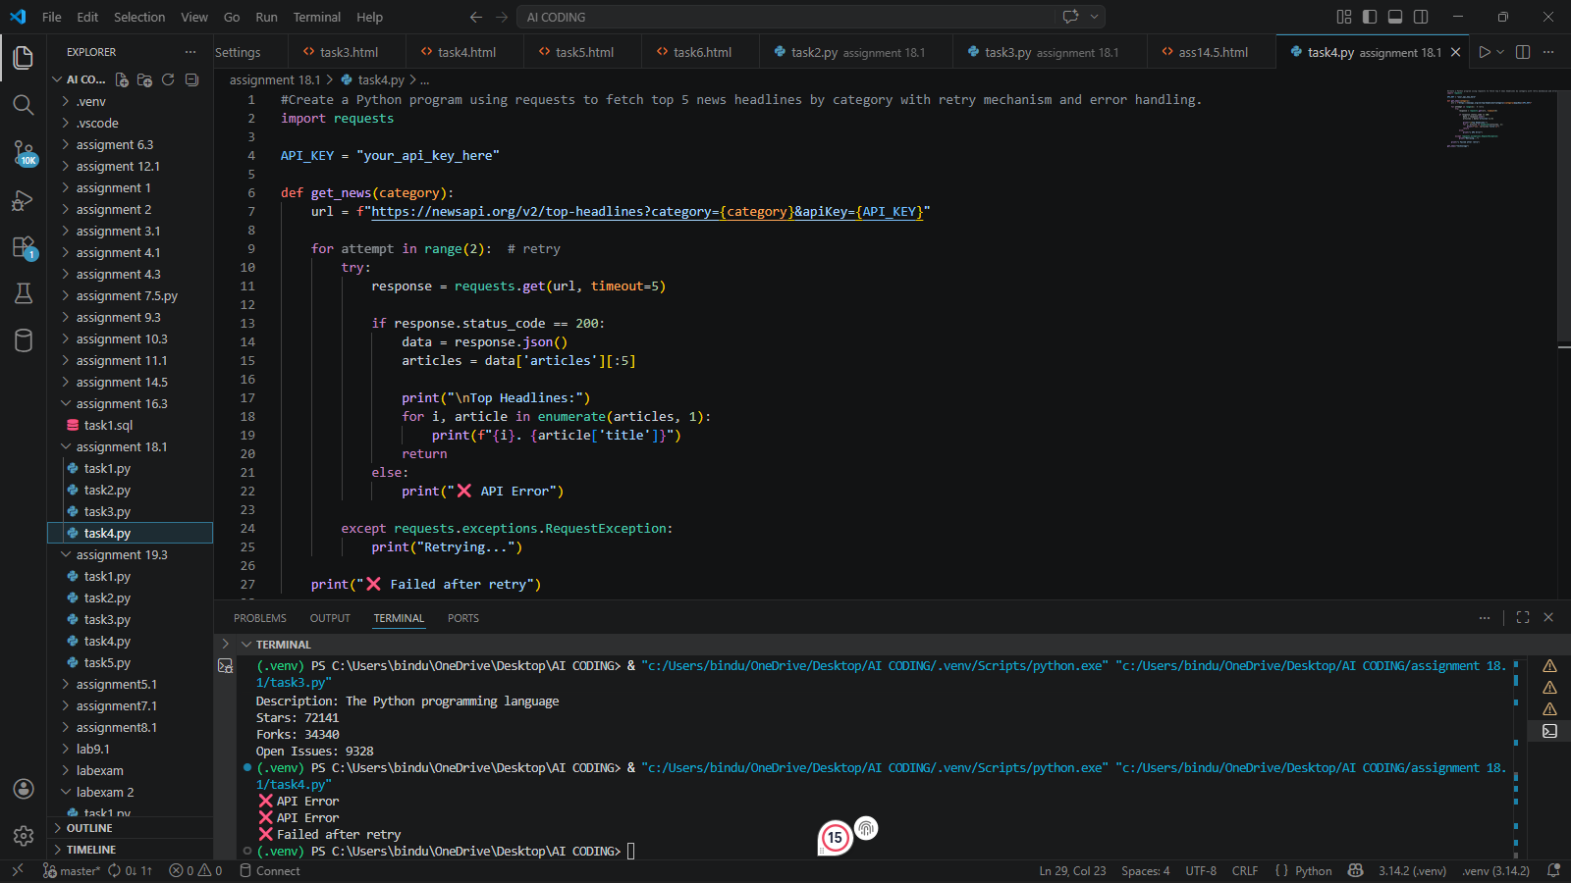  Expected Output: ❌ API Error  ❌ API Error  ❌ Failed after retry  EXPLANATION : This task involves creating a real-time application that fetches top news headlines based on categories like sports, technology, or health.Error handling includes:A retry mechanism is implemented so that if the request fails initially, the program tries again automatically. This improves reliability.The output is displayed in a numbered list, making it easy to read. |  |  |  |  |  | Week9 - Monday

