SCHOOL OF COMPUTER SCIENCE AND ARTIFICIAL INTELLIGENCE |  |  |  |  | DEPARTMENT OF COMPUTER SCIENCE ENGINEERING
Program Name: B. Tech |  |  |  | Assignment Type: Lab |  |  | Academic Year:2025-2026
Course Coordinator Name |  |  |  | Dr. Rishabh Mittal
Instructor(s) Name
CourseCode |  |  | 23CS002PC304 | Course Title |  | AI Assisted Coding
Year/Sem |  |  | III/II | Regulation |  | R23
NAME |  |  | V.SUSHMITHA | HALLTICKET: |  | 2303A54055
Duration |  |  | 2 Hours | Batches |  | 47_B
Assignment Number:19.3(Present assignment number)/24(Total number of assignments)
 | Q.No. | Question |  |  |  |  |  | Expected Time  to complete
 | 1 | Lab 19 – Code Translation: Converting Between Programming Languages  Lab Objectives:  - Understand how AI tools can assist in translating code between different programming languages.  - Learn to verify correctness and functionality after translation.  - Explore syntactic and semantic differences between languages (e.g., Python, Java, C++).  - Practice debugging and optimizing AI-translated code. |  |  |  |  |  | Week10 - Wednesday
Task 1 – Python to C++ Conversion
Task:
Translate a simple Python class into C++ using AI assistance.
Scenario
A college system stores student details (name, age) and displays them. Convert this logic from Python to C++.
Prompt Used
Convert a Python class Student with attributes name and age into equivalent C++ code with constructor and display method.
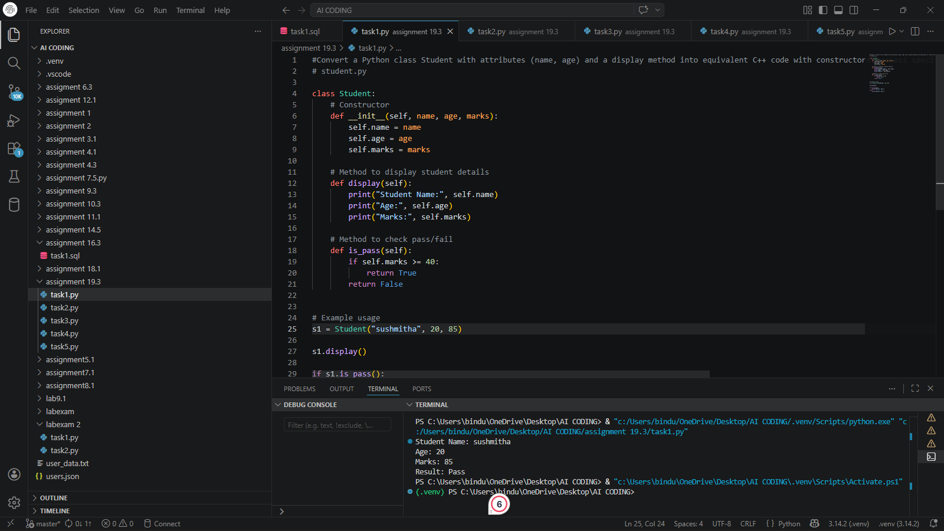

Expected Output:
Name = sushmitha
Age = 20

Name: Sushmitha Age: 20
Explanation
This program creates a student class and stores name and age. The display function prints the values. In C++, we use constructor and access specifiers unlike Python.

Task 2 – Java to Python Function Conversion
Task:
Convert a Java method that checks whether a number is prime into Python.
Scenario
A system checks whether a number is prime. Convert Java method into Python.
Prompt Used
Convert Java method isPrime into Python function using simple syntax.
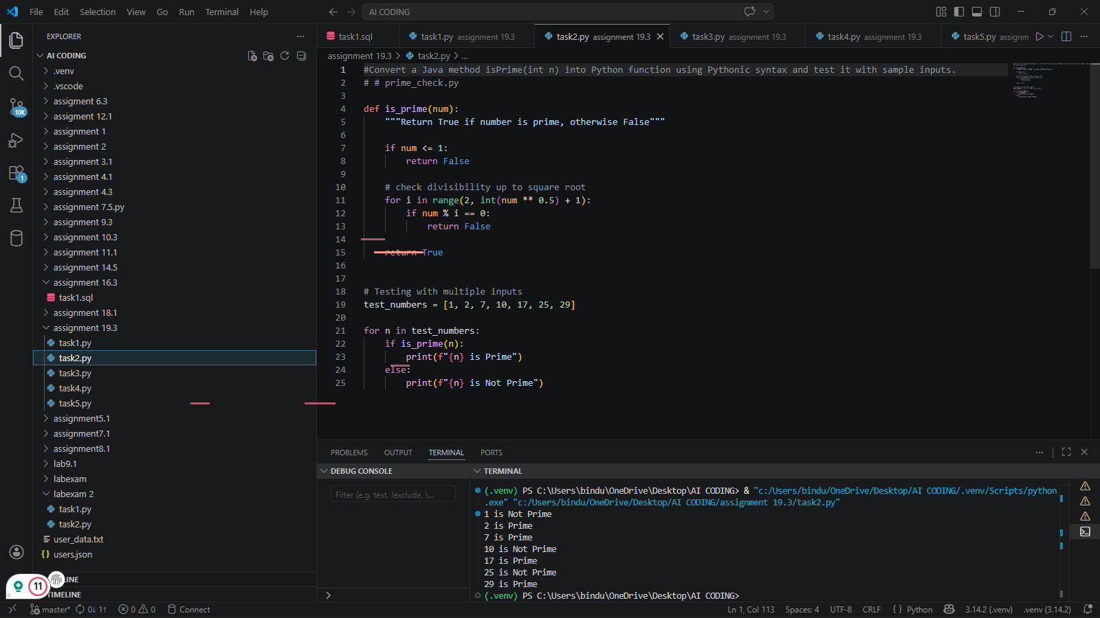

Sample Input/output
1 is Not Prime
2 is Prime
7 is Prime
10 is Not Prime
17 is Prime
25 is Not Prime
29 is Prime

Explanation
The program checks if a number is divisible by any number other than 1 and itself. If yes, it is not prime.

Task 3 – Pseudocode to Python Implementation
Task:
Translate a given pseudocode algorithm into Python using AI.
Scenario
Sort a list of numbers using bubble sort logic.
Prompt Used
Convert bubble sort pseudocode into Python program with example.
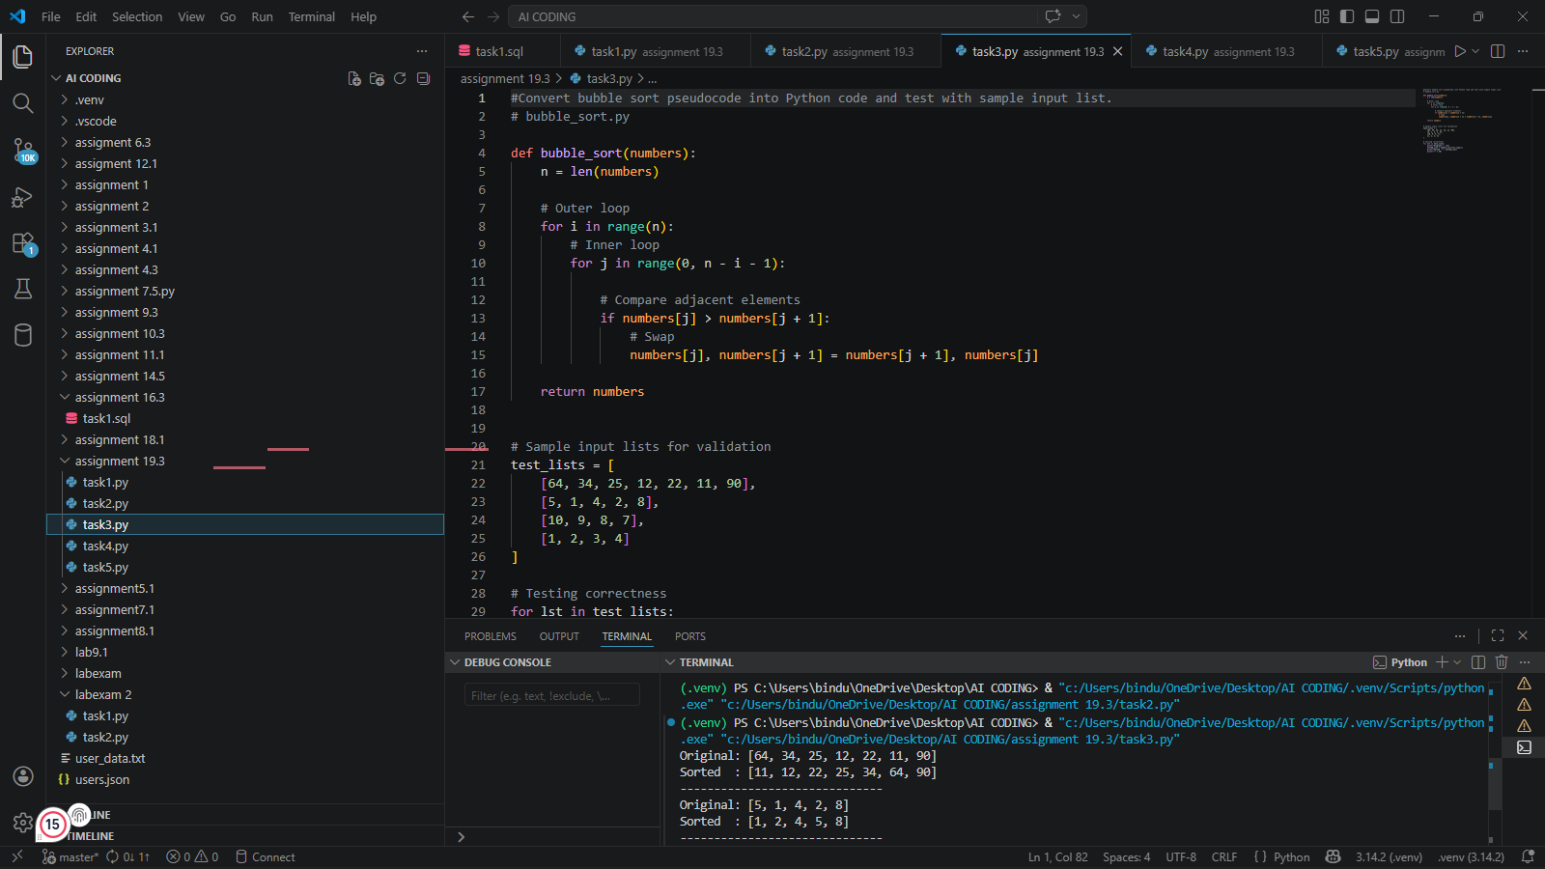
Sample Input/output

Original: [64, 34, 25, 12, 22, 11, 90]
Sorted : [11, 12, 22, 25, 34, 64, 90]
------------------------------
Original: [5, 1, 4, 2, 8]
Sorted : [1, 2, 4, 5, 8]
------------------------------
Original: [10, 9, 8, 7]
Sorted : [7, 8, 9, 10]
------------------------------
Original: [1, 2, 3, 4]
Sorted : [1, 2, 3, 4]
------------------------------
Explanation
Bubble sort compares adjacent elements and swaps them if they are in wrong order until the list is sorted.

Task 4 – SQL to Pandas Query
Task:
Translate a SQL query into a Pandas DataFrame operation in Python.
Scenario
Convert SQL query into Python Pandas code.
Prompt Used
Convert SQL SELECT query with condition into Pandas filtering.
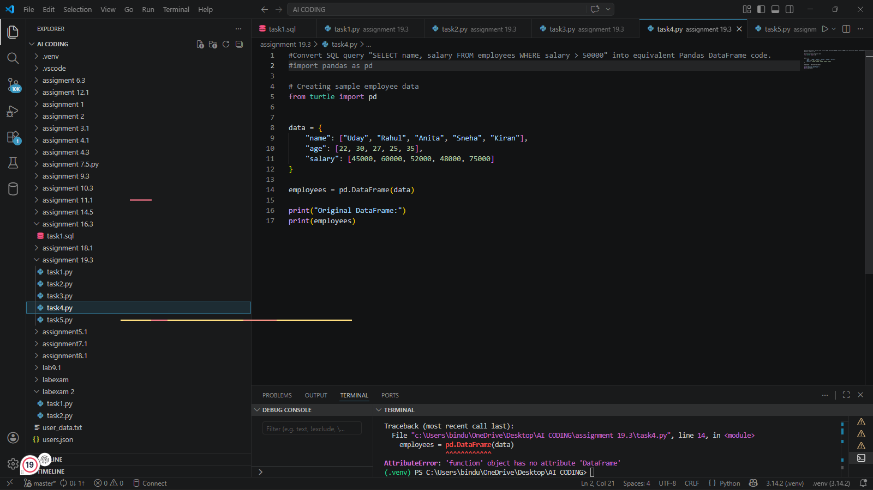
Sample Input
salary > 50000
Sample Output
name salary
1 B 60000
2 C 70000
Explanation
The program filters rows where salary is greater than 50000 using Pandas similar to SQL WHERE clause.

Task 5 – Real-Time Application: Algorithm Translation Across Languages
Scenario:
A company maintains algorithms written in different programming languages.
Prompt Used
Translate a Python linear search algorithm into equivalent C code. Ensure both versions are executable and produce the same output. Highlight syntax, memory management, and library differences.

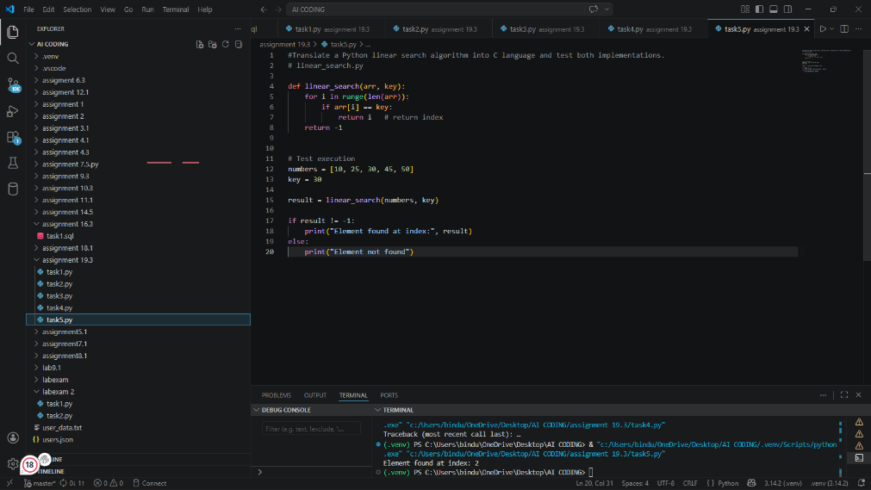

Sample Input
Array: 10 20 30 40
Key: 30

Sample Output
Element found at index: 2

Short Explanation :
This program searches for an element in a list using linear search. It checks each element one by one until it finds the key. The same logic is implemented in both Python and C, but the syntax and memory handling differ.

