

**PROGRAMME: DIPLOMA IN COMPUTER SCIENCE ENGINEERING.**

**COURSE: SOFTWARE TESTING LAB**

**REPORT ON MINI PROJECT**

**TEST CASES FOR ADDMISSION FORM**

**SUBMITTED BY:**

**(6TH SEM STUDENTS)**

**SUSHMITHA.A.T (102CS15056)**

**SUMA.M (102CS15055)**

**SHIRISHA.K.C (102CS150547)**

**SUCHITHRA.C (102CS14054)**

**VEDA.M.N (102CS14060)**

**UNDER THE GUIDANCE OF:**

**PRAVEEN KUMAR.K.**

**LECTURER OF COMPUTER SCIENCE & ENGG. DEPARTMENT,**

**S.J. (GOVT).POLYTECHNIC , K.RCIRCLE , BANGALORE.**

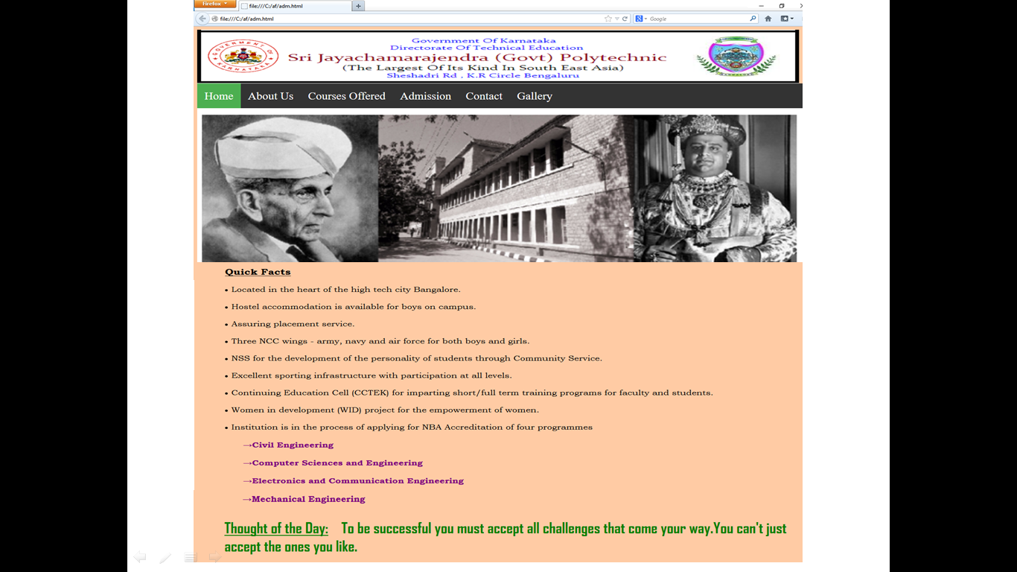

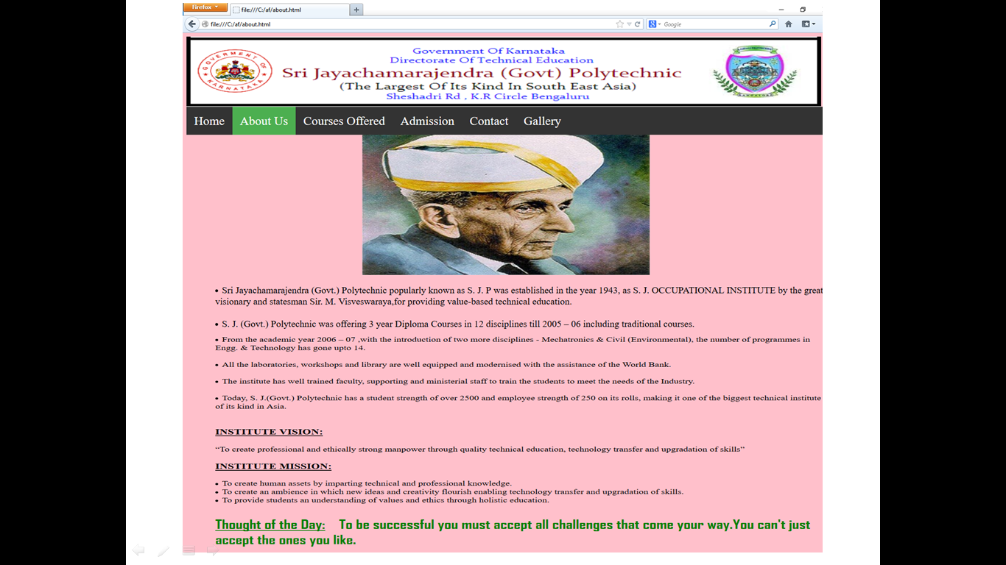

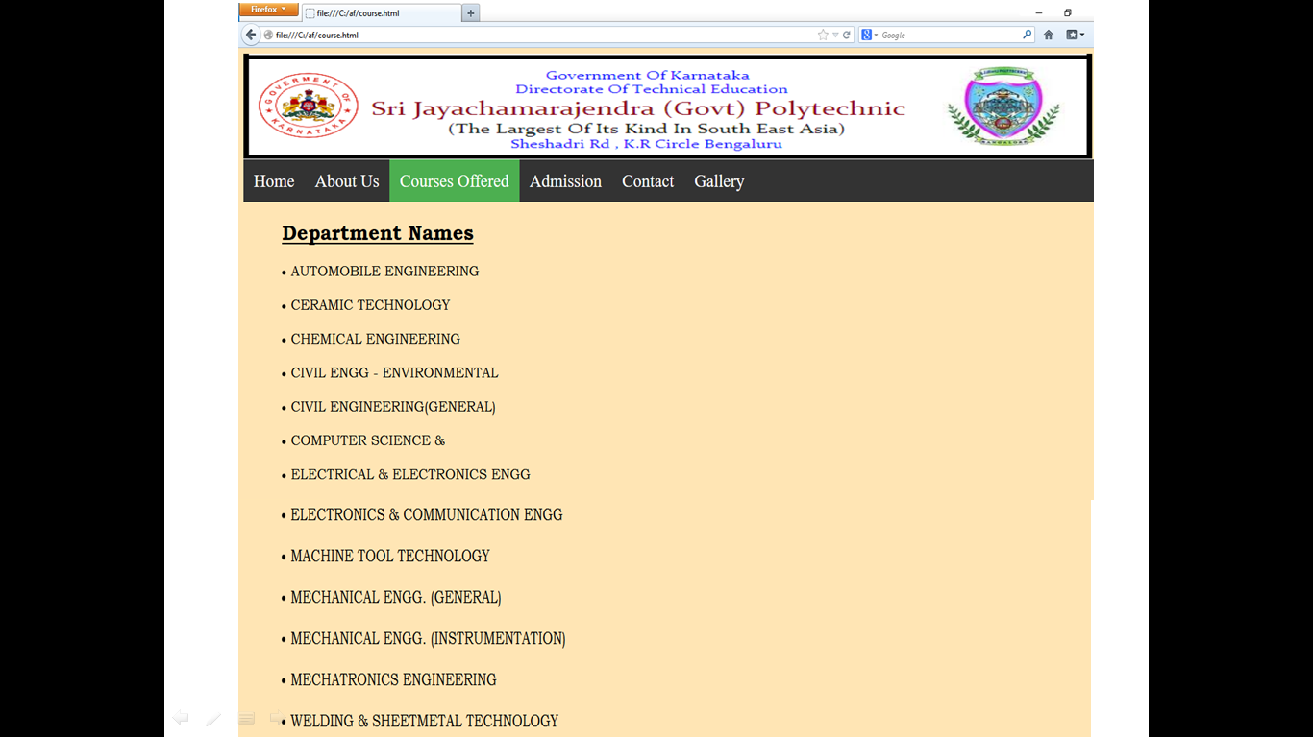

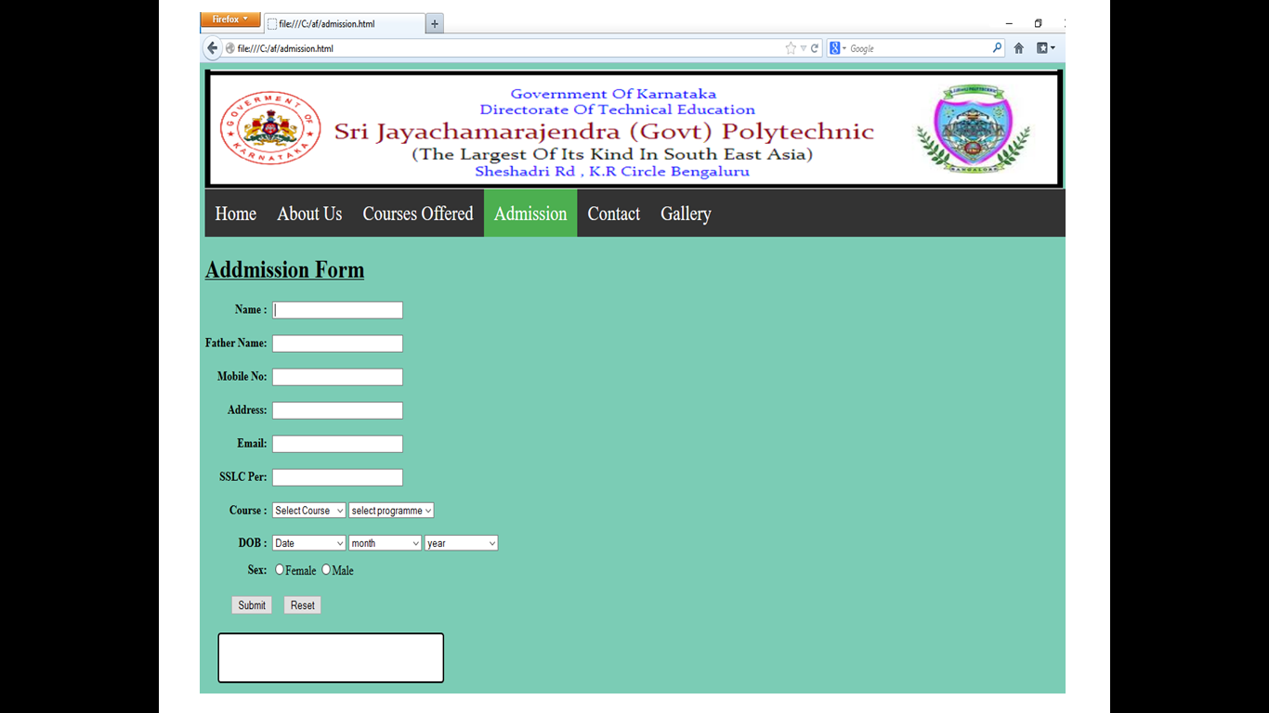

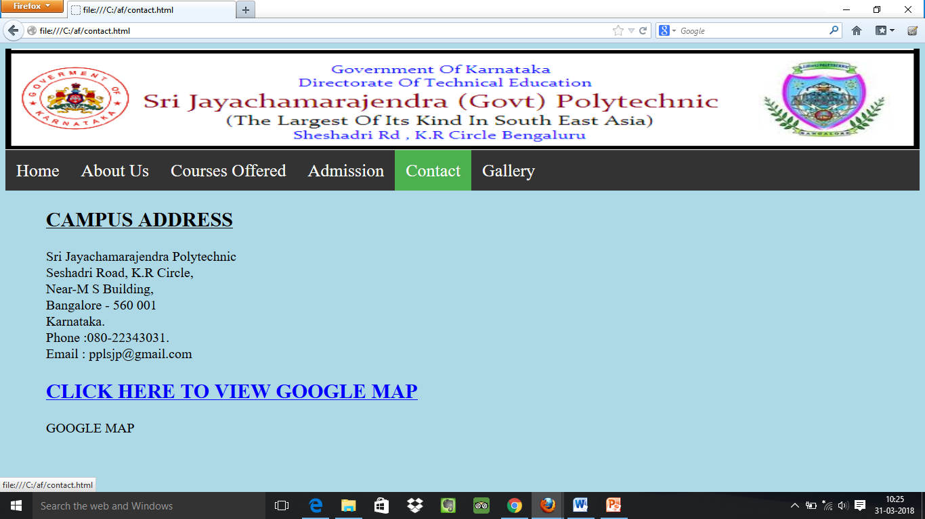

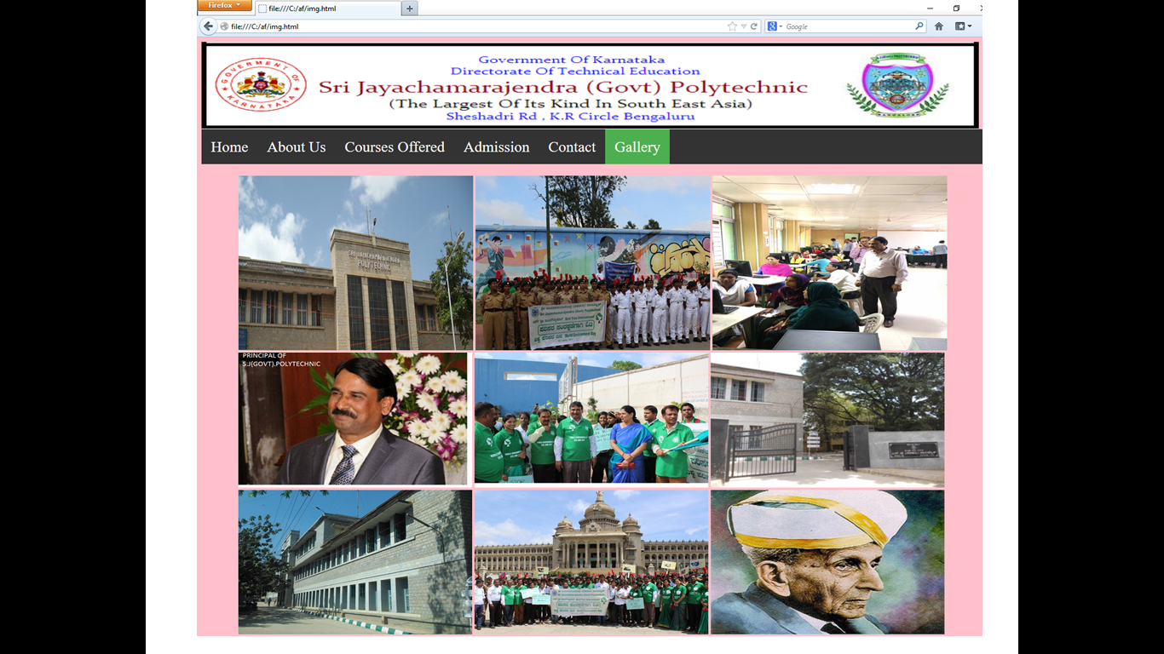

**TEST CASES FOR ADDMISSION FORM**

