**DAILY ONLINE ACTIVITIES SUMMARY**

|  |  |  |  |  |  |  |  |  |
| --- | --- | --- | --- | --- | --- | --- | --- | --- |
| **Date:** | **18/05/2020** | | | | | **Name:** | **sushmitha** | |
| **Sem & Sec** | **6Th sem** | | | | | **USN:** | **4al17cs102** | |
| **Online Test Summary** | | | | | | | | |
| **Subject** | | **CNSC** | | | | | | |
| **Max. Marks** | | **60** | | **Score** | | | **52** | |
| **Certification Course Summary** | | | | | | | | |
| **Course** | **Python for machine learning** | | | | | | | |
| **Certificate Provider** | | | **IBM** | | **Duration** | | | **-** |
| **Coding Challenges** | | | | | | | | |
| 1. **Problem Statement:** Using methods charAt() & length() of String class, write a program to print the frequency of each character in a string.   “Hello friend”  Output should be -: 1 d: 1 e: **2** f: 1 (continued for all character in the string)   1. Write down a java program to print even and odd numbers series respectively from two threads: t1 and t2 synchronizing on a shared object   Let t1 print message “ping — >” and t2 print message “,—-pong”.  Take as command line arguments, the following inputs to the program: Sleep Interval for thread t1 Write down a java program to print even and odd numbers series respectively from two threads: t1 and t2 synchronizing on a shared object  Let t1 print message “ping — >” and t2 print message “,—-pong”.  Take as command line arguments, the following inputs to the program:  Sleep Interval for thread t1  Sleep Interval for thread t2  Message per cycle  No of cycles | | | | | | | | |
| **Status:done** | | | | | | | | |
| **Uploaded the report in Github** | | | | | **yes** | | | |
| **If yes Repository name** | | | | | <https://github.com/sushmithaganiga/coding> | | | |
| **Uploaded the report in slack** | | | | | **yes** | | | |

Online Test Details: (Attach the snapshot and briefly write the report for the same)

Certification Course Details: (Attach the snapshot and briefly write the report for the same)

Coding Challenges Details: (Attach the snapshot and briefly write the report for the same)

Online Test Details:

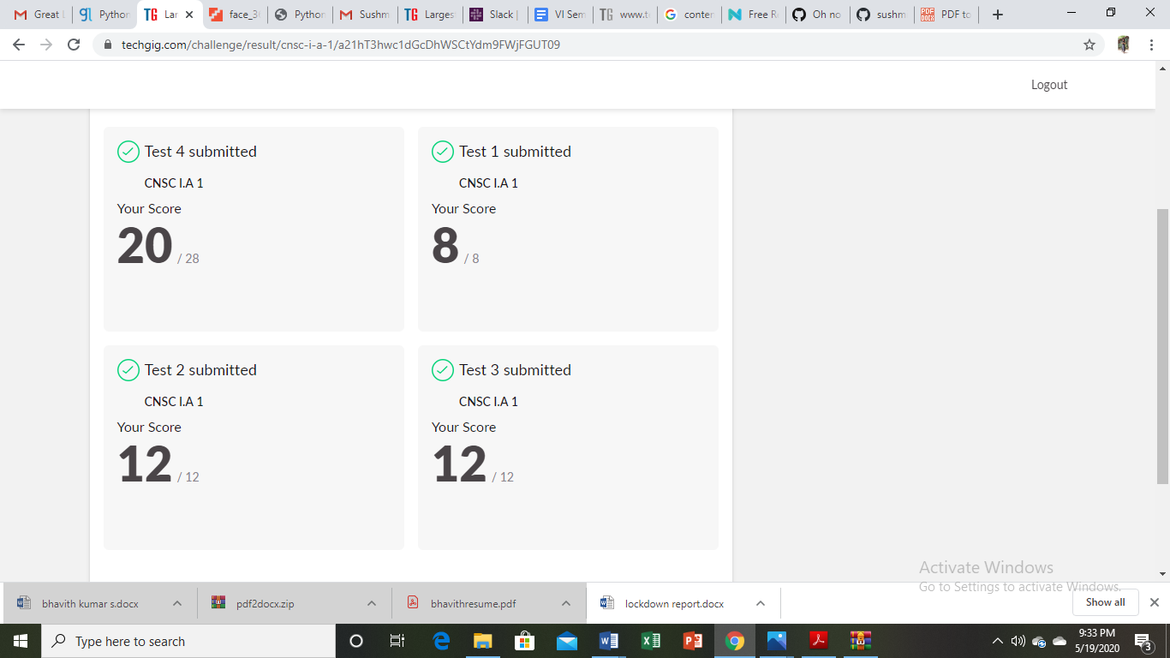

Certification Course Details:

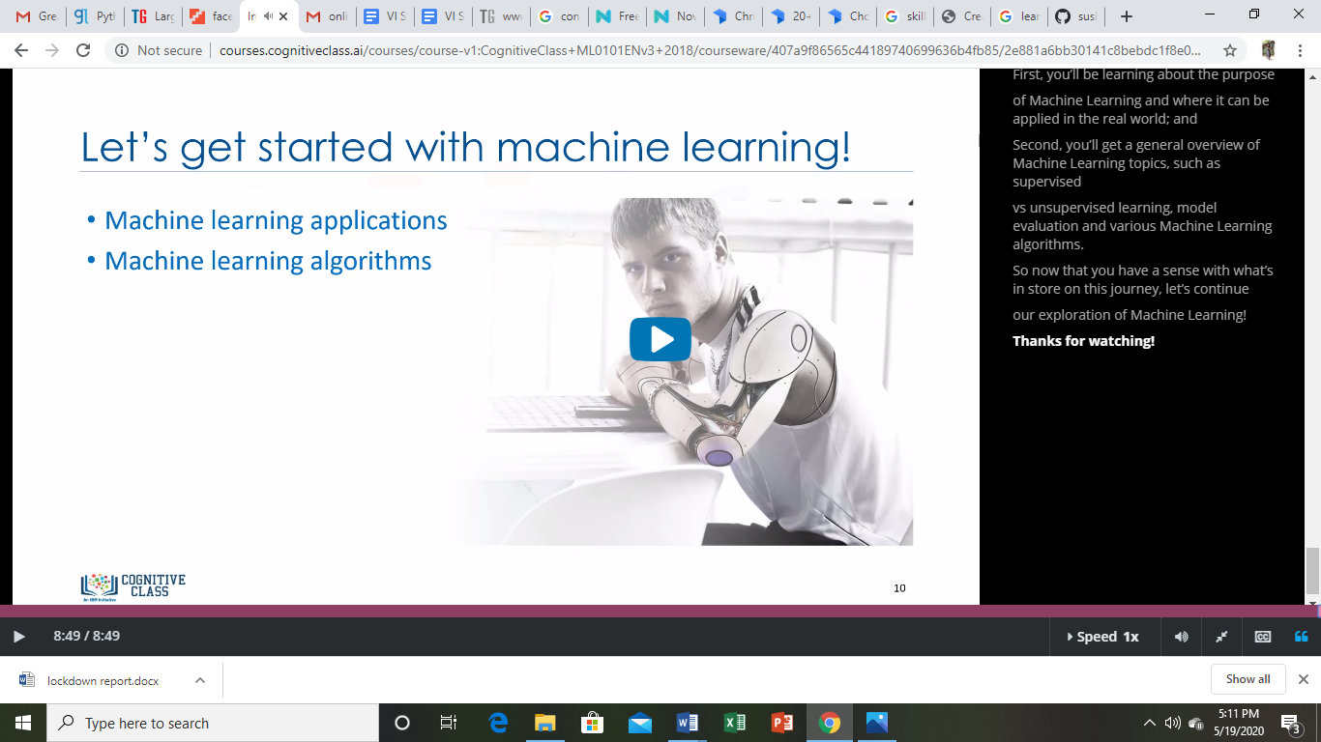

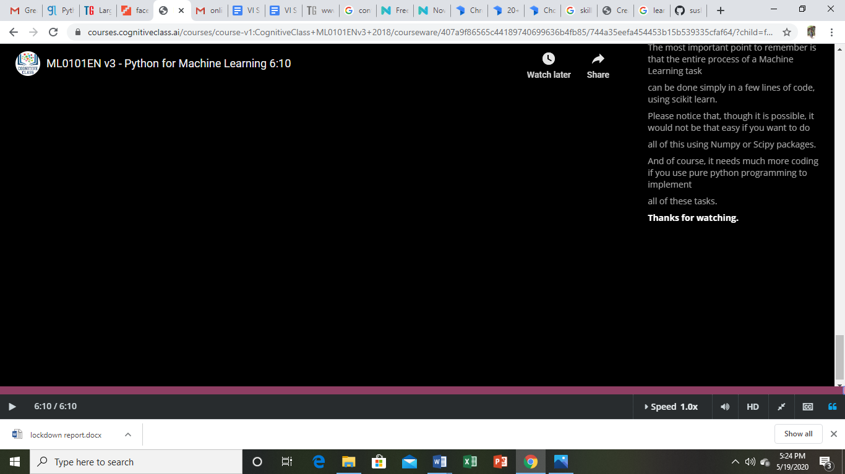

Coding Challenges Details:

Coding Challenges Details:

