Name:Aws

Topic: Aws Deployment

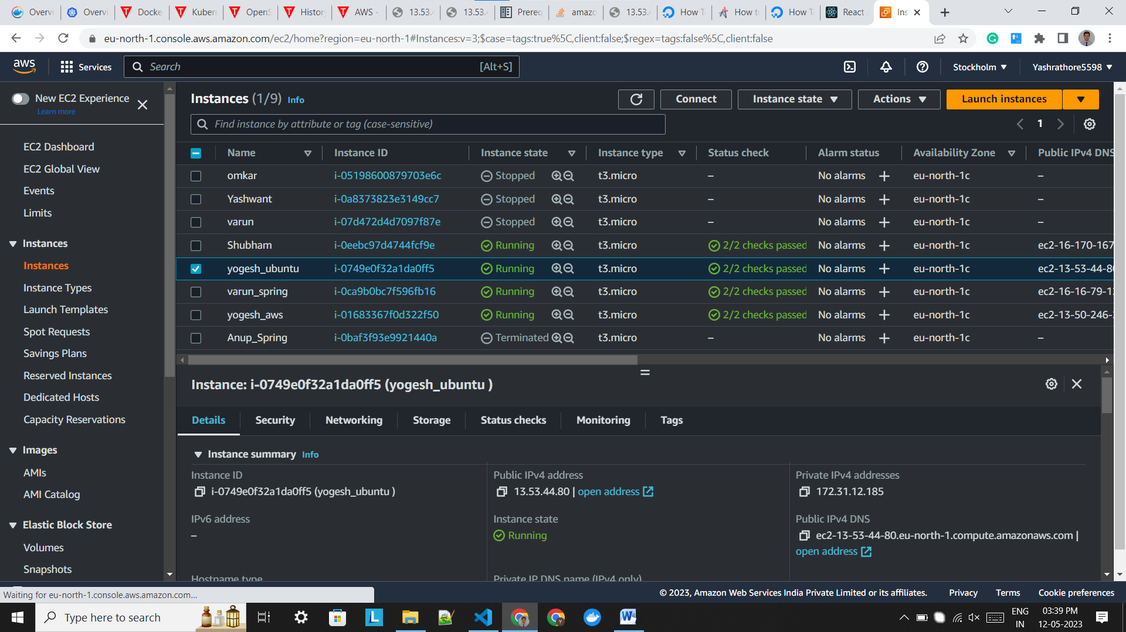

# C:\Users\lenovo\Downloads\WhatsApp Image 2023-05-12 at 4.06.15 PM.jpeg

# C:\Users\lenovo\Downloads\WhatsApp Image 2023-05-12 at 4.05.57 PM.jpeg