Q3. Description-Script for addition of two real numbers

Input-  bash 03_real_add.sh

    Enter the numbers to addition: 4.28 1.21

Output- The sum of 4.28 and 1.21 is 5.49

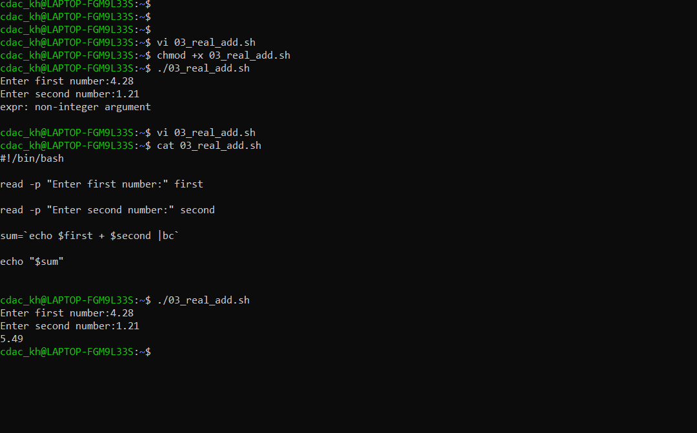

Q6.  Script to print a given number in reverse order.

Input-  bash 06_reverse.sh 639872

Output- The reversed number of entered number is 278936

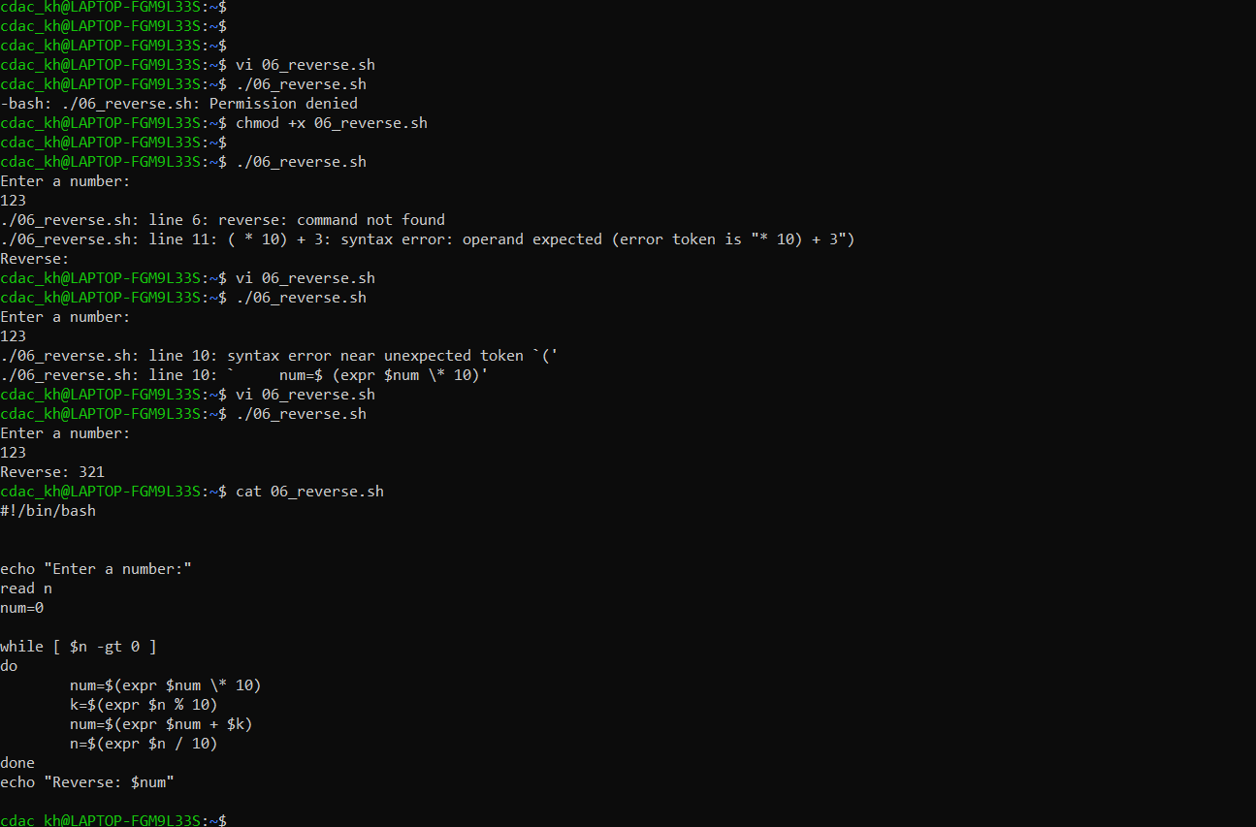

Q7.Description- Script to delete empty lines from a file

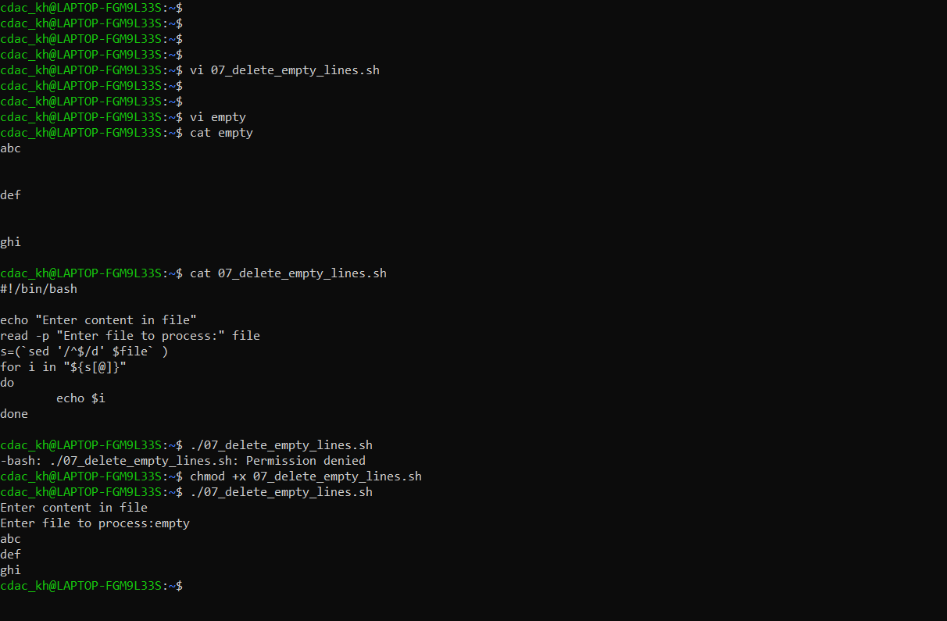

Q10. Description- Script to print the length of each and every string using arrays

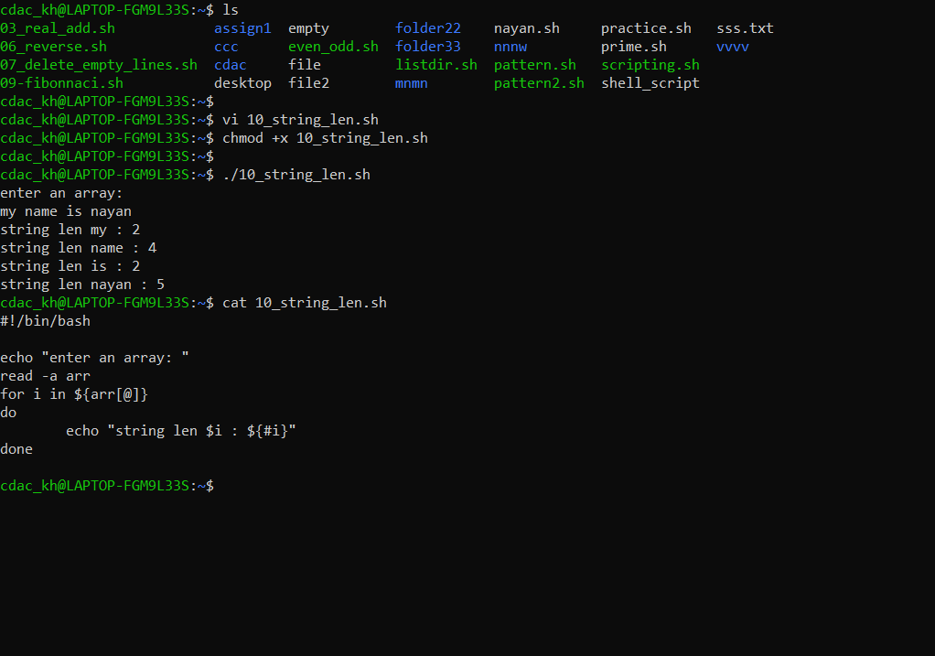

Q9. Description- script to read 'n' and generate Fibonacci numbers <= n

Input-  bash 09_fibonacci.sh

    Enter limit for fibonacci series: 13

Output- The expected fibonacci series is:

    0, 1, 1, 2, 3, 5, 8, 13,

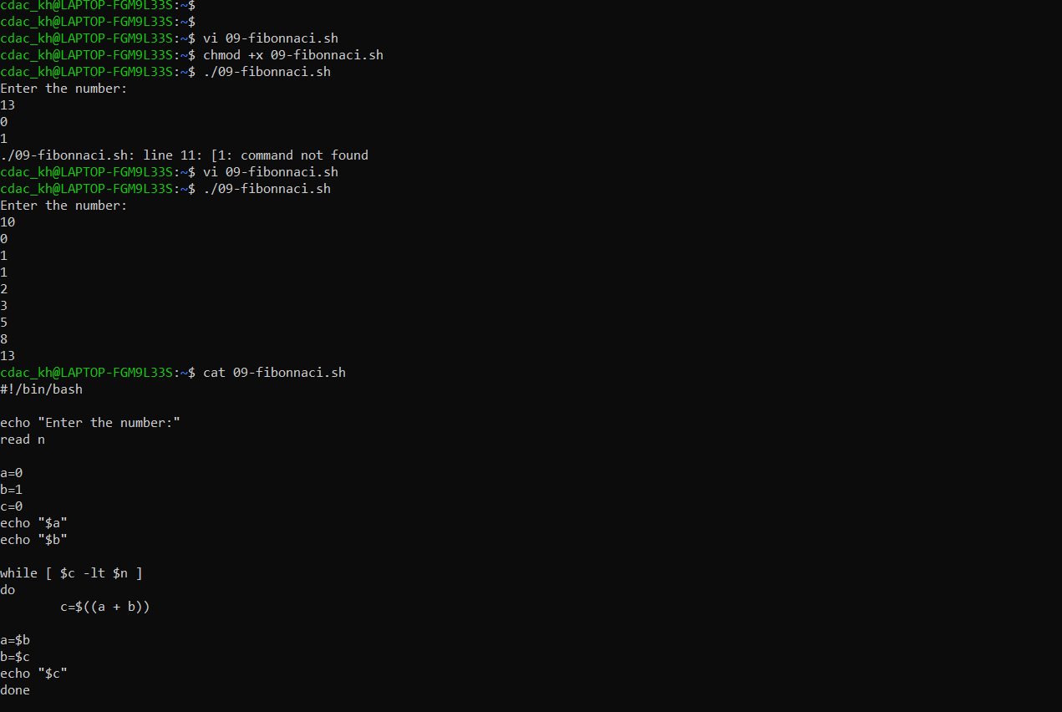

Write a shell script that consists of a function that displays the number of files in the present working directory. Name this function “file_count” and call it in your script. If you use variable in your function, remember to make it a local variable.

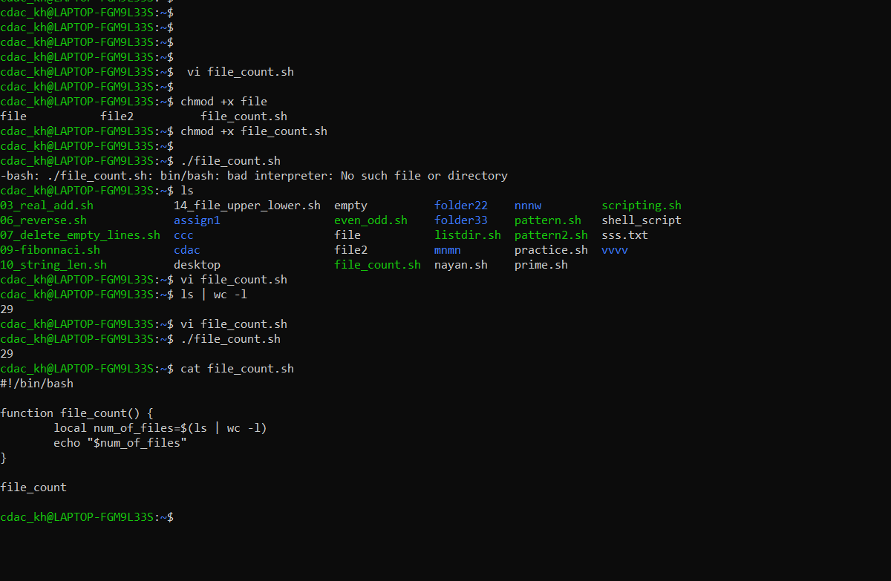

* For each directory in the $PATH, display the number of executable in that directory

