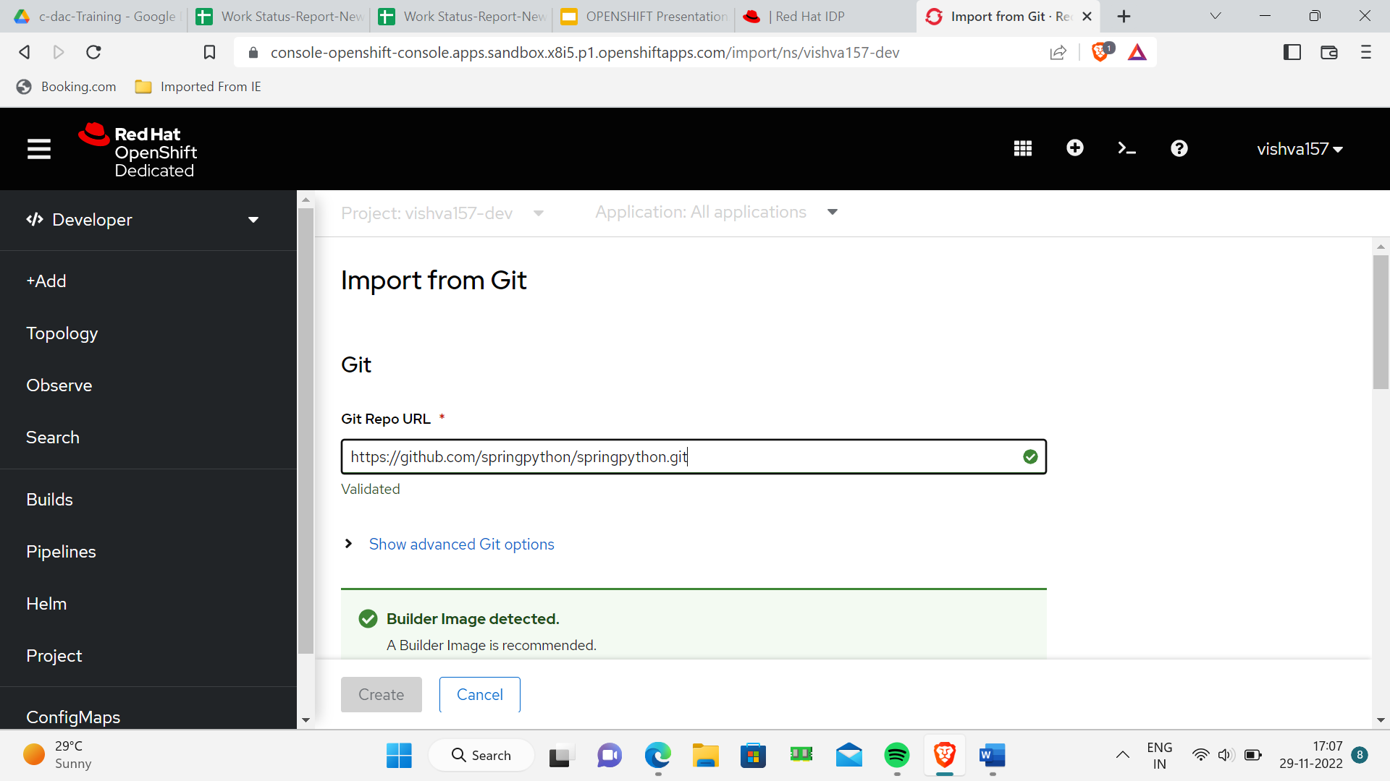

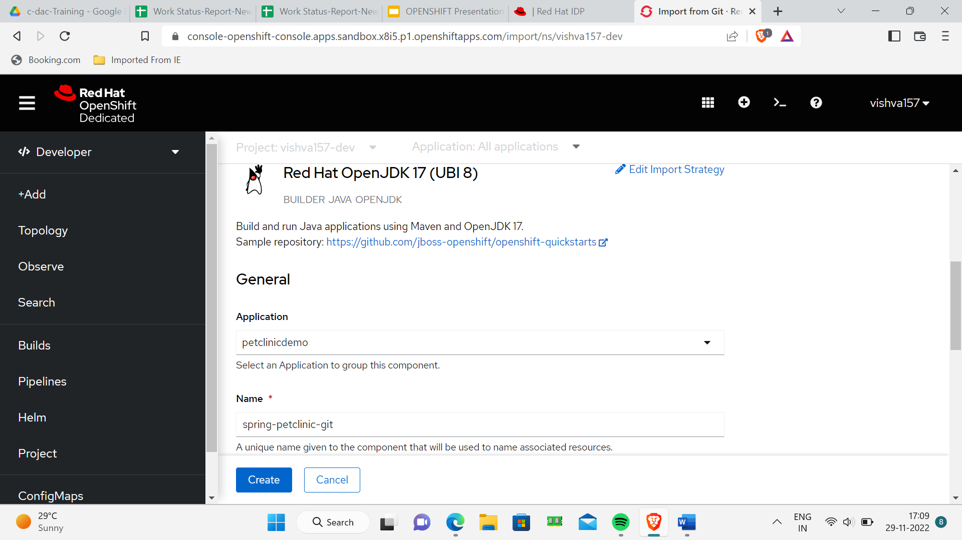

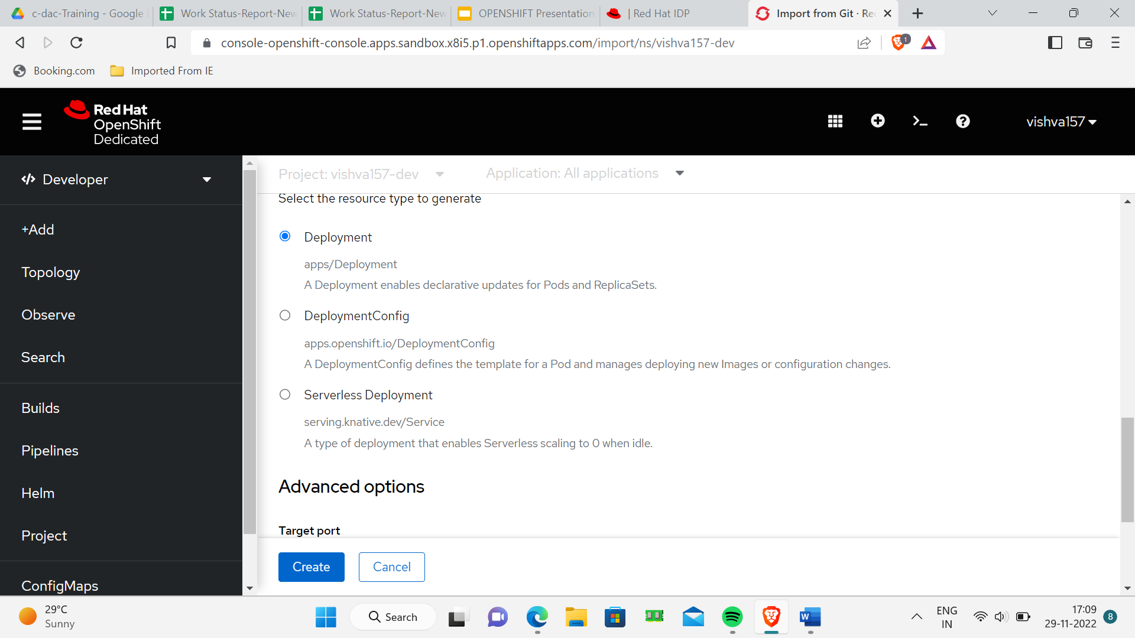

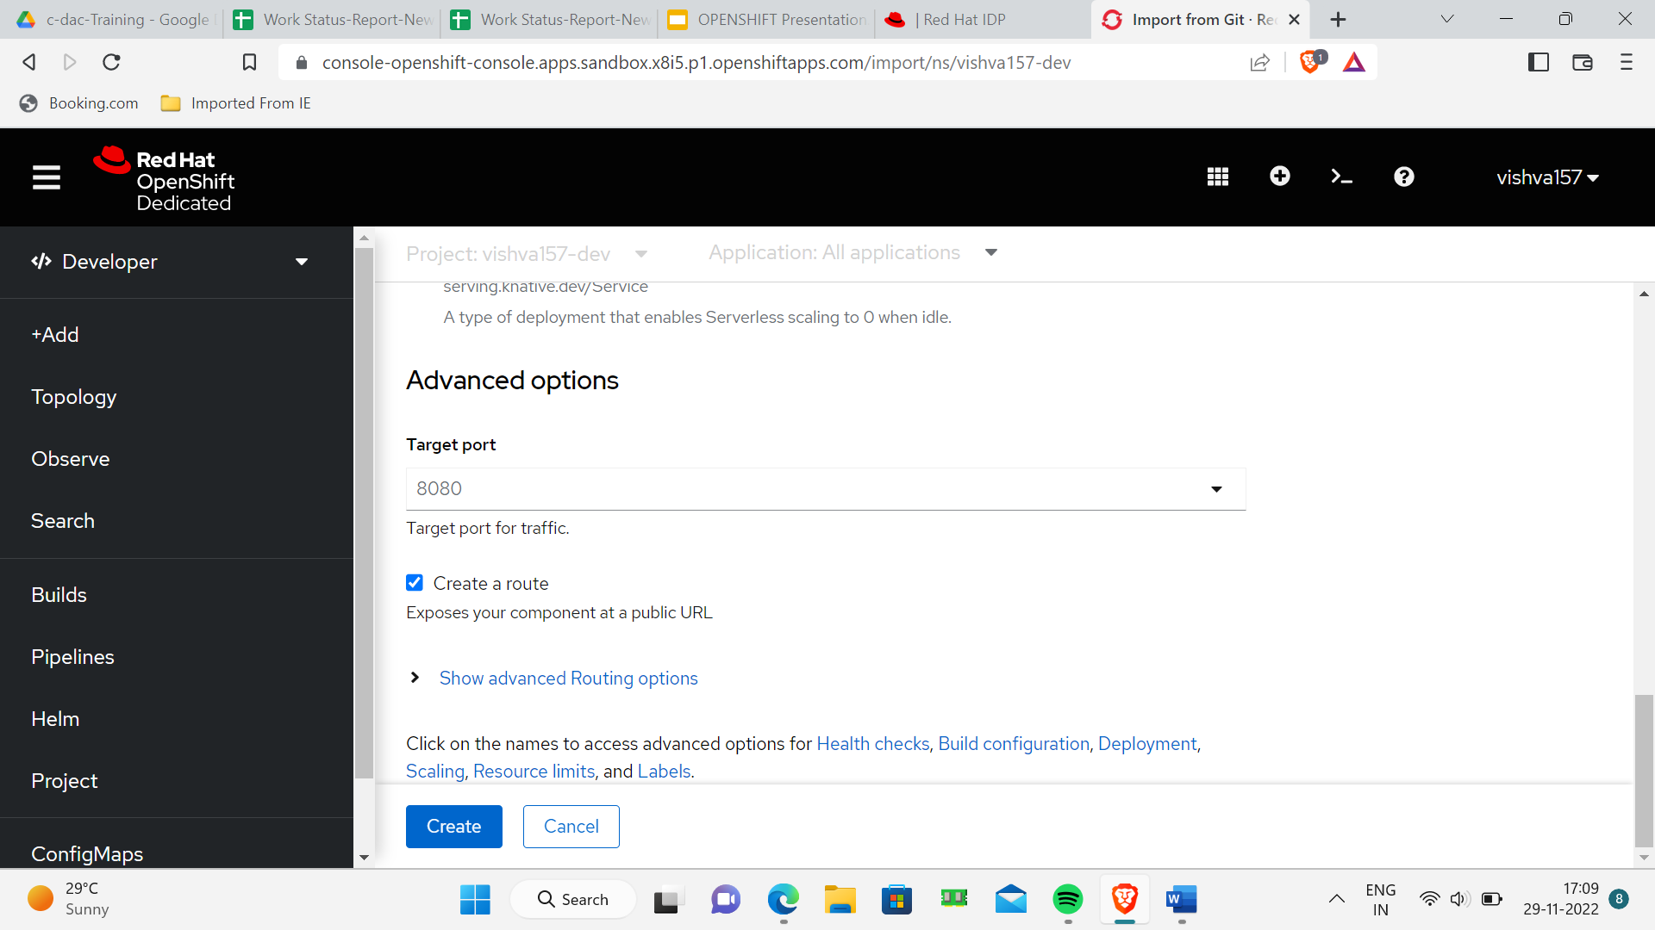

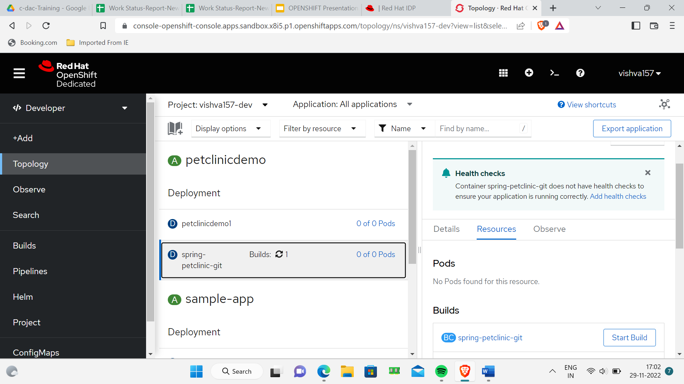

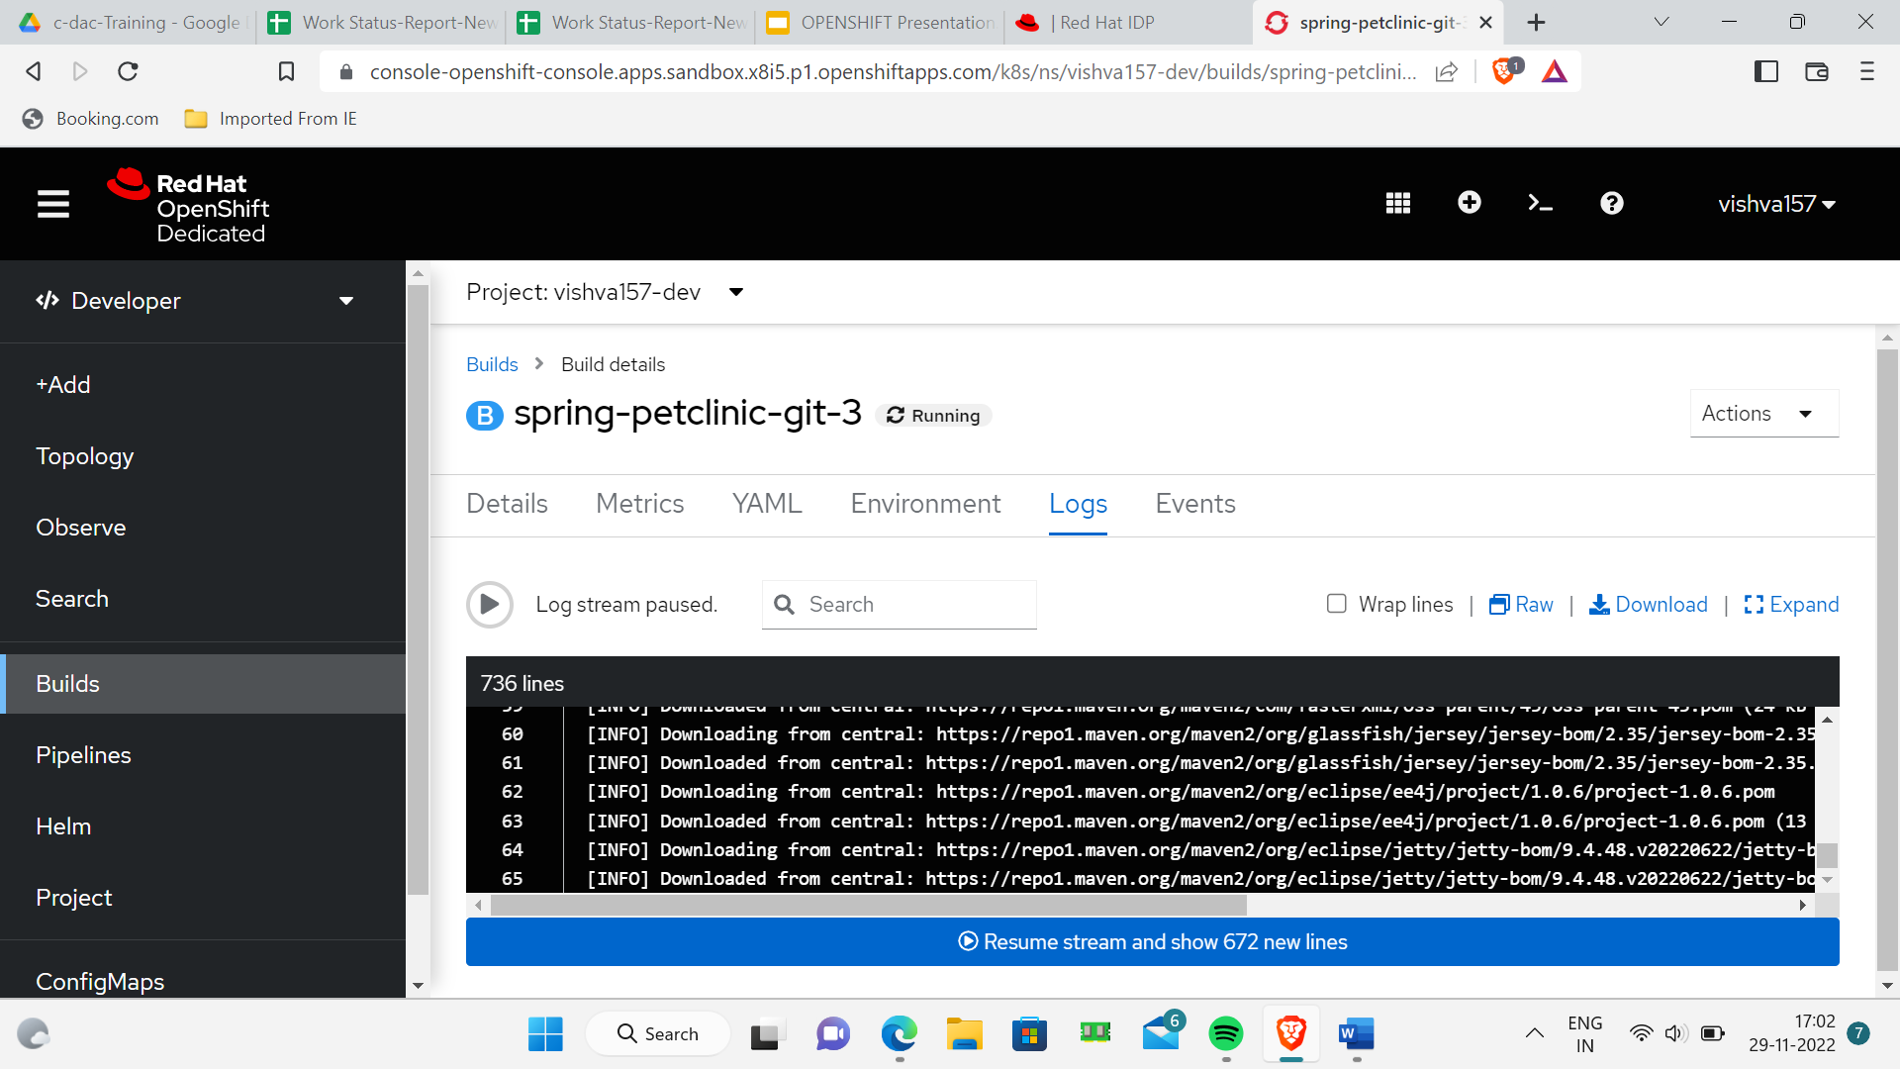

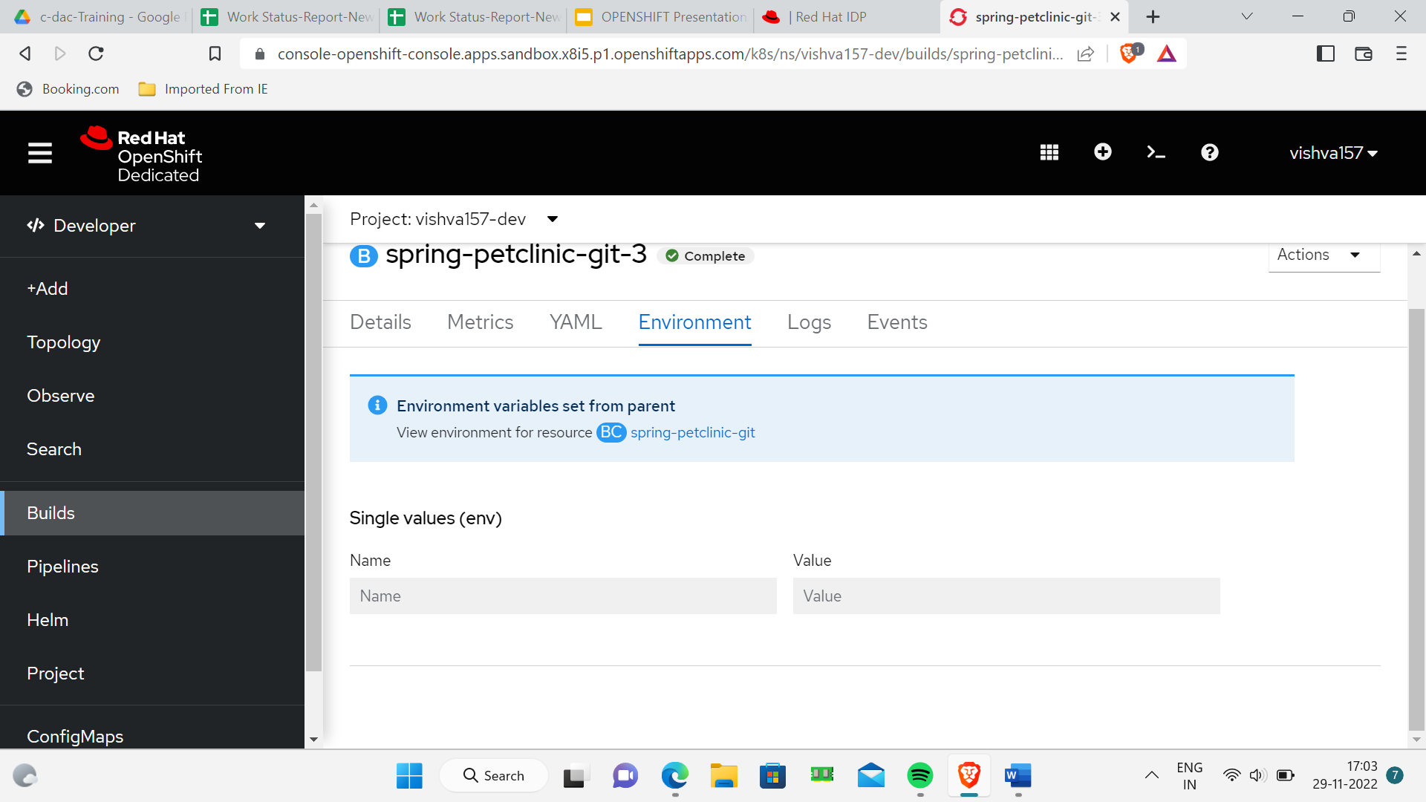

YAML

ind: Build

apiVersion: build.openshift.io/v1

metadata:

  annotations:

    openshift.io/build-config.name: spring-petclinic-git

    openshift.io/build.number: '3'

    openshift.io/build.pod-name: spring-petclinic-git-3-build

  resourceVersion: '1962514108'

  name: spring-petclinic-git-3

  uid: 9d69bbc8-d6db-453b-bb1a-1410c630e4bf

  creationTimestamp: '2022-11-29T11:31:34Z'

  generation: 2

  managedFields:

    - manager: Go-http-client

      operation: Update

      apiVersion: build.openshift.io/v1

      time: '2022-11-29T11:31:34Z'

      fieldsType: FieldsV1

      fieldsV1:

        'f:metadata':

          'f:annotations':

            .: {}

            'f:openshift.io/build-config.name': {}

            'f:openshift.io/build.number': {}

          'f:labels':

            'f:app.openshift.io/runtime': {}

            'f:app': {}

            'f:app.kubernetes.io/name': {}

            .: {}

            'f:app.kubernetes.io/part-of': {}

            'f:app.openshift.io/runtime-version': {}

            'f:app.kubernetes.io/instance': {}

            'f:openshift.io/build-config.name': {}

            'f:app.kubernetes.io/component': {}

            'f:buildconfig': {}

            'f:openshift.io/build.start-policy': {}

          'f:ownerReferences':

            .: {}

            'k:{"uid":"30bf3ffc-0065-4a56-a722-1e1f01937289"}': {}

        'f:spec':

          'f:output':

            'f:to': {}

          'f:serviceAccount': {}

          'f:source':

            'f:contextDir': {}

            'f:git':

              .: {}

              'f:uri': {}

            'f:type': {}

          'f:strategy':

            'f:sourceStrategy':

              .: {}

              'f:from': {}

              'f:pullSecret': {}

            'f:type': {}

          'f:triggeredBy': {}

        'f:status':

          'f:conditions':

            .: {}

            'k:{"type":"New"}':

              .: {}

              'f:lastTransitionTime': {}

              'f:lastUpdateTime': {}

              'f:status': {}

              'f:type': {}

          'f:config': {}

    - manager: openshift-controller-manager

      operation: Update

      apiVersion: build.openshift.io/v1

      time: '2022-11-29T11:33:18Z'

      fieldsType: FieldsV1

      fieldsV1:

        'f:metadata':

          'f:annotations':

            'f:openshift.io/build.pod-name': {}

        'f:spec':

          'f:output':

            'f:pushSecret': {}

        'f:status':

          'f:completionTimestamp': {}

          'f:duration': {}

          'f:outputDockerImageReference': {}

          'f:phase': {}

          'f:startTimestamp': {}

  namespace: vishva157-dev

  ownerReferences:

    - apiVersion: build.openshift.io/v1

      kind: BuildConfig

      name: spring-petclinic-git

      uid: 30bf3ffc-0065-4a56-a722-1e1f01937289

      controller: true

  labels:

    app: spring-petclinic-git

    app.kubernetes.io/part-of: petclinicdemo

    app.kubernetes.io/instance: spring-petclinic-git

    openshift.io/build-config.name: spring-petclinic-git

    app.kubernetes.io/component: spring-petclinic-git

    openshift.io/build.start-policy: Serial

    buildconfig: spring-petclinic-git

    app.openshift.io/runtime: java

    app.kubernetes.io/name: spring-petclinic-git

    app.openshift.io/runtime-version: openjdk-17-ubi8

spec:

  nodeSelector: null

  output:

    to:

      kind: ImageStreamTag

      name: 'spring-petclinic-git:latest'

    pushSecret:

      name: builder-dockercfg-qmvr5

  resources: {}

  triggeredBy:

    - message: Manually triggered

  strategy:

    type: Source

    sourceStrategy:

      from:

        kind: DockerImage

        name: >-

          image-registry.openshift-image-registry.svc:5000/openshift/java@sha256:210e5ce062df2cc601fb8ce4be4848fe25d87238cd44aa4abe833eb3d4893640

      pullSecret:

        name: builder-dockercfg-qmvr5

  postCommit: {}

  serviceAccount: builder

  source:

    type: Git

    git:

      uri: 'https://github.com/spring-projects/spring-petclinic.git'

    contextDir: /

  revision:

    type: Git

    git:

      commit: 9ecdc1111e3da388a750ace41a125287d9620534

      author:

        name: Oliver Drotbohm

        email: odrotbohm@vmware.com

      committer:

        name: Oliver Drotbohm

        email: odrotbohm@vmware.com

      message: Polish Thymeleaf templates.

status:

  output:

    to:

      imageDigest: 'sha256:602d845b5920594539e7f26172c440756dedad91dadc0df16dba5a61fa36960a'

  config:

    kind: BuildConfig

    namespace: vishva157-dev

    name: spring-petclinic-git

  outputDockerImageReference: >-

    image-registry.openshift-image-registry.svc:5000/vishva157-dev/spring-petclinic-git:latest

  duration: 104000000000

  startTimestamp: '2022-11-29T11:31:34Z'

  stages:

    - name: FetchInputs

      startTime: '2022-11-29T11:31:37Z'

      durationMilliseconds: 370

      steps:

        - name: FetchGitSource

          startTime: '2022-11-29T11:31:37Z'

          durationMilliseconds: 370

    - name: PullImages

      startTime: '2022-11-29T11:31:39Z'

      durationMilliseconds: 19624

      steps:

        - name: PullBaseImage

          startTime: '2022-11-29T11:31:39Z'

          durationMilliseconds: 19624

    - name: Build

      startTime: '2022-11-29T11:31:59Z'

      durationMilliseconds: 68160

      steps:

        - name: DockerBuild

          startTime: '2022-11-29T11:31:59Z'

          durationMilliseconds: 68160

    - name: PushImage

      startTime: '2022-11-29T11:33:07Z'

      durationMilliseconds: 8669

      steps:

        - name: PushImage

          startTime: '2022-11-29T11:33:07Z'

          durationMilliseconds: 8669

  conditions:

    - type: New

      status: 'False'

      lastUpdateTime: '2022-11-29T11:31:34Z'

      lastTransitionTime: '2022-11-29T11:31:34Z'

    - type: Pending

      status: 'False'

      lastUpdateTime: '2022-11-29T11:31:37Z'

      lastTransitionTime: '2022-11-29T11:31:37Z'

    - type: Running

      status: 'False'

      lastUpdateTime: '2022-11-29T11:33:18Z'

      lastTransitionTime: '2022-11-29T11:33:18Z'

    - type: Complete

      status: 'True'

      lastUpdateTime: '2022-11-29T11:33:18Z'

      lastTransitionTime: '2022-11-29T11:33:18Z'

  completionTimestamp: '2022-11-29T11:33:18Z'

  phase: Complete

