**Kubernetes Assignment**

**Starting minikube:**

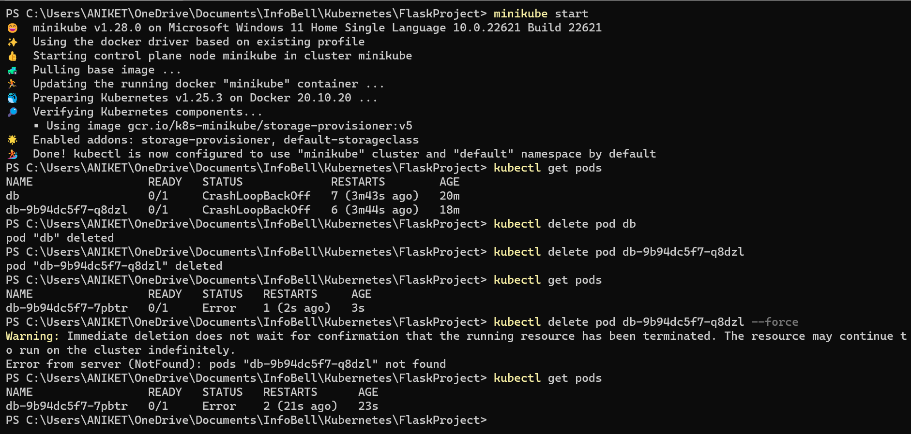

**Creating Flask Pod using “kubectl run” command:**

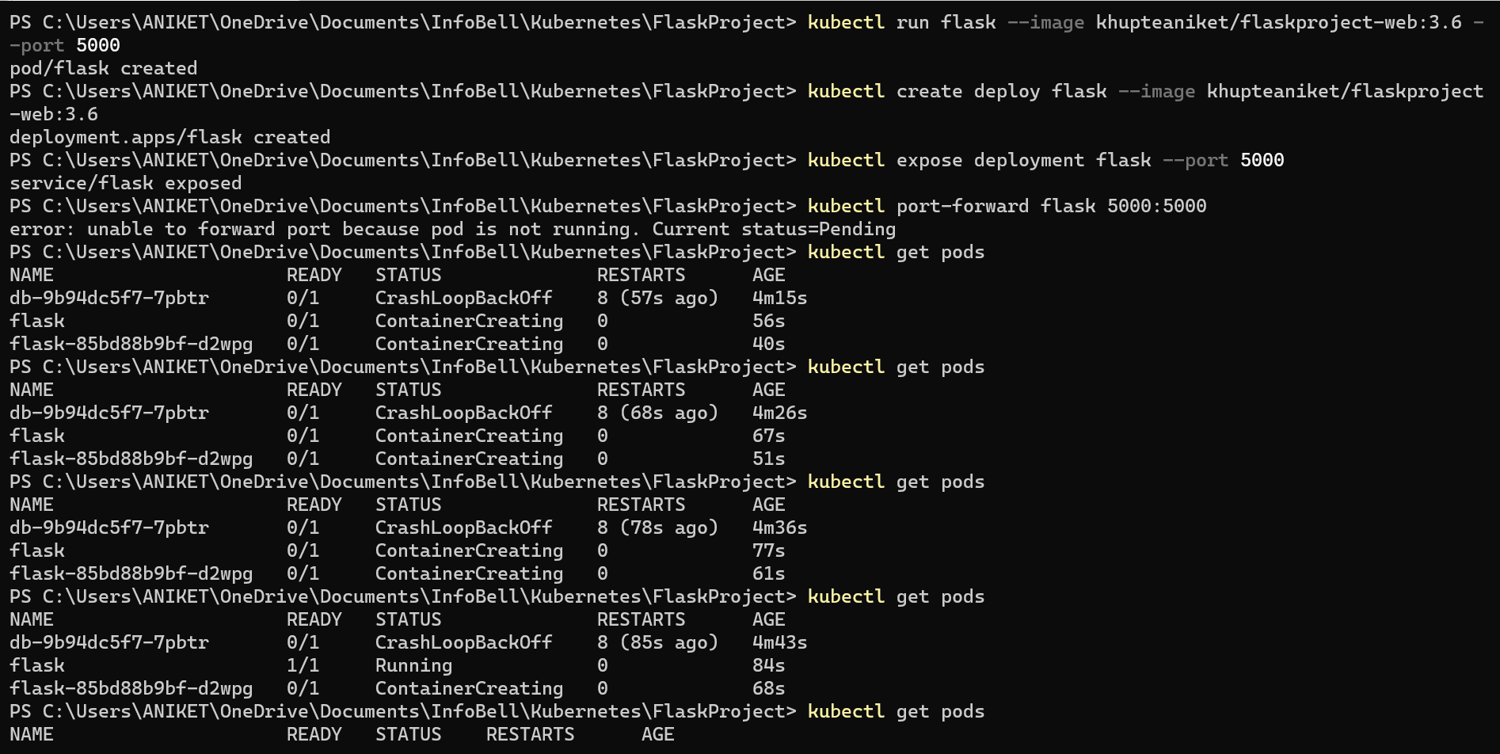

**Deploy pod using “kubectl create deploy” command:**



**Expose the current running pod using “kubectl expose deployment” command:**

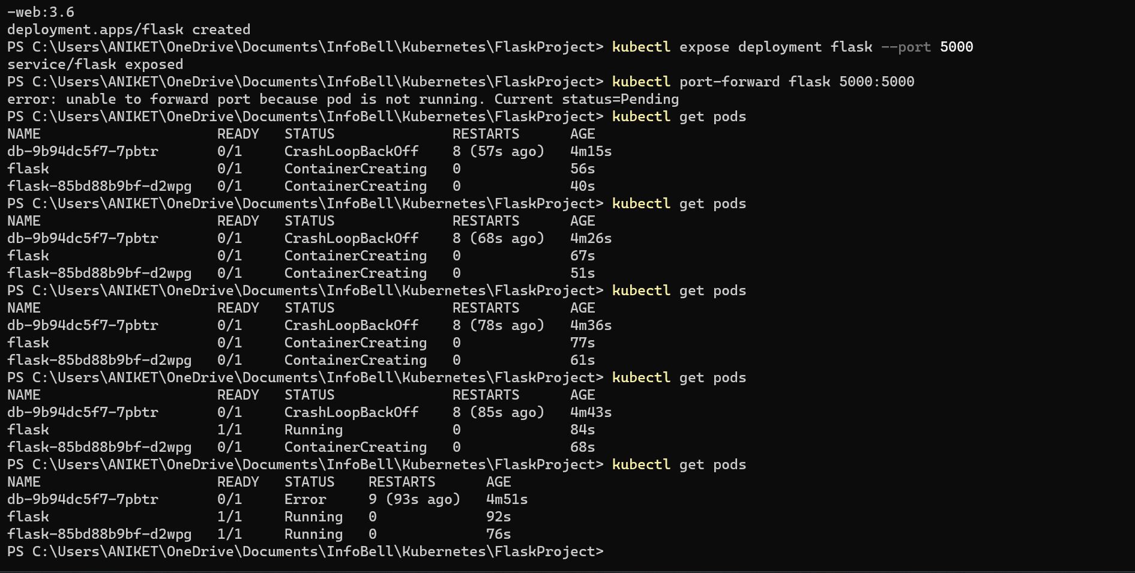

**Forward the port using “kubectl port-forward” command:**



**By “localhost:5000”, we connect to our application:**

