**Application Deployment on OpenShift**

**Building Image For Flask Application:**

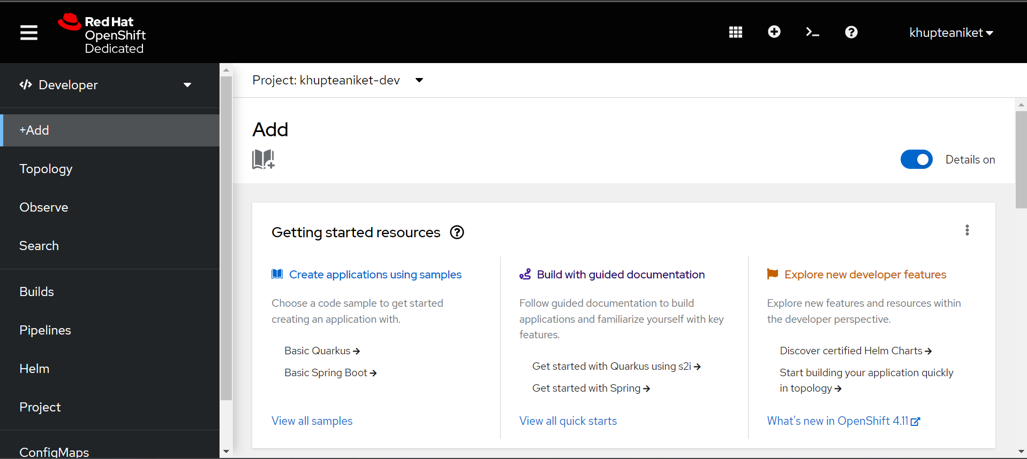

**Importing Flask Image from DockerHub:**

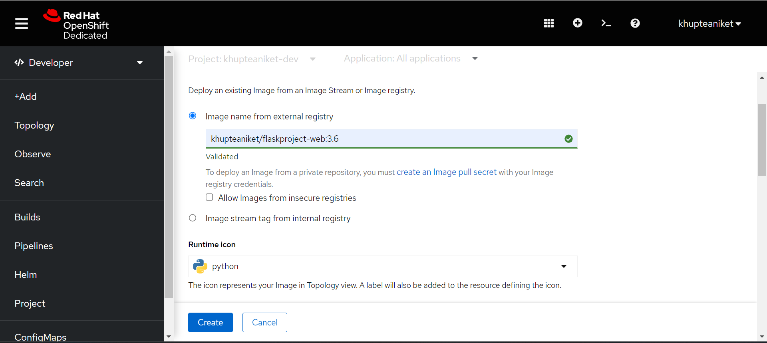

**Selecting DeploymentConfig for Image:**

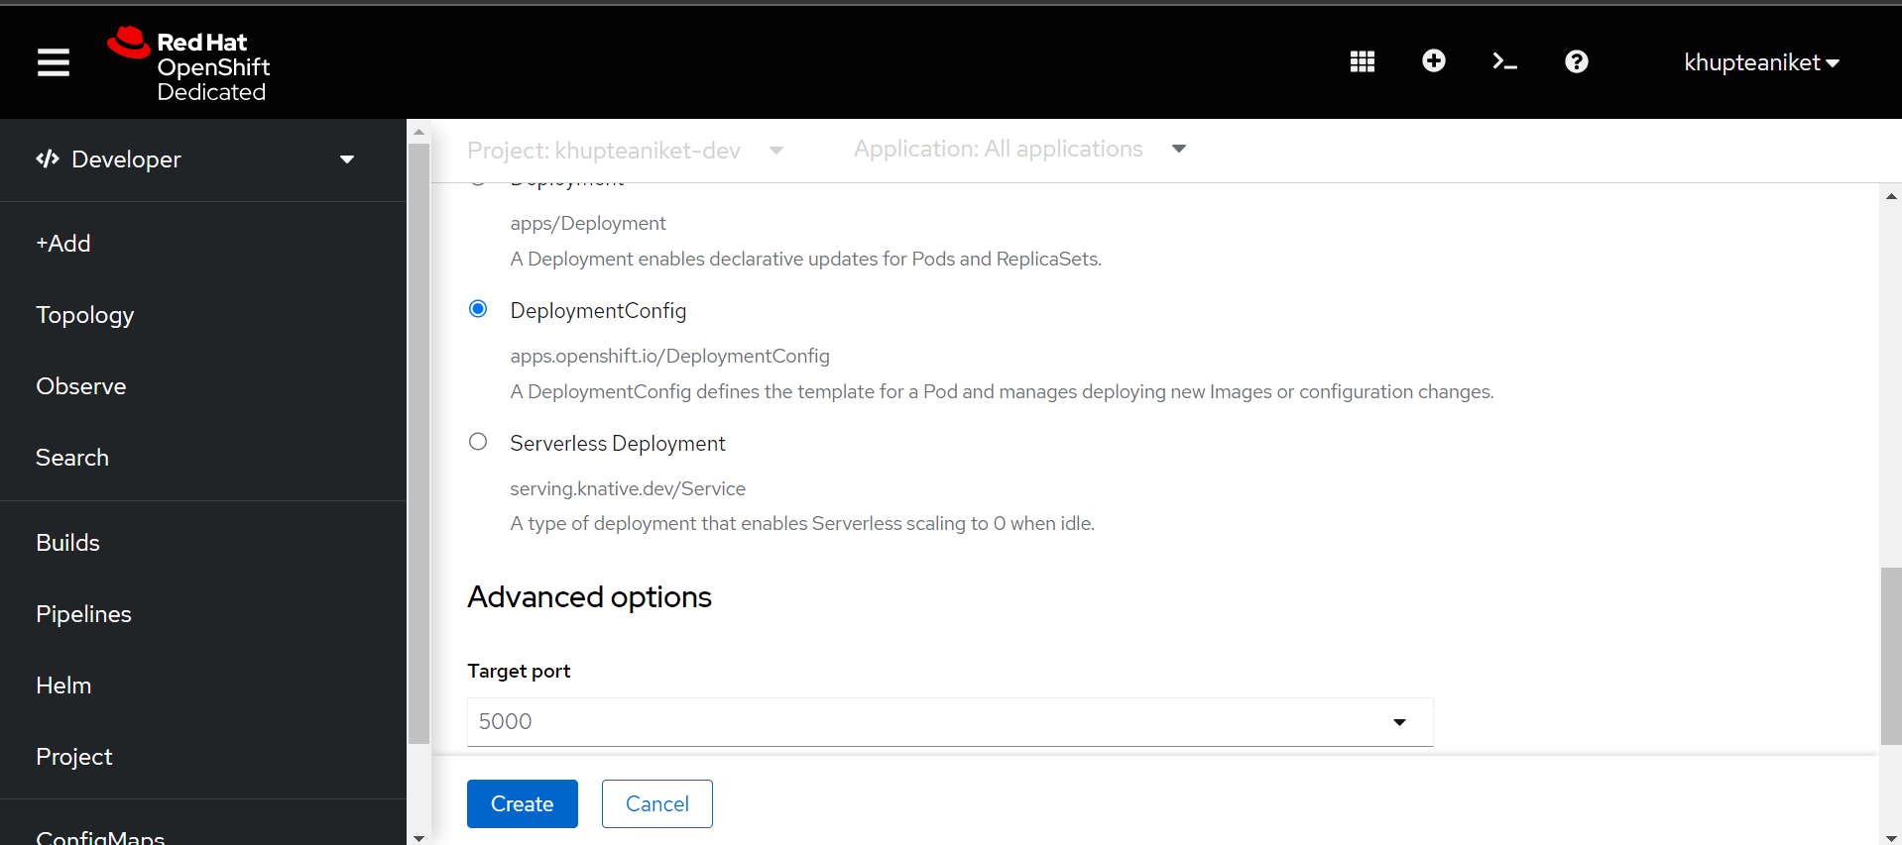

**Created Python pod from Docker Image:**

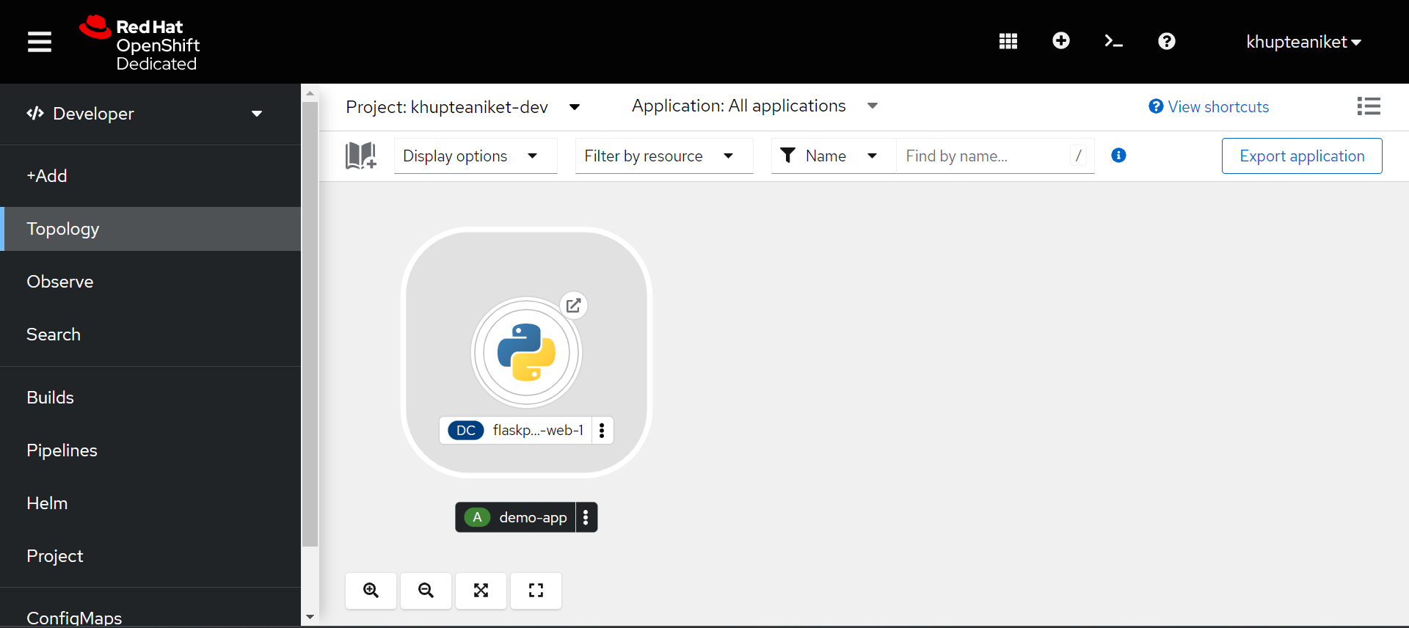

**Flask Pod is running:**

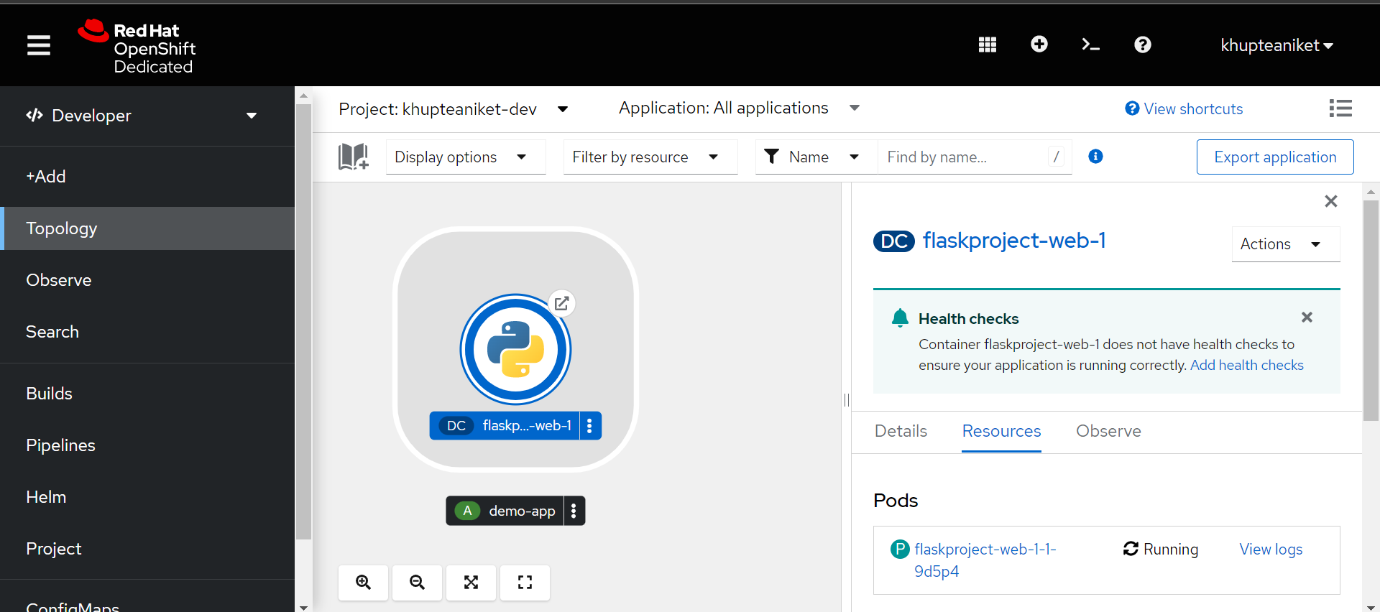

**Opening OpenShift Terminal:**

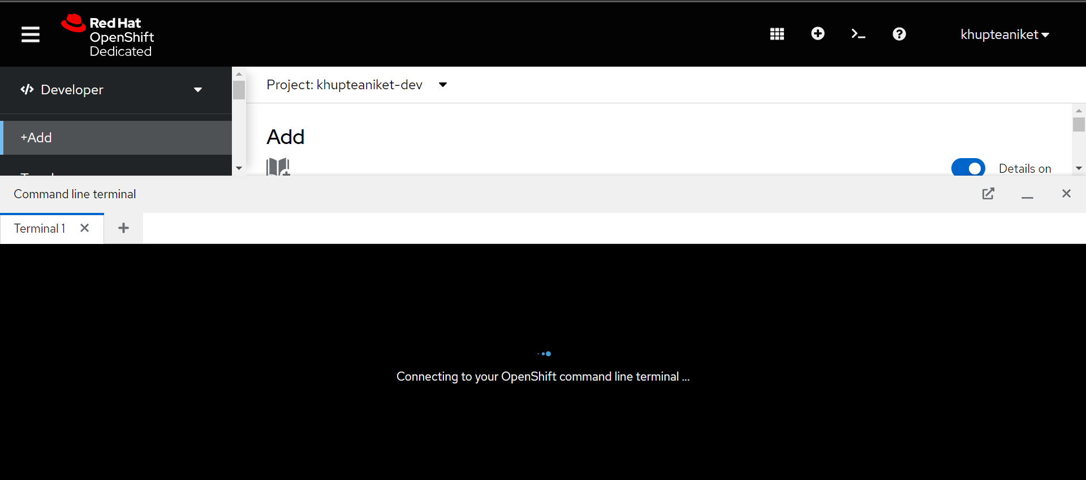

**Creating New Pod for MySQL on terminal:**

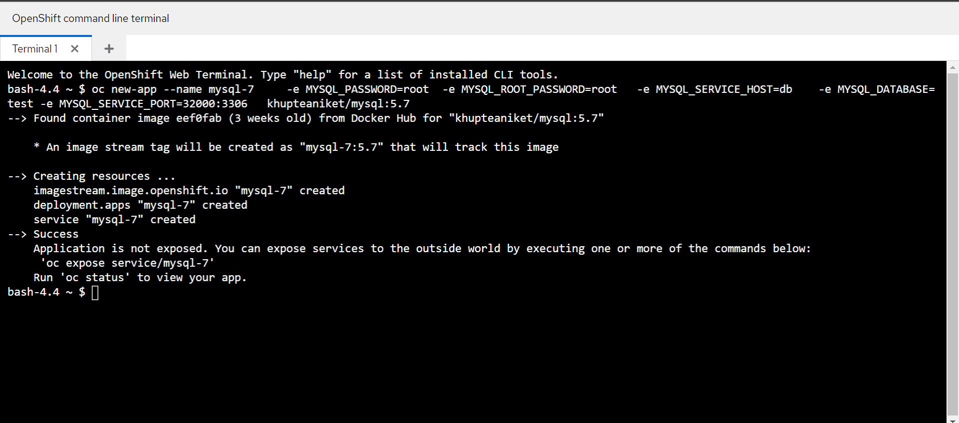

**MySQL pod is created:**

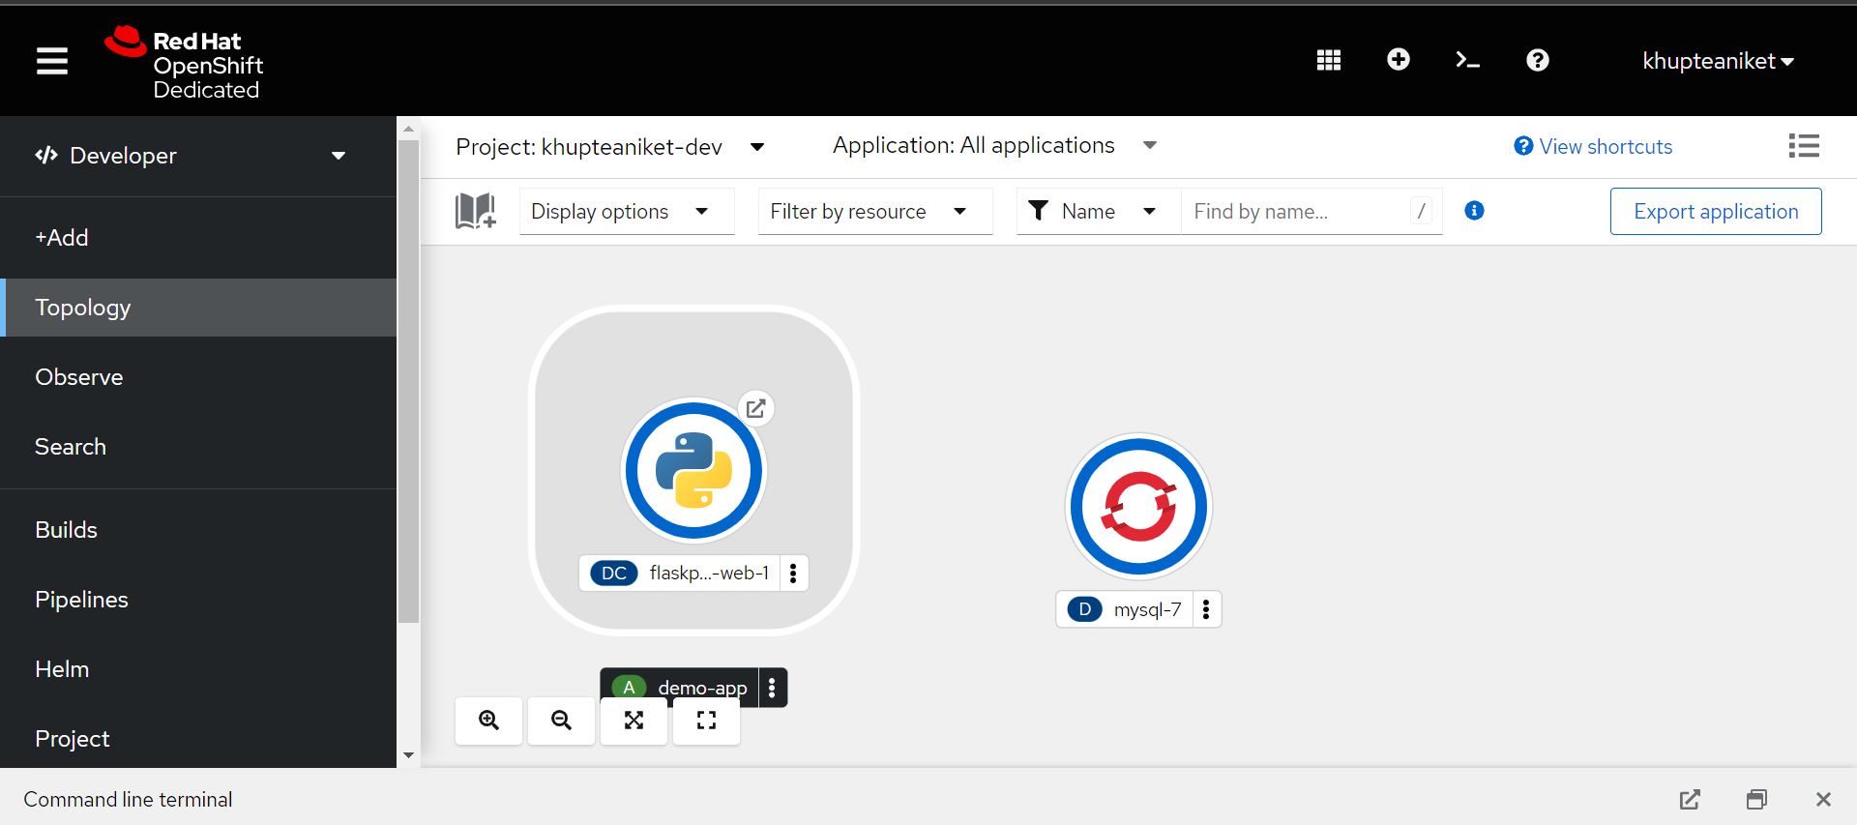

**MySQL pod is now running:**

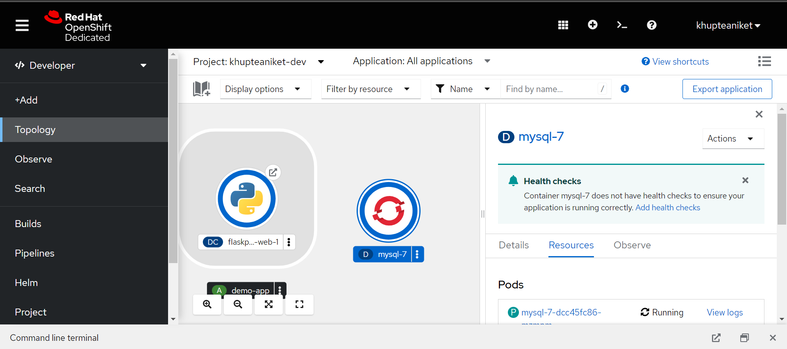

**Now we redirect our app from Route:**

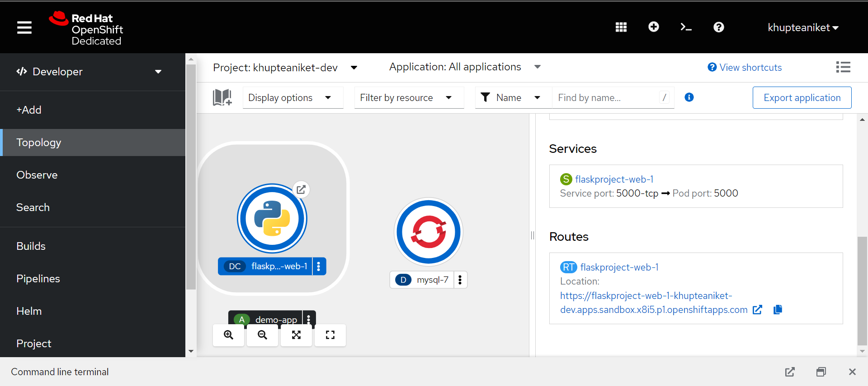

**We successfully deployed our application on OpenShift:**

