**Assignment on Shell Scripting**

**Write 5 shell scripts for the following scenarios, check in the files, and screenshot documents checkin to GIT**

* Create the startup script for an application start and stop
* Write a shell script that consists of a function that displays the number of files in the present working directory. Name this function “file_count” and call it in your script. If you use a variable in your function, remember to make it a local variable.

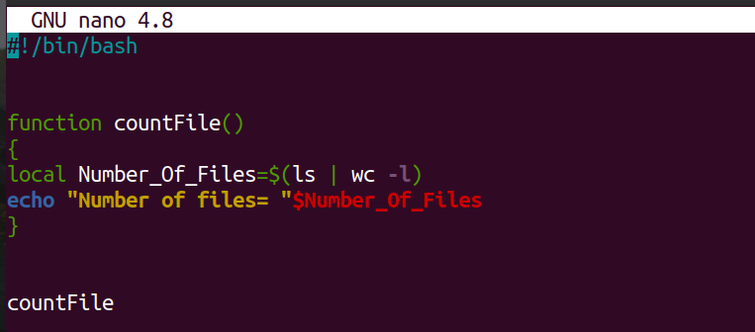

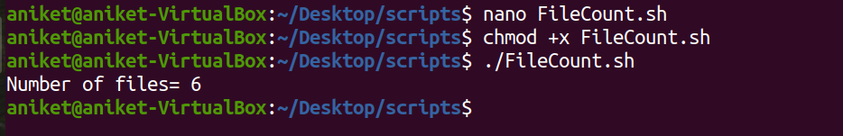

* For each directory in the $PATH, display the number of executables in that directory

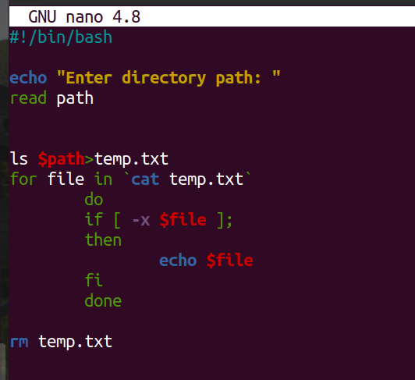

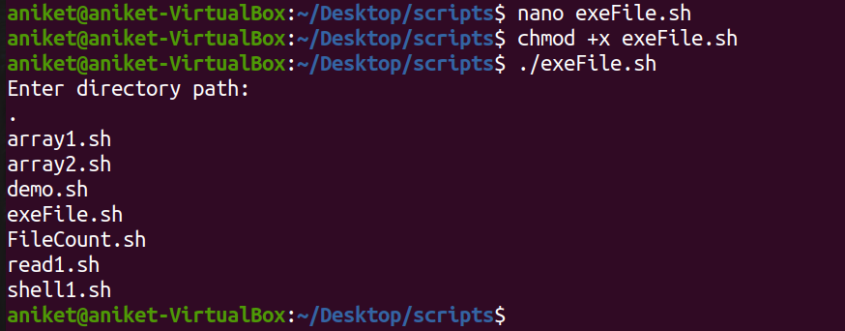

* Display the names of any file system which have less than 10% free space available
* Write a script that takes any number of directories as command-line arguments and then lists the contents of each of these directories.

