**Assignment 2 : Hands on practice on the Linux Basic Commands**

1 ls : List commands to show the content of directory



2 ls –l : To get detailed list of the directory content

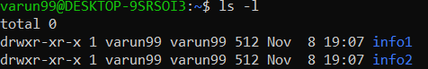

3 ls –a : To get the list Off all files/dir including hidden object.



4 pwd : Print Working directory



5 : mkdir directory_name To create a new directory.



6 touch :It is used to create file without content.



7 cat > : It is used to create a file with content. And can concatenate two or more file contents.

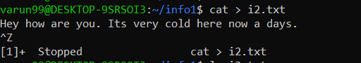

8 whoami : Prints the username of the active user.



9 cal :Cal command is used to display the calendar.

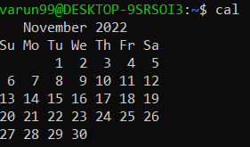

10 cd COMMAND : Cd command is used to change the directory.



11 cp : Used to copy files from one location to another. If the destination is an existing file, then the file is overwritten.

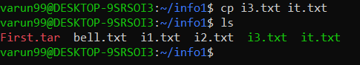

12 grep : grep command selects and print the lines from a file which matches a given string or pattern.



13 rm : This command delete the files

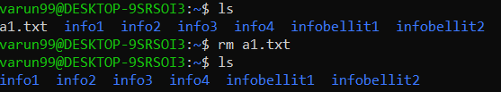

14 chmod : modifies the permissions of the file specified by file name to the permissions specified by permissions.

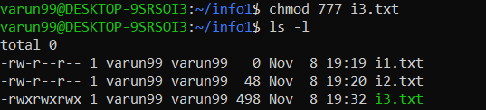

15 head : Used to display the first ten lines of a file



16 tail : Without any option it displays only the last 10 lines of the file specified.



17  Find : It can be used to find files and directories



18 awk : Awk is mostly used for pattern scanning and processing.



19  uname [-a] : Displays the operating system name as well as the system node name, operating system release, operating system version, hardware name, and processor type.



20 ps : To know the information about running processes in system

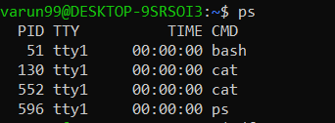

21 **df** : command that displays the amount of disk space available on the file system containing each file name argument.

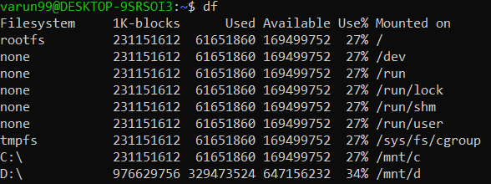

22 **du** command, short for disk usage, is used to estimate file space usage

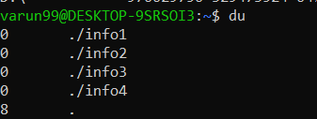

23 top : to view the information of running processes in detail

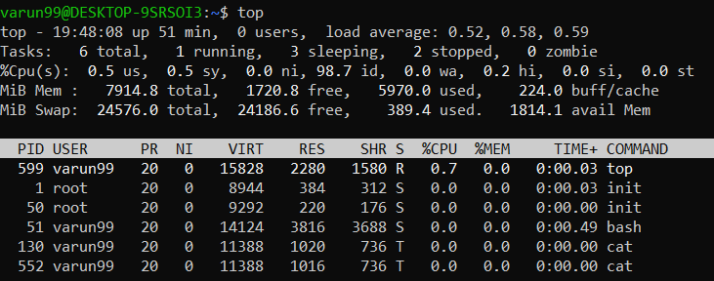

24 mv : To rename the file name

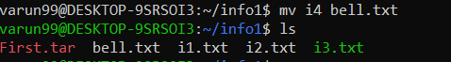

25 Tar : used for making TAR and compressed file

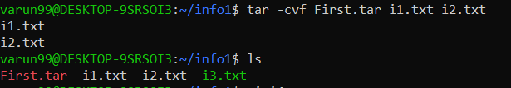

**Assignment cntd : Linux Commands**

26 Iostat :iostat is the basic workhorse utility for monitoring I/O device activity on the system

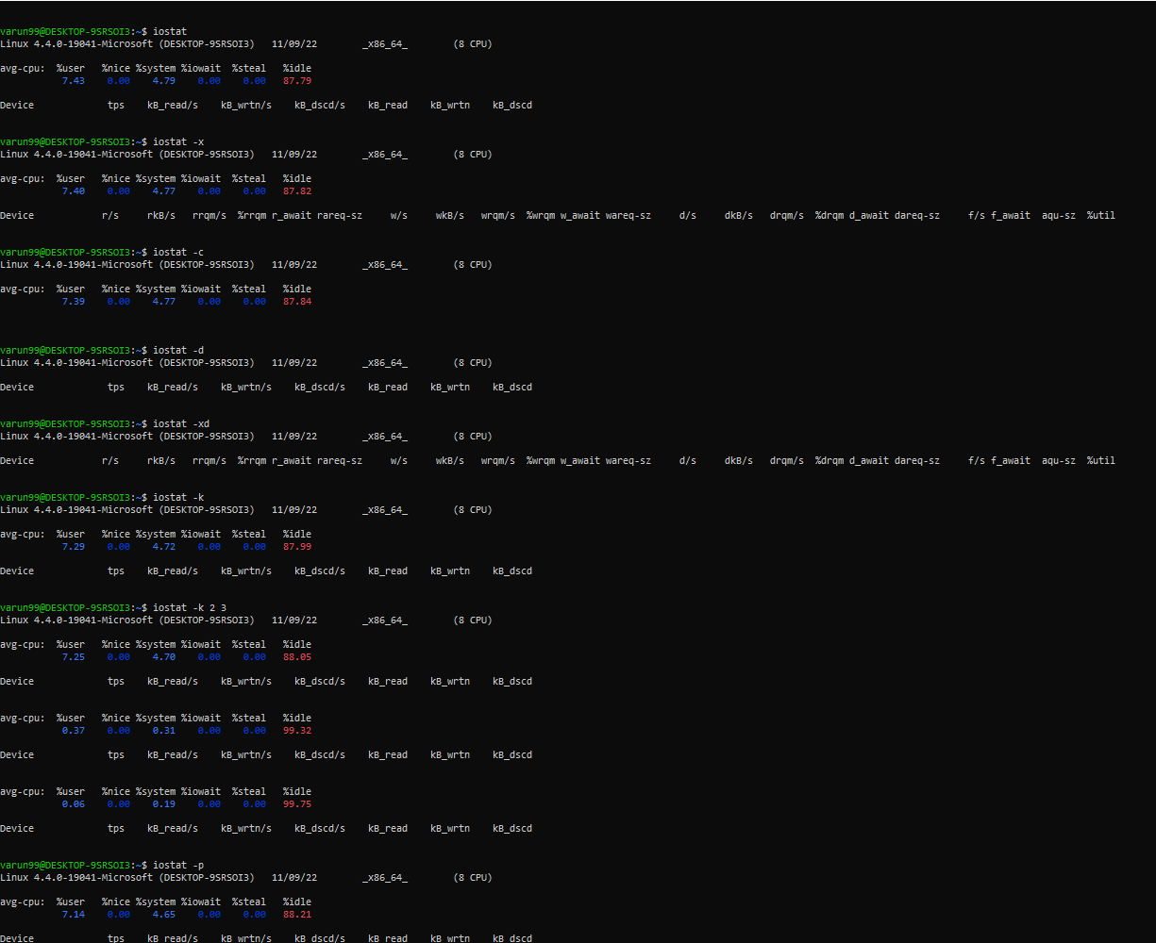

27 Clear : Clear the terminal display



28 diff : The command will compare data between two text files and display the difference



29 : Echo : Can be used to identify current user.



30 : Exit : It does is exit the shell in which it is active.

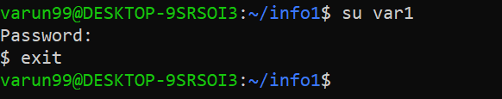

31 : finger : to look up and obtain brief information on users.

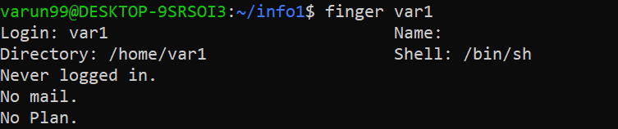

32 Free : The free command-line utility provides users with a summary of the total available free space on the computer

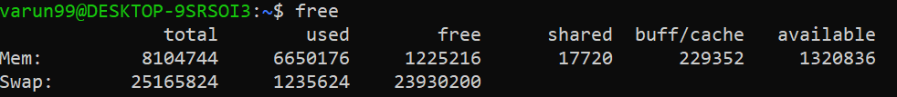

33 dmidecode : midecode command is used when the user want to retrieve system’s hardware related information



34 : History : To know the commands that we have used previously.

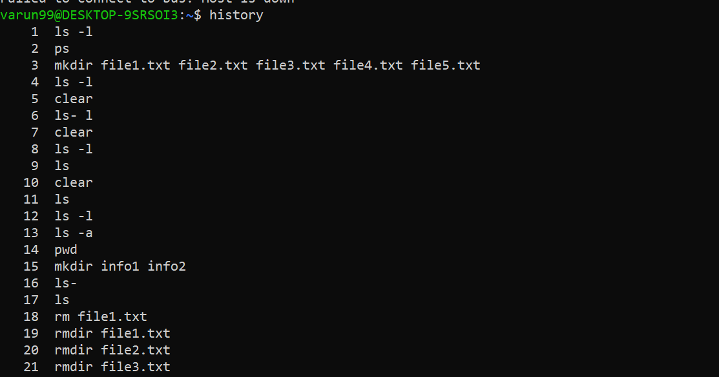

35 : less : With the less command, one does not have to use an editor to view files.

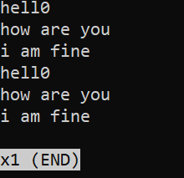

36 : ping : To know the internet status

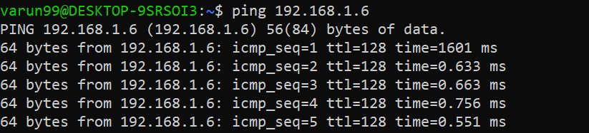

37 : Netstat : The netstat is a command-line tool that presents an overview of the network connections.



38 : Uptime : print current time when machine starts



39 : ifconfig – print ip address.

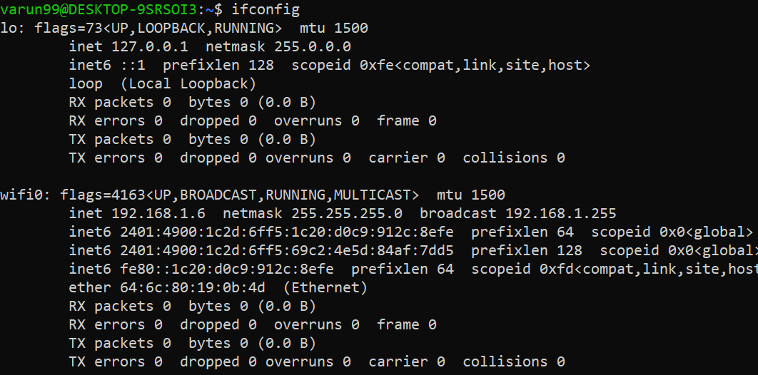

40 : Bc : is another cool and useful command for Linux users as it allows you to enable command line calculator in Linux Terminal

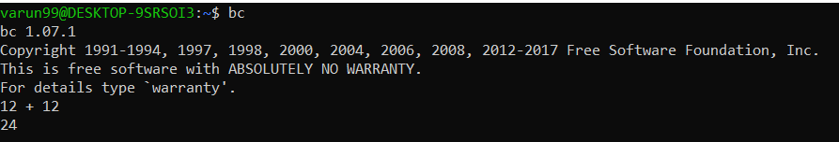

41 : Factor : give you all the possible factors of the decimal number

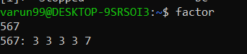

42 : Banner : will display whatever text you type will be displayed in big banner format

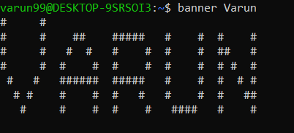

43 : *w:*  is the short and simple command which will help you view the list of currently logged in users.



44 :  lscpu : This command will display all the CPU architecture information such as threads, sockets, cores and CPU count.

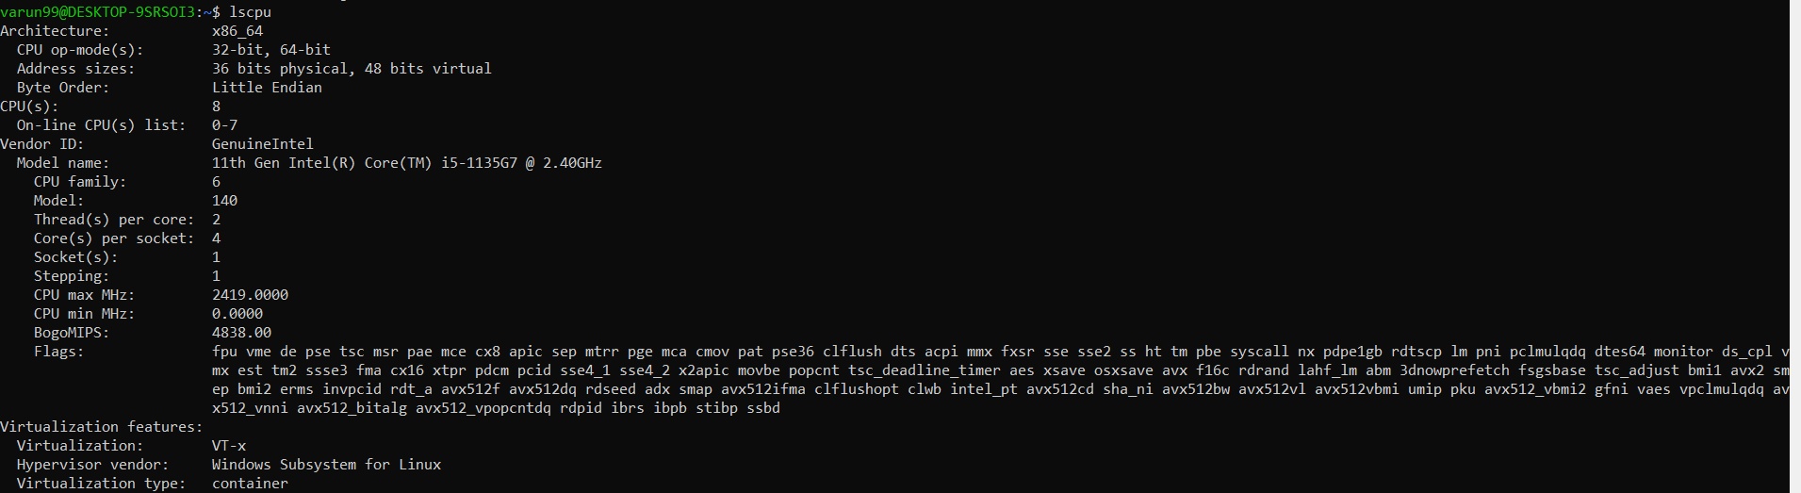

45 : cksum is a command to generate the checksum value for the file



46 : cmp : Compares byte to byte info of two files.



47 :  last command will display the list of last logged in users into the system

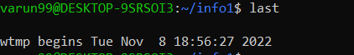

48 : Man : Used to display the manual

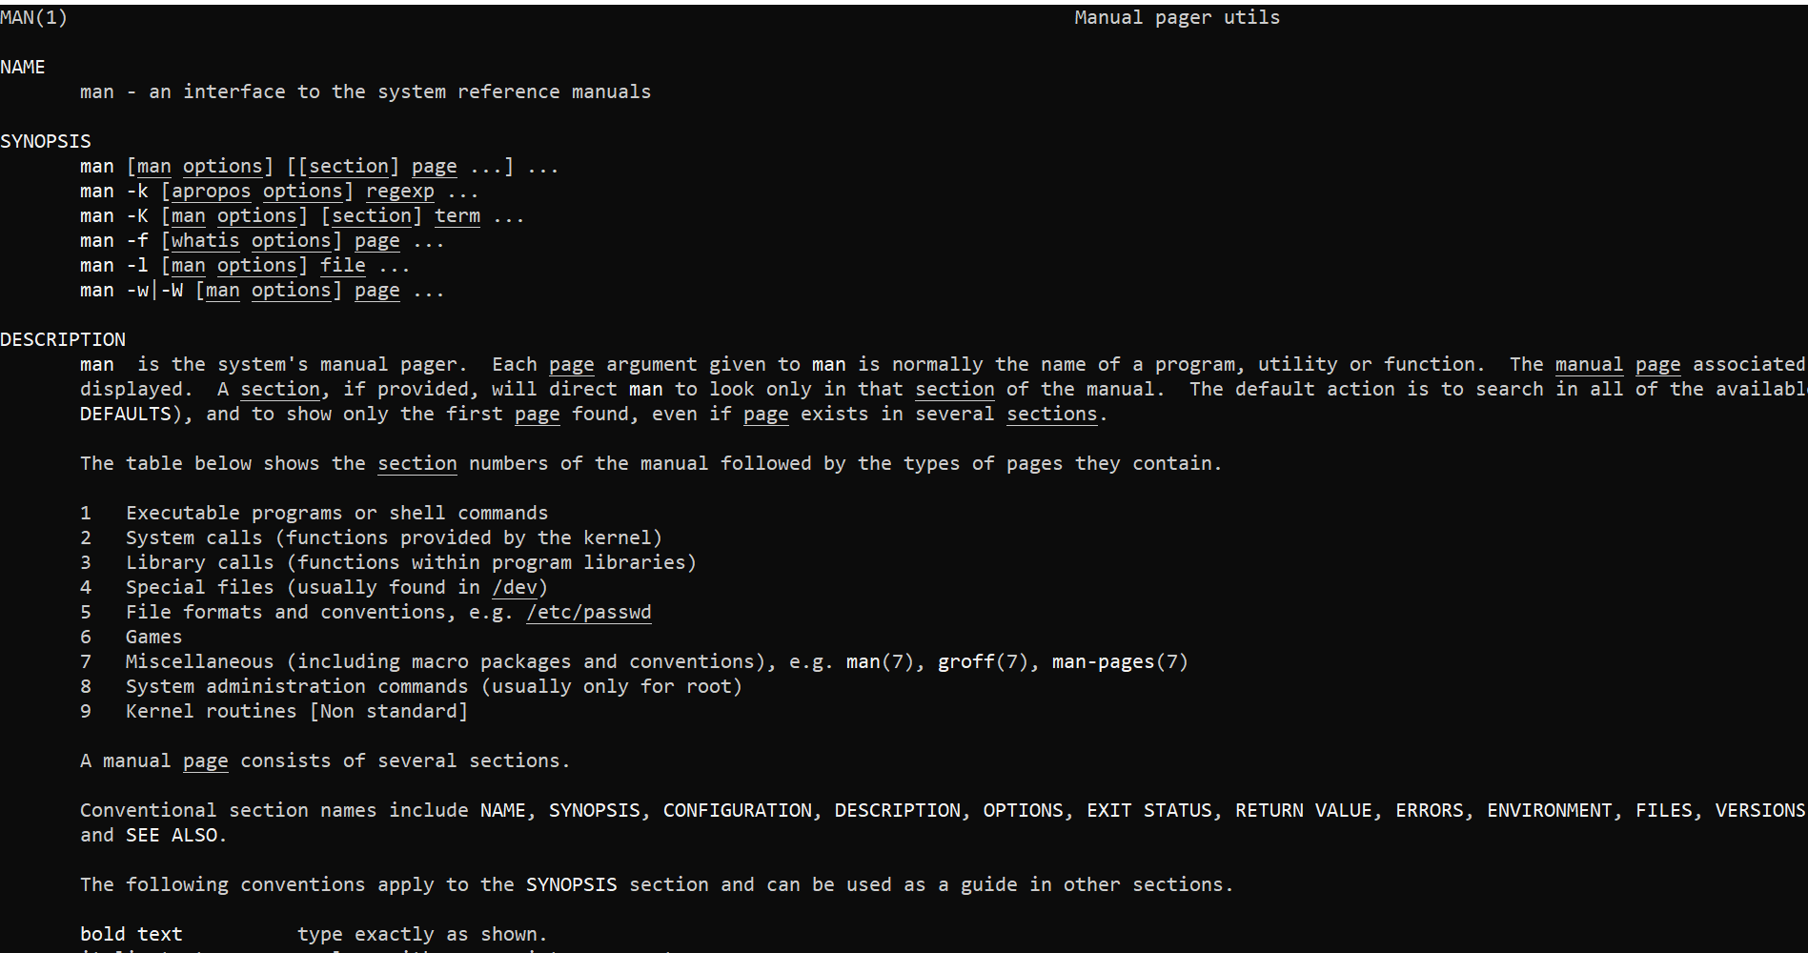

49 : Useradd : Adds the new user to the system

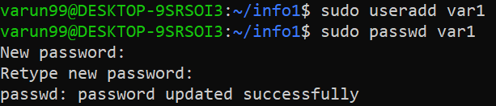

50 gruopadd : Creates/adds a new group to the system

