**GitHub Assignment**

1: Creating a **Repository**

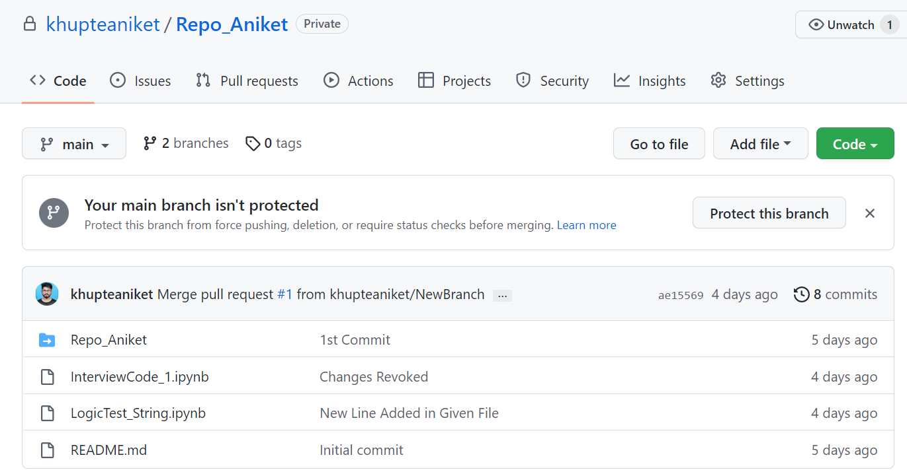

2: Use of clone command on git bash to download repository files from remote to local system with the use of **git clone** command

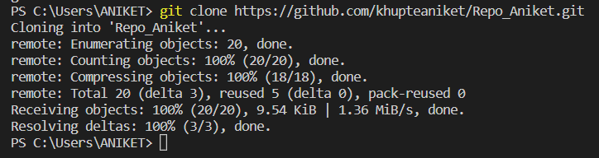

3: Creating and Adding Files to the local system with use of **git add** command

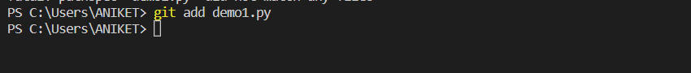

4: Commit the changes to the local with **git commit -m “text”** command

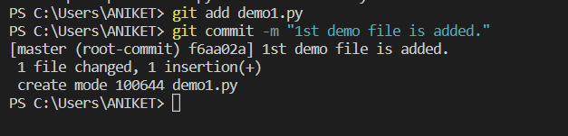

5: Pushing files from local to remote server **using git push origin main** command

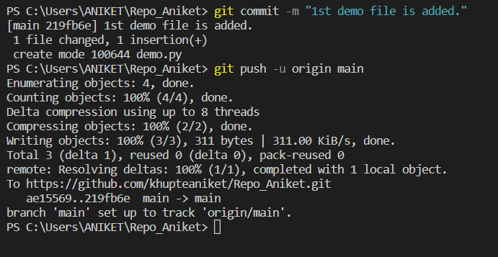

6: Checking whether we got the files on the remote server

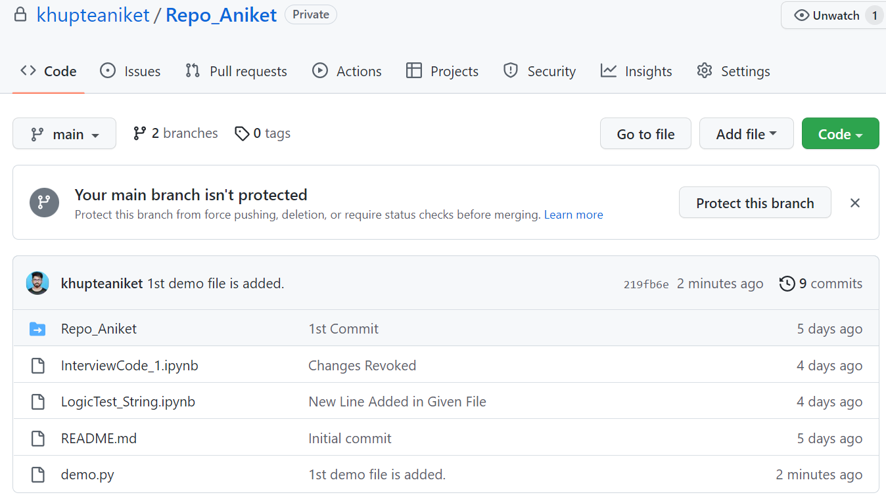

7: Making changes in the remote server.

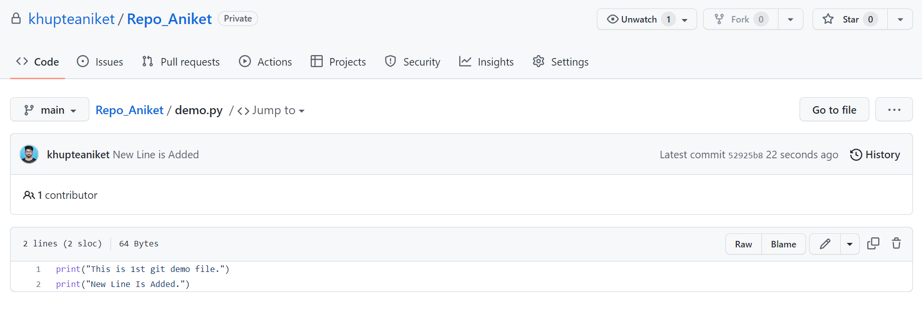

8: Pulling those changes to the local system using **git pull origin main** command.

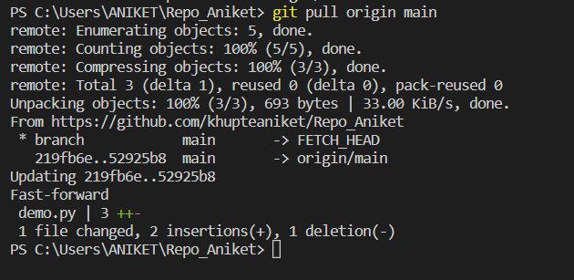

9: Creating a branch and adding a new file, pushing the file to the branch.

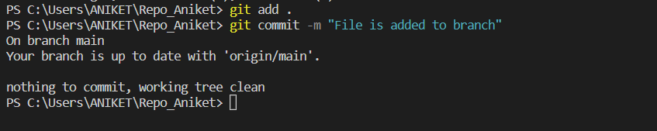

10: Using the **git merge** command add the final result to the master branch

