1. **Merge sorted array**

You are given two integer arrays nums1 and nums2, sorted in non-decreasing order, and two integers m and n, representing the number of elements in nums1 and nums2 respectively. Merge nums1 and nums2 into a single array sorted in non-decreasing order. The final sorted array should not be returned by the function, but instead be stored inside the array nums1. To accommodate this, nums1 has a length of m + n, where the first m elements denote the elements that should be merged, and the last n elements are set to 0 and should be ignored. nums2 has a length of n. Example 1: Input: nums1 = [1,2,3,0,0,0], m = 3, nums2 = [2,5,6], n = 3

Output: [1,2,2,3,5,6] Explanation: The arrays we are merging are [1,2,3] and [2,5,6]. The result of the merge is [1,2,2,3,5,6] with the underlined elements coming from nums1.

Example 2: Input: nums1 = [1], m = 1, nums2 = [], n = 0

Output: [1]

Explanation: The arrays we are merging are [1] and []. The result of the merge is [1]. Example 3: Input: nums1 = [0], m = 0, nums2 = [1], n = 1

Output: [1]

Explanation: The arrays we are merging are [] and [1]. The result of the merge is [1].

Note that because m = 0, there are no elements in nums1. The 0 is only there to ensure the merge result can fit in nums1.

Constraints:

nums1.length == m + n

nums2.length == n

0 <= m, n <= 200

1 <= m + n <= 200

-109 <= nums1[i], nums2[j] <= 109

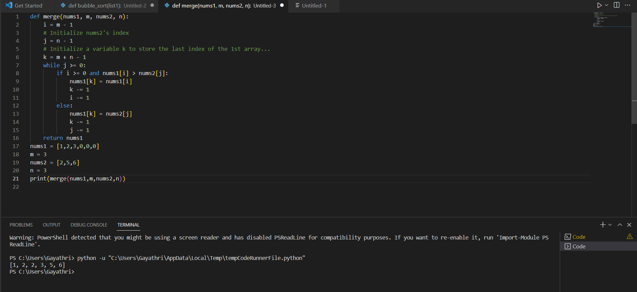

1. **Squares of a Sorted Array**

Given an integer array nums sorted in non-decreasing order, return an array of the squares of each number sorted in non-decreasing order.

Example 1:

Input: nums = [-4,-1,0,3,10]

Output: [0,1,9,16,100]

Explanation: After squaring, the array becomes [16,1,0,9,100].

After sorting, it becomes [0,1,9,16,100].

Example 2:

Input: nums = [-7,-3,2,3,11]

Output: [4,9,9,49,121]

Constraints:

1 <= nums.length <= 104

-104 <= nums[i] <= 104

nums is sorted in non-decreasing order.

