1. Create the startup script for an application start and stop

USE watch date (To start a process)

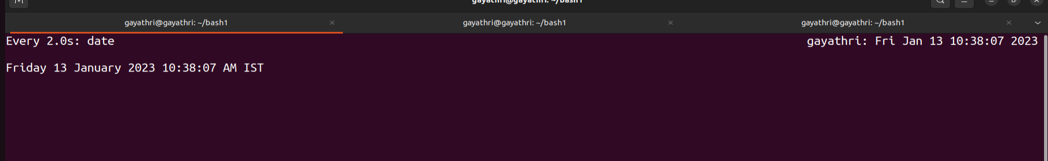

Use top command to find PID



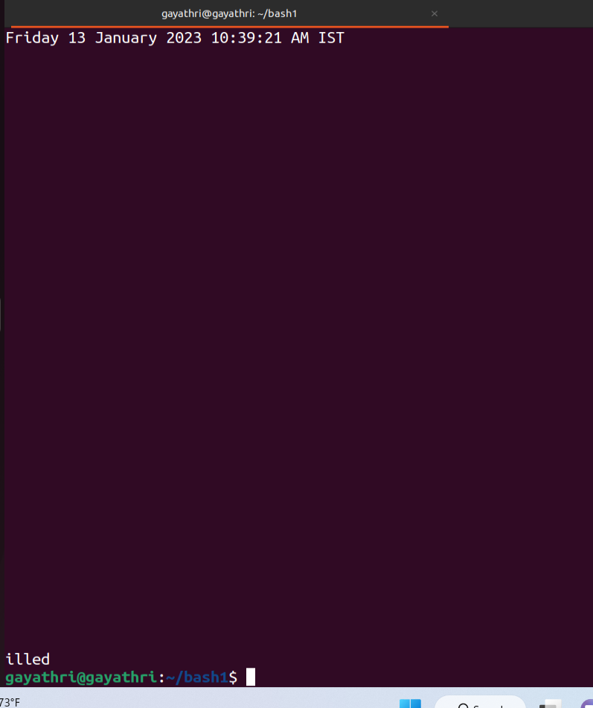

2. Write a shell script that consists of a function that displays the number of files in the present working directory. Name this function “file_count” and call it in your script. If you use variable in your function, remember to make it a local variable.

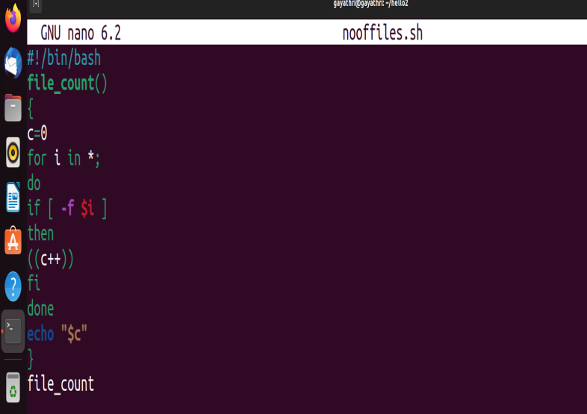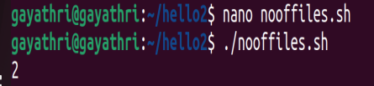

3.For each directory in the $PATH, display the number of executable in that directory

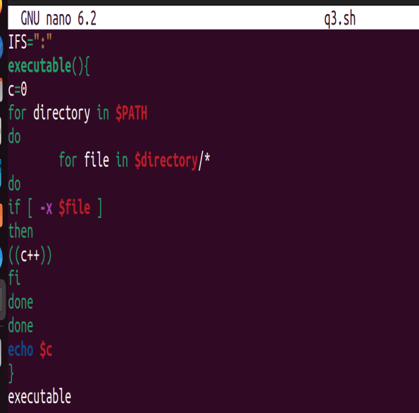

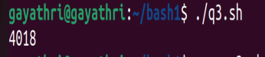

1. Display the names of any file-system which have less than 10% free space available

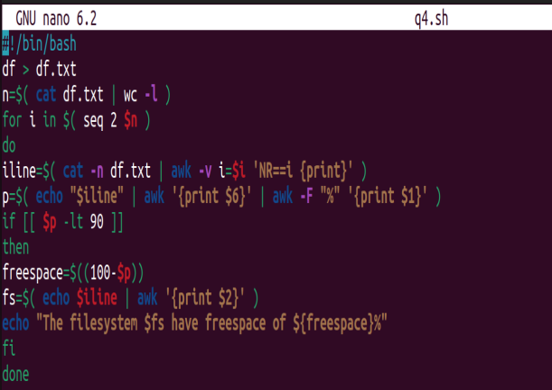

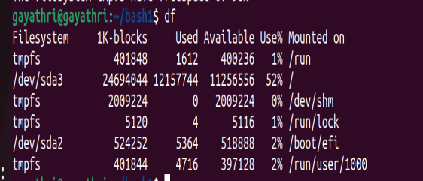

1. Write a script that takes any number of directories as command-line arguments and then lists the contents of each of these directories.

