28. Description- Script to locks file permissions for a particular directory for groups and others

Input- bash 28_lock_permissions.sh test

Output- total 8

-rw-rw-r-- 1 siddaling siddaling 0 Jan 17 01:24 a.txt

-rw-rw-r-- 1 siddaling siddaling 0 Jan 17 01:24 b.txt

-rw-rw-r-- 1 siddaling siddaling 0 Jan 17 01:24 c.txt

-rw-rw-r-- 1 siddaling siddaling 0 Jan 17 01:24 d.txt

drwxrwxr-x 2 siddaling siddaling 4096 Jan 17 01:25 Emertxe

-rw-rw-r-- 1 siddaling siddaling 0 Jan 17 01:24 f.sh

drwxrwxr-x 2 siddaling siddaling 4096 Jan 17 01:25 Siddaling

-rw-rw-r-- 1 siddaling siddaling 0 Jan 17 01:24 z.sh

All files are locked for groups and others

total 8

-rw------- 1 siddaling siddaling 0 Jan 17 01:24 a.txt

-rw------- 1 siddaling siddaling 0 Jan 17 01:24 b.txt

-rw------- 1 siddaling siddaling 0 Jan 17 01:24 c.txt

-rw------- 1 siddaling siddaling 0 Jan 17 01:24 d.txt

drwxrwxr-x 2 siddaling siddaling 4096 Jan 17 01:25 Emertxe

-rw------- 1 siddaling siddaling 0 Jan 17 01:24 f.sh

drwxrwxr-x 2 siddaling siddaling 4096 Jan 17 01:25 Siddaling

-rw------- 1 siddaling siddaling 0 Jan 17 01:24 z.sh

Source code:

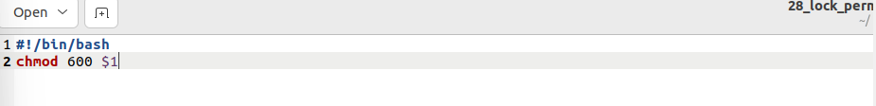

Output:

29. Description- Script to display the names of any file-system which have less than 40% free space available

Input- bash 29_free_space.sh

Output- The filesystem /dev/sda5 has less than 40% free space

The filesystem /dev/sda6 has less than 40% free space

Source code:

Output:

