1. Write a script to print the permissions for the .txt files in the specified directory?

Script:

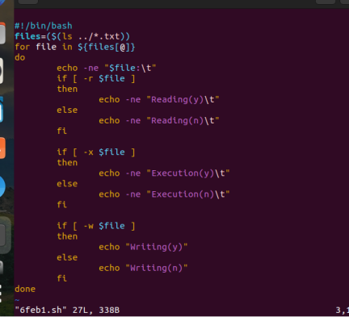

Output:

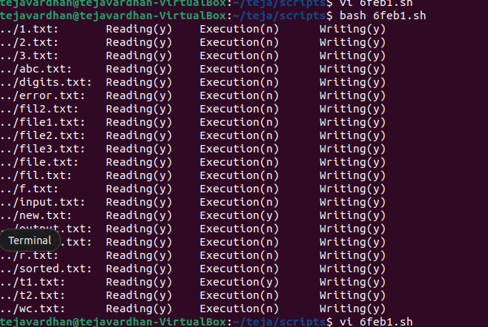

1. Write a Function to find Factorial of a given Integer Number?

Script:

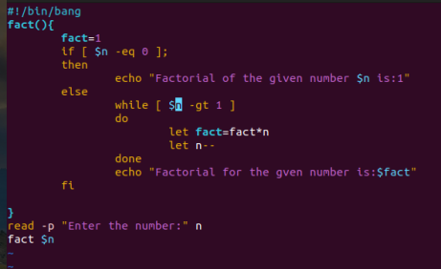

Output:

