1)Consider that vowels in the alphabet are a, e, i, o, u and y.

Function score_words takes a list of lowercase words as an argument and returns a score as follows:

The score of a single word is 2 if the word contains an even number of vowels. Otherwise, the score of this word is 2 . The score for the whole list of words is the sum of scores of all words in the list.

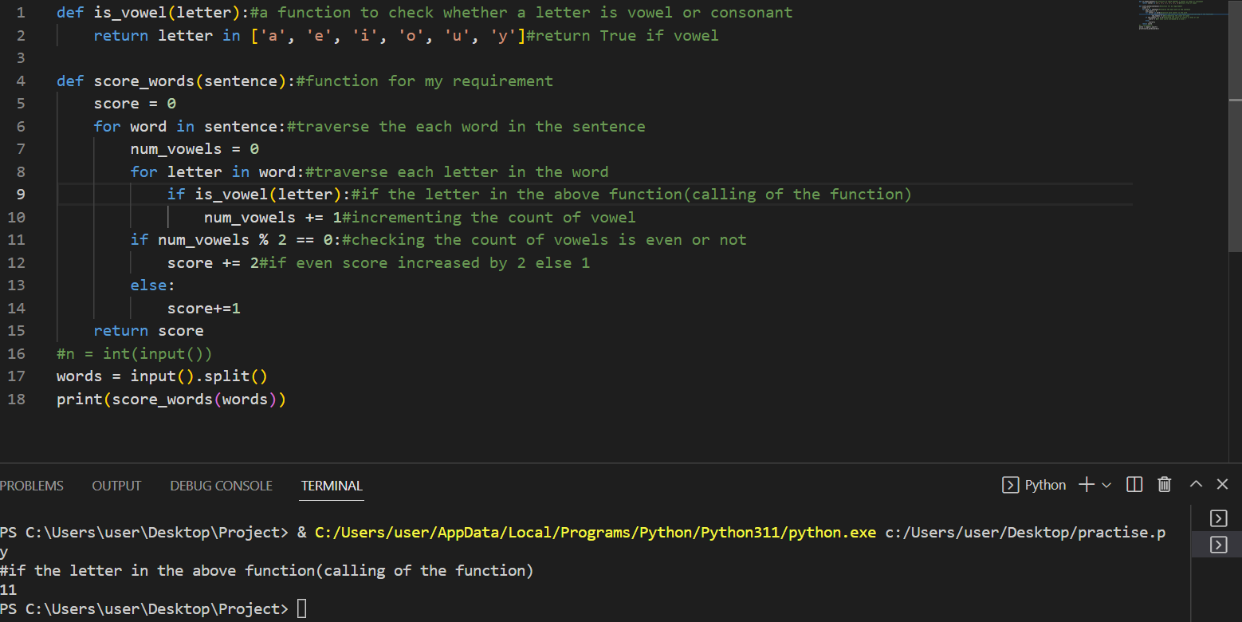

1. It is a concept of debugging the code for the required output.

input:

Odd 2

Even 3

Odd 5

Output:

1

3

0

2

4

1

3

5

7

9

**class** EvenStream(**object**):

**def** __init__(**self**):

**self**.current = 0

**def** get_next(**self**):

        to_return = **self**.current

**self**.current += 2

**return** to_return

**class** OddStream(**object**):

**def** __init__(**self**):

**self**.current = 1

**def** get_next(**self**):

        to_return = **self**.current

**self**.current += 2

**return** to_return

**def** print_from_stream(n, stream=EvenStream()):

**for** i **in** **range**(n):

**print**(stream.get_next())

    stream.current=0

queries = **int**(**input**())

**for** _ **in** **range**(queries):

    stream_name, n = **input**().split()

    n = **int**(n)

**if** stream_name == "even":

        print_from_stream(n)

**else**:

        print_from_stream(n, OddStream())