Date : 03/01/2023

Name : K Prasad Achari

**1.Write a python program to remove the duplicate elements without using in-built function.**

**Code :**

**n = input("enter the input elements : ")  
list = n.split()  
new_list = []  
for i in list:  
 if i not in new_list:  
 new_list.append(i)  
print("output : ",*new_list)**

**Screenshot:**

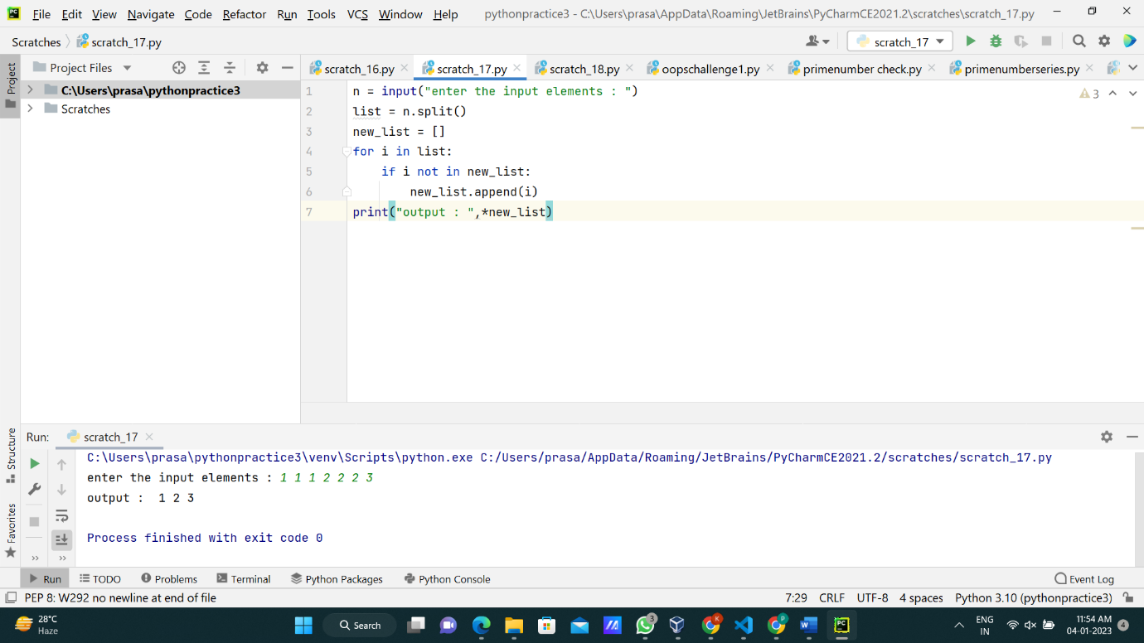

**2.Write a python program to print prime numbers for given range.**

**Code :**

**n = int(input("enter first value :"))  
x = int(input("enter second value :"))  
for num in range(n,x+1):  
 count = 0  
 for j in range(1,x+1):  
 if(num % j==0):  
 count=count+1  
 if(count==2):  
 print(num,end=" ")**

**Screenshot:**

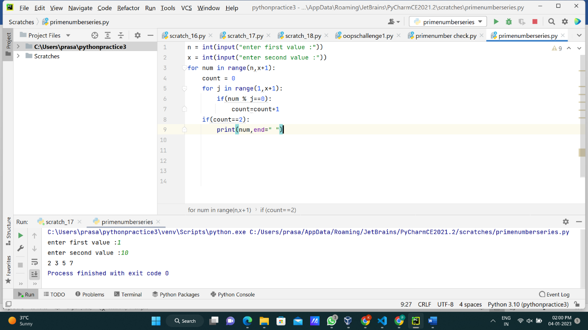

**3.Write a python program to find a factorial of a number.**

**Code :**

**x = int(input("enter a number : "))  
fact = 1  
for i in range(1,x+1):  
 fact = fact*i  
print("output : ",fact)**

**Screenshot:**

