Date : 04/01/2023

Name : K Prasad Achari

**1.Write a python program to find nth fibonacci number by using recursive function.**

**Code :**

**def fibonacci(n):  
 if n<=1:  
 return n  
 return fibonacci(n-1)+fibonacci(n-2)  
n=int(input("enter number : "))  
print(fibonacci(n))**

**Screenshot:**

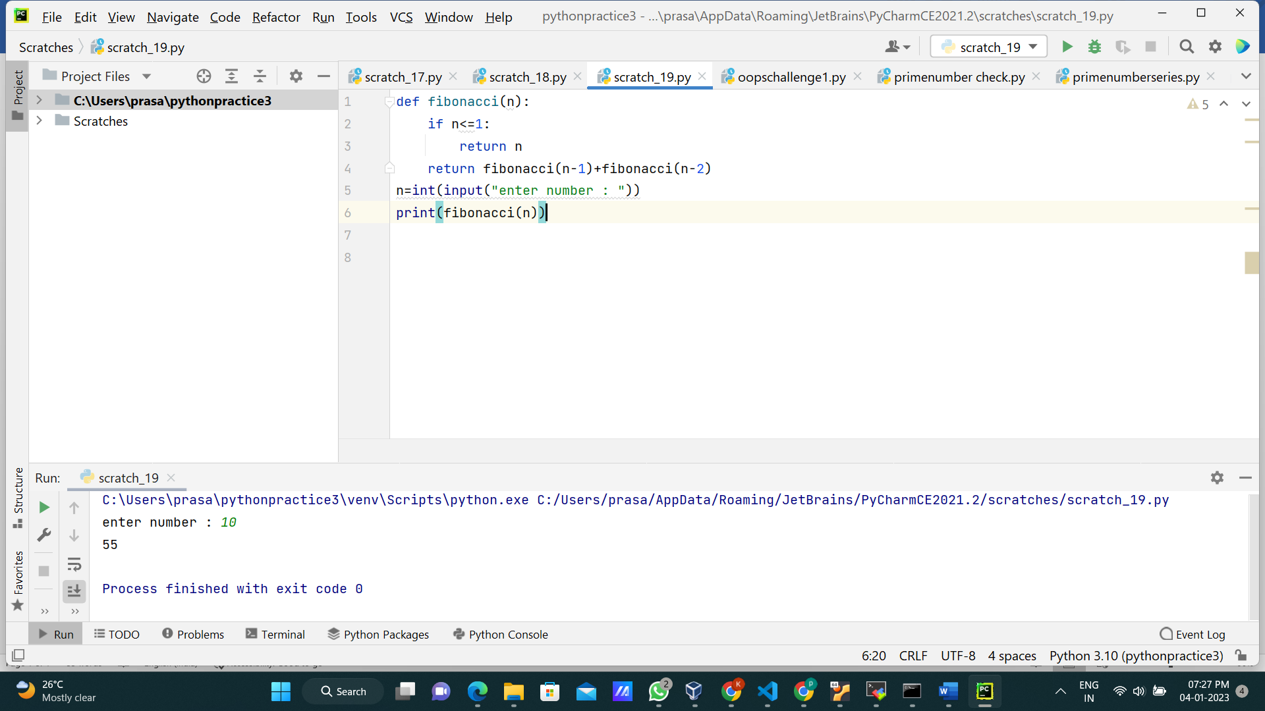

**2.Write a python program to find whether the given input is palindrome or not.**

**Code :**

**def palindrome(n):  
 if n[::-1]==n:  
 return "Palindrome"  
 return "Not Palindrome"  
n=input("input : ")  
print("output : ",palindrome(n))**

**Screenshot:**

