Date : 05/01/2023

Name : K Prasad Achari

**1.Write a python program to check given array is monotonic array or not.**

**Code :**

**def isMonotonic(A):  
 ac = 0  
 dc = 0  
 for i in range(len(A) - 1):  
 if (A[i] <= A[i + 1]):  
 ac += 1  
 if (A[i] >= A[i + 1]):  
 dc += 1  
 if ac == len(A) - 1 or dc == len(A) - 1:  
 return True  
 else:  
 return False  
  
  
A = list(map(int, input().split(",")))  
print(isMonotonic(A))**

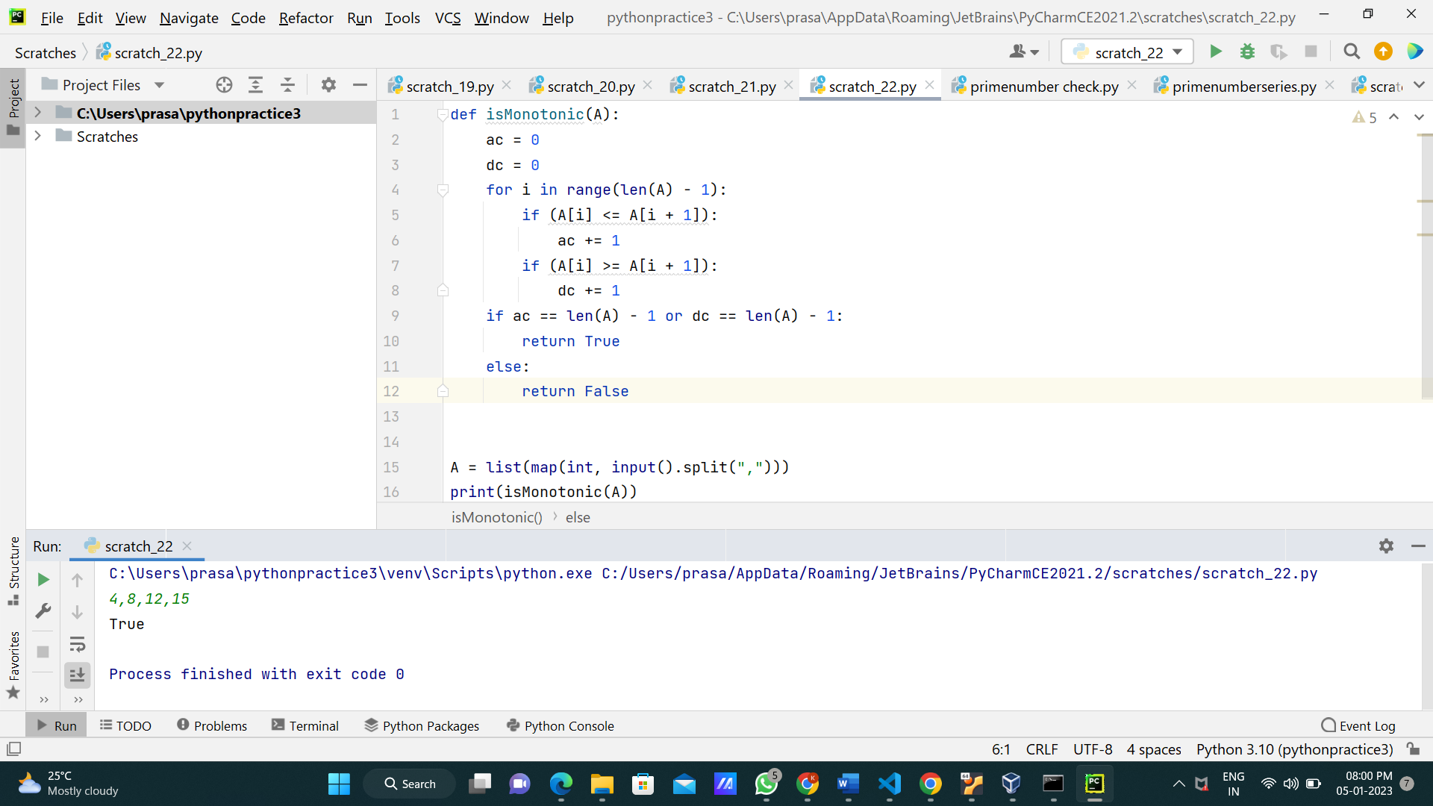

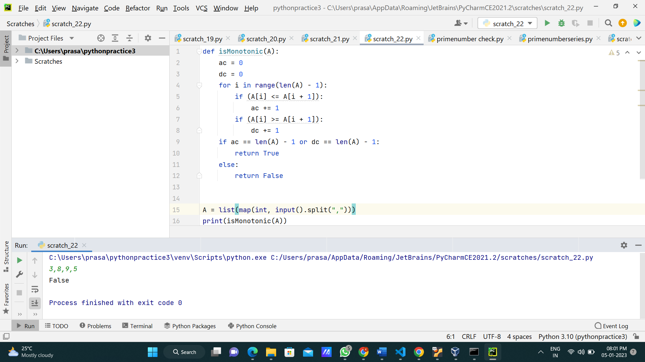

**2.Write a python program to sort the given array by using any sorting algorithm.**

**Code :**

***#Bubble sort*def bubbleSort(arr):  
 n = len(arr)  
  
 for i in range(n):  
 for j in range(0, n - i - 1):  
 if arr[j] > arr[j + 1]:  
 arr[j], arr[j + 1] = arr[j + 1], arr[j]  
 return arr  
arr = list(map(int,input("enter elements : ").split(",")))  
print("sorted array",bubbleSort(arr))**

