Date : 09/01/2023

Name : K Prasad Achari

1.4Sum

Given an array nums of n integers, return *an array of all the****unique****quadruplets* [nums[a], nums[b], nums[c], nums[d]] such that:

* 0 <= a, b, c, d < n
* a, b, c, and d are **distinct**.
* nums[a] + nums[b] + nums[c] + nums[d] == target

You may return the answer in **any order**.

**Example 1:**

**Input:** nums = [1,0,-1,0,-2,2], target = 0

**Output:** [[-2,-1,1,2],[-2,0,0,2],[-1,0,0,1]]

**Example 2:**

**Input:** nums = [2,2,2,2,2], target = 8

**Output:** [[2,2,2,2]]

**Code :**

class Solution:

    def fourSum(self, arr: List[int], target: int) -> List[List[int]]:

        arr.sort()

        n=len(arr)

        se=set()

        for i in range(n-4+1):

            for j in range(i+1,n-3+1):

                s=arr[i]+arr[j]

                k=j+1

                m=n-1

                while k<m:

                    a=s+arr[k]+arr[m]

                    if a<target:

                        k+=1

                    elif a>target:

                        m-=1

                    else:

                        se.add((arr[i],arr[j],arr[k],arr[m]))

                        k+=1

                        m-=1

        return se

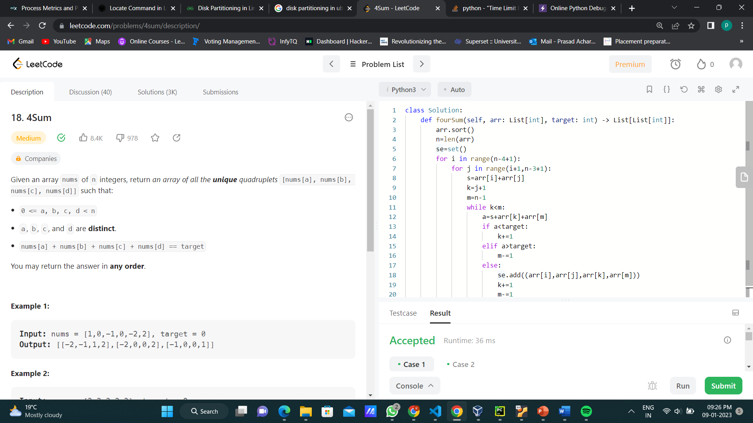

2.Find First and Last Position of Element in Sorted Array

Given an array of integers nums sorted in non-decreasing order, find the starting and ending position of a given target value.

If target is not found in the array, return [-1, -1].

You must write an algorithm with O(log n) runtime complexity.

**Example 1:**

**Input:** nums = [5,7,7,8,8,10], target = 8

**Output:** [3,4]

**Example 2:**

**Input:** nums = [5,7,7,8,8,10], target = 6

**Output:** [-1,-1]

**Example 3:**

**Input:** nums = [], target = 0

**Output:** [-1,-1]

**Code:**

class Solution:

    def searchRange(self, nums: List[int], target: int) -> List[int]:

        l=[]

        if target not in nums:

            res=[-1,-1]

            return res

        else:

            for i in range(0,len(nums)):

                if nums[i]==target:

                    l.append(i)

            return [l[0],l[-1]]

