- Write a script to allow the current users only?
Script and output:
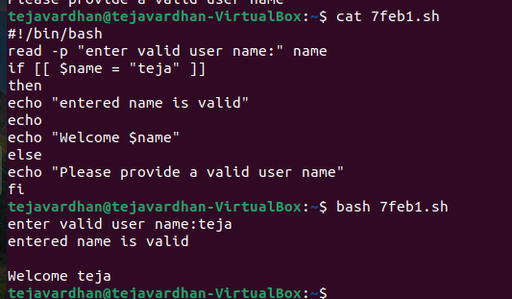

- Write a shell script to display the even and odd count in the given range?
Script and output:
