- Write a Script that Print all Command Line Arguments?
Script:
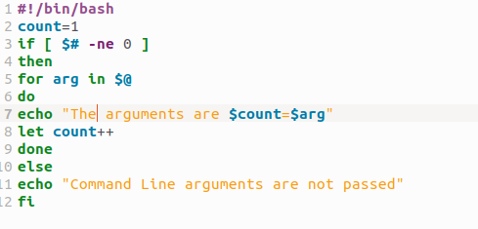
Output:
