- Program to print pattern in Python:
Method 1
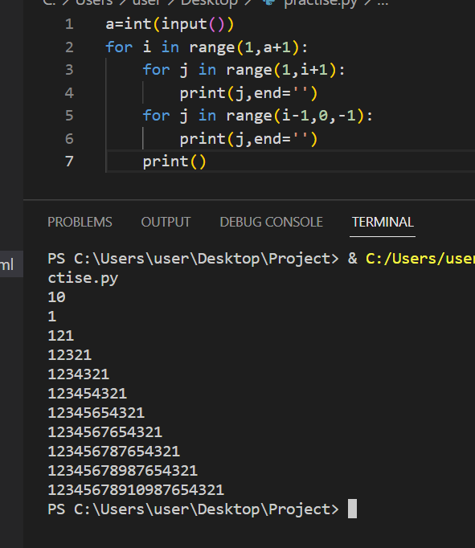
Method 2:
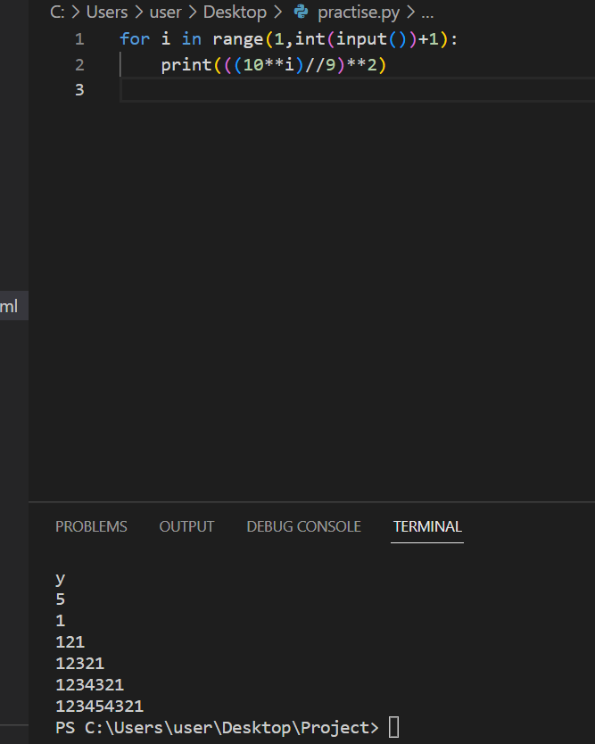
2)
Pattern 2
Method 1:
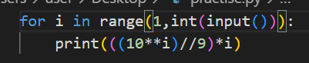
Method 2:
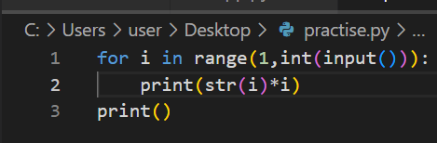
Output:
