- Write a program to return the single occurrence number and index of that number?
Code and output:
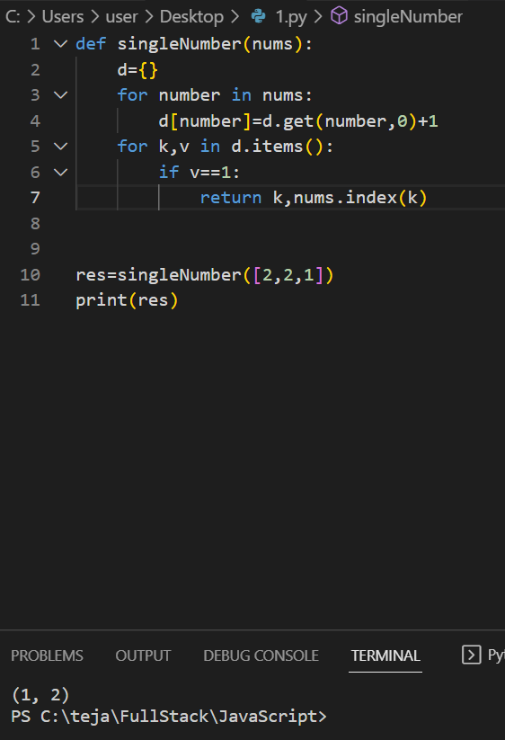 iff one unique number:
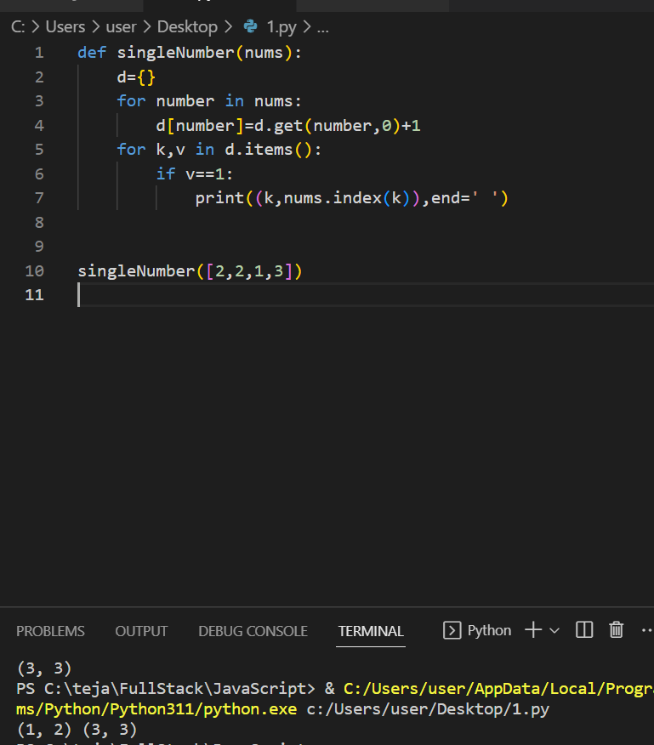 any number of unique numbers.

2)A phrase is a palindrome if, after converting all uppercase letters into lowercase letters and removing all non-alphanumeric characters, it reads the same forward and backward. Alphanumeric characters include letters and numbers.
Given a string s, return true if it is a palindrome, or false otherwise.

Code and Output:
