- Write a Script to Read File Name and Display its Content?
Script:
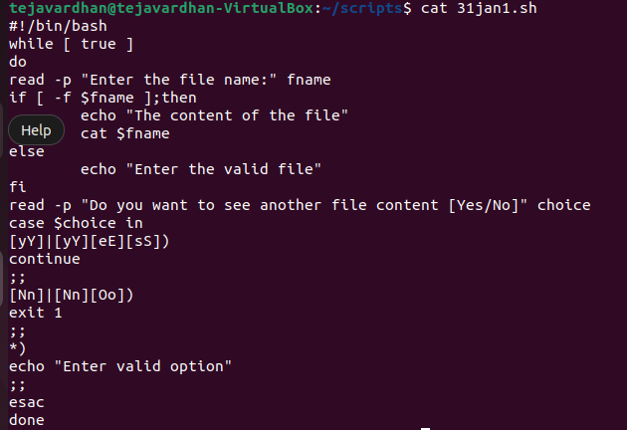
Output:
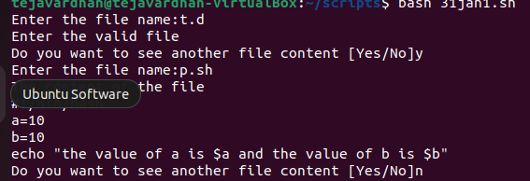

- Write a shell Script for the reversing of a string?
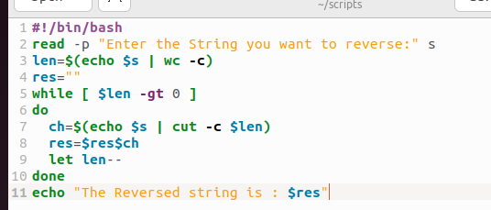
Output:

