Name:T.Harshitha

Date:04/01/2023

Python codes for the day

Problem Statement :Reverse Words in a String

Given an input string s, reverse the order of the **words**.

A **word** is defined as a sequence of non-space characters. The **words** in s will be separated by at least one space.

Return a string of the words in reverse order concatenated by a single space.

**Note** that s may contain leading or trailing spaces or multiple spaces between two words. The returned string should only have a single space separating the words. Do not include any extra spaces.

**Example 1:**

**Input:** s = "the sky is blue"

**Output:** "blue is sky the"

**Example 2:**

**Input:** s = " hello world "

**Output:** "world hello"

Source Code:

 def reverseWords(s):

        return " ".join(s.split()[::-1])

output:

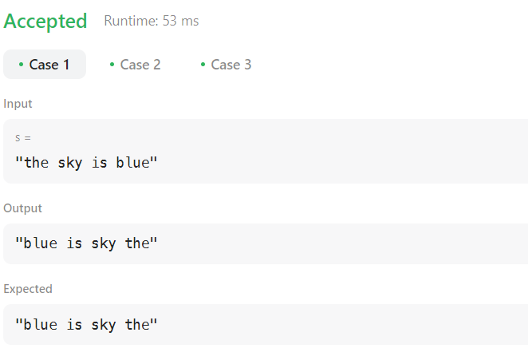

2.Problem Statement

 Isomorphic Strings

Given two strings s and t, determine if they are isomorphic.

Two strings s and t are isomorphic if the characters in s can be replaced to get t.

All occurrences of a character must be replaced with another character while preserving the order of characters. No two characters may map to the same character, but a character may map to itself.

**Example 1:**

**Input:** s = "egg", t = "add"

**Output:** true

**Example 2:**

**Input:** s = "foo", t = "bar"

**Output:** false

Source code:

def isIsomorphic(s,t):

        d1 = {}

        d2 = {}

        for (cs, ct) in zip(s, t):

            if d1.get(cs) is None and d2.get(ct) is None:

                d1[cs] = ct

                d2[ct] = cs

            else:

                if d1.get(cs) != ct or d2.get(ct) != cs:

                    return False

        return True

output:

