Date : 27/01/2023

Name : K Prasad Achari

Shell Script

1. Description- script to print chess board , black as 1 , white as 0.

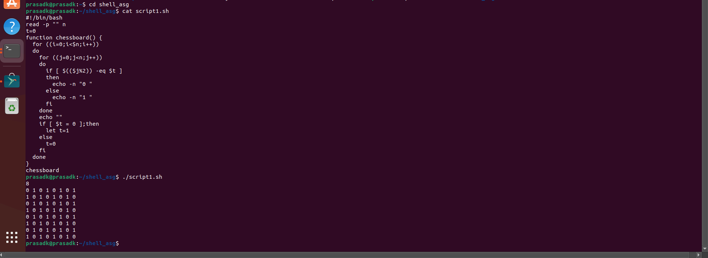

2. Description- Script to sort a given number in ascending or descending order.

