Date : 30/01/2023

Name : K Prasad Achari

**Shell scripts**

**1.**script for generating random 8-character passwords including alpha numeric characters.

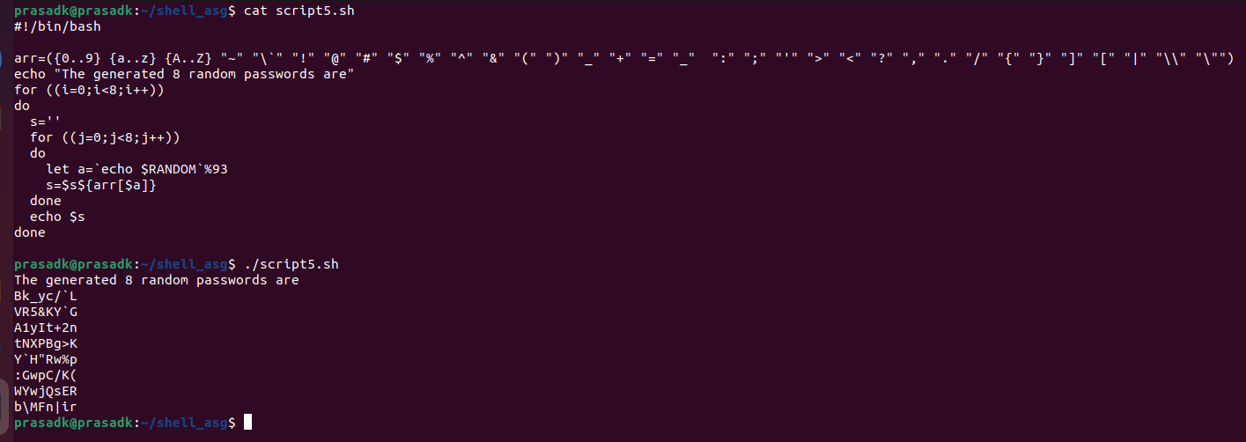

**2.**Script to rename a file/directory replaced by lower/upper case letters.

