 |  | 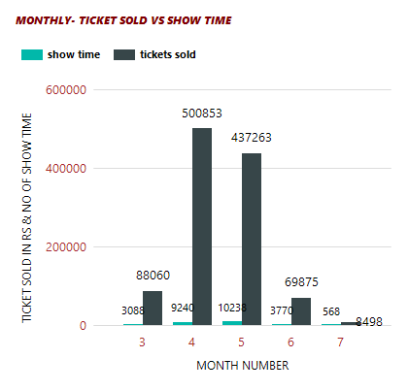 |  | 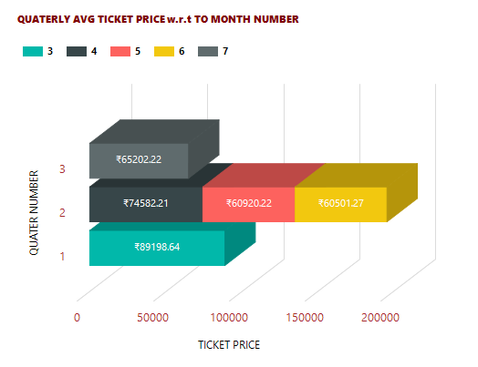
3 - MARCH
4 - APRIL
5 - MAY
6 - JUNE
7 - JULY

 | 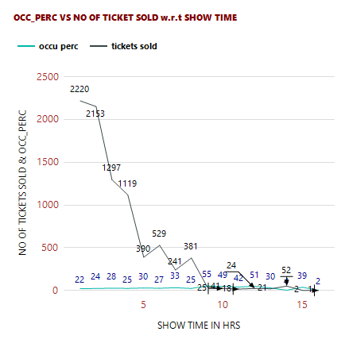 |  |  |  | 