DCSE, CEG, ANNA UNIVERSITY CHENNAI - 600025

IOT LAB - MINI PROJECT

**ME – CSE**

IOT BASED SMART HOME SECURITY SYSTEM WITH EMAIL ALERT USING RASBERRY PI

**Instructor :** Dr T. RAGHUVEERA / Dr P. UMA MAHESWARI

## TABLE OF CONTENTS

**CH. TITLE PAGE NO**

## ABSTRACT 3

## INTRODUCTION 4

## REQUIREMENTS 5

## SOFTWARE REQUIREMENTS

## WORKING EXPLANATION 6

## IMPLEMENTATION 7

## CODE

## OUTPUT SCREENSHOT

## CONCLUSION 12

**ABSTRACT**

# Home Security System will be build by using PIR Sensor and PI Camera.

* This system will detect the presence of Intruder and quickly alert the user by sending him a alert mail.

# This mail will also contain the Picture of the Intruder, captured by Pi camera.

* Raspberry Pi is used to control the whole system.

# This system can be installed at the main door of your home or office and you can monitor it from anywhere in the world using your Email over internet.

## INTRODUCTION

In the world of Internet of Things when we have all the technologies to revolutionize our life, it's a great idea to develop a system which can be controlled and monitored from anywhere. There are many types of good security systems and cameras out there for home security but they are much expensive so today we will build a low cost simple **Raspberry Pi based Intruder Alert System**, which not only alert you through an email but also sends the picture of Intruder when it detects any.

In this IoT project we will build a **Home Security System using PIR Sensor and PI Camera**. This system will detect the presence of Intruder and quickly alert the user by sending him a alert mail. This mail will also contain the Picture of the Intruder, captured by Pi camera. Raspberry Pi is used to control the whole system. This system can be installed at the main door of your home or office and you can monitor it from anywhere in the world using your Email over internet.

## REQUIREMENTS

**HARDWARE REQUIREMENTS**

* Raspberry Pi
* Pi Camera
* PIR Sensor
* LED
* Bread Board
* Resistor (1k)
* Connecting wires
* Power supply

**Working Explanation**

* A PIR sensor is used to detect the presence of any person and a Pi Camera is used to capture the images when the presence it detected.
* Whenever anyone or intruder comes in range of PIR sensor, **PIR Sensor triggers the Pi Camera through Raspberry Pi**. Raspberry pi sends commands to Pi camera to click the picture and save it.
* After it, Raspberry Pi creates a mail and sends it to the defined mail address with recently clicked images. The mail contains a message and picture of intruder as attachment.
* Here the pictures are saved in Raspberry Pi with the name which itself contains the time and date of entry. So that we can check the time and date of intruder entry by just looking at the Picture name, check the images below.

## IMPLEMENTATION

**CODE:**

* import RPi.GPIO as gpio
* import picamera
* import time

✓

* import smtplib
* from email.MIMEMultipart import MIMEMultipart
* from email.MIMEText import MIMEText
* from email.MIMEBase import MIMEBase
* from email import encoders
* from email.mime.image import MIMEImage

✓

* fromaddr = "[example@gmail.com](mailto:example@gmail.com)" # change the email address accordingly
* toaddr = "[example@gmail.com](mailto:example@gmail.com)"

✓

* mail = MIMEMultipart()

✓

* mail['From'] = fromaddr
* mail['To'] = toaddr
* mail['Subject'] = "Attachment"
* body = "Please find the attachment"

✓

* led=17
* pir=18
* HIGH=1
* LOW=0
* gpio.setwarnings(False)
* gpio.setmode(gpio.BCM)
* gpio.setup(led, gpio.OUT) # initialize GPIO Pin as outputs
* gpio.setup(pir, gpio.IN) # initialize GPIO Pin as input
* data=""

✓

* def sendMail(data):
* mail.attach(MIMEText(body, 'plain'))
* print data
* dat='%s.jpg'%data
* print dat
* attachment = open(dat, 'rb')
* image=MIMEImage(attachment.read())
* attachment.close()
* mail.attach(image)
* server = smtplib.SMTP('smtp.gmail.com', 587)
* server.starttls()
* server.login(fromaddr, "your password")
* text = mail.as_string()
* server.sendmail(fromaddr, toaddr, text)
* server.quit()

✓

* def capture_image():
* data= time.strftime("%d_%b_%Y|%H:%M:%S")
* camera.start_preview()
* time.sleep(5)
* print data
* camera.capture('%s.jpg'%data)
* camera.stop_preview()
* time.sleep(1)
* sendMail(data)

✓

* gpio.output(led , 0)

camera = picamera.PiCamera()

camera.rotation=180

camera.awb_mode= 'auto'

camera.brightness=55

while 1:

✓

if gpio.input(pir)==1:

✓

gpio.output(led, HIGH)

✓

capture_image()

✓

while(gpio.input(pir)==1):

✓

time.sleep(1)

✓

✓

else:

✓

gpio.output(led, LOW)

✓

time.sleep(0.01)

## OUTPUT SCREENSHOT:

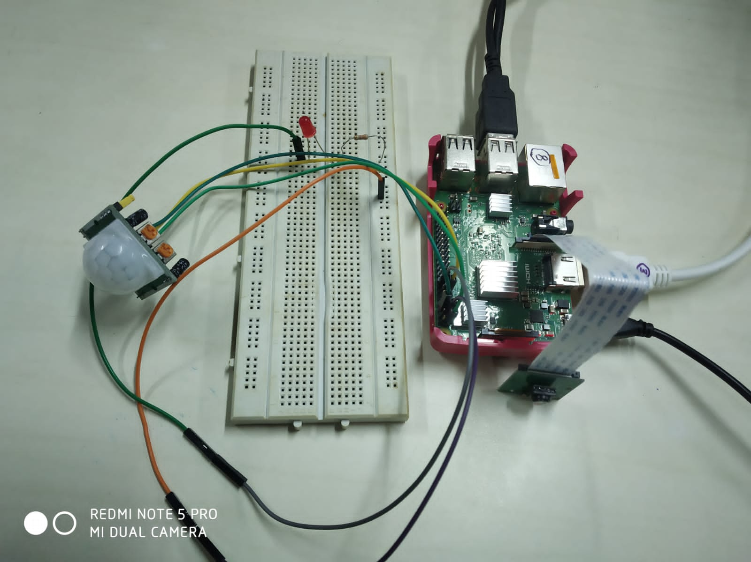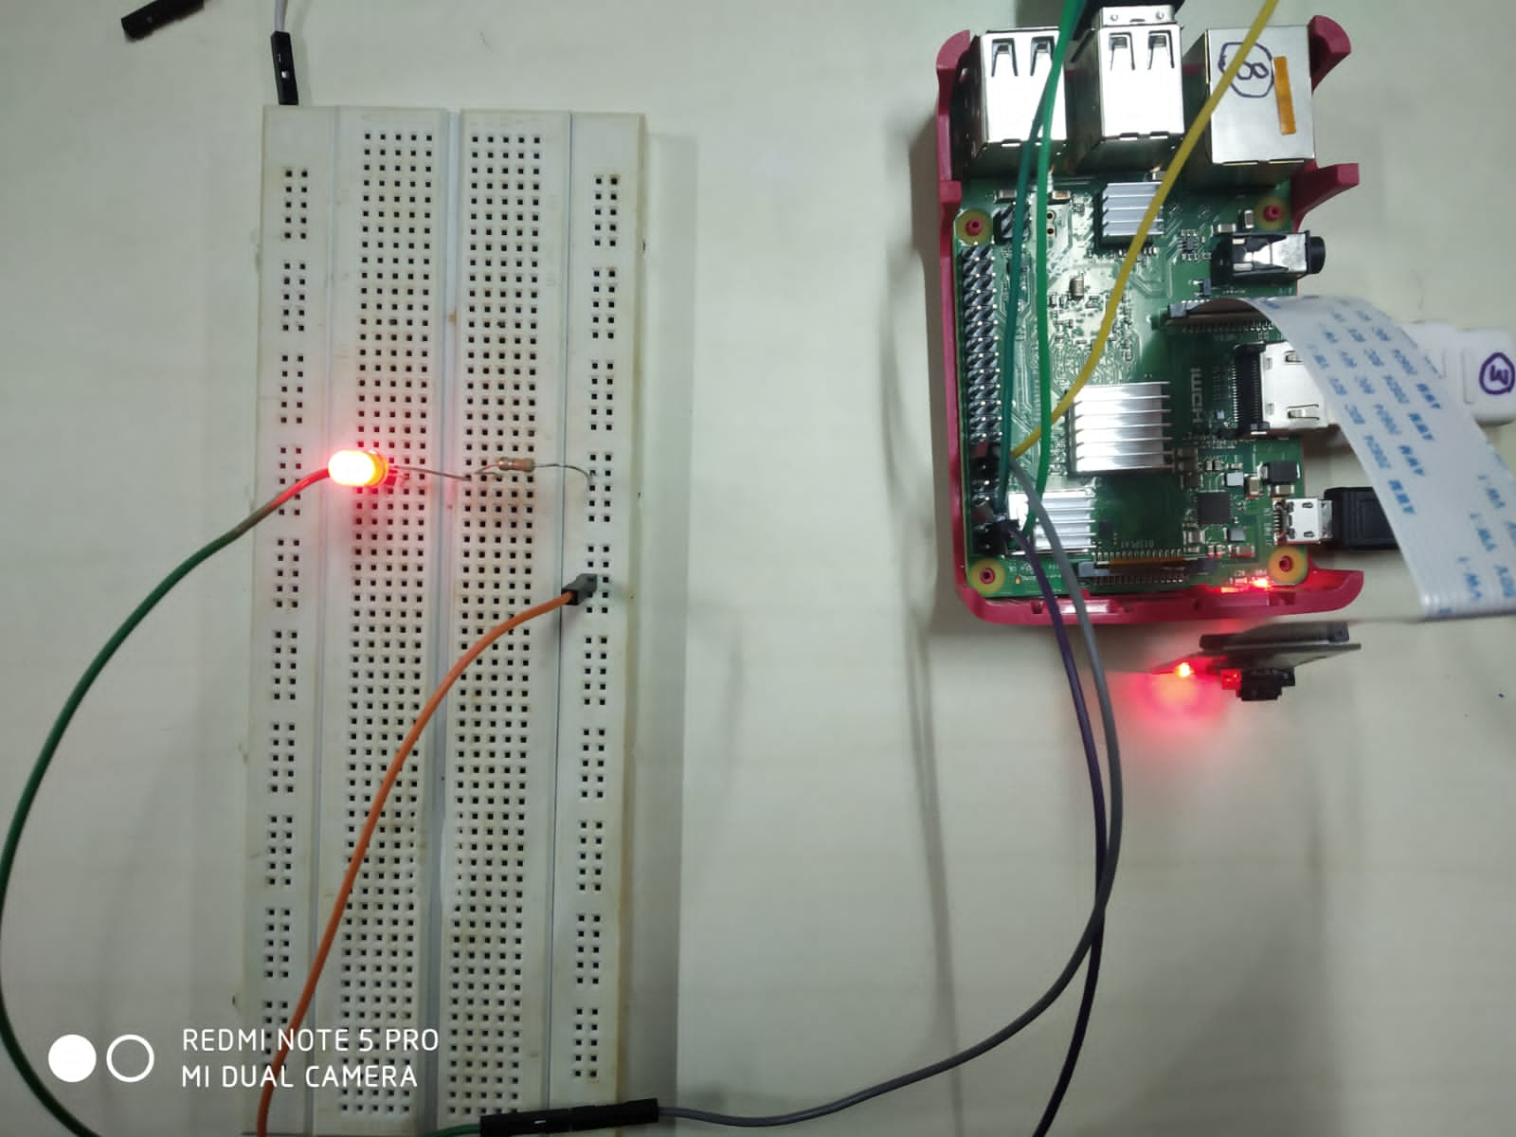

**CONCLUSION**

This system will detect the presence of Intruder and quickly alert the user by sending him a alert mail. This mail will also contain the Picture of the Intruder, captured by Pi camera. Raspberry Pi is used to control the whole system. This system can be installed at the main door of your home or office and you can monitor it from anywhere in the world using your Email over internet.