The program takes a string as a input to query with the location JSON API and transforms the output to a CSV file.The user can either input a file name and path or choose to use the default location “E:\LocationDetails.csv”.

The program can be run in the command line as follows :

java -jar GoEuroTest.jar Berlin

Please follow the further directions are provided in the console.

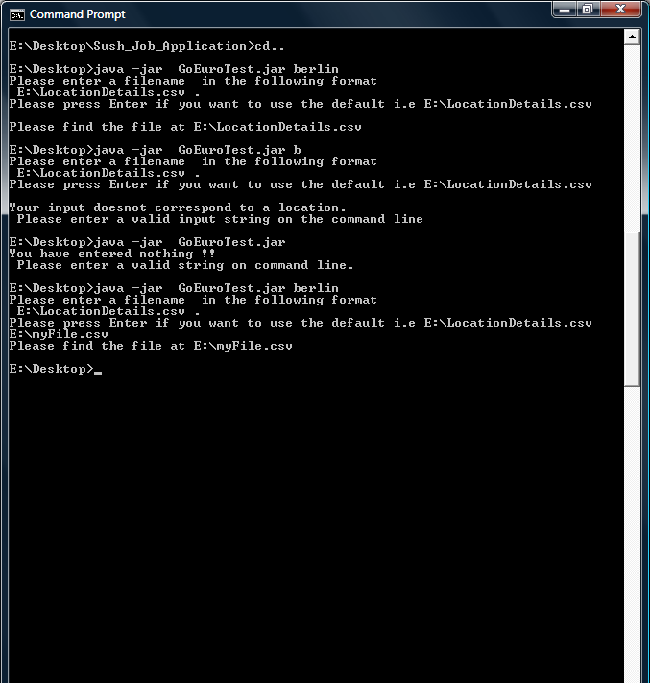

The above snaphot of the console illustrates 5 input possibilities

1. With command line argument : Berlin
2. With command line argument : B
3. Without command line arguments.
4. Using Default location E:\LocationDetails.csv.
5. Using user defined path and file name