**Exercise-1**

**1.Define SPA and its benefits**  
A SPA (Single Page Application) is a web app that dynamically updates a single HTML page as the user interacts with the app, rather than loading entire new pages from a server.  
Benefits:

* Faster navigation
* Better user experience
* Reduced server load
* Smooth transitions between views

**2. Define React and identify its working**  
React is a JavaScript library developed by Facebook for building user interfaces, especially SPAs.  
It works by creating components and using a virtual DOM to efficiently update and render UI elements when data changes

**3.Identify the differences between SPA and MPA**

| **Feature** | **SPA** | **MPA** |
| --- | --- | --- |
| Page Load | Loads once | Loads on each interaction |
| Speed | Faster | Slower |
| User Experience | Smooth | Less fluid |
| Server Requests | Fewer | More |
| URL Handling | Needs routing | Native to browser |
|  |  |  |

|  |  |
| --- | --- |
| **4. Explain Pros & Cons of SPA** **Pros**:   * Fast and responsive * Seamless user experience * Reduces server requests   **Cons**:   * SEO is harder * Initial load time can be longer * Browser history management needed |  |

**5. Explain about React**React is a front-end JavaScript library used to build reusable UI components. It is declarative, efficient, and flexible. It enables developers to create large web applications that can update data without reloading the page.

**6.Define Virtual DOM**  
The Virtual DOM is a lightweight copy of the actual DOM. When the state of a component changes, React compares the virtual DOM with a previous snapshot and updates only the changed parts in the real DOM. This makes React apps fast.

**Explain Features of React**

* Component-Based Architecture
* Virtual DOM
* Unidirectional Data Flow
* JSX (JavaScript + XML)
* Declarative Syntax
* Strong Community and Ecosystem

Create a new React Application with the name “myfirstreact”, Run the application to print “welcome to the first session of React” as heading of that page.

1. To create a new React app, Install Nodejs and Npm from the following link:

<https://nodejs.org/en/download/>

1. Install Create-react-app by running the following command in the command prompt:



1. To create a React Application with the name of “myfirstreact”, type the following command:



1. Once the App is created, navigate into the folder of myfirstreact by typing the following command:



1. Open the folder of myfirstreact in Visual Studio Code
2. Open the App.js file in Src Folder of myfirstreact
3. Remove the current content of “App.js”
4. Replace it with the following:

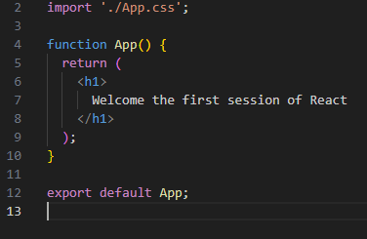

1. Run the following command to execute the React application:



