Exercise-2

1. **Explain React Components**  
React components are independent, reusable pieces of UI. Each component behaves like a JavaScript function that returns HTML (JSX).

2. **Difference between Components and JavaScript Functions**

| **React Component** | **JavaScript Function** |
| --- | --- |
| Returns JSX (UI) | Returns any value |
| Can maintain state (in class components or hooks) | No built-in state management |
| React lifecycle methods supported (class) | No lifecycle methods |
| JSX syntax used | Pure JS syntax used |

3. **Types of Components**

* **Class Component**
* **Function Component**

4. **Explain Class Component**  
A class component is a JavaScript class that extends React.Component. It must have a render() method that returns JSX.

5. **Explain Function Component**  
A function component is a simpler way to write components using plain JavaScript functions. It can use hooks like useState or useEffect to manage state or lifecycle logic.

6. **Define Component Constructor**  
In class components, the constructor(props) is used to initialize state or bind methods. It runs before the component is mounted.

7. **Define render() Function**  
The render() method is required in class components and is responsible for returning JSX that defines what should be rendered on the UI.

**Create a react app for Student Management Portal named StudentApp and create a component named Home which will display the Message “Welcome to the Home page of Student Management Portal”. Create another component named About and display the Message “Welcome to the About page of the Student Management Portal”. Create a third component named Contact and display the Message “Welcome to the Contact page of the Student Management Portal”. Call all the three components.**

1. Create a React project named “StudentApp” type the following command in terminal of Visual studio:



1. Create a new folder under Src folder with the name “Components”. Add a new file named “Home.js”
2. Type the following code in Home.js

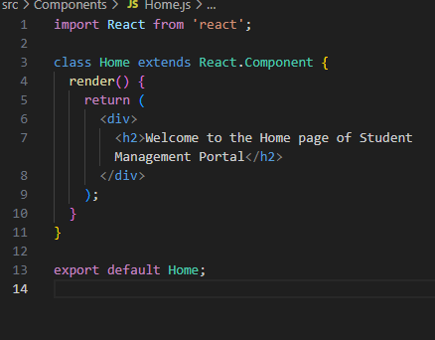

4.Under Src folder add another file named “About.js”

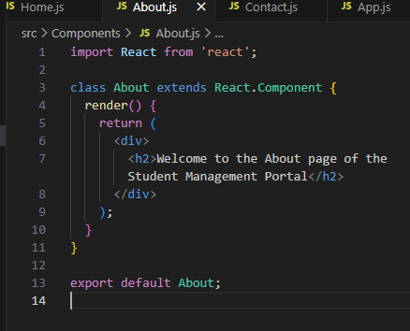

5.Repeat the same steps for Creating “About” and “Contact” component by adding a new file as ”About.js”, “Contact.js” under “Src” folder and edit the code as mentioned for “Home” Component.

Contact.js

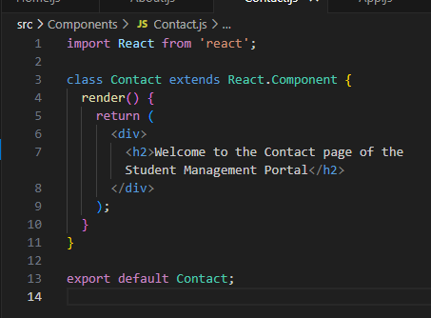

6. Edit the App.js to invoke the Home, About and Contact component as follows:

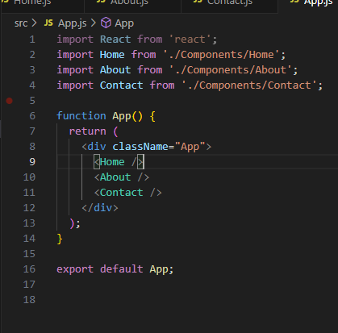

1. In command Prompt, navigate into StudentApp and execute the code by typing the following command:



1. Open browser and type “localhost:3000” in the address bar:

